🇦🇪 Mar 6:

In this edition:

- Events in March 2026
- Emergency alert across Dubai
- UAE clinics aid tourists

Spotlight

Food routes under strain

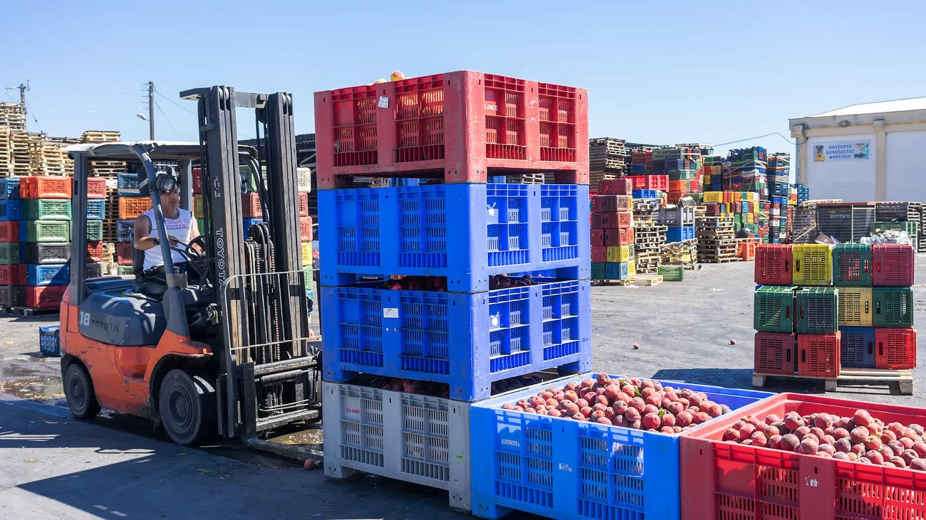

What’s happening? The Iran war is putting Gulf food security under serious pressure by snarling shipping routes and threatening key ports. Wealthy Gulf states import around 80% to 90% of their food, and much of it normally moves through the Strait of Hormuz. That means a prolonged conflict could quickly turn a logistics problem into a price and supply problem, despite years of planning following the 2008 food crisis.

On the ground: Analysts say more than 70% of GCC food imports pass through Hormuz, making the region highly exposed to disruption. Iranian attacks this week hit major trade lifelines, including Jebel Ali, the Gulf’s biggest container port, temporarily suspending operations. Smaller ports outside the strait, such as Khorfakkan and Fujairah, have far lower capacity and cannot fully replace Jebel Ali or Abu Dhabi’s Khalifa Port. Supermarket shelves in the UAE remain mostly stocked for now, but restocking is taking longer; panic buying has already flared, and some residents report sudden price jumps, especially for perishables like bananas.

What’s next? Governments may rely on strategic reserves, subsidies, and rerouted supply chains, but if disruption drags on, longer lead times and higher food prices will be hard to avoid.

Fact: The UAE’s Fujairah grain silos, opened in 2016, hold roughly 300,000 metric tons outside Hormuz.

Events

Aghany Almosalsalat
Go back in time with Aghany Almosalsalat, an immersive live show at Dubai Opera, celebrating the iconic music from Arabic TV series over the decades.

27 Mar - 28 Mar, Tickets available from AED 170 - AED 570


Dubai World Cup
Catch Dubai's action-packed horse racing season as it hits a resounding peak of glamour and competition at Meydan Racecourse.

28 Mar, Tickets available from AED 40 - AED 36000


Quiz Room
Step into the UAE’s first immersive game show experience in Dubai, packed with buzzers, lights, strategy, and surprises. Expect fast-paced trivia battles, music challenges, and competitive fun for teams.
03 Mar to 01 Apr, Tickets start from AED70

Where to eat?
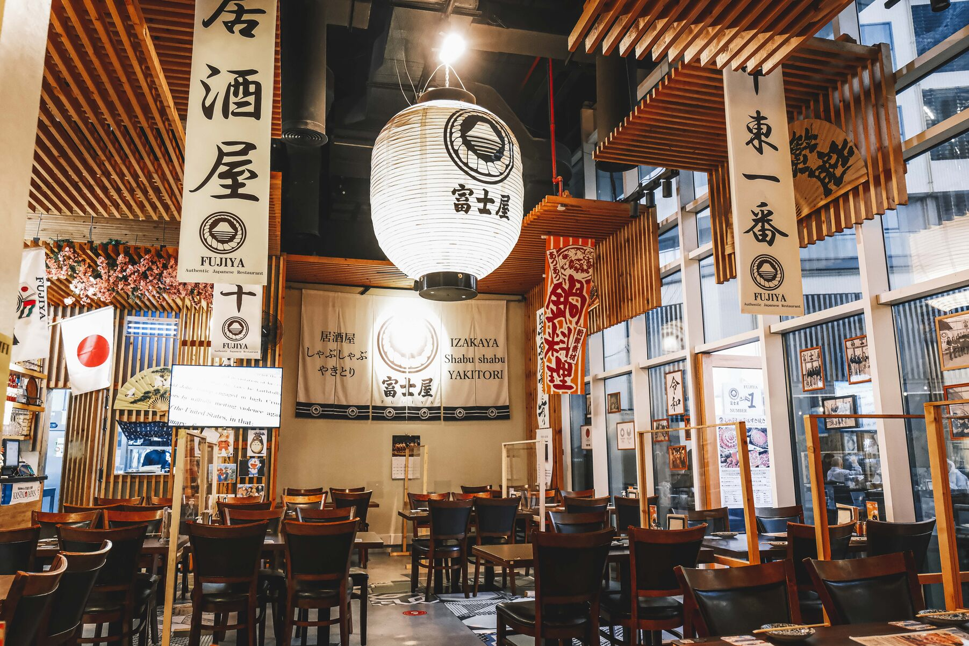

Fujiya in Dubai Marina is a long-standing Japanese dining destination, known for bringing authentic Japanese flavours and traditional izakaya-style hospitality to the UAE. Holder of a 2025 Michelin Star and Asia's 50 Best recognition. Standout dishes include wagyu tiradito with yuzu ponzu and black cod miso-glazed with truffle. No alcohol, but premium sake and teas pair perfectly.

Pro tip: Opt for the omakase tasting menu to savor the chef's seasonal innovations; reserve well in advance for counter seats.

Career

Operations Manager – Meal Delivery Business

On-site
Full-time
AED 6,000 - 7,999/month
EatClean, a healthy meal delivery company based in Dubai, is looking to hire an Operations Manager to oversee daily operations and support the company’s expanding retail partnerships. The role focuses on coordinating with outsourced kitchen and delivery partners, ensuring meal quality, managing production schedules, resolving operational issues, and monitoring food costs and performance metrics. Candidates should have 5–10 years of experience in restaurant, catering, cloud kitchen, or food operations, and experience managing vendors or partners. UAE experience is preferred.

Register here

Meanwhile
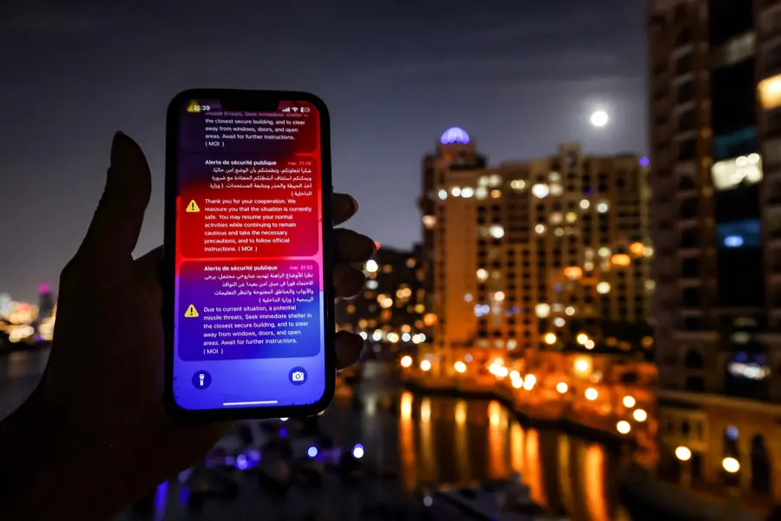

Dubai missile threat alert
The UAE Ministry of Interior issued an emergency alert across Dubai, urging people to immediately seek shelter following warnings of a potential missile threat. Authorities advised people to stay inside secure buildings and avoid windows and open areas. Authorities also called on residents to rely solely on official government channels for updates and further instructions as the situation develops.

No photos of drone damage

The UAE Attorney-General warned residents against photographing or sharing images and videos of damage caused by falling drone debris or projectiles. Authorities said such content could spread panic or misinformation. Authorities also cautioned against AI-generated or manipulated footage, stressing that violators may face legal action.

Aid for stranded travellers
Pakistan Medical Center in Umm Hurair is offering stranded travellers free consultations, diagnostics, and essential medication amid ongoing airspace closures, covering 37 specialties daily. Supported by UAE authorities and volunteer doctors, the centre allocates a special fund for treatment. Thumbay Healthcare is providing urgent medical assistance, while Aster DM Healthcare offers free online mental health video consultations nationwide via the myAster app.

Did you know?
Dubai issued nearly 1,600 new restaurant licences in 2025, More than any other city, sign of just how aggressively the city’s food scene is expanding. It reflects rising demand from residents, tourists, and investors, and helps explain why Dubai now pitches itself as the region’s biggest and most influential gastronomy hub

Day
Friday

Date
Mar 6

Temperature
26°C

Preview text
Plus Dubai World Cup

Image credits
Elesely Holdings, Platinumlist, Visit Dubai, Fever, Fujiya, AFP

