🌍 Mar 6: Drone zone diplomacy

In this edition:

- Russia holds back
- Venezuelan gold agreement
- What is game theory?

Spotlight

EU presidency tested

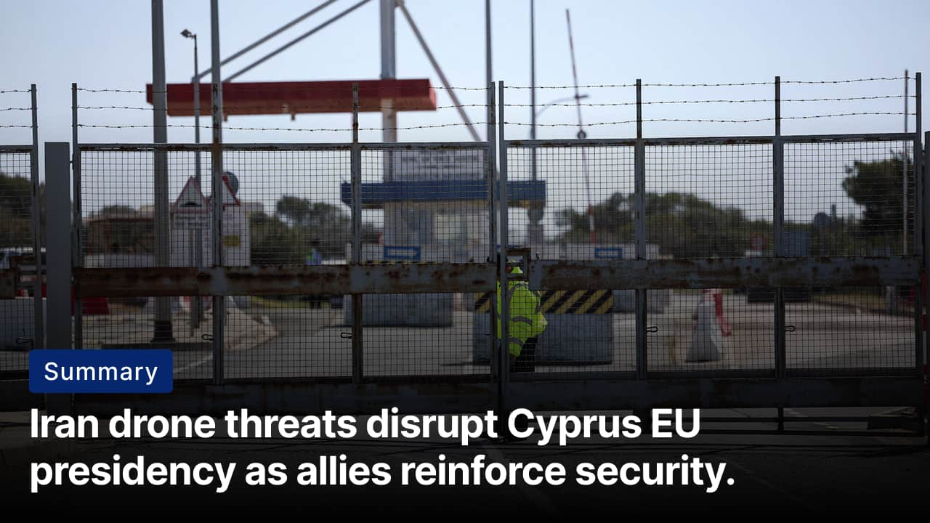
What’s happening? Cyprus has been forced to reschedule several major EU meetings after Iranian drones targeted the island during escalating regional tensions. The attacks came as Cyprus holds the rotating presidency of the Council of the EU. Meetings involving EU ministers on the bloc’s long-term budget and the EU accession paths of Ukraine and Moldova were postponed, along with cybersecurity and health conferences.
Dilemma: As the EU member closest to the Middle East, Cyprus risks being drawn into the regional conflict after Iranian threats and drone activity near British bases. At the same time, it must continue leading the EU Council presidency, coordinating legislation and ministerial meetings while managing rising security risks at home.
Support: Greece has deployed warships and fighter jets to reinforce regional security, while France has sent naval frigates and pledged additional air-defense systems to help protect strategic sites. EU institutions are also coordinating closely with Cypriot authorities to ensure the Council presidency can continue functioning despite disruptions. EU ambassadors and crisis teams are monitoring the conflict and preparing possible evacuations of EU citizens.

Senate paves the way
Summary: Senate blocks effort to limit Trump’s war powers as the Iran conflict escalates.
What happened? The US Senate rejected a bipartisan resolution that sought to limit President Trump’s authority to continue military strikes against Iran without congressional approval. The proposal aimed to require Congress to authorise further military measures and potentially halt current hostilities. Just two senators crossed party lines: Republican Rand Paul supported the resolution, while Democrat John Fetterman opposed it.
Why? Most Republicans rejected the resolution, arguing the president already has authority as commander-in-chief to conduct military operations without prior congressional approval during an active conflict. Many lawmakers also view Iran as a major national security threat and worry that restricting Trump’s powers could weaken the US military response. Some Republicans said they may reconsider if the war expands.
Big picture: The dispute reflects wider concerns in Washington about “forever wars” in the Middle East and the limits of presidential power during conflicts. At the same time, the Senate vote shows strong political support for confronting Iran despite these concerns. If the conflict expands or lasts longer than expected, pressure may grow in Congress to reassert its authority.

Analysis

Russia holds back
Summary: Russia backs Iran politically but avoids military involvement, prioritizing the Ukraine war and strategic interests.
What happened? Russia has strongly condemned the US-Israeli strikes on Iran but has stopped short of providing direct military support to Tehran. Despite being one of Iran’s closest partners, cooperating on projects like the North-South transport corridor and military cooperation, such as drone technology used in the Ukraine war, Moscow is unlikely to intervene. Russia is also balancing its own priorities, including the war in Ukraine and complex relations with Israel.
Background: Russia and Iran have developed closer ties over the past decade, largely driven by shared tensions with the West and international sanctions. Their cooperation deepened after Russia’s 2022 invasion of Ukraine, when Iran supplied Shahed drones that significantly boosted Moscow’s battlefield capabilities. In return, Russia has provided Iran with military technology, intelligence support, and diplomatic backing at the UN.
Future: If the current regime weakens or falls, Moscow may shift quickly to engage any successor government to protect its strategic interests. Russia is likely to continue offering diplomatic backing but prevent direct military involvement to prevent escalation with the US and Israel. At the same time, Moscow may benefit from higher energy prices and global attention shifting away from Ukraine.

Worldwide
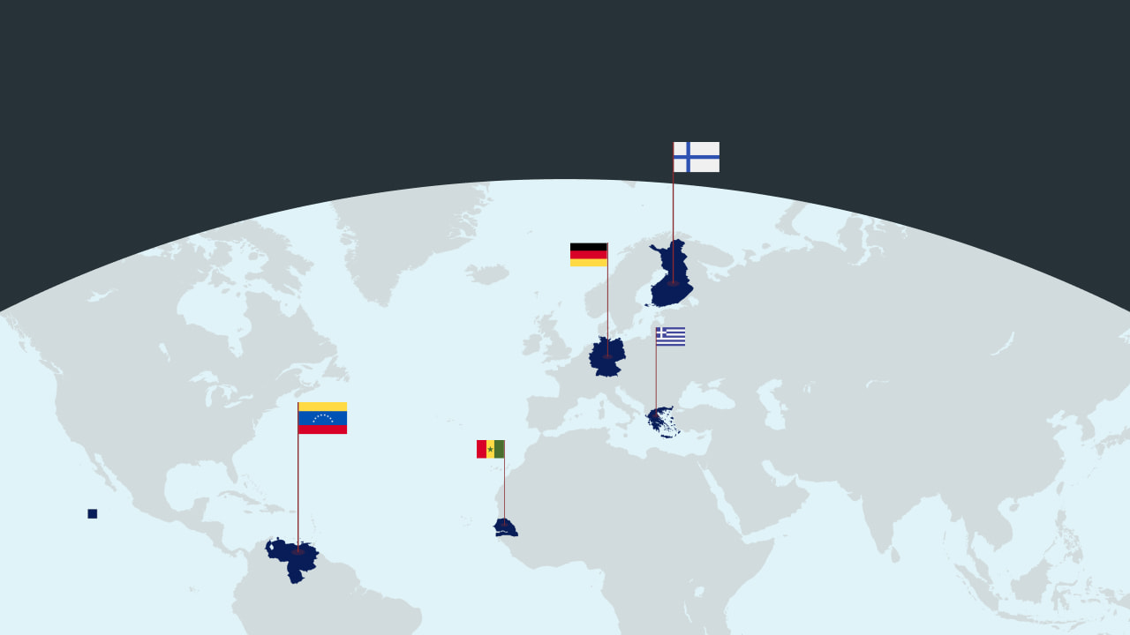

🇬🇷 Greece - Upholds Neo Nazi’s conviction. A Greek appeals court has upheld the 2020 convictions of leaders and members of the neo-Nazi party Golden Dawn. It confirmed that the party operated as a criminal organization. The ruling reaffirmed sentences for 42 figures, including former leader Nikos Michaloliakos (request denied).

🇻🇪 Venezuela - Gold agreement with the US. Venezuela’s state mining company, Minerven, has signed a multimillion-dollar agreement to sell 650 to 1,000 kilograms of gold to Trafigura. This gold will be refined in the US. The agreement happened during US Interior Secretary Doug Burgum’s visit. It is the third major resource agreement under the Trump administration (digging for gold).

🇩🇪 Germany - Hefty sentence for stabbing. A Berlin court sentenced a 20-year-old Syrian man to 13 years for stabbing a Spanish tourist at the Holocaust memorial in February 2025. Prosecutors said he acted for IS and targeted a Jewish person. He was tried as an adult because of his maturity. The attack happened just days before Germany’s elections, sparking debates about Syrian refugees and migration (justice served).

🇸🇳 Senegal - ECOWAS tackles jihad. West African states plan to create a 2,000-strong force to fight jihadist threats. This force does not include Burkina Faso, Mali, and Niger, as they have left ECOWAS after recent coups. Troops will stay in their home countries, with Sierra Leone acting as a logistical hub. Talks about funding and deployment are ongoing (West African cooperation).

🇫🇮 Finland - Lifts ban on hosting nuclear weapons. Finland plans to lift its ban on nuclear weapons. This change aims to align better with NATO’s deterrence strategy. The proposal will amend the 1987 Nuclear Energy bill. It allows nuclear weapons for national defense. Defence Minister Antti Häkkänen stated that this move addresses security concerns following Russia's invasion of Ukraine (change in course).

Foundations

What is game theory?


What is it? Game theory analyzes strategic situations in which one player's outcome depends on others' choices. It was formalized in the 1940s by the mathematician John von Neumann and the economist Oskar Morgenstern, and became an important tool during the Cold War for modeling nuclear deterrence (convincing an enemy not to attack by threatening a strong response). It is currently widely used in politics, economics, and military planning.

Example: In a potential Iran-Israel nuclear standoff, Iran must decide whether to continue its nuclear program, knowing Israel might attack. Similarly, Israel would need to consider whether to strike, aware that Iran could retaliate. This is called a “game” because it’s a situation of strategic independence: each side’s best choice depends on what it thinks the other side will do.

Application: In international relations, game theory can show the sequence of moves and decisions (extensive model), compare all possible strategies and preferred results (strategic model), or measure the value each partner brings to an alliance (coalition model). It provides a clear framework through different scenarios and consequences. While it doesn’t provide a definitive answer, it helps decision makers understand how their choices and assumptions about others’ choices can shape the final outcome.

Image credits

Reuters, Privatdozent

Preview text
Plus ECOWAS tackles jihad

