🇬🇧 Mar 6: Spy games London
In this edition:

- North London outbreak
- Telegraph Media acquisition
- Leeds United’s request

Spotlight

Spy plot disrupted

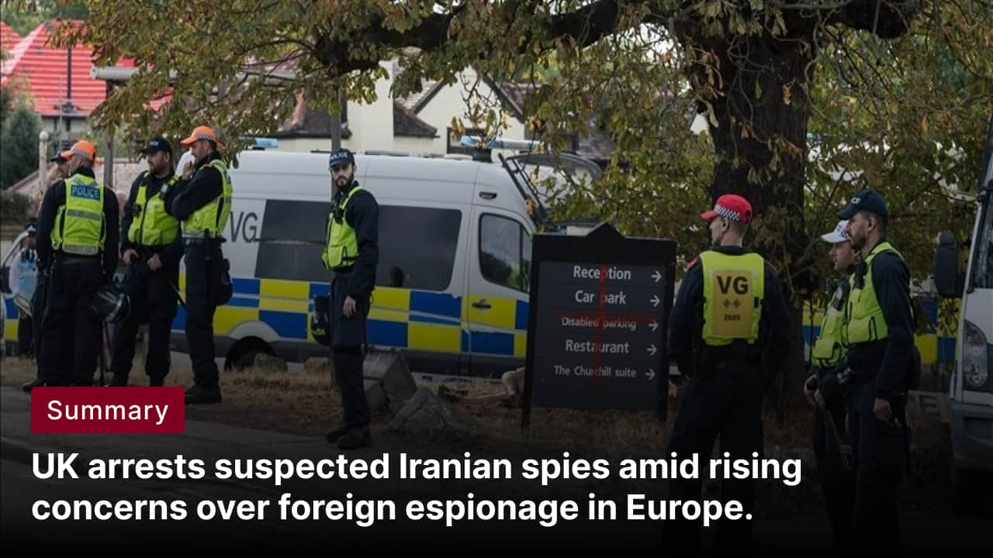

What happened? Four men were arrested in London on suspicion of spying for Iran as part of a counterterrorism investigation by the Metropolitan Police. Officers detained the suspects during early-morning raids at addresses in Barnet and Watford, on the northern outskirts of the capital. Police also arrested six additional people suspected of assisting the alleged activity, while another person was detained for assaulting an officer. The suspects, aged 55, 52, 40, and 22, remain under investigation.

Why? Authorities believe the suspects were conducting surveillance on locations and individuals linked to London’s Jewish community on behalf of Iranian networks. UK and allied intelligence agencies fear Iran-linked networks are expanding covert operations in Europe. Police acted early to disrupt possible surveillance before it could escalate into intimidation, violence, or espionage.

Big picture: The case underscores growing concern in Europe about foreign state espionage and proxy operations. As a result, the UK increasingly sees an overlap between counterterrorism and counter-espionage, especially when hostile state activity targets communities within Western countries. In response, European governments are tightening security measures and strengthening intelligence coordination to detect and disrupt such threats earlier.

North London outbreak


What’s happening? Measles cases are rising in north London, with the boroughs of Enfield and Haringey accounting for nearly half of all reported infections in England. Enfield recorded 12 new cases in the final week of February, bringing its total to 71 this year, while Haringey has reported 13 cases over the past two months. London currently accounts for about 65% of England’s measles cases.

Why? In some areas of London, uptake of the measles, mumps, and rubella (MMR) vaccine has fallen below the level required to prevent outbreaks. The outbreak is mainly affecting young children in schools and nurseries, with the most severe cases linked to unvaccinated patients. Delayed vaccinations following the COVID-19 pandemic and lingering vaccine hesitancy among some parents have also contributed.

Big picture: Measles had been largely suppressed through widespread immunisation, but gaps in vaccine coverage have created conditions for new outbreaks. Health authorities warn that London’s surge could spread to other regions if vaccination rates are not quickly improved. The situation also reflects wider global trends, as measles cases have risen in several countries following pandemic-related disruptions.

What’s on
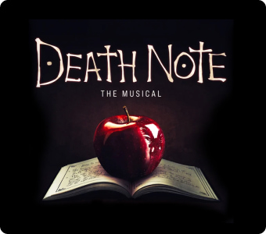
Death Note - The Musical
The world premiere of Death Note: The Musical arrives at the Barbican for a strictly limited run of 50 performances.
July 30 - September 12, tickets starting at £31

Shadowlands - Play
Based on a true story, Shadowlands follows Oxford don and author C. S. Lewis as he opens his heart to a surprising and transformative romance with Joy Davidman, a spirited poet whose wit and honesty challenge his long-held beliefs.
Multiple dates, tickets starting at £55

Long story short

Business
German media giant Axel Springer has agreed to acquire Telegraph Media Group, the owner of The Daily Telegraph, for £575M. Axel Springer said the acquisition will help expand the brand internationally and strengthen its presence in English-language media, particularly in the US. The agreement ends a prolonged battle over ownership of the conservative-leaning British newspaper group.

Royal Mail has announced another increase in stamp prices, with first-class stamps rising by 10p to £1.80 and second-class stamps increasing by 4p to 91p from April 7. The postal operator said the price hikes are needed to offset rising delivery costs and a sharp decline in letter volumes. However, consumer group Citizens Advice has criticised the move, arguing that customers are paying more for a service that continues to miss delivery targets.

Art & culture
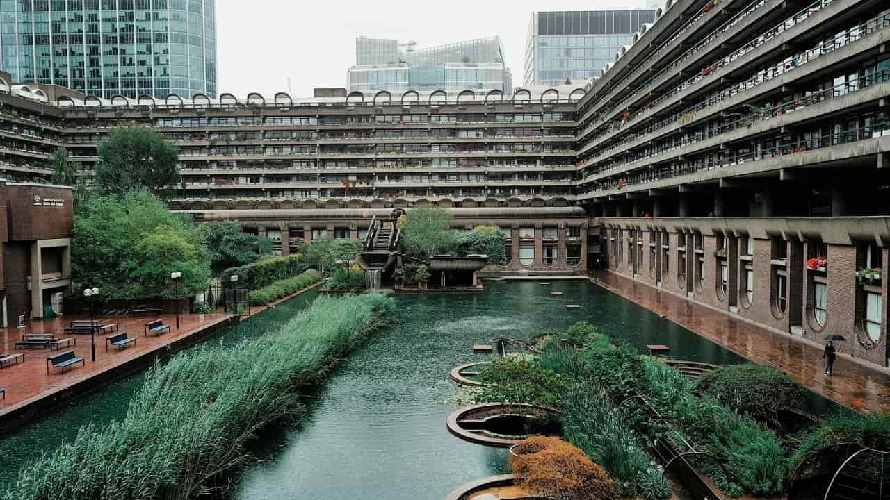

The Barbican Centre in London will host a large immersive film and art exhibition titled In Other Worlds from May 21 to September 6, 2026. The exhibition will explore imagined futures through science fiction, climate themes, and technological speculation. It will feature collaborations with artists, scientists, musicians, and designers linked to major productions such as Westworld, Fallout, The Handmaid’s Tale, and Andor.
Actor Timothée Chalamet has sparked backlash after saying “no one cares” about ballet or opera during a public conversation with Matthew McConaughey. The remarks drew criticism from performers and industry figures in the classical arts, who said the comments dismissed centuries-old art forms and the artists who practice them. Opera singers, ballet professionals, and cultural leaders responded online, arguing that both disciplines remain vibrant and influential.

Sports
The Australian Grand Prix has announced that Turn Six at Melbourne’s Albert Park Circuit will be temporarily renamed “In Her Corner” for the 2026 race to mark International Women’s Day. The tribute honours two prominent female Formula 1 engineers: Laura Mueller, race engineer at Haas for driver Esteban Ocon, and Hannah Schmitz, Red Bull’s head of race strategy. Organisers say the initiative aims to highlight women’s contributions to engineering and inspire more young people to pursue careers in the field.

Leeds United has urged supporters to show respect when play is paused during Sunday’s FA Cup match against Norwich City, allowing Muslim players observing Ramadan to break their fast. The appeal follows boos heard during a similar pause in last weekend’s game against Manchester City at Elland Road. The club condemned the reaction and acknowledged that some fans may not have understood why the match was briefly halted.

Misc

Leak from UK security meeting on Trump's war request branded 'utterly destructive'
Why is HMS Dragon taking so long to get to Cyprus
WW3 survival techniques can save you in a life-or-death nuclear blast
A dog trainer says 3 breeds are the worst behaved, and they're really popular

Did you know?
The River Thames was declared “biologically dead” in 1957 due to severe pollution. Decades of cleanup and environmental protection have transformed the river, which today supports more than 115 species of fish and a wide range of wildlife in London.

Day
Fri

Date
Mar 6

AQI
66

Image credits
Apa, iStock, London Theatre Tickets, London Theatre Tickets, FLO London

Preview text
Plus German media acquires Telegraph Group

