🇦🇪 Mar 10: Building safety

In this edition:

- March 2026 events
- Dubai tops cleanliness
- Fairmont Palm operational

Spotlight

Dubai tightens building rules
What happened? Sheikh Mohammed issued Law No. (3) of 2026 to strengthen building quality, safety, and maintenance standards across the emirate. The law applies to all buildings in Dubai, including those in private developments and free zones such as DIFC, whether they were built before or after the law’s introduction. It gives Dubai Municipality a central role in oversight, including creating a digital management system, maintaining a unified building database, carrying out inspections, and enforcing standards.
What changes? Building owners must now obtain a Quality and Safety Certificate after completion, based on an inspection by a licensed engineering office. Owners are also required to fix identified defects, carry out periodic maintenance, and allow official inspections. Certificates will remain valid for 10 years for buildings under 40 years old and 5 years for older buildings, with renewals possible under future executive rules.
Why it matters: The law is designed to improve structural safety, reduce accidents, protect lives and property, and preserve Dubai’s urban quality. Violations can trigger fines from Dh100 to Dh1 million, rising to Dh2 million for repeat offences, along with permit suspensions and other enforcement measures.

Events
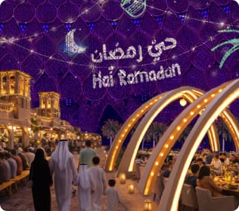
Hai Ramadan
Indulge in Dubai’s flagship Ramadan experience at the Al Wasl Plaza, Expo City Dubai. Enjoy a month-long celebration that beautifully blends tradition, community, and contemporary culture.
09 Mar - Sun 15 Mar, Tickets start from 42.51 USD


Readles
The museum, located in Dubai Mall Zabeel, combines magic, stories, and modern technology to create fun learning adventures for the whole family. Inspired by fairy tales from around the world, each zone lets kids see, touch, and play with their favorite heroes brought to life through lights, sounds, and digital art.
Multiple dates, Tickets start from 99AED + VAT

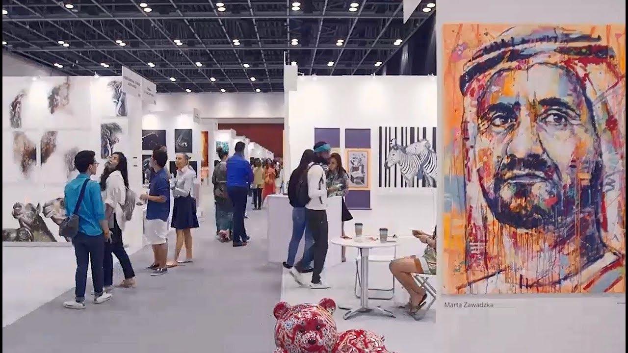
Art Fest International
Head to Taj Dubai for Art Fest International, a curated international art exhibition from India, showcasing contemporary artworks by Indian artists and talent from other countries.
13 Mar - 15 Mar, Free entry

Where to eat?
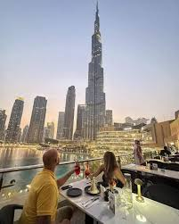

Joe’s Café Dubai is a stylish café in Fashion Avenue known for premium ingredients, specialty coffee, and a diverse all-day dining menu. Inspired by its London heritage, the venue blends elegant interiors with a cosmopolitan vibe and views of Downtown Dubai. Menu highlights include risotto, gourmet burgers, pancakes, and eggs Benedict, alongside fresh salads, seafood starters, and artisan coffee drinks.

Pro tip: Pair terrace dining with fountain show timings for an unforgettable experience.

Career

Digital Marketing Manager

On-site
Full-time
AED 4,000 - 5,999/month
GBH Media Company in the UAE is looking to hire a Digital Marketing Manager to lead its online campaigns and growth initiatives. The role involves developing digital strategies, managing social media platforms, running paid advertising and SEO campaigns, creating content, and overseeing email and website marketing. Candidates should have experience in digital marketing, analytics, and campaign management. Background in media, events, or real estate marketing is an advantage.

Register here

Meanwhile
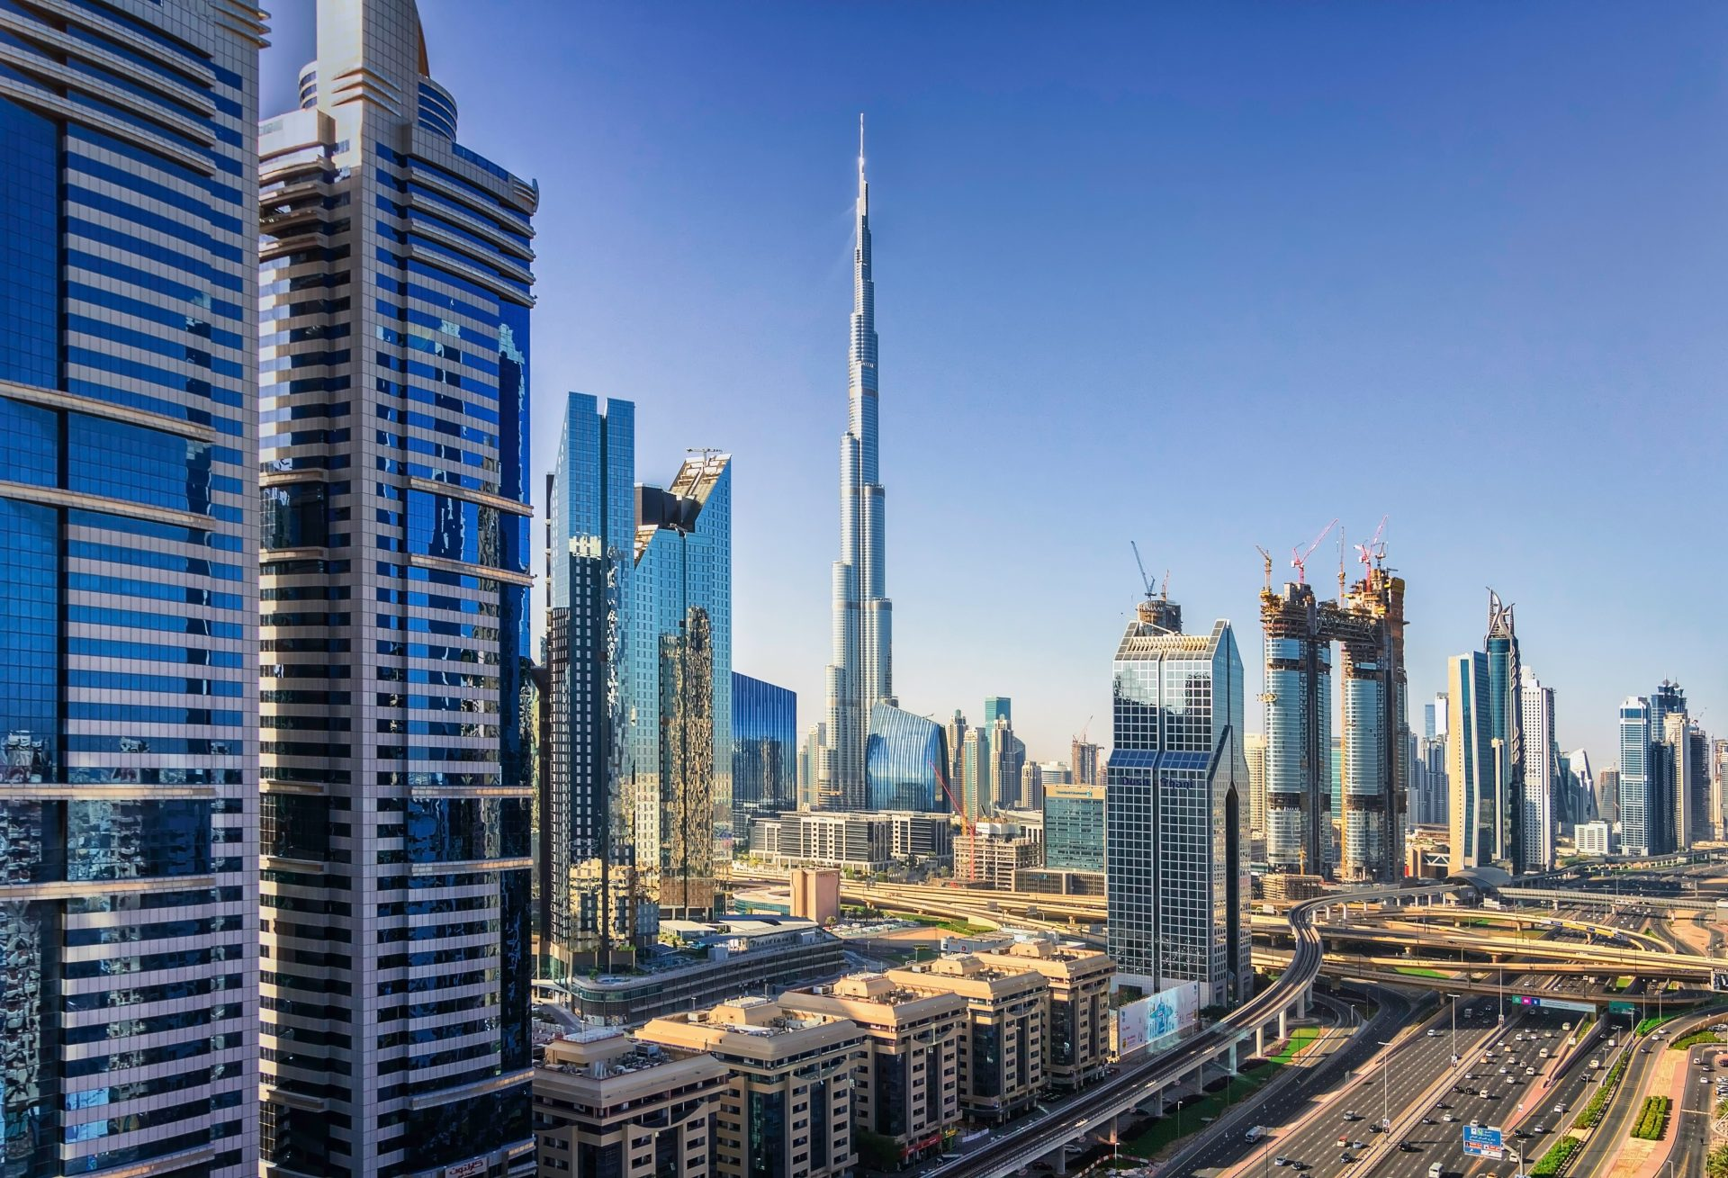

Six-year clean streak
Dubai has retained its title as the world's cleanest city for the sixth straight year, scoring 100% in the Global Power City Index's cleanliness indicator. The recognition highlights Dubai Municipality's round-the-clock operations, with 785 vehicles, 23,300 waste units, and initiatives such as the Warsan Waste-to-Energy Centre and Circle Dubai, aligning with the 2041 waste management strategy for a circular economy.

Fairmont Palm operational
Fairmont The Palm remains fully operational after drone debris from Iranian attacks fell on February 28, causing limited car park damage and injuring four individuals nearby. No hotel guests or staff were harmed; a small fire was quickly contained with the aid of Civil Defence. Executives confirmed all safety protocols remain active amid flexible booking policies for affected regional guests.

Emergency alert noise
The UAE has changed how its national emergency phone alerts sound depending on the time of day. From 9am to 10:30pm, alerts use the current high-tone alarm, ending with a standard message tone. From 10:30pm to 9am, both the alert and its end use a standard text tone.

Did you know?
Dubai aims to eliminate landfill sites by 2041 through waste-to-energy projects. The Warsan Waste-to-Energy Centre has already processed over 4.5mn tonnes of waste, diverting about 62% from landfills while generating clean electricity.

Day
Tuesday

Date
Mar 10

Temperature
27°C

Preview text
Plus March events

Image credits
Deezen, Visit Dubai, Readles, Genesis Allen, Dubai Holidays, Construction Week

