🇦🇪 Mar 9: Finance fright

In this edition:

- War effect on DIFC
- UAE temperature dip
- Emirati racing milestone

Spotlight

Financial fright
What’s happening: Dubai’s status as the Gulf’s leading financial centre is facing a serious stress test as the Iran conflict fuels security fears, market volatility, and rising unease among investors and expatriate professionals. Reports describe attacks and disruptions that have pushed banks, wealth managers, and major financial institutions into contingency mode. Although there has been no broad exodus of finance workers or client capital, anxiety has clearly risen, with firms across Dubai and Abu Dhabi confronting tougher questions about resilience, safety, and operational continuity.
Wealth managers’ reactions: Even so, the response from the financial sector has been more cautious than panicked. Wealth managers in the DIFC, which hosts roughly 500 firms, have been fielding increased client questions about asset protection and backup plans rather than handling mass withdrawals. Major banks including Citigroup, Goldman Sachs, JP Morgan, Standard Chartered, and UBS shifted staff to remote work, while regulatory and administrative services moved online to keep key systems running. Clients appear to be taking a wait-and-see approach, helped by diversified holdings and booking centres in places such as Singapore and Hong Kong.
What next: The bigger risk is not immediate collapse but slower erosion of confidence. Dubai’s economy depends heavily on trade, tourism, transport, real estate, and financial services, making it more exposed than oil-rich neighbours. Fundraising, dealmaking, and travel have already been affected, and markets have wobbled sharply. Still, analysts argue the UAE’s infrastructure, regulation, and long-term safe-haven appeal remain intact, at least for now.

Events


Hai Ramadan
Indulge in Dubai’s flagship Ramadan experience at the Al Wasl Plaza, Expo City Dubai. Enjoy a month-long celebration that beautifully blends tradition, community, and contemporary culture.
09 Mar - Sun 15 Mar, Tickets start from 42.51 USD


Readles
The museum, located in Dubai Mall Zabeel, combines magic, stories, and modern technology to create fun learning adventures for the whole family. Inspired by fairy tales from around the world, each zone lets kids see, touch, and play with their favorite heroes brought to life through lights, sounds, and digital art.
Multiple dates, Tickets start from 99AED + VAT

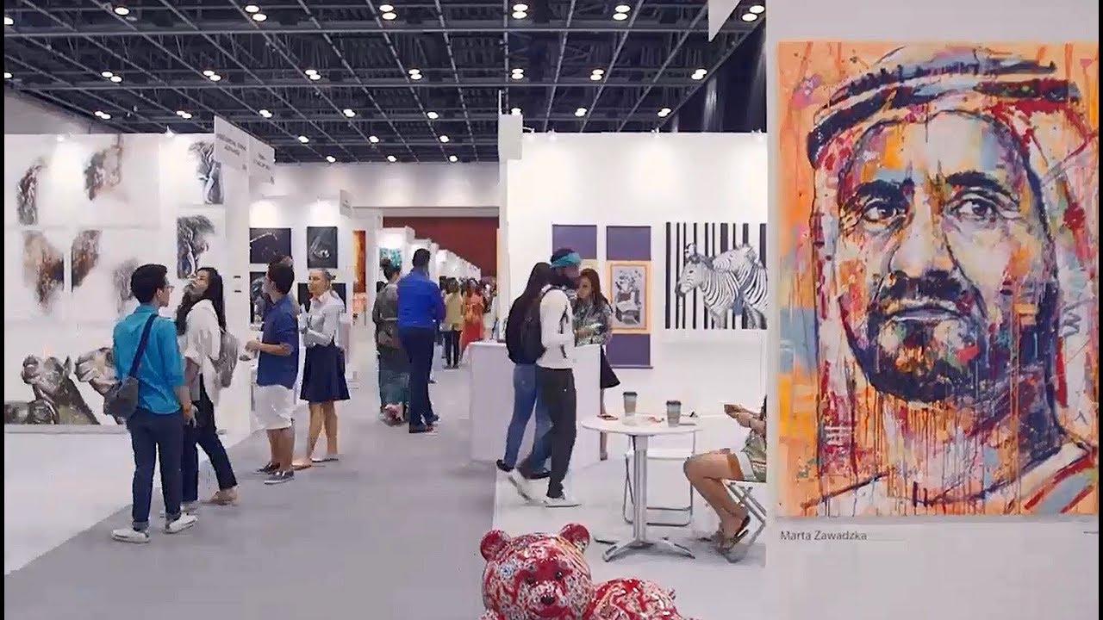
Art Fest International
Head to Taj Dubai for Art Fest International, a curated international art exhibition from India, showcasing contemporary artworks by Indian artists and talent from other countries.
13 Mar - 15 Mar, Free entry

Where to eat?
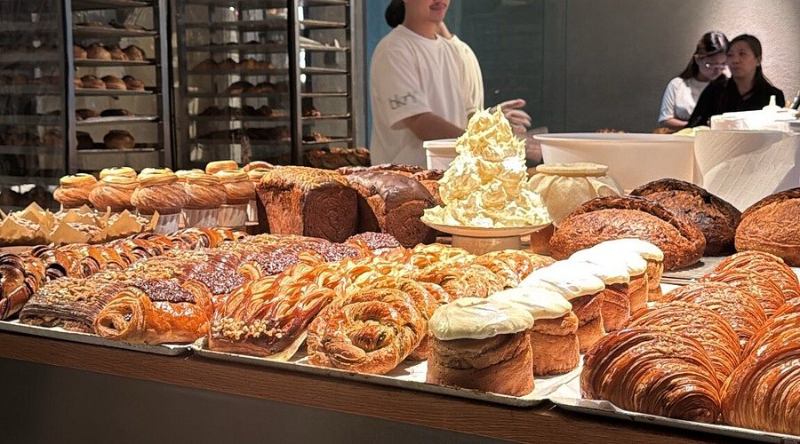

Bkry in Alserkal Avenue is a trendy bakery-café known for inventive pastries, specialty coffee, and an all-day dining menu. The open bakery concept lets guests watch breads and croissants being crafted using house-processed grains and creative flavours like miso caramel and candied citrus. Popular picks include almond croissants, Pantone French toast, and salmon cream-cheese bagels.

Pro tip: pair the cinnamon roll with fresh coffee.

Career

Dental Assistant

On-site
Full-time
AED 4,000 - 5,999/month
A clinic in JLT is looking to hire a Filipina nurse or dental assistant to join its team. The role involves assisting dentists during procedures, preparing treatment rooms, sterilising instruments, managing patient records, and supporting general clinic operations. Candidates with or without a licence may apply. Prior dental clinic experience is an advantage, and strong communication and patient-care skills are preferred. The position offers an opportunity to work in a busy outpatient setting.

Register here

Meanwhile

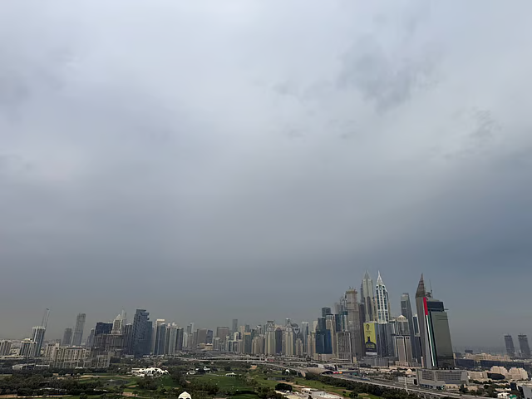

Cooler UAE weather

Temperatures are expected to dip slightly across Abu Dhabi and Dubai. Partly cloudy to cloudy skies are forecast through the week, and possible showers in western, coastal, and northern areas. Temperatures will noticeably drop on Tuesday amid strengthening winds up to 40 km/h; expect rising humidity and potential fog overnight Wednesday into Thursday.

Women in motorsport
Amna Al Qubaisi will become the first woman to compete in the Pro class of the Porsche Carrera Cup Asia in the 2026 season. The 25-year-old Emirati racer, already a trailblazer in regional motorsport, will face a competitive grid of around 30 drivers. The campaign begins at Shanghai International Circuit during the Chinese Grand Prix weekend.

Gold price drop

Gold prices in Dubai fell sharply, with 24K dropping Dh10 to Dh613.25 per gram. The decline followed a stronger US dollar and fading expectations of interest-rate cuts, pushing global prices below $5,100 per ounce. Other variants: 22K at Dh567.75, 21K Dh544.50. Analysts see short-term consolidation but long-term bullishness if the US-Israel-Iran conflict disrupts trade and fuels inflation.

Did you know?
One of Dubai’s key advantages as a financial centre is its legal structure. While the wider UAE follows a civil law system influenced by Sharia and continental legal traditions, the Dubai International Financial Centre (DIFC) operates under a framework based on common law principles. This gives many international investors and firms a more familiar environment for doing business.

Day
Monday

Date
Mar 9

Temperature
26°C

Preview text
Plus March events

Image credits
DIFC, Visit Dubai, Readles, Genesis Allen, Tripadvisor, Gulf News

