🌍 Mar 10: Oil bubble pops

In this edition:

- Kenya budget shock
- War hits FIFA qualification
- What is a frozen conflict?

Spotlight

Trump calms markets
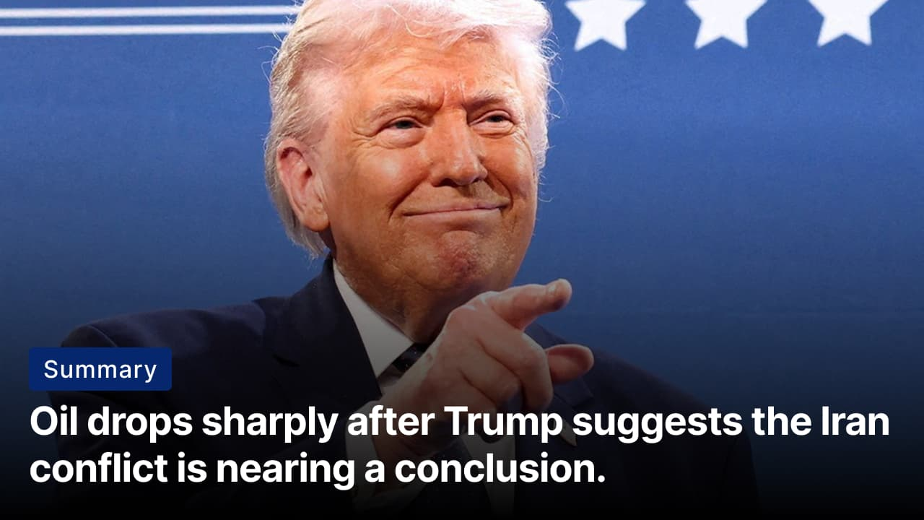

What happened? Global oil prices dropped sharply after President Trump said the conflict with Iran could end “very soon,” easing fears of prolonged war. Brent Crude, which had surged near $120 per barrel amid escalating tensions and airstrikes, fell to around $93 during trading. Markets responded positively, with global equities rebounding, including the FTSE 100, which rose at the open.

What did Trump say? Speaking at a press conference in Florida, Trump said the war was “pretty much complete” and suggested the main objective had already been achieved. However, he issued a strong warning to Iran not to disrupt shipping through the Strait of Hormuz. He said that if Iran blocks or interferes with oil flows in the strait, the US would respond with force “twenty times harder” than previous strikes.

Big picture: Comments from President Trump temporarily eased markets, but volatility is likely to persist. Even speculation about escalation can send prices sharply higher, affecting inflation, fuel expenses, and economic growth worldwide. The conflict demonstrates how geopolitical risks, energy security, and global stability remain tightly interconnected.

Kenya budget shock
Summary: Kenya’s State House budget doubles, sparking debate over spending priorities and transparency.

What happened? Kenya’s State House budget has come under scrutiny after supplementary estimates increased its allocation to about Sh16.9B ($130M), nearly double the original Sh8.6B ($66M). Kenya’s State House budget funds State Lodges, presidential administration, travel and hospitality, and benefits for former leaders. Supplementary estimates increased the allocation to cover operational shortfalls and ongoing government activities.

Criticisms: Economists say the allocation appears excessive given the country’s rising public liabilities, pressure on government revenues, and shortages in essential sectors such as healthcare, education, and drought relief. Some analysts also question transparency, warning that minimal disclosure makes it difficult to track how the funds are actually used. Others claim the State House may be spending beyond what Parliament originally approved.

Big picture: The debate over Kenya’s State House budget reflects broader concerns about fiscal discipline and government priorities. The issue highlights a broader challenge for developing economies: balancing public spending with economic needs while avoiding perceptions of excess in government leadership.

Analysis

War hits FIFA qualification

Summary: War disruption threatens Iraq’s historic World Cup qualification chance after forty years.

What’s happening? Iraq’s men’s national football team faces uncertainty about its chances of qualifying for the 2026 FIFA World Cup amid regional conflict, which is disrupting travel plans. The team is scheduled to play the winner of a playoff between Bolivia and Suriname in Monterrey, Mexico, on March 31 for a spot in the tournament. However, the war in neighboring Iran has led to the closure of Iraqi airspace, preventing most players and staff from leaving the country.

Demand: The Iraq Football Association (IFA) has formally asked FIFA to postpone the playoff qualifier. Around 60% of the squad remains stranded in Iraq, while some support staff are stuck in other countries due to disrupted flights and visa complications. Iraq’s coach, Graham Arnold, says delaying the game would give the team a fair possibility to travel, regroup, and properly prepare for a crucial match.

Big picture: The war is threatening Iraq’s possibility of qualifying for the World Cup for the first time in 40 years. This crisis also places FIFA in a difficult position, balancing fairness to competing teams with extraordinary circumstances caused by war. The situation highlights how external crises can jeopardize years of sporting progress and deny teams a rare possibility to compete on football’s biggest stage.

Worldwide
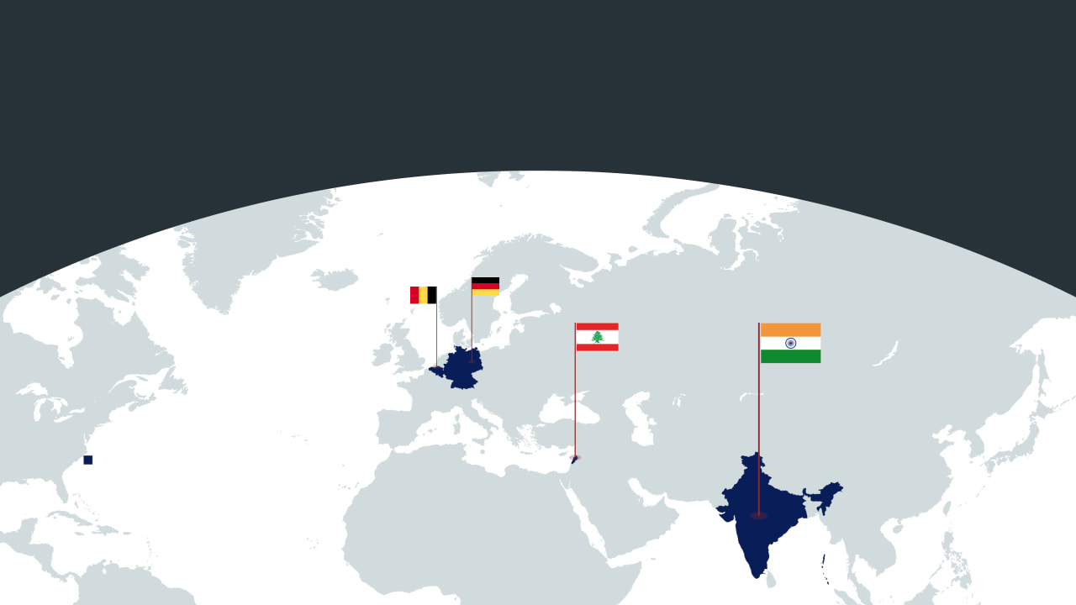

🇮🇳 India - No price hike. India’s government has decided not to raise petrol and diesel retail prices despite global crude oil prices rising above $100 per barrel. Officials say the policy aims to protect consumers and prevent inflation from rising sharply. State-owned oil companies, which dominate India’s fuel retail market, are expected to absorb temporary losses amid surging international prices (waiting game).

🇩🇪 Germany - Exports dropped. Germany’s exports fell more than expected in January, highlighting continued weakness in Europe’s largest economy. Exports declined 2.3% month-on-month to €130.5B, slightly worse than analysts’ forecasts of a 2% drop. The decline was mainly driven by sharp reductions in shipments to China and other EU countries. Exports to China dropped by more than 13%, while exports to EU nations fell by nearly 5% (no hope).

🇱🇧 Lebanon - White Phosphorous shelling. Human Rights Watch has accused Israel of unlawfully using white phosphorus munitions over residential areas in the southern Lebanese town of Yohmor. White phosphorus is typically used for smoke screens or illumination, but can also behave as an incendiary weapon, causing severe burns and fires. The Israeli military said it could not confirm the alleged use and maintained that its policy prohibits deploying such munitions (learn more).

🇧🇪 Belgium - Synagogue blast. An explosion struck a synagogue in the Belgian city of Liège, damaging the building but causing no injuries. Authorities have described the incident as an antisemitic attack targeting the Jewish community. Belgian Interior Minister Bernard Quintin condemned the explosion as a “despicable” measure and said security around Jewish sites would be strengthened. The exact cause of the explosion remains unclear (what is happening).

Foundations

What is a frozen conflict?
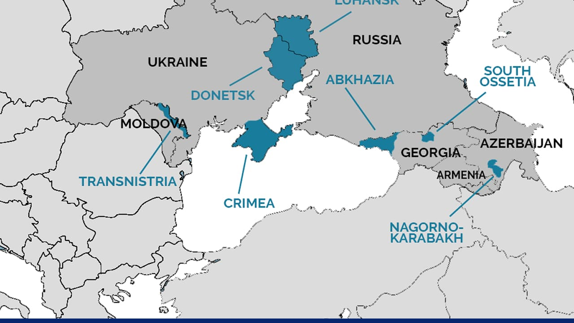

What is it? A frozen conflict occurs when active fighting has stopped, but no peace agreement has been reached, leaving the dispute unresolved. This happens when the deeper issues, such as sovereignty, borders, governance, and national identity, remain unsettled. While a frozen conflict could lead to sporadic violence, a full-scale war will not occur. These conflicts create prolonged instability, hinder economic development, and compromise protections for human rights.

Impact: Frozen conflicts often arise from ceasefires, armistices, or external interventions that halt violence without achieving a long-term political resolution. It can lead to the creation of unrecognized entities or states. These territory ends up being controlled by breakaway regions or de facto authorities that lack international recognition but maintain their own political or military structures. Foreign powers often play influential roles, either as peacekeepers or as supporters of one side, further complicating resolution.

Examples: The frozen conflicts in Transnistria in Moldova, Abkhazia, and South Ossetia in Georgia stem from post-Soviet disputes. Russia serves as a guarantor state, as its involvement in these conflicts has prevented Georgia and Moldova from drifting toward Western institutions. The Korean Peninsula is another classic case in which a technical state of war still exists.

Image credits
The Independent, ISPI

Preview text
Plus Kenya budget shock

