🌍 Mar 9: Ayatollah nepotism edition

In this edition:

- Rapper turned politician
- Gulf security test
- Namibia’s Caprivi Strip

Spotlight

The Khamenei dynasty begins
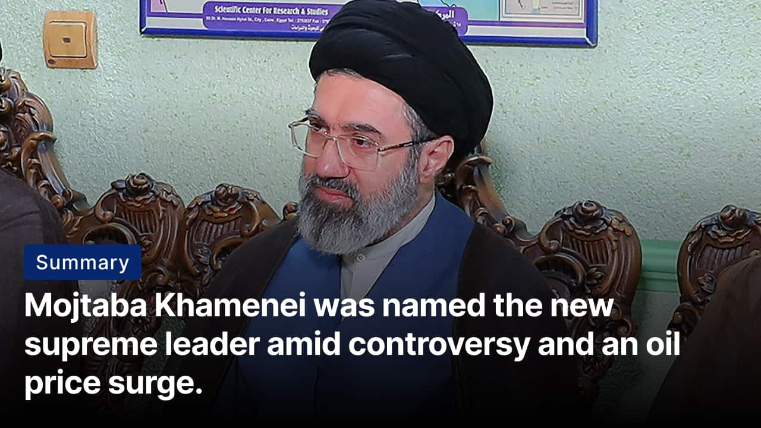

What happened? Mojtaba Khamenei, the 56-year-old son of Iran’s former supreme leader Ali Khamenei, has been selected as Iran’s new supreme leader. Born on 8 September 1969 in Mashhad, he studied at Tehran’s Alavi religious school before later continuing advanced Shia theological studies in Qom. He was accused by reformists of interfering in the 2005 and 2009 elections, which helped hardliner Mahmoud Ahmadinejad rise to and remain in power.

Controversy: Critics argue that his rise to power resembles hereditary succession, something the Islamic Republic was designed to prevent after the Iranian Revolution. Reformists and some clerics have long questioned Mojtaba’s religious credentials, noting he is just a mid-ranking cleric. Critics warn his selection could deepen public discontent and reinforce perceptions that Iran’s leadership is becoming increasingly concentrated within one family.

On the ground: Global benchmark oil values have surged past $100/barrel for the first time since 2022 as the war in the Middle East disrupts energy distribution and shipping routes. The sudden spike has rattled monetary markets and raised concerns about inflation, fuel expenses, and potential economic slowdowns. The Iranian regime warned that US-Israeli strikes risk pushing values even higher.

Rapper turned politician

Summary: Nepal voters back outsider party, reshaping politics and challenging traditional leadership.

What happened? Nepal’s parliamentary elections have produced a major political upset, with the Rastriya Swatantra Party (RSP) emerging as the dominant force. The relatively young party, led by former rapper and Kathmandu mayor Balendra “Balen” Shah, is projected to secure a landslide victory in parliament. Early results show the party clinching a large share of directly elected seats and leading in several others.

Why? The surge in support reflects growing frustration among Nepali voters with traditional political parties. Citizens blamed older leaders for corruption, political instability, slow economic growth, and poor governance. Youth voters were drawn to Balendra “Balen” Shah’s outsider image and reform-oriented message, which promised transparency, accountability, and generational change in politics. Shah’s popularity as Kathmandu’s mayor also strengthened his credibility.

Big picture: The election result signals a potential turning point in Nepal’s political landscape. If the leadership delivers on promises of transparency and governance reforms, it could reshape how politics functions in the country. Regionally, Nepal’s political direction also matters because it sits strategically between India and China, both of which closely watch developments in Kathmandu.

Analysis

Gulf security test

Summary: Missile strike near Riyadh heightens Gulf tensions, testing deterrence and regional alliances.

What happened? Saudi Arabia intercepted missiles and drones aimed at Prince Sultan Air Base near Riyadh, highlighting the widening regional fallout. The attack underscored rising security risks for Gulf states and signaled that strategic military infrastructure in Saudi Arabia is within the conflict’s operational reach.

Reaction: Iranian President Masoud Pezeshkian issued a rare public apology to Gulf neighbors. Pezeshkian stated Iran would halt attacks on neighboring countries unless those countries were used as launch points for strikes against Iran, and expressed regret for the incidents affecting Gulf states. However, the apology has been viewed cautiously because missile and drone attacks continued in parts of the Gulf.

Moreover, Prince Khalid bin Salman’s meeting with Pakistan’s Field Marshal Asim Munir highlighted Riyadh’s growing defense partnership with Islamabad. The move signalled that Saudi Arabia is not isolated and is strengthening deterrence while maintaining measured rhetoric to prevent reckless regional escalation.

Big picture: Gulf states that tried to remain neutral are facing pressure to strengthen defenses and coordinate more closely with partners such as the US and Pakistan. At the same time, rising oil values and disruptions to shipping routes underline the economic stakes for the global energy market. Whether the crisis stabilizes will depend on whether deterrence and diplomacy can prevent further strikes.

Worldwide
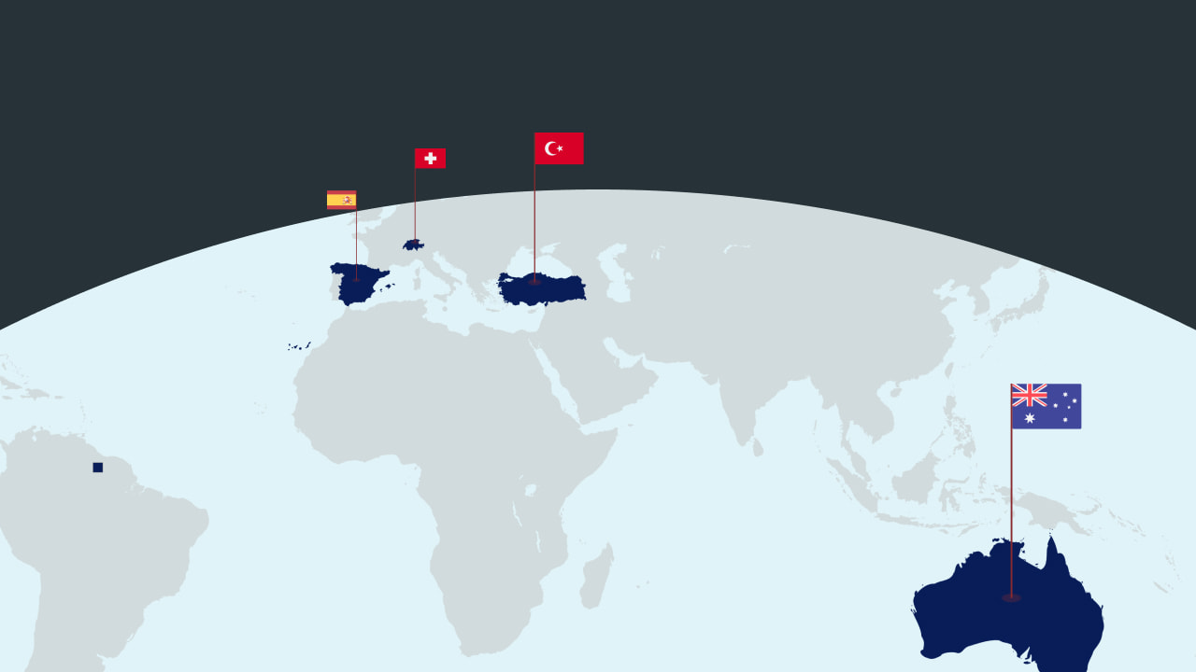

🇪🇸 Spain - Amnesty plans. Spain’s government has announced a plan to grant judicial status to at least 500,000 undocumented migrants through a temporary regularisation programme. Eligible migrants who can prove they have lived in Spain for at least five months and have no criminal record will be able to apply for a one-year renewable residency visa between April and June (Spain shows the way).

🇨🇭 Switzerland - Rejects license fee cut. Swiss voters have rejected a referendum proposal to significantly reduce the annual licence fee that funds the national public broadcaster. The initiative, backed by the right-wing Swiss People’s Party, sought to cut the fee from 335 Swiss francs to 200 francs and exempt more businesses from paying it. In a separate vote, citizens supported a proposal to constitutionally assure the availability of cash (hard rejection).

🇹🇷 Turkey - Mayor corruption hearing. Istanbul Mayor Ekrem Imamoglu has gone to a hearing alongside more than 400 defendants in a sweeping corruption case. Prosecutors accuse Imamoglu of leading a criminal organization involved in bid-rigging, bribery, and monetary misconduct dating back to his tenure as mayor of Beylikduzu. The 3,900-page indictment includes 142 charges and could result in a prison sentence exceeding 2,000 years if he is convicted (all eyes on this).

🇦🇺 Australia - Bondi gunman’s demand. Naveed Akram, the alleged gunman behind the Bondi Beach shooting, has asked a Sydney court to block media from publishing details about his immediate family due to safety concerns. Akram faces 59 charges, including 15 counts of murder, over the attack at a Jewish festival, considered Australia’s deadliest mass shooting since 1996 (its personal).

Foundations

Namibia’s Caprivi Strip
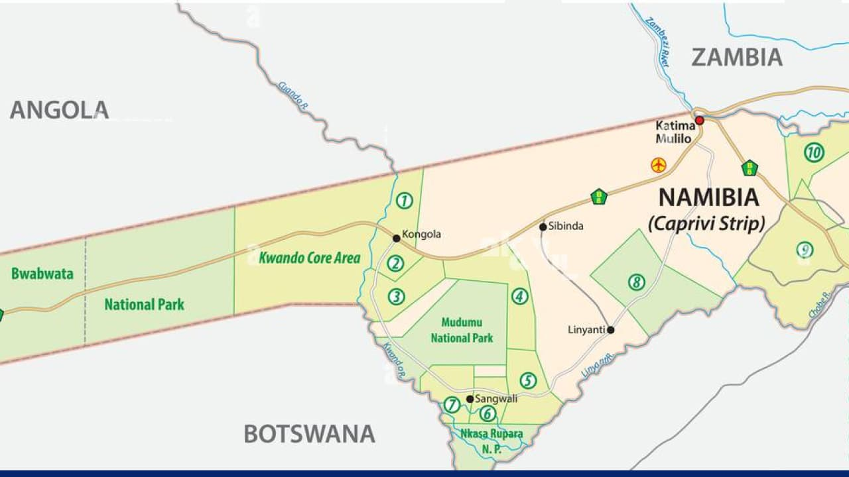

What is it? Namibia’s Caprivi Strip is a narrow, 450 km (269 miles) extension that sticks out from its main territory. It stretches between Angola, Zambia, Botswana, and Zimbabwe. This area is one of the most unique geopolitical regions in southern Africa. The strip serves as a key transit corridor linking various regional economies.

History: The Caprivi Strip was created in 1890 by the Heligoland–Zanzibar Treaty, when Germany negotiated a narrow corridor across southern Africa to gain a gateway to the Zambezi River. The river proved unnavigable, but the border stayed. The area later became a transit route during southern Africa’s liberation wars and, after Namibia’s 1990 independence, saw a brief secessionist revolt in 1999 by the Caprivi Liberation Army, which was swiftly crushed.

On the ground: The Caprivi, known as the Zambezi Region since 2013, is pivotal for tourism, conservation, and cross-border trade. However, its geography also creates security challenges, encourages smuggling routes, and fuels debates over regional autonomy. This unusual stretch of land remains highly influential in Namibia’s politics and economy.

Learn more about the Caprivi Strip here.

Image credits

Reuters, Alamy

Preview text

Plus Gulf security test

