🇬🇧 Mar 9: Make Carnaby groovy
In this edition:

- Festival of champions
- Art pieces given Grade II status
- Hundred player auction

Spotlight

Soho style revival


What’s happening? Shaftesbury Capital has unveiled early design proposals to revamp Carnaby Street, one of London’s most iconic retail destinations in Soho. Proposed upgrades include softer lighting, significantly more greenery, and design elements that highlight the street’s cultural heritage from the Swinging Sixties era. The project is currently at a consultation stage, and people have been invited to provide feedback before formal planning applications are submitted to Westminster City Council.

Why? Although the street has historic cultural value dating back to the 1960s fashion boom, competition from online retail and newer shopping destinations has reduced footfall over time. Through these updates, landlords hope to encourage longer visits, increase spending, and strengthen the area’s identity as a cultural and retail hub. The project also aligns with broader urban trends supported by Westminster City Council to create greener, more walkable city centres.

History: Carnaby Street, in London’s West End, Soho, rose to global fame during the 1960s “Swinging London” era. Independent boutiques such as Lady Jane and Lord John sold bold, modern styles that attracted celebrities, including members of The Beatles and The Rolling Stones. The street symbolised the Mod movement and Britain’s cultural revolution. After declining in the 1970s–80s, the area gradually revived through retail funding, tourism, and heritage branding.

Festival of champions
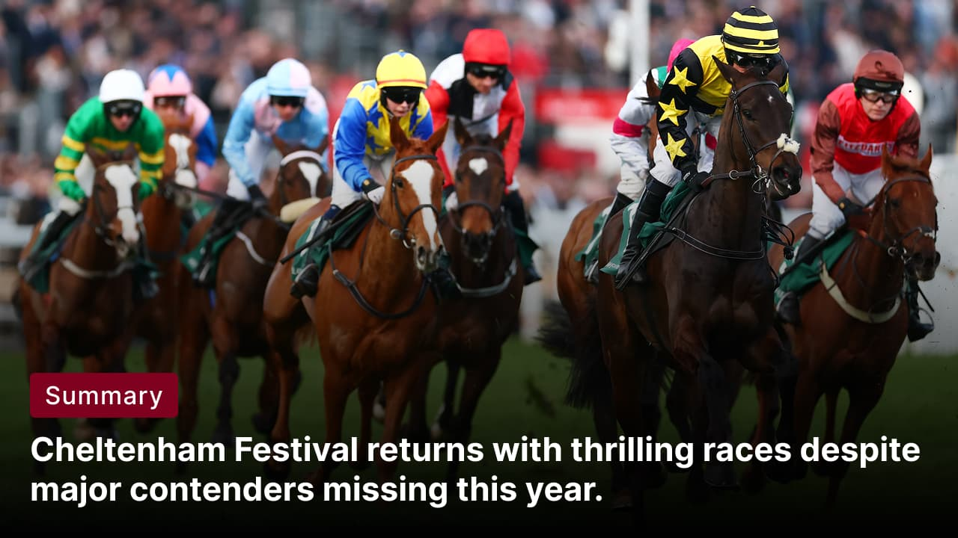

What’s happening? The Cheltenham Festival has begun in Gloucestershire, bringing horse racing fans to Cheltenham Racecourse for four days of top-level National Hunt racing. Running from March 10–13, 2026, the event features 28 races across four days, including highlights such as the Champion Hurdle on Tuesday and the prestigious Cheltenham Gold Cup on Friday.

Concerns: The Cheltenham Festival in 2026 is unusually unpredictable after several major contenders were ruled out before the meeting. Star horses Sir Gino and Marine Nationale will miss the festival due to injury. Former champion Constitution Hill will appear for a farewell at Cheltenham Racecourse, but will not compete as connections shift focus to flat racing. The prestigious Cheltenham Gold Cup is particularly open after Galopin Des Champs and Fact To File were ruled out

History: The Cheltenham Festival is one of the most prestigious events in National Hunt horse racing. The festival began in 1860 as the National Hunt Meeting and gradually evolved into a multi-day international racing event. The Cheltenham Gold Cup, first run in 1924, became its most famous contest. Over time, the festival expanded to four days with 28 races, attracting top trainers, jockeys, and horses from Britain and Ireland.

What’s on
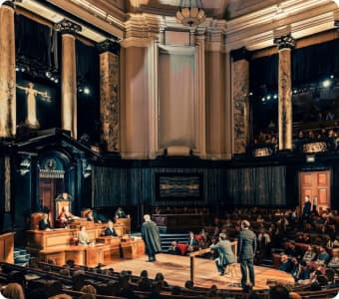
Witness for the Prosecution - Play
Step inside a real courtroom, performed in the historic London County Hall, which opened in 1922 and served as the seat of London’s local government for over six decades.
Multiple dates, tickets starting at £20

Beginner Tango classes
Fun and relaxed tango classes in London’s Angel neighbourhood.
Multiple dates, tickets starting at £15

Long story short

Business
Teleware Limited, a UK technology firm based in Easingwold near York, has collapsed after 30 years in business and entered administration. Teleware developed communication software that helped organisations improve workplace communication and productivity, particularly through Microsoft-based solutions. The company worked with major clients including British Airways, Bank of England, Sainsbury's, Samsung, the NHS, Bupa, and Barclays.

Four major English water suppliers, Anglian Water, Southern Water, Wessex Water, and South East Water, have been allowed to raise customer bills above the originally permitted level after appealing to the Competition and Markets Authority. The companies argued they needed additional revenue to fund upgrades to ageing water infrastructure such as pipes, sewers, and reservoirs. The regulator approved an average annual increase of about 2.65%.

Art & culture


Eduardo Paolozzi’s large “pop art” mural inside the Kingfisher Shopping Centre has been granted Grade II listed status. The mural, unveiled in 1983 in Milward Square, consists of 12 colourful mosaic panels inspired by Redditch’s historic needle-making industry. The listing was recommended by Historic England, which praised the work’s craftsmanship and cultural importance.

Houghton Hall will host a major sculpture exhibition dedicated to Lynn Chadwick beginning 2 May 2026. The exhibition will present around 30 works spanning four decades of Chadwick’s career, from the 1950s to the 1990s. Curated by Pangolin London, the show will feature artworks placed throughout the estate's interiors and outdoor grounds. It will be the largest UK exhibition of Chadwick’s work in more than twenty years, following the retrospective held at Tate Britain in 2003.

Sports
The Hundred will hold its first-ever player auction this week, replacing the previous draft system used since the tournament’s launch. Organised by the England and Wales Cricket Board, this format allows franchises to bid competitively for players rather than selecting them in turns. The change mirrors the auction model used in the Indian Premier League and follows increased funding from IPL franchise owners.

Tottenham Hotspur is reportedly planning a major squad overhaul over the next three transfer windows as part of a long-term rebuild. The club is prepared to sell most of its current players this summer to fund signings, with just nine members of the squad expected to be retained. Among those potentially leaving is vice-captain Cristian Romero, despite signing an agreement last year.

Misc

Sainsbury's just made online shopping more expensive for many customers

Trump sees a massive increase in wealth as the billionaire list is released

Harrow makes open parking scheme permanent

Southwark is the most expensive borough to get a property in South East London

Did you know?
Prince Andrew once joked in 2008 that the royal family avoids playing Monopoly because “it gets too vicious.” The comment, reported by The Telegraph, was made when he declined a Monopoly gift at an event.

Day
Tue

Date
Mar 10

AQI
64

Image credits
AOL, The Independent, Reuters, Tango Movement, BBC

Preview text
Plus festival of champions

