🇬🇧 Mar 9: GSK’s final formula
In this edition:

- Phantom AI funding
- Bank of England predicts inflation
- Portraits marking Women’s Day

Spotlight

GSK site transformation


What happened? Hounslow councillors have approved plans to redevelop the former GlaxoSmithKline headquarters site in Brentford, West London, into a large mixed-use “15-minute neighbourhood. The regeneration project will deliver 1,522 homes, student accommodation for 506 people, and a 296-unit co-living building. Phase one includes five residential towers reaching up to 26 storeys and 761 homes, with a mix of private, social, and intermediate housing.

Concerns: Opponents say the development’s height and scale could harm the area’s character and nearby heritage sites, such as Kew Gardens, Boston Manor, and Osterley House. Historic England warned that the tall towers may disrupt important sightlines and historic landscapes. There are also concerns about pressure on local infrastructure, including transport, schools, and healthcare services, as many residents will move in.

About the site: It served as GlaxoSmithKline's headquarters before operations moved elsewhere. Positioned close to key transport links, including the M4 corridor and nearby rail services, the location is considered strategically suitable for high-density regeneration. The surrounding area already includes offices, residential developments, and business parks, making it a prime candidate for mixed-use redevelopment.

Phantom AI funding


What’s happening? The UK government’s AI expansion drive is under scrutiny after an investigation found that some major funding may be overstated or unclear. Several AI projects announced since 2024, including new data centres and a UK “sovereign AI supercomputer,” appear to involve rented facilities, early-stage planning, or sites not yet under construction. The multibillion-dollar funding by Nscale and CoreWeave was largely based on company announcements rather than audited commitments.

Why? Governments are racing to lead in AI and often rely on big funding announcements from tech firms to signal economic growth. However, many AI infrastructure projects are based on future plans, equipment purchases, or leased capacity rather than immediate construction or capital spending. With minimal oversight, governments often accept company estimates without auditing them, while firms inflate figures to boost valuations, partnerships, and political support.

Big picture: As countries compete for funding from major tech companies, large-scale announcements about data centres, chips, and supercomputers often become part of economic and political messaging. Without clear oversight, governments risk overstating economic gains or relying on projects that may take years to materialize.

What’s on
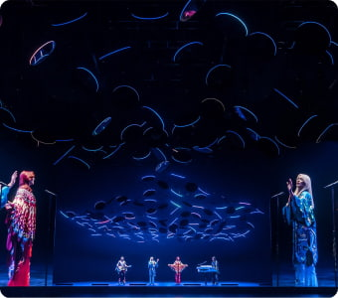
ABBA Voyage
Step into a new era of pop as ABBA returns to the stage as hyper-real ‘ABBAtars’ created by Industrial Light & Magic (ILM).
Multiple dates, tickets starting at £48

Introduction to Natural Dyes Workshop
Join artist Johanna Tagada Hoffbeck to learn the basics of natural dyes.
March 14, tickets starting at £39

Long story short

Business
UK AI infrastructure startup Nscale has raised £1.5B in a new funding round, valuing the London-based company at £12.6B. The company also announced that former Meta executives Sheryl Sandberg and Nick Clegg will join its board of directors. Nscale, backed by Nvidia, is building a large AI computing infrastructure, including a planned supercomputer in Loughton.

The Bank of England faces the possibility of inflation rising sharply again in the UK as global energy prices surge. Economists warn inflation could climb close to 5%, more than double the bank’s 2% target, if oil and gas prices remain elevated. They estimated that inflation could reach 4.7% by September after Brent crude oil surged above $100 per barrel for the first time since 2022.

Art & culture
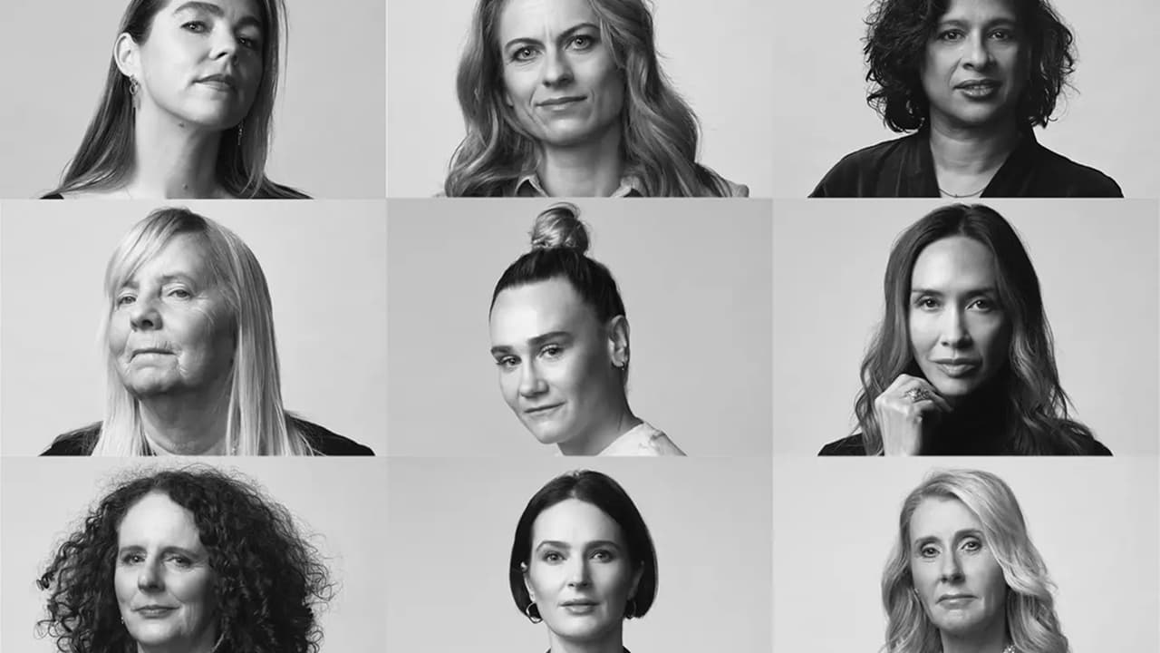

Portraits of influential women across the UK have been unveiled at an exhibition in London to mark International Women’s Day. The showcase highlights women featured in Independent Women 2026 - The Influence List, celebrating 50 women shaping society across sport, politics, arts, and business. Footballer Chloe Kelly tops this year’s list for her impact on women’s sport. Nine portraits, photographed by Sane Seven, are displayed at Outernet London until the end of March.
British billionaire Joe Lewis and his family have generated massive gains by selling artworks from their collection at an auction held by Sotheby's in London. Pieces from prominent “School of London” artists, including Francis Bacon, Lucian Freud, and Leon Kossoff, achieved dramatic returns. A 1972 self-portrait by Bacon alone sold for £13.5M. Overall, the artworks produced have gained more than 3,500%.

Sports
Rodri has been fined £80,000 by The Football Association for comments he made about match officials after Manchester City drew 2–2 with Tottenham Hotspur. Rodri publicly suggested referee Robert Jones was not “neutral,” questioning the integrity of the officiating after a controversial goal was allowed to stand. The FA charged him with improper conduct under Rule E3.1, which prohibits comments implying bias by officials.

A potential ownership battle has emerged in F1, with Toto Wolff reportedly leading a bid backed by the Mercedes-AMG Petronas F1 Team to acquire a 24% stake in Alpine F1 Team. The stake is currently owned by Otro Capital. The move could challenge Christian Horner, who is reportedly seeking the same funding as part of a consortium to return to the sport after leaving Red Bull Racing.

Misc

Chancellor and ministers to address MPs, as war in Iran causes oil expenses to soar

PlayStation users could get £162 compensation
The Royals are recruiting a Kitchen Porter on a fixed-term contract at Buckingham Palace
Yet another humiliation for Andrew as York Minster confirms dedication move

Did you know?
Kensington Palace has been home to members of the royal family for more than 300 years. Currently, it houses several royals, including Prince William and Catherine, Princess of Wales.

Day
Mon

Date
Mar 9

AQI
66

Image credits
My London, IBM, London Musicals, Refash, The Independent

Preview text
Plus phantom AI funding

