🗽 Mar 10: Cartel clash continues

In this edition:

- Ethnic policy shift
- G7 energy measures
- Cosmic 3D map

Spotlight

Mexico blames the US
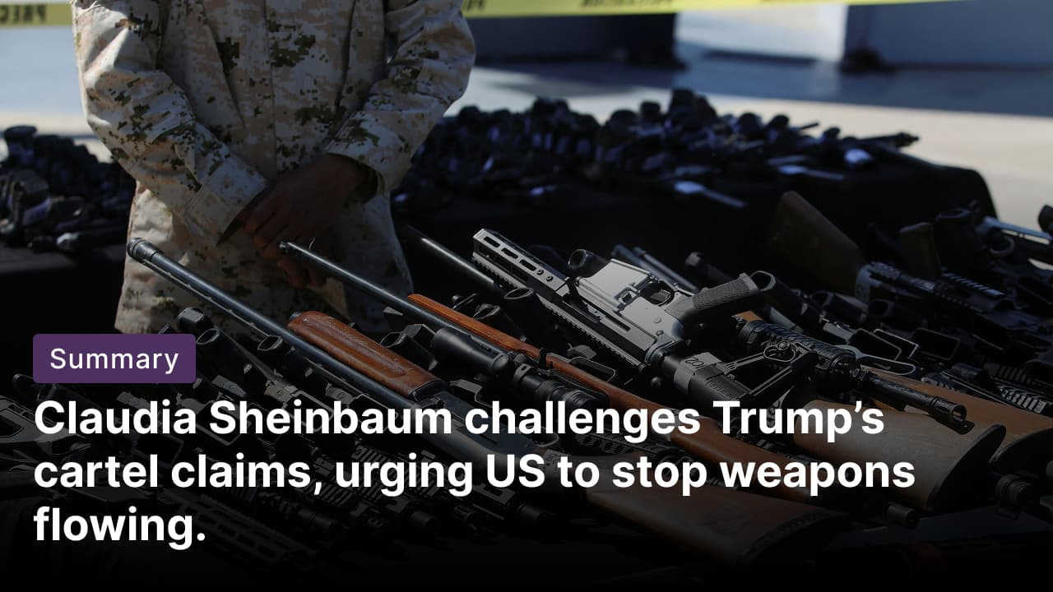

What’s happening? Mexican President Claudia Sheinbaum called on the US to halt the illegal trafficking of firearms into Mexico, responding to President Trump's description of her country as the "epicenter of cartel violence." Sheinbaum argued that cartel violence in Mexico is heavily fueled by weapons smuggled from the US, noting that about 75% of guns used by criminal groups originate there. She rejected any possibility of US military involvement in Mexico.

Trump’s comments: Trump argued that Mexican drug cartels were responsible for widespread bloodshed and instability across the region. Trump also claimed he had offered to help Mexico eradicate the cartels with stronger US measures. In his remarks, he referred to President Claudia Sheinbaum as a “beautiful woman” with a “beautiful voice,” comments that critics in Mexico described as inappropriate.

History: Mexicans are wary of US interventions, having lost half their national territory to the US in a 1846-48 war that two US presidents, Abraham Lincoln and Ulysses Grant, said was waged under false pretenses to conquer territory and expand slavery. The US also invaded and briefly occupied the port city of Veracruz in 1914 and launched a punitive invasion targeting the revolutionary Pancho Villa’s forces in 1916-17.

Ethnic policy shift


What’s happening? China's parliament is poised to pass a law on promoting ethnic unity and progress this week, formalizing aggressive assimilation policies under Xi Jinping. The legislation prioritizes Mandarin over minority languages in schools and official use, bans interference with inter-ethnic marriages, mandates parental guidance to support the ruling Chinese Communist Party, and prohibits acts harming ethnic unity.

Criticisms: China officially recognises 56 ethnicities (the Han majority and 55 minority groups), many of whom live in regions such as Xinjiang, Tibet, and Inner Mongolia. Human rights groups say the legislation could legitimize long-criticised policies, including limits on minority language education, tighter religious controls, and restrictions on expressions of ethnic identity. Beijing says the measure will advance modernization and unity by integrating ethnic minority regions more closely into national development.

Big picture: Analysts say the law reflects a broader shift under Xi toward stronger central control and a unified national identity. While authorities frame it as essential for stability and development, critics warn it could deepen grievances among minority communities and further entrench Beijing’s controversial “Sinicisation” policies in law.

Long story short

Global Affairs

Lebanon has called for direct negotiations with Israel to establish permanent arrangements for security and stability along their border, while accusing the Iran-backed Hezbollah of betraying the country’s interests. Beirut said Hezbollah’s involvement in regional conflicts had endangered Lebanon, urging an internationally backed truce, Israeli withdrawal from southern areas, and steps to disarm the group to stabilise the country (Lebanon blames Hezbollah).

G7 nations declared readiness to take necessary measures, including potential stockpile releases, to support global energy supplies. A meeting with finance ministers and the IEA ended without agreeing to tap 1.2Bn barrels of emergency reserves. The International Energy Agency warned that disrupted production and halted tanker traffic through the Strait of Hormuz are increasing risks to global oil supply (supply safeguards).

Business & Markets
Anthropic sued the US Department of Defense over its blacklist, which designated it a supply-chain risk for refusing to lift AI restrictions on autonomous weapons and surveillance. The company argues the designation is unlawful and violates constitutional rights amid threats to revenue and government contracts (Anthropic challenges blacklist).

Airlines launched broader fare hikes amid a jet fuel surge to $150-$200 per barrel from the US-Israel-Iran war, with Air New Zealand raising domestic fares by NZ$10 and long-haul by NZ$90 while suspending its 2026 outlook. Airline shares stabilized after Trump's comments eased oil prices to $90/barrel, lifting carriers like Korean Air and Qantas (Airlines hike fares).

German publishers and advertisers rejected Apple's proposed changes to its App Tracking Transparency rules, urging the antitrust authority to impose a fine and halt the tool. The groups, including the German Advertising Federation, argued that the changes fail to address market power abuses, keeping Apple as a "data gatekeeper" that controls access to ad tracking despite proposed neutral prompts and simplified consents (Germany targets Apple).

Science & Tech
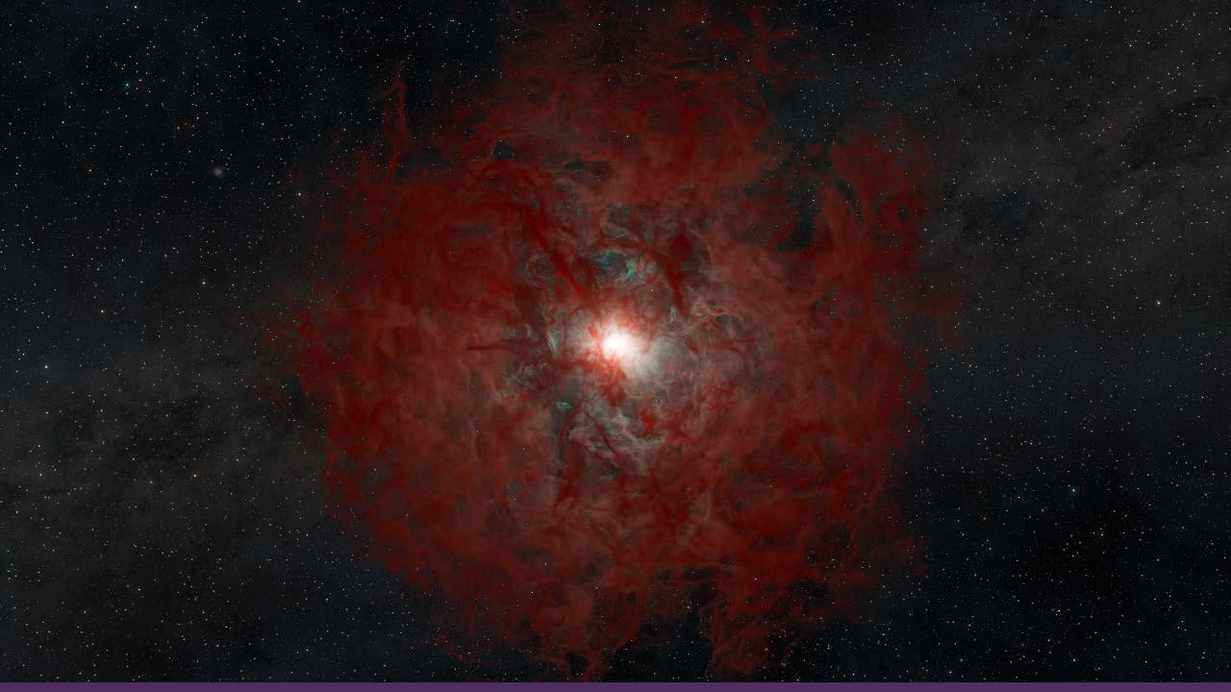

Astronomers using the Hobby-Eberly Telescope Dark Energy Experiment have created the most detailed 3D map of the early universe, revealing hidden galaxies and gas clouds from 9–11Bn years ago. Using Line Intensity Mapping to track Lyman-alpha radiation from hydrogen, researchers analysed hundreds of minutes of spectra to detect the faint glow of distant objects, offering fresh insights into galaxy formation and cosmic structure (cosmic 3D map)

X says users can block its Grok chatbot from editing photos they upload to the platform. A new toggle in the iOS app’s image settings allows people to prevent Grok from modifying a post’s image through tagged replies. However, the control has limitations: images can still be edited using other Grok tools, such as saving and re-uploading the photo for modification (Grok edit block).

Whatnot
Australia grants humanitarian visas to five Iranian women’s footballers (visa granted).

Live Nation Entertainment avoids breakup in major antitrust case (bid fails).

Researchers link the keto diet to improved exercise response (endurance boost).

Ukrainian athlete says ChatGPT served as a coach and a psychologist during Paralympic victory (AI coach).

The Trump administration adds Afghanistan to the wrongful detention sponsor list.

Image credits
Reuters, Xinhua, Space

Preview text
Plus Anthropic sues the Pentagon

