🇦🇪 Feb 10: Still got a pulse

In this edition:

- Majlis of possible
- Healing hands
- Algorithms for peace

Spotlight

Heart in a box

Summary: UAE showcases Heart in a Box technology to extend organ viability and enable cross-border transplants.

The UAE Ministry of Health and Prevention showcased an advanced organ-preservation system, “Heart in a Box,” at the opening of the World Health Expo 2026. The technology uses machine perfusion to keep donated organs, including hearts, livers, lungs, and kidneys, functioning outside the human body by circulating oxygenated blood.

Unlike traditional cold storage, which limits heart transplants to a narrow four–to five-hour window, the system can preserve a beating heart for up to 24 hours. This eases time pressure on surgical teams, improves organ assessment before transplantation, and enables safe long-distance, cross-border transport. UAE officials say the technology could transform regional cooperation, enabling the reliable sharing of organs across countries.

Despite still not being commercialised, the system is included in the UAE's future transplant roadmap, the ‘Hayat programme,’ which has already saved 1,663 lives. Since 2021, hundreds of organs have been traded with neighbours; authorities emphasize that technology, education, and consent of families will be the focus to expand donation.

Majlis of possible

Summary: Publicis Groupe has launched the Majlis of Possible in Abu Dhabi, a leadership platform uniting regional decision-makers to discuss future growth.
The UAE has introduced a sweeping new higher education law that reshapes the regulation of universities nationwide. The legislation creates a single national framework for all universities. It shifts oversight away from paperwork and toward outcomes such as graduate employability, programme quality, and data-driven performance.
The new UAE higher education law mandates mandatory data integration. All universities must connect to a central digital infrastructure and continuously share standardised academic and administrative data. This will enable real-time oversight, accreditation, and national workforce planning. It tightens controls on programme approvals and academic advertising, banning the promotion or delivery of unapproved degrees.
Meanwhile, online education is regulated separately from in-person learning, with strict limits on fully remote delivery for hands-on disciplines. From 2026, enrolment choices will be more closely aligned with labour market needs. Universities have welcomed the reforms, despite operational challenges during the compliance grace period.

Event
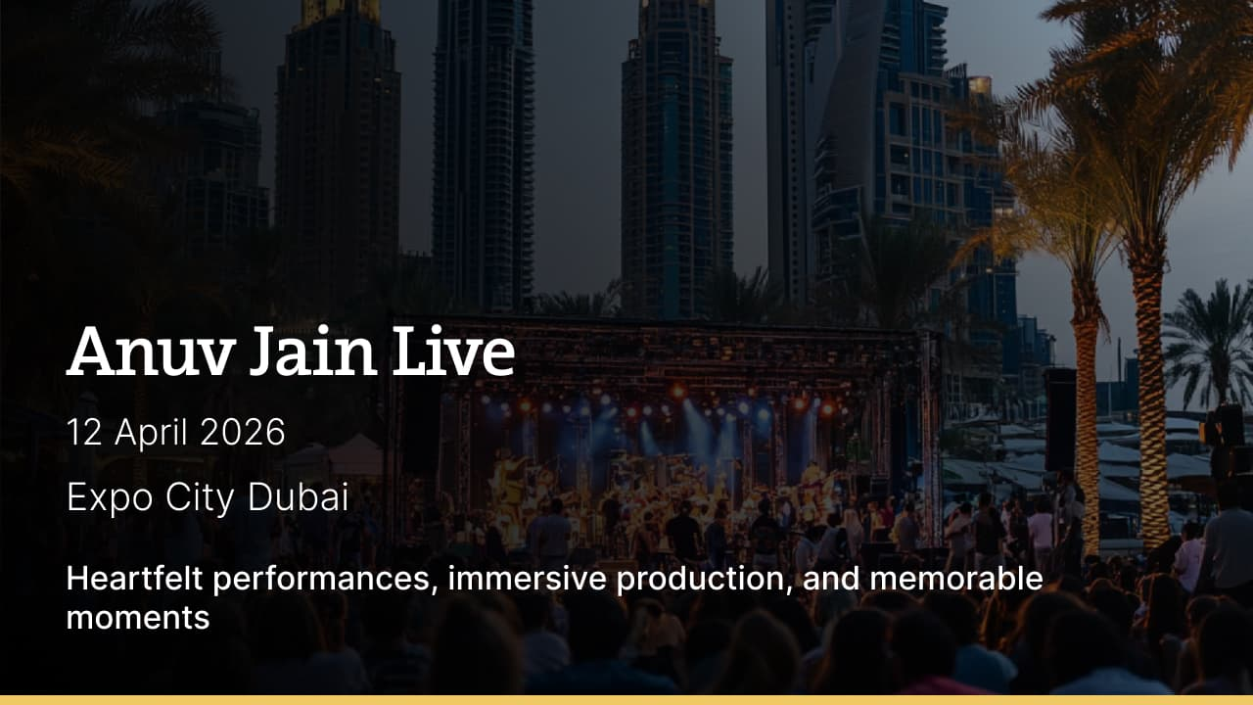
https://dubai.platinumlist.net/event-tickets/104347/anuv-jain-live-in-expo-city-dubai

Where to eat?

Avli → Avli brings the warmth and generosity of Greek hospitality to the heart of Dubai’s DIFC. Inspired by the spirit of a traditional Greek courtyard, Avli offers a refined yet relaxed dining experience. The menu highlights fresh Mediterranean ingredients, including mezze spreads, grilled seafood, slow-cooked meats, and vibrant salads. Elegant interiors, an open terrace, and attentive service make Avli ideal for business lunches and long dinners

Pro tip: Arrive early to savor the signature cocktails in the Cycladic-themed bar.

Career

Executive Secretary

On-site
Full-time
AED 8,000-11,999 /month
Summary → IKK Group UAE is looking to hire an executive secretary who will render full-time administrative assistance to the top management by analyzing operations and reporting. The ideal candidate will track KPIs, identify efficiency gaps, create dashboards, support budgeting and forecasting, and liaise with cross-functional teams to deliver data-driven insights aligned with business goals.

Register here

Meanwhile

Healing hands

A lightweight robotic glove called ‘The HandTasker Rehabilitation Handbringing’ is bringing new hope to stroke survivors in the UAE and children with cerebral palsy by helping them regain hand movement. Introduced through local care centres, the glove uses brain and muscle signals to retrain motor activity. It is adult- and child-friendly, soft, easy to fit, and transforms therapy into fun, supporting short-term rehabilitation and a hopeful recovery.

Property, tokenised

Since February 2020, Dubai has reached Phase II of its Real Estate Tokenisation Project, enabling the trading of digital property stakes in a regulated secondary market. This shift moves the pilot test to live trading, with approximately 7.8M tokens live. The liquidity, pricing, transparency, and investor protection will be monitored by authorities as part of a managed rollout to support Dubai's long-term real estate and digital economy goals.

Algorithms for peace

TRENDS Research and Advisory has launched the AI4ID Alliance to advance AI in interreligious dialogue, alongside the release of the 2025 Global Muslim Brotherhood Influence Index. The project combines data-driven analysis of extremism and a three-year AI initiative, including an intelligent dialogue system to combat polarization and promote tolerance and ethical values in online religious communication.

Did you know?
Abu Dhabi’s TAMM 4.0 super app brings together over 1,100 government services using AI-driven automation, enabling residents and businesses to complete licenses, visas, payments, and approvals through one unified digital platform without visiting government offices physically.

Day
Tuesday

Date
Feb 10

Temperature
22°C

Preview text
Plus algorithms for peace

