🌍 Feb 9: No orange wave
In this edition:

- US knocks on Sahel’s door
- Japan and Portugal election results
- Where is Abkhazia?

Spotlights

Thai election results
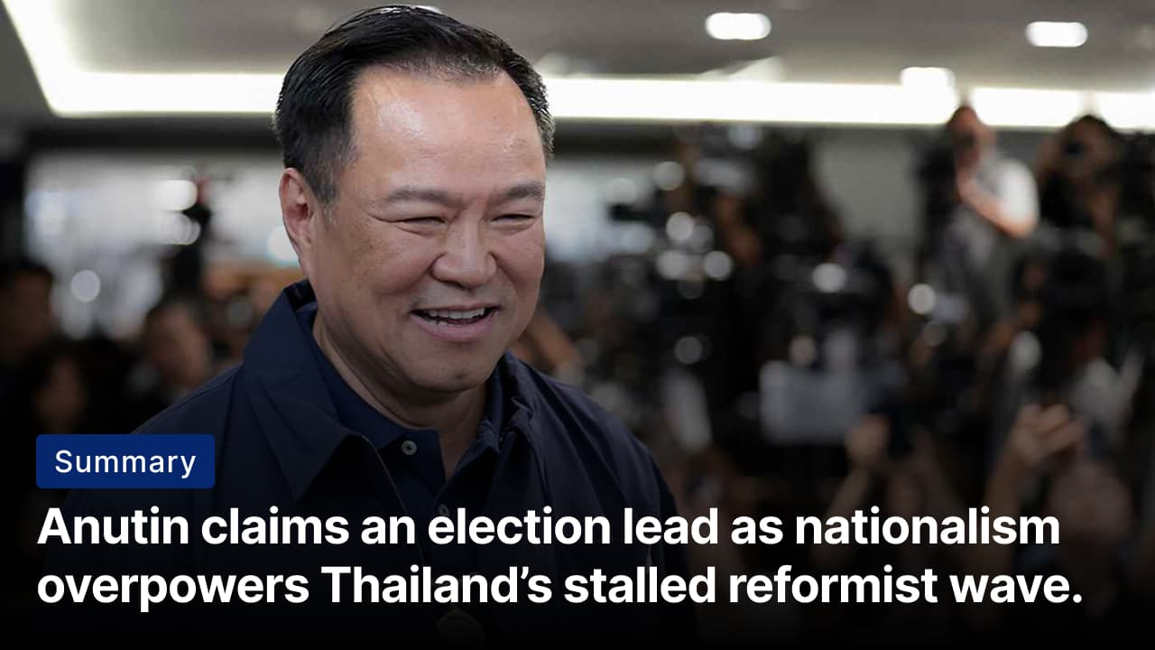
The election was called in December after the coalition led by Anutin collapsed after just three months. Credits: Reuters
The what: PM Anutin Charnavirakul has claimed victory in Thailand’s snap general election. With about 90% of ballots counted, his conservative Bhumjaithai Party is projected to secure roughly 194 of 500 seats, far more than any other party but short of an outright majority. The reformist People’s Party fell to second with about 116 seats and signalled it would accept opposition if Anutin forms a coalition.
The factors: Anutin Charnavirakul’s victory stemmed from a mix of nationalism, organization, and electoral arithmetic. His Bhumjaithai Party harnessed patriotic sentiment after border tensions with Cambodia, presenting itself as the guardian of the monarchy and military. Populist economic pledges appealed to older and rural voters. Crucially, Anutin secured the backing of influential local figures, giving him a clear edge in constituency-based races.
The failure: The much-anticipated “orange wave” behind the reformist People's Party failed to materialize because enthusiasm did not translate into votes. While the party retained strong urban and youth support, it struggled in provincial constituencies dominated by local patronage networks. Its reform-heavy agenda appealed to younger voters but resonated less with older and rural Thais, prioritizing immediate economic relief.

Manhunt ends
Summary: Russia extradites suspect in Moscow shooting of senior GRU official, underscoring rising security risks.
The what: Russian authorities say they have detained the suspected gunman who shot senior military officer Vladimir Alekseyev in Moscow. The suspected gunman, named Lyubomir Korba, was detained by police in the UAE before being extradited to Russia. A second suspect has been arrested in Moscow, while a suspected female accomplice is believed to have fled to Ukraine. Investigators say several suspects will be questioned and charged.
The background: Alekseyev is a senior Russian military intelligence officer and the Deputy Head of the GRU, one of Russia’s most secretive and powerful security agencies. He has played a central role in intelligence and covert operations linked to Ukraine, Syria, and Russia’s broader confrontation with the West. Alekseyev was awarded the Hero of Russia medal by Vladimir Putin.
The implications: The attack shows increasing security risks for Russia’s military leaders. It also fuels tensions as peace talks begin. Since Russia’s war in Ukraine in 2022, several senior Russian officers have been killed or targeted. Some attacks were claimed by Ukrainian military intelligence. However, Kyiv denies any involvement in this situation.

Analysis

US knocks on Sahel’s door
Summary: The US reengages Sahel states to counter jihadist violence and Russian influence.
The what: Mali’s junta-led government has begun a cautious reset of relations with Washington after years of estrangement. Abdoulaye Diop, the foreign minister of Mali, hosted a senior US official to explore a “new course” in ties. The US official reaffirmed US respect for Mali’s sovereignty and signalled consultations with neighbouring junta-run states Burkina Faso and Niger on shared security and economic interests.
The why: Washington is responding to deteriorating security and shifting geopolitics. Jihadist violence keeps spreading, even with military rule. Meanwhile, Russia is rapidly expanding its presence by providing security support without imposing democratic conditions. US officials view past isolation as a mistake. They believe that pragmatic engagement might reduce instability and limit Moscow’s influence.
The big picture: This shift shows a move from a democracy-first foreign policy to one focused on interests. It gives junta-led governments greater legitimacy and bargaining power as they consolidate through the Alliance of Sahel States. For Sahelian regimes, multipolar rivalry expands their options and bargaining power; for Western states, it signals a shift from shaping norms to managing risk in an increasingly unstable region.

Worldwide
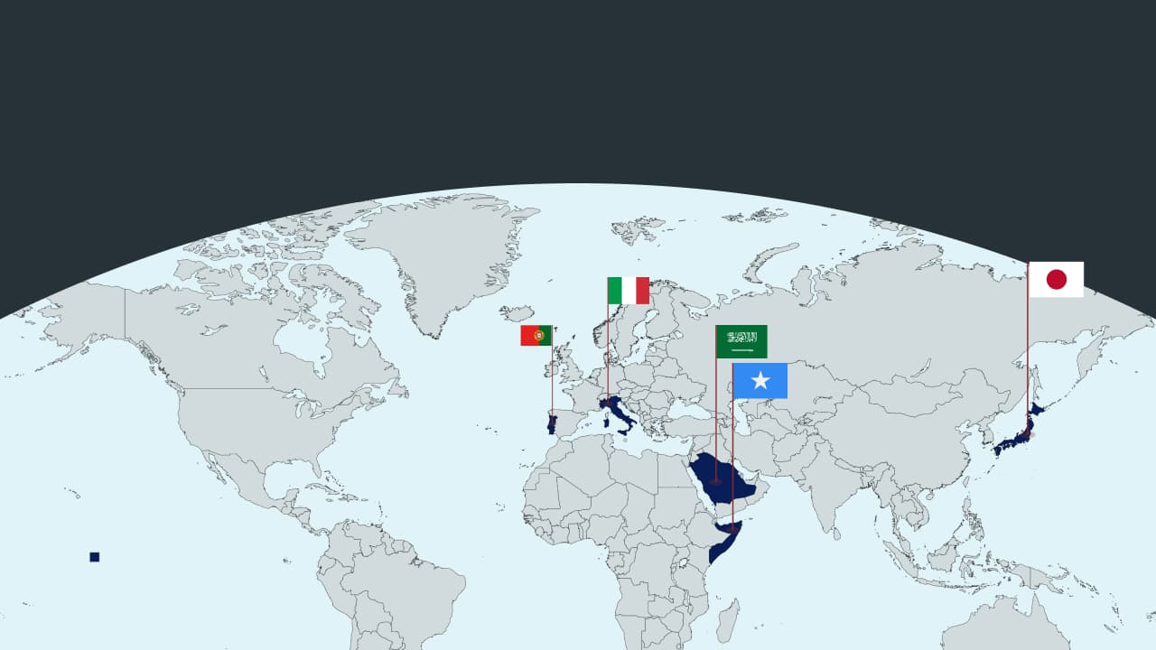

🇯🇵 Japan - Snap elections. Japan’s ruling Liberal Democratic Party is set to regain a majority in the lower house elections. This marks a big victory for ultraconservative PM Sanae Takaichi. She enjoys support from young people and projects a populist image. Her plans include fiscal stimulus and a stronger defense. A large mandate might allow constitutional changes (Iron lady prevails).

🇸🇦 Saudi Arabia - Invests in Syria. Saudi Arabia will invest heavily in post-war Syria. This includes a low-cost airline they will co-own, a $1B telecom project, and infrastructure deals for airports and water desalination. This shows Riyadh’s support for Syria’s Islamist-led government as Damascus works to rebuild its economy (shifting priorities).

🇵🇹 Portugal - Socialist bags run-off. Centre-left Socialist António José Seguro clinched Portugal’s presidential runoff, defeating far-right populist André Ventura. With roughly 70% of ballots counted, Seguro led with about 64% of the vote to Ventura’s 36%. This vote tested support for Ventura’s Chega party amid instability from repeated elections and rising debates on immigration and populism (breaking the mold).

🇸🇴 Somalia - Slams Israel. Somalia’s president has condemned Israel’s recognition of Somaliland as illegal interference, warning against any Israeli military base in the breakaway region. Israel’s move, the first of its kind, has brought on regional tensions in the Horn of Africa and Red Sea, challenging Somalia’s territorial integrity and raising fears of further instability and geopolitical rivalry (concerns on the horn).

🇮🇹 Italy- Protestors arrested. Protests in Milan disrupted the start of the Winter Olympics. Six people were arrested after clashes with police. Demonstrators criticized the Games for their costs, social impact, and environmental issues. Suspected sabotage on northern Italy’s railways also caused delays. Authorities defended the new security laws and labeled the unrest criminal (local grievances).

Foundations

Where is Abkhazia?
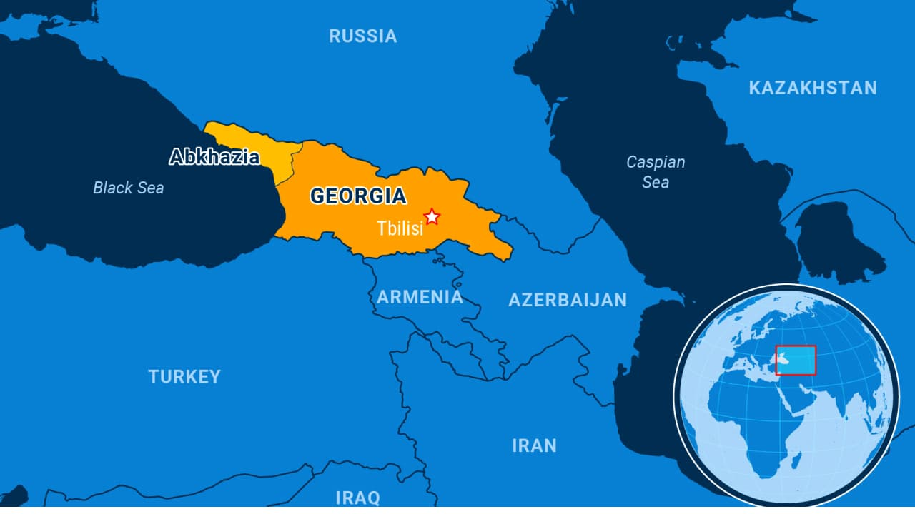
Prior to the separatist rebellion in the early 1990s led by ethnic Abkhaz, ethnic Georgians had made up almost half of Abkhazia’s population. Credits: GlobalPost

The what: Abkhazia is a breakaway region of Georgia that declared independence in 1992 after the collapse of the Soviet Union. It functions as a de facto independent state with its government and institutions. Abkhazia borders Russia to the north and Georgia’s Samegrelo region to the east and south. Only a handful of countries recognize it, including Russia and some of its historical allies, such as Syria, Venezuela, Nauru, and Nicaragua. The UN and the rest of the world legally recognize it as part of Georgia.

The history: Historically, Abkhazia lay at the crossroads of Greek, Byzantine, and Ottoman influence before being absorbed by the Russian Empire in the 19th century. Under Soviet rule, Abkhazia was first a separate republic, then, in 1931, downgraded to an autonomous republic within Georgia. As the Soviet Union disintegrated, conflict erupted between Abkhaz separatists and Georgian forces in 1992–93. With decisive backing from Russia, Abkhaz forces prevailed, leading to the mass displacement of ethnic Georgians.

On the ground: Abkhazia remains politically unstable, with frequent protests and leadership struggles. The economy is fragile, reliant on Russian subsidies, pensions, and tourism from southern Russia. Many ethnic Georgians displaced by the 1992–93 war have not returned, leaving deep demographic scars. Politically, local authorities operate independently but are closely aligned with Moscow

Last year, the country held elections after President Aslan Bzhania resigned following protests against a proposed funding agreement with Russia, which many locals viewed as threatening Abkhazia's autonomy. The region's future is uncertain, as it remains caught between its pursuit of sovereignty and reliance on Russia.

Preview text
Plus Somalia slams Israel

