🗽 Feb 9: Silencing a voice

In this edition:

- Rise of 996
- Burger King fined
- iPhone 17e update

Spotlight

Media mogul convicted
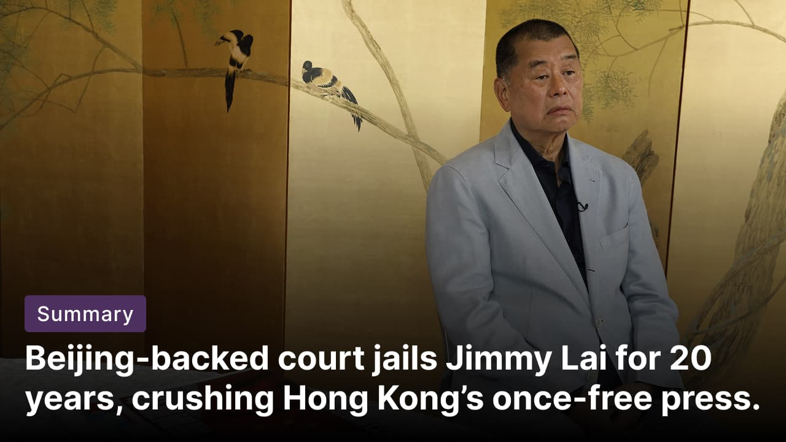

What happened? Former Hong Kong media tycoon Jimmy Lai has been sentenced to 20 years in prison, the harshest punishment yet under Beijing’s National Security Law. The 78-year-old founder of Apple Daily was convicted on two national security charges, including collusion with foreign forces, and one sedition charge tied to editorial content and overseas lobbying. The sentence effectively rules out parole, given Lai’s age and failing health.

Case background: After founding Apple Daily in 1995, he built a fiercely anti-Beijing tabloid that shaped opposition politics for decades. Following the 2019 mass protests, Beijing enacted a sweeping National Security Law in 2020, broadening the criminalisation of activities deemed subversive or involving foreign collusion. Lai was arrested multiple times, Apple Daily was raided and shut down, and his prosecution became the most prominent test case of the latest law.

Global support: International leaders condemned Lai’s sentence, with Taiwan decrying rights violations, and Amnesty International slamming the attack on freedom of expression. Britain, the EU, and G7 governments urged his release. Trump and Western lawmakers have raised Lai’s case diplomatically, framing it as a growing point of tension with Beijing.

Start-up grind culture
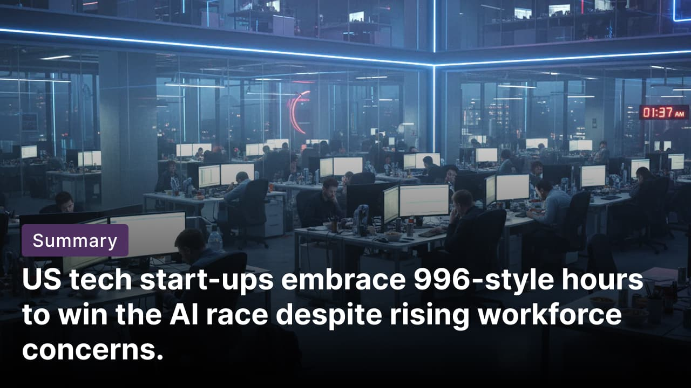

What happened? Tech firms competing in the AI boom are adopting high-intensity work models, with some openly advocating 70–72-hour workweeks. Start-ups say long hours enable rapid development as capital floods into the AI sector. The approach mirrors the “996” culture popularised in China, which the US tech industry has chosen to embrace.

996 culture: This requires working 9 am-9 pm shifts, 6 days a week, totaling 72 hours. Originating in China’s tech sector, this model prioritizes speed, ambition, in-person collaboration, and constant availability. Job listings frequently stress intensity, obsession, and speed, warning applicants not to apply unless they are willing to work 60–70 hours or more, often in person. Founders and senior executives argue that such workloads are voluntary, flexible, and driven by motivation rather than rigid schedules.

Criticisms: Experts warn that the 996 culture exposes workers to severe health risks, including heart disease, stroke, and burnout. Studies show productivity declines beyond 40 hours weekly due to fatigue (70-hour workers match 50-hour output), undermining assertions that longer hours boost efficiency. They said companies were ignoring labour laws, failing to pay overtime, and forcing employees to work excessive hours.

Fact: The WHO reported an estimated 398,000 deaths from stroke and 347,000 deaths from heart disease as a result of working 55+ hours a week.

Long story short

Global Affairs

PM Sanae Takaichi’s party bagged a majority in Japan's snap elections. Japan’s LDP secured victory over 310 of 465 lower-house seats, becoming the first party since World War II to secure a two-thirds majority. Takaichi pledged to suspend the 8% sales tax on food to help households cope with rising expenses, a move that has spooked investors (Takaichi tightens grip).

Thailand’s PM Anutin Charnavirakul has claimed victory in the general election after conservative Bhumjaithai outperformed expectations. With most votes counted, the party is projected to secure the largest bloc in parliament, keeping Anutin in office despite falling short of a majority. Reformist rivals conceded defeat and are set to remain in opposition following another unpredictable poll (Thailand poll shock).

Business & Markets
Australian AI firm Firmus finalized a $10B debt package led by Blackstone and Coatue to expand Project Southgate. The initiative, in partnership with CDC Data Centres and Nvidia, aims to deploy 1.6 gigawatts of AI training data centre capacity across Australia within three years. Blackstone hailed it as key to the AI infrastructure boom (AI infrastructure boost).

Namibia has withheld recognition of the offshore license agreement announced by TotalEnergies and Petrobras. Authorities said required applications were not submitted before the public announcement, rendering the agreements invalid under Namibian law. The move comes as Namibia tightens oversight of its energy sector and advances plans for its first oil production (approval withheld).

Wisconsin demanded over $1M from Burger King franchisee Cave Enterprises for 1,656 child labor and wage violations affecting 600+ minors. Issues included unpermitted work, missed breaks, and illegal hours at 105 locations. Authorities demands $237K in back wages plus $828K penalties. The case is the largest child labor enforcement case in modern Wisconsin history (labor violations).

Science & Tech


According to Bloomberg’s Mark Gurman, Apple will launch the iPhone 17e this year, keeping the price at $599. Key upgrades include MagSafe charging, the powerful A19 chip from iPhone 17, and Apple’s latest in-house wireless technology. Aimed at emerging markets like China and India, as well as enterprises, it targets Google's Pixel 10a while improving the camera and efficiency over the iPhone 16e (budget iPhone boost).

Scientists at the University of Warwick have cracked how to predict the movement of irregularly shaped nanoparticles, such as soot and dust, in the air. The breakthrough comes from re-examining the Cunningham correction factor, which explains how tiny particles experience drag in air. The scientists have reworked Cunningham’s original idea and introduced a “correction tensor” that predicts particle motion without complex simulations or fitted parameters, improving models of air pollution (airborne mystery solved).

Whatnot

This drug resets the body clock and nearly halves jet lag recovery time (faster recovery).

Pakistan’s iconic kite festival has returned under tight controls after a 19-year ban (cautious comeback).

NY Lawmakers propose a three-year pause on approving fresh data centers (permits on hold).

The Seahawks claim Super Bowl 60 with a 29-13 secure victory over the Patriots.

Footer
On this day in 1996, German physicist Peter Armbruster and his team synthesized the chemical element 112, a heavy transuranium element later named copernicium.

Image credits
Vincent Yu/AP, Tsukushi, Apple

Preview text
Plus Sanae Takaichi tightens grip

