🗽 Feb 6: Where is Nancy?

In this edition:

- TrumpRx drug platform
- xAI merger perks
- Cancer mutation map

Spotlight

Tucson kidnapping investigation

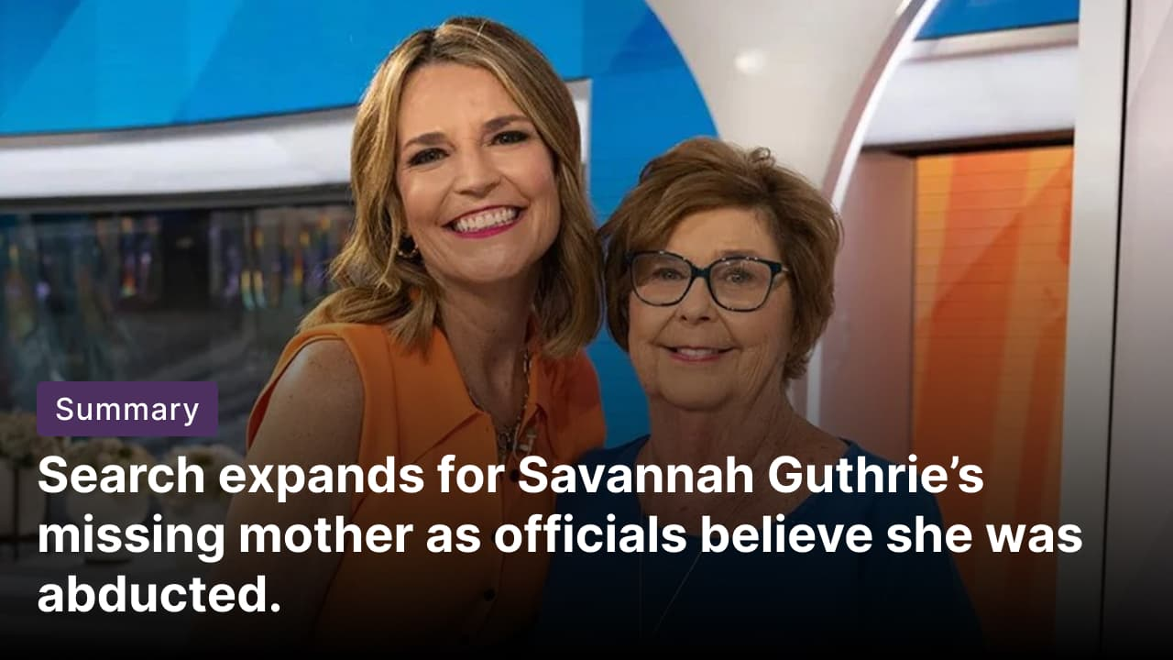

What happened? Investigators in Arizona are probing the suspected abduction of Nancy Guthrie, the 84-year-old mother of NBC anchor Savannah Guthrie. Authorities have not identified a suspect, but they believe Guthrie is still alive. Multiple ransom notes sent to the media remain unverified, while a separate message to the family was confirmed as a hoax.

How did it unfold? Nancy Guthrie was last spotted on Saturday night after being dropped off by family. An alarm was raised Sunday morning when church members noticed she was missing. Police later found blood at her home, confirmed to be hers, prompting homicide detectives to treat the residence as a crime scene. Officials have warned she is in poor health and without critical medication, heightening urgency.

Who is Savannah? Savannah Guthrie, 54, is a veteran broadcast journalist. Guthrie became a Today co-anchor in 2012 and is widely recognized for her incisive interviews with political leaders and newsmakers. President Trump called Savannah, pledging to deploy all federal law enforcement resources to help locate and safely return her mother. She has withdrawn from NBC's 2026 Winter Olympics opening coverage to support her family.

Trump's drug initiative
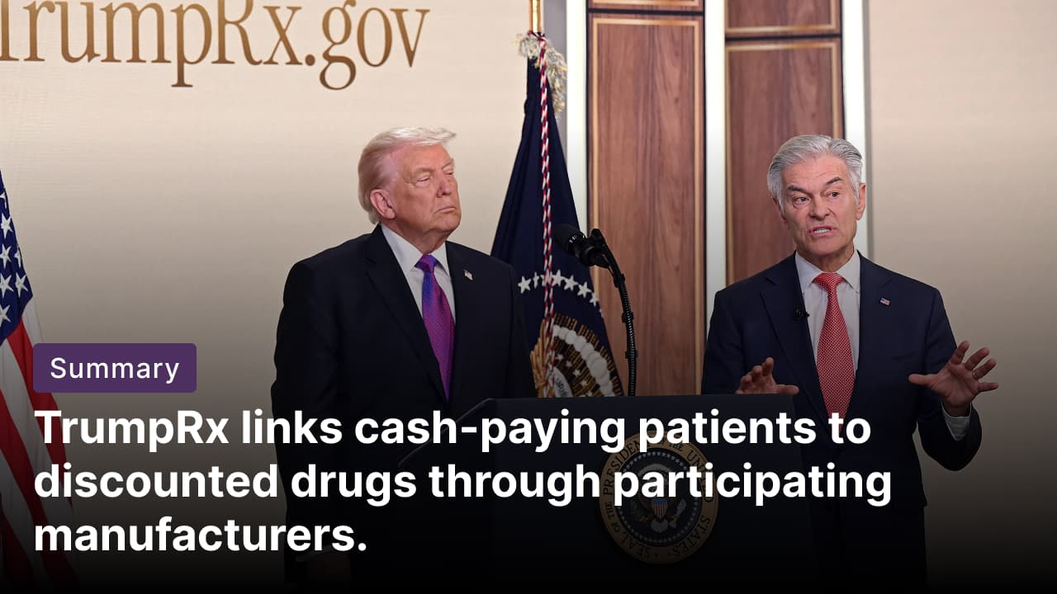

What happened? President Trump launched the TrumpRx website, the much-anticipated direct-to-consumer drug platform. TrumpRx is part of the administration’s “Most Favored Nation‘ drug pricing initiative, which seeks to push US drug prices closer to the lowest prices paid in other developed countries. TrumpRx does not sell medicines directly. Instead, it functions as a clearinghouse, directing patients to pharmaceutical companies’ own direct-purchase programs or providing coupons.

How does it work? TrumpRx operates as a government-run referral platform and not a pharmacy. When a user selects a drug, the site either redirects them to the manufacturer’s own direct-to-consumer portal or provides a coupon to use at a pharmacy. Patients must forgo coverage and pay out of pocket. Savings vary and mainly benefit uninsured or underinsured patients.

What drugs are available? There are currently 43 medications available on TrumpRx. Some of the most familiar medications on the website are Insulin lispro, Wegovy in both oral and pen form, Ozempic, Zepbound, the fertility medication Gonal-F, the rescue inhaler Airsupra, and Farxiga.

Long story short

Global Affairs

Ukraine and Russia exchanged prisoners of war and civilians after two days of US-brokered peace talks in Abu Dhabi. A total of 157 Ukrainians and 157 Russian soldiers were returned home in the first such swap in four months. No breakthrough in the negotiations has been reported. Ukrainian President Volodymyr Zelensky said the talks had not been easy and that he wanted "faster results" (rare POW swap).

Homeless or at-risk refugee households in England jumped fivefold to 19,310 in 2024/25 from 3,560 in 2021/22. Charities blame the 28-day move-out from Home Office accommodation post-refugee status, amid faster claim processing and housing shortages. The government pledges to clear the backlog and provide local support (refugees without homes).

Business & Markets
Elon Musk structured SpaceX’s $250B acquisition of xAI as a tax-efficient triangular merger, keeping xAI as a wholly owned subsidiary. It creates a combined entity worth $1.25T. This approach shields SpaceX from xAI’s borrowings and litigation-related liabilities, avoids change-of-control triggers, and grants shareholders tax deferrals. The design is especially beneficial amid high interest rates. SpaceX’s IPO plans remain intact (Musk merger structure).

Telehealth firm Hims & Hers Health has launched a $49-a-month compounded oral GLP-1 weight-loss pill, positioning it as an alternative to injectable drugs like Wegovy. The price undercuts Novo Nordisk’s $149 introductory offer. Novo has called the product illegal and said it will pursue judicial measures. The announcement sent Novo shares down 8.6%. (Hims undercuts Novo).

The US Postal Service (USPS) reported a net quarterly loss of $1.25B as it faces ongoing liquidity concerns. Officials urged reforms to retirement obligations, pricing flexibility, and the agency’s borrowing limit. Operating revenue in the three months ending December 31 fell 1.2% to $22.2B. USPS has lost about $120B since 2007 amid declining mail volumes. It is currently seeking fresh revenue through bids for access to its costly last-mile delivery network (postal service losses).

Science & Tech


Scientists have created a complete map showing how hundreds of possible mutations in a key cancer gene influence tumour growth. The study focused on CTNNB1, a gene that produces the protein β-catenin, which helps regulate tissue growth and repair. When β-catenin is disrupted, cells can begin uncontrolled growth, a hallmark of cancer. By systematically testing all possible mutations in a defined region of the gene in mouse cells, the map helps explain why certain mutations are associated with specific cancers (mutation impact).

Anthropic has released Opus 4.6, upgrading its flagship model with “agent teams” that split complex tasks across multiple coordinated agents. The update also increases the context length to 1M tokens, enabling work with larger codebases and documents. Opus 4.6 adds deeper PowerPoint integration, positioning the model for broader use beyond software development (agent teams debut).

Whatnot
Japan cancels cherry blossom festival (see why).

NASA astronauts will carry smartphones on upcoming ISS and Artemis II missions (space selfies).

The US military struck a suspected drug-trafficking boat in the eastern Pacific, killing two (Pacific interdiction).

Deep-Earth structures have influenced Earth’s magnetic field for centuries (mantle mystery).

Footer
On this day in 1862, Union naval commodore Andrew Foote, leading a flotilla of ironclads, captured Fort Henry, Tennessee, a strategic Confederate position during the American Civil War.

Image credits
lagracelaverite, Reuters, Shutterstock

Preview text
Plus US-Russia prisoners exchange

