🇦🇪 Feb 13: Is this Dr. Bot?

In this edition:

- Ramadan Games unveiled
- Algiers route suspension
- Ramadan rescue drive

Spotlight

AI clinic assistant

Summary: UAE launches an AI physician assistant, transforming clinical workflows and improving consultation efficiency.

The UAE has introduced Amal, the country’s first AI-powered physician assistant, designed to transform pre-consultation workflows across Emirates Health Services. Developed by Boston Health AI and unveiled at the World Health Expo, Amal conducts structured interviews with patients before they meet their doctor. The AI analyses responses and generates a comprehensive clinical summary, which is shared with physicians before the consultation.

The technology has been deployed to more than 30,000 patients in the US and Pakistan, achieving patient satisfaction rates of over 95%. The platform has demonstrated measurable reductions in documentation time and improved physician consultation readiness. By standardizing health history intake and generating structured summaries, the system enhances data accuracy and operational efficiency.

Amal reflects the UAE’s broader ambition to embed artificial intelligence across critical public services. The initiative aligns with national goals to enhance efficiency, attract health-tech innovation, and improve population-level outcomes. By integrating AI into frontline clinical workflows, the country is moving beyond pilot projects toward system-wide operational adoption.

Ramadan Games unveiled

Summary: Dubai Police launches Ramadan Games 2026, blending sport and community engagement.

Dubai Police has officially launched Ramadan Games 2026, a city-wide sporting initiative scheduled from February 20 to March 11, spanning six venues across Dubai. The programme will feature 25 championships and competitions, with a total prize pool exceeding Dh700,000. Organisers expect participation and attendance to exceed 20,000.

Announced during a media briefing, the initiative is positioned as a structured Ramadan engagement platform that integrates competitive sport with community programming. Organised under the theme aligned with Dubai Police's message, “Smart. Secure. Together.”, the Games aim to combine competitive sport with social cohesion throughout Ramadan.

In addition to sporting contests, the programme will integrate community-focused initiatives such as the Happiness Village and protection-themed sports activities. The authorities mentioned that the initiative is designed to be inclusive and accessible to all segments of society.

Event
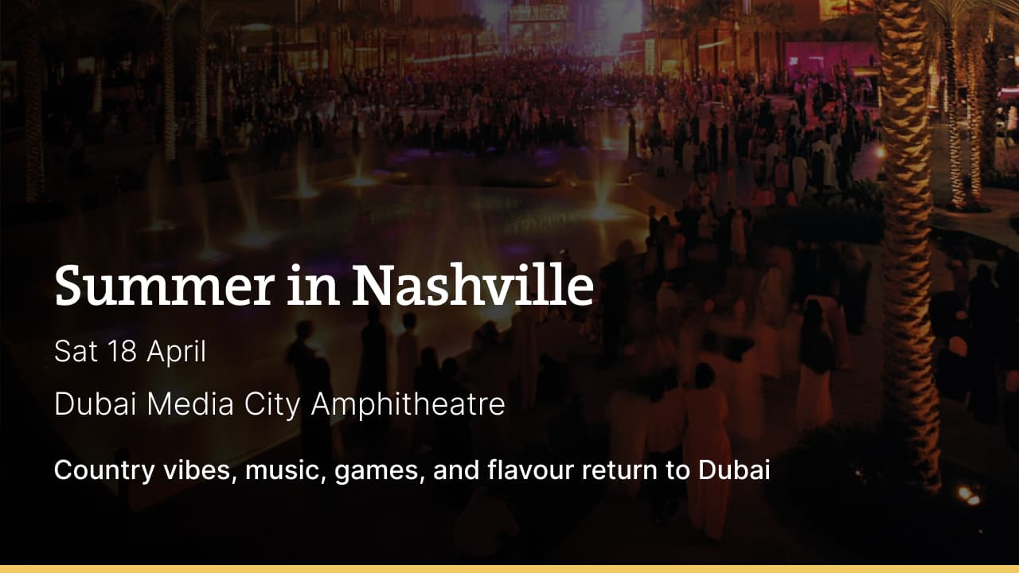

Where to eat?

3Fils → Located in Jumeirah Fishing Harbour, 3Fils is an award-winning modern Asian restaurant that strongly emphasizes the Japanese influences. Its menu includes sushi, nigiri, wagyu, and a variety of fusion food items. It has a minimalist, casual interior with comfortable seats and views of the marina.

Pro tip: Arrive early, as there is no reservation system at 3Fils and it fills up quickly, especially on weekends.

Career

Design Application Engineer

On-site
Full-time
AED 2,000-3,999 /month
Summary → Lab 26 Aluminum and Steel is hiring a full-time design and application engineer. The ideal candidate must have a bachelor's degree and 5-10 years of work experience. The job entails reviewing drawings and gathering project information, preparing quotations, selecting aluminum and steel systems, and supporting the sales and technical teams.

Register here

Meanwhile

Cannon signals sunset

Dubai Police have announced the locations for the 2026 Ramadan iftar cannons, which signal sunset and the end of the fast. Major spots include Expo City Dubai, Vida Creek Harbour Hotel, and JBR, which is returning after nearly a decade. The mobile cannon will visit 11 destinations on its first trip, including neighbourhoods, schools, Bab Al Shams, Meydan Hotel, Atlantis Hotel, and Global Village.

Algiers route suspension
Emirates has confirmed it will suspend its Algiers route effective February 3, 2027, following Algeria’s notification to terminate the bilateral Air Services Agreement. The UAE’s General Civil Aviation Authority clarified that the agreement remains valid during this transition and that there is no immediate disruption to air movement. Emirates stated it will comply fully with government directives and advised affected passengers to arrange alternative travel through their booking agents.

Ramadan rescue drive

Dubai Ruler Sheikh Mohammed launched the “Edge of Life” Ramadan campaign to save 5Mn children from hunger and malnutrition. Operating under Mohammed bin Rashid Al Maktoum Global Initiatives (MBRGI), the campaign seeks to raise at least AED 1B locally and internationally. It will support children in the world’s most vulnerable communities, particularly in conflict zones and disaster-affected regions.

Did you know?
Dubai residents may soon be able to book a fully driverless taxi via Uber, as Baidu’s Apollo Go autonomous vehicles prepare to launch in partnership with Uber and the RTA.

Day
Friday

Date
Feb 13

Temperature
28°C

Preview text
Plus Ramadan rescue drive

