🗽 Feb 13: ICE age ends

In this edition:

- Olympic controversy
- US-Taiwan trade tariff
- Protein rejuvenates brain aging

Spotlight

Federal enforcement withdrawal
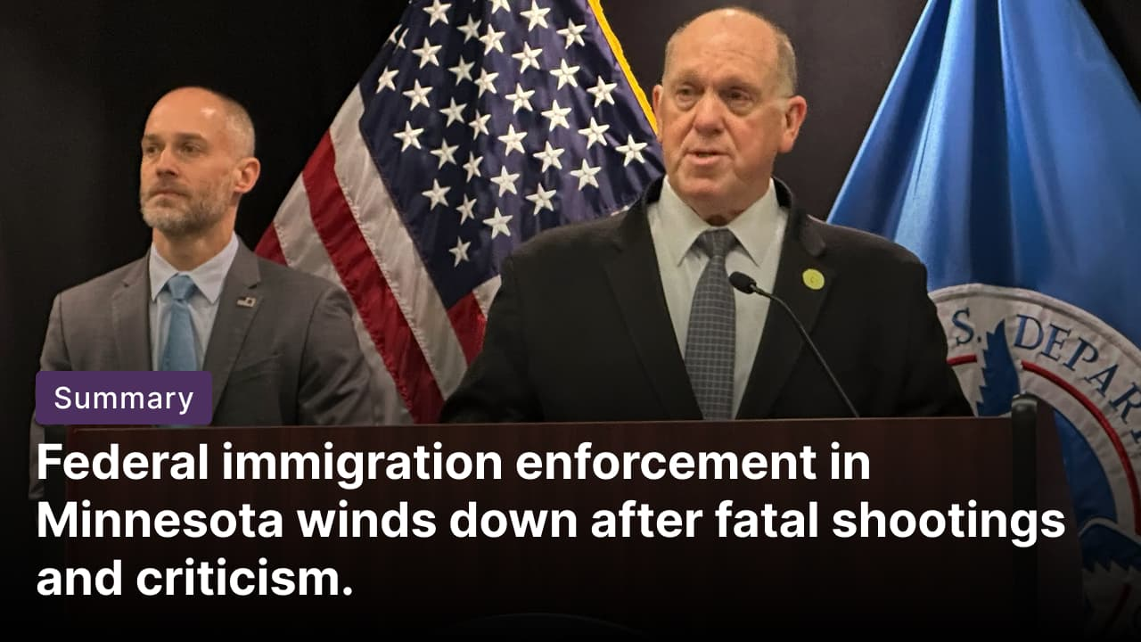

What happened? The Trump administration has ended “Operation Metro Surge,” a months-long immigration crackdown across Minneapolis–St. Paul and the surrounding Minnesota communities. Border czar Tom Homan announced an immediate drawdown of roughly 700 officers. The operation triggered mass protests, economic disruption, and two fatal shootings of US citizens (Renee Good and Alex Pretti) during encounters with federal agents.

Operation Metro Surge: It was a large-scale federal immigration enforcement campaign launched in December by the Trump administration. Officials said the operations aimed to deport those with removal orders, target alleged offenders, and curb “sanctuary state” protections in Minnesota. The administration wanted to curb public benefits fraud and reassert federal immigration authority.

Governor warns: Minnesota Gov. Tim Walz urged residents to stay vigilant as federal immigration officers begin withdrawing, sharply criticizing the Trump administration for what he called an unconstitutional assault on the state. Walz proposed a $10M relief package for affected businesses and pressed Washington to fund recovery, saying authorities cannot “break things” and walk away without accountability.

Olympic controversy


What happened? US ice dancing duo Madison Chock and Evan Bates bagged silver after their free dance at the Olympics, missing out on gold by just 1.43 points. Entering as three-time reigning world champions, they were narrowly edged out by France’s Laurence Fournier Beaudry and Guillaume Cizeron. However, the result drew scrutiny over judging discrepancies, particularly from a French judge who heavily favored the home team.

Controversy: In the ice dance event, skaters perform two distinct routines across two days: the rhythm dance and the free dance. In the rhythm dance, most judges kept the teams within a narrow margin, but a French judge scored the French team 5.74 points ahead of Chock and Bates, a margin far wider than the others. Similar gaps appeared in the free dance, where the same judge gave the French pair a 7.71-point edge. The International Skating Union defended the scoring as fair, with many dubbing the situation ‘SkateGate 2.0.’

Infamous SkateGate scandal: The Salt Lake City scandal was one of the biggest judging controversies in Olympic history. At the 2002 Winter Olympics, the pairs event erupted after Russia’s Elena Berezhnaya and Anton Sikharulidze triumphed over Canada’s Jamie Salé and David Pelletier despite a visible error. French judge Marie-Reine Le Gougne later admitted political pressure influenced her vote. The scandal prompted the overhaul of figure skating’s Code of Points to limit the impact of individual judges.

Long story short

Global Affairs

Switzerland will hold a vote on a right-wing party’s proposal to restrict the nation’s population to 10Mn. If the vote gets approved, the government would have to refuse entry to newcomers, including asylum seekers and family reunifications, once the population reaches 9.5Mn. And when it reached 10Mn, the government would be forced to end its free-movement agreement with the EU, which is Switzerland’s largest trading partner (population cap).

Indonesia plans to turn its vast archipelago into a network of emergency runways for its fighter jets. This move is set to strengthen the operational readiness of the Indonesian Air Force (IAF). Having emergency runway entry across all 38 provinces would strengthen Indonesia’s strike capability and make it harder for an adversary to target the air force (freeways as runways).

Business & Markets
Anthropic has raised $30B in a fresh funding round, more than doubling its valuation to $380B. Anthropic has further deepened its push for business agreements with products like Claude Cowork AI agent, which executes computer tasks for white-collar workers. Backed by Google and Amazon, the company is also expanding AI agents and pledging $20M to support AI regulation (AI funding frenzy).

US officials signed a final reciprocal trade agreement lowering the general tariff on Taiwanese goods from 20% to 15%. In return, Taiwan committed to boost purchases of US goods from 2025 through 2029, including $44.4B of liquefied natural gas and crude oil, $15.2B of civil aircraft and engines, $25.2B of power grid equipment and generators, and marine and steelmaking equipment (strategic trade swap).

A US court blocked a 2024 rule that would have expanded merger disclosure requirements, ruling that the FTC exceeded its statutory authority and failed to demonstrate that the rule’s regulatory benefits justified its compliance costs. The rule required more detailed disclosures to the FTC and the Department of Justice to strengthen oversight of merger reviews (merger rule overturned).

Science & Tech


Sony launched the WF-1000XM6 TWS earphones globally, with dual processors, including the QN3e. It boasts a 25% improvement in ANC via the HD Noise Canceling Processor QN3e and four microphones, plus enhanced calling quality with AI beamforming and bone conduction sensors. Key features include dual processors for 32-bit audio, revamped driver for deep bass, Hi-Res Wireless, 360 Reality Audio, Gemini support, IPX4 rating, and a 11% slimmer design (smarter Sony Buds).

Scientists at the National University of Singapore have identified DMTF1 as a key regulator of aging neural stem cells. Restoring the protein revives cells’ ability to regenerate. Using genome-binding and transcriptome analyses, researchers showed DMTF1 activates helper genes Arid2 and Ss18, which unpack DNA for growth genes and switch on growth pathways, potentially opening avenues to counter age-related cognitive decline (stem cell revival).

Whatnot
Deadly avian influenza outbreak confirmed in Antarctica for the first time (H5N1 bird flu).

Pinterest reports higher monthly searches than ChatGPT (search rivalry).

Taylor Swift urges the US government to block “Swift Home” trademark filing (trademark dispute).

Astronomers identify an Earth-like planet possibly colder than Mars (frozen Earth twin).

President Trump revokes a landmark finding that greenhouse gases threaten public health (climate rollback).

Image credits
AP Photo, AP Photo, LifeHacker

Preview text
Plus Switzerland population cap

