

|  |  |
| --- | --- |
| ***Module Title:*** | *DATA VISUALIZATION* |
| ***Module Code:*** | *B9DA106* |
| ***Module Leader:*** | *Basel Magableh* |
| ***Assessment Title:*** | *Exploratory Data Analysis* |
| ***Assessment Type:*** | *Group Submission* |
| ***Student Names:*** | *Elango Soundarajan* |
| ***Student ID:*** | *10506775* |
| ***Student Names:*** | *Gowtham Ganesan* |
| ***Student ID:*** | *10510832* |
| ***Student Names:*** | *Krupesh Shetty* |
| ***Student ID:*** | *10509099* |

INTRODUCTION……………………………………………………………………………………………………...

DATASET SELECTION………………………………………………………………………………………………

VIZUALIZATION TOOL…………………………………………………………………………………………….

INITIAL ANALYSIS…………………………………………………………………………………………………...

QUESTION

* **DISCOVERY AND INSIGHTS 4**
* **DESCRIPTION FOR EACH VISUALIZATION 4**
* **BARPLOTS ON VICTIM TERROR ATTACK TYPES, WEAPON AND VICIMS INVOLVED 5**
* **MAP PLOT ANALYSIS DESCRIBING COUNTRIES WITH MOST TERROR ATTACKS 7**
* **BUBBLE MAP PLOT ON CRIME TARGET TYPE IN CITIES OF IRELAND 8**
* **LINE PLOT ON THE DAMAGE TO PROPERTY OVER THE YEARS 9**
* **CIRCLE PLOT ABOUT TERRORIST ATTACK FATALITIES 10**
* **HORIZONTAL BAR GRAPH ABOUT ORGANIZATIONS RESPONSIBLE FOR THE TERROR ATTACKS 11**
* **BUBBLE GRAPH ON COUNTRIES WIITH WORST TERRORIST ATTACK THROUGH YEARS 12**
* **HEATMAP GRAPH ON WORST TERROR ATTACKS THROUGH YEARS 13**
* **STACKED BAR GRAPH ON CASUALITY BY THE TERRORISTS THROUGHOUT YEARS 13**
* **BAR GRAPH WITH MEAN LINE ON THE TERRORIST MODE OF CLAIM 14**

CONCLUSION

**Development Process**

**Team Member’s Contribution**:

**Elango Soundarajan** - I have taken initiate to learn Python for perform the visualization and other related subjects like Python Dash for the web app. I did self-study and shared the knowledge among the team members to ensure everyone in the team have knowledge in the area of work.

**Krupesh Shetty** – Krupesh Primary formed the business queries to get better observation on the chosen dataset. He has also plotted the Tableau charts and Maps in Python code. Also performed bug fixing on some of the other charts where we have faced problem.

**Gowtham Ganesan** – Gowtham majorly worked on the extra features that can be applied on the plots in python to enhance the look and feel of the chart. He has also performed research on implementing the interacting charts in Python. He has implemented the Python dash code (app.py) in which he has integrated charts to view in the web application.

**Hours Spent on Development:**

We have spent around 40-50 Hours in overall, in which it took around 10% for dataset selection, 50% for technology learning and remaining 40% for implementation.

**Aspect Took Most Time:**

As we stated earlier, it took much time for learning the technologies used for plotting the charts in Python.

**INTRODUCTION**

Global Terrorism Database (GTD) is an open-source database that provides information on occasions of acts of terrorism from 1970 to 2017 (with added yearly updates). Unlike many of the other databases, the GTD encompasses genuine local data as well as transnational and globally fear-based aggressor incidents that appeared in the middle of this period and now covers above 180,000 stories. Data can be found for each GTD episode on the date and location of the incident, the weapons used in the nature of the objective, the extent of setbacks, and - if the applicable-the meeting or individual sensitivity.  
Measurable data in the Global Terrorism Database focuses on a multitude of open media sources broadcasting. Data is still not added to the GTD if the sources are firm until and if we have decided. Clients must not induce any additional measures or outcome past what is displayed in a GTD section and users must not adequately discern that a person linked to an event has been tried and charged for fear-based oppression or some other criminal offense. If unique documentation winds up open around an event, a passage might be altered as crucial and relevant.   
  
Through this internet interface, the National Consortium for the Study of Terrorism and Terrorism Responses (START) makes the GTD available to create an understanding of psychological oppressor violence so that it can be examined and crushed more quickly.

**Dataset Selection:**

Global Terrorism Database (GTD) is the dataset we have chosen for this consideration. It contains data about the terrorist attacks from 1970 to 2017 around the country and during this phase it has more than 1,81,000 incidents.  
  
Attributes: eventid, iyear, imonth, iday, approxdate, expanded, resolution, nation, region, provstate, town, latitude, longitude, specificity, proximity, place, overview, etc.

**Visualization Tool:**

After the information has been gathered, we analyze the dataset and create a tool that will provide the most efficient and interactive visualization. The instrument we choose is Jupyter notebook and we used Altair, Plotly, matplotlib, seaborn, folium, python cufflinks packages to accomplish the outcome we're expecting.

**INITIAL ANALYSIS QUESTION**

1. Amount of damage caused by the property at a specific year?  
2. Evaluating the attack count with respect to different categories such as attack, weapon, and target?  
3. Finding the country with the highest terrorist attack?

4. The common motive behind any terrorist attack?  
5. The city with the highest terrorist attack in Ireland?  
6. The highest number of a terrorist attack with respect to a terrorist organization?  
7. The terrorist attack with maximum property damage with respect to Year?  
8. The number of casualties occurred in any terrorist attack?  
9. The number of individuals injured and killed in the course of the years during the terrorist attack?   
10.The number of individuals injured and killed in different nations during the terrorist attack?

# DISCOVERY AND INSIGHTS

1. Who is significant to these questions issues and what kind of credible information you expect to accumulate:

2. We need to discover who is more precious for this insight? Our military force including the Air Force, Army, Coast Guard, Marine Corps, Navy will be more beneficial in understanding the statistics of the terrorist attacks.

3.The military can come up with a strategy to defend the nation from the terrorist attack and deter it.

4.It will support us comprehend the definition of terror attack in unique ways, such as how they connect during the terrorist attack and what policy they employed in the years

5.With the facts given, the Military Force can introduce a modern workout routine to prepare the forces for the attack and inflict damage

6.Also, the Military Force can prepare the environment for the citizen who had been hurt.

7.In which country / city the military force requires to be more attentive because there is no terrorist attack everywhere, significant states and main towns will be involved.

8.The Military will get to realize from the criminal background which institution most of the terrorist attack and why they used it.

9.Using the data released, the military can develop and capture the terrorist organization's heavy threat alarm or prevent it from pursuing terrorist attacks.

# DESCRIPTION for each visualization

## **BarplotS on Victim Terror Attack Types, Weapon and Vicims Involved**

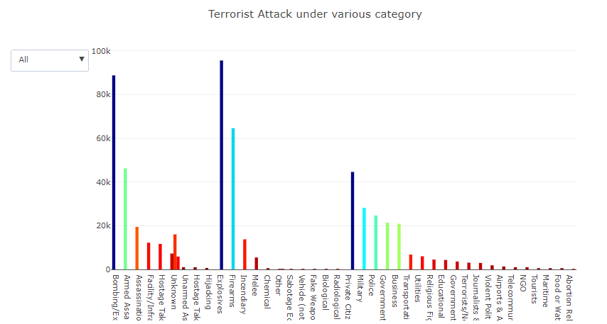

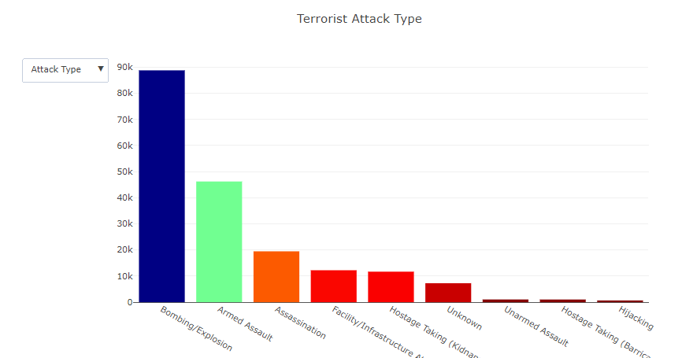

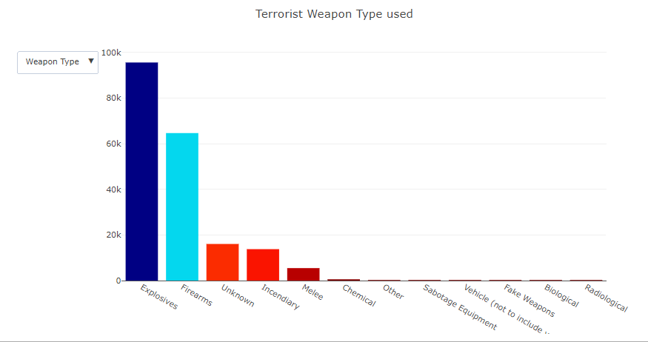

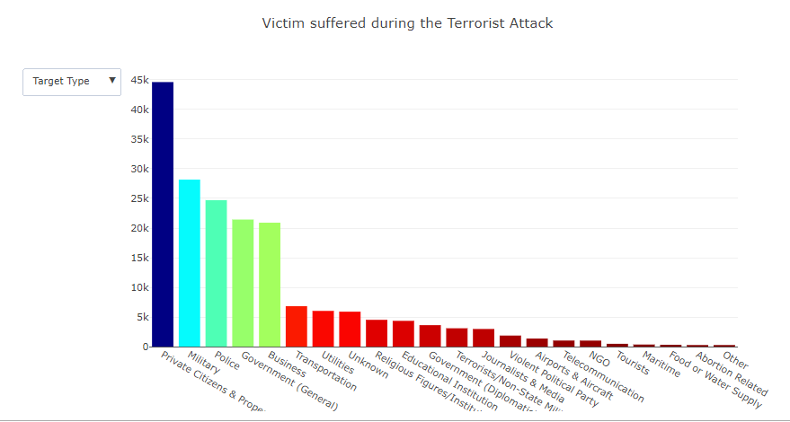

This plot provides an overview / summary of numbers of terrorist attacks under varying type of assault, weapon system and type of target which suffered the most in it. "Attack Types" reflects the terrorist's sort of attack. In Attack type, the Bombing is mostly considered in attacks other than any other sort, In Weapon Type, the most commonly used is Explosives, and Private Citizens & Property is commonly used in the Target Type. The objective is to comprehend the types of attacks in separate sizes and have a brief overview. It shows how many assaults each sort has made. And the largest one in it.

## **MAP PLOT Analysis describing Countries With most Terror attacks**

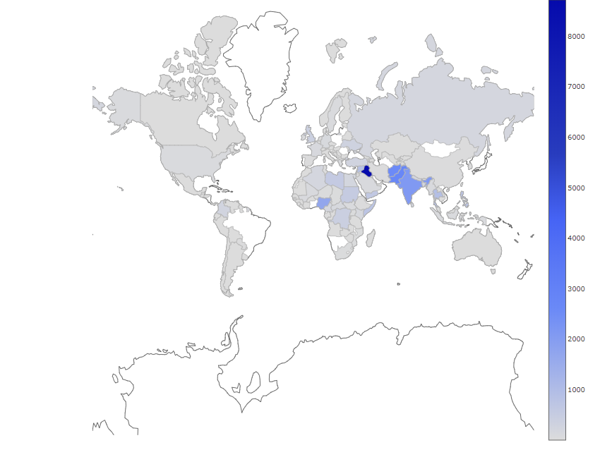

We are visualizing the terrorist attack that occurred around the globe in the map plot. In Iraq, the greatest amount of crimes is 8747 attacks and the second highest is India and Pakistan with even more than 3000 attacks. The interesting factor because we have a terrorist attack interval range from 1 to over 8500. Fiji documented in this type of crime with a terrorist attack. It introduces the number and highest amount of countries assaulted by the terrorist.

In this Map Plot, among other areas in Ireland, we can see the huge number of crimes happening in Dublin town. The interesting factor is the count of terror attacks as above 120 in Dublin isn't even above 20 when it comes to other cities. Is to understand the cities that are influenced by Ireland's terrorist attacks. It shows the level of cities which the terrorist has assaulted in Ireland and the highest in it.

## **BAR plot on the Damage to Property over the Years**

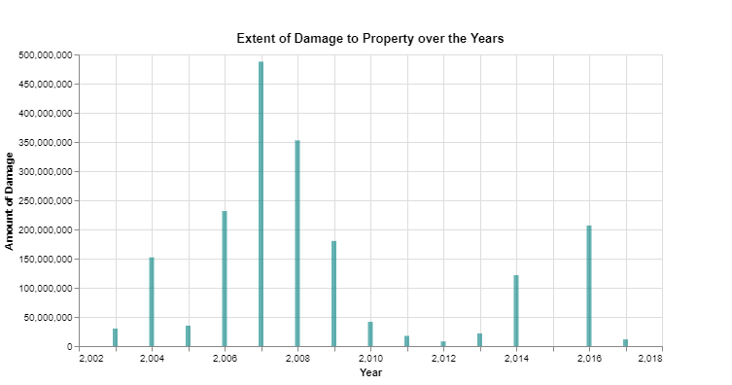

The price of property damage occurred from 1970 to 2017 in a terrorist attack. Roughly 900 trillion of the estate was damaged in the Major property damage classification during the 2001 and 2007 terrorist attack. It has been lowered after 2010 and it's much less for properties per year before damage occurred in 1981. It introduces and gives the greatest damage from 1970–2017.

## **LIne Plot about Terrorist attack Fatalities**

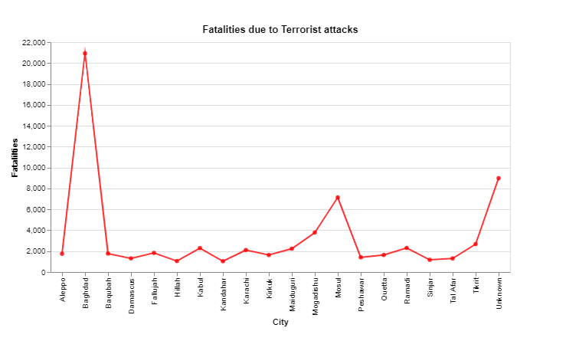

We see in this plot the quantity of individuals who died in the terrorist attack, including the terrorists and victims. In Baghdad city, the highest amount of individuals killed and count is about 21,000. Is to understand about the areas that terrorism has operated for the highest amount of fatalities. It introduces the numbers of casualties from terrorist attacks to the towns from all over the globe.

## **Horizontal Bar Graph about Organizations Responsible for the Terror Attacks**

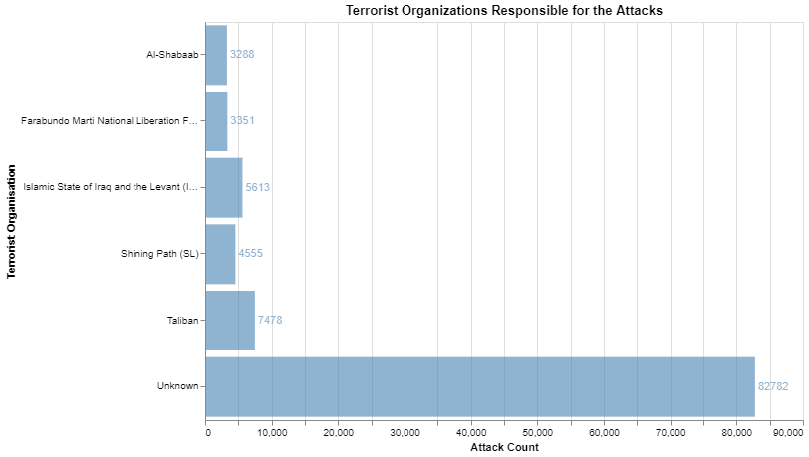

The bar above shows the attacks by multiple fear-based oppressor organizations of the psychological oppressor. We plotted the graph against their attack controls with the psychological militant organization. The shading power in the bar is based on the amount of assaults, the darker the shading, the higher the gathering tallies assaults. Every other rally was demolished by the Taliban bunch. Many organizations do not hold the assaults to account. Taliban (Afghanistan) is the most vibrant meeting on the planet with 7478 attacks until 2017, as stated by data. It's followed by ISIL (5613 attacks in the Middle East). Sparkling path (4555 assaults) at next, and Al-Shabaab at the least. Is to know which organization made the highest number of attacks. It presents the count of attacks made by each terrorist organization.

## **Bubble Graph on countries Wiith Worst Terrorist Attack through years**

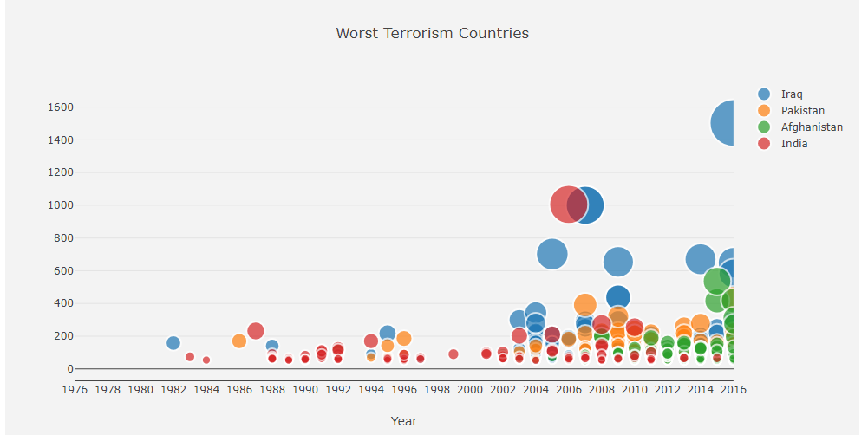

The Global Terrorism Index showed a process with a pattern of a decline in psychological oppression, with passages from fear mongering dropping back to back year for the third year after cresting in 2014. The absolute amount of passes dropped somewhere in the 2016 range by 27 percent, with Iraq's largest drops. It also shows that psychological oppression is still far-reaching, despite the deterioration in some places.

## **Heatmap Graph on worst Terror Attacks through years - Tableau**

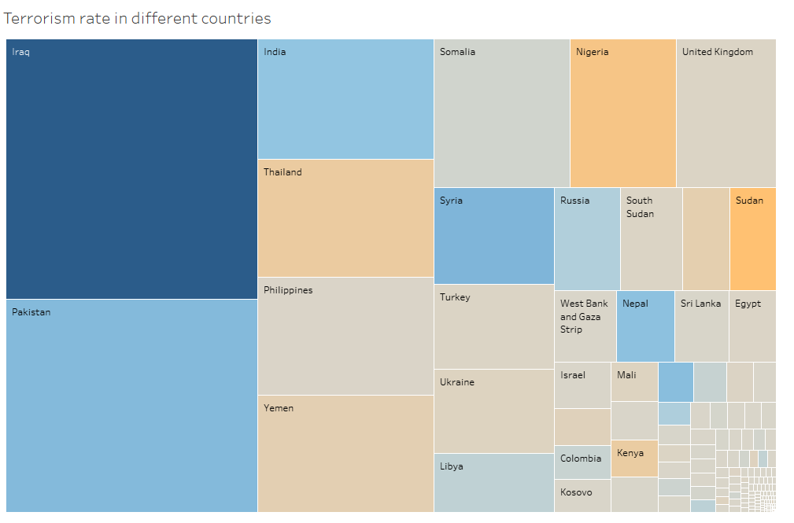

Over the years, several blameless lives have been secured by fear mongers. Dread continues to reign constantly in our boulevards in today's times. Psychological militants are all over from the highways to the war-dug metropolitan regions of Iraq, to Nairobi and Angola in Africa, and across Iran and the Persian Gulf.

## **Stacked Bar Graph on casuality by the TerroristS throughout years**

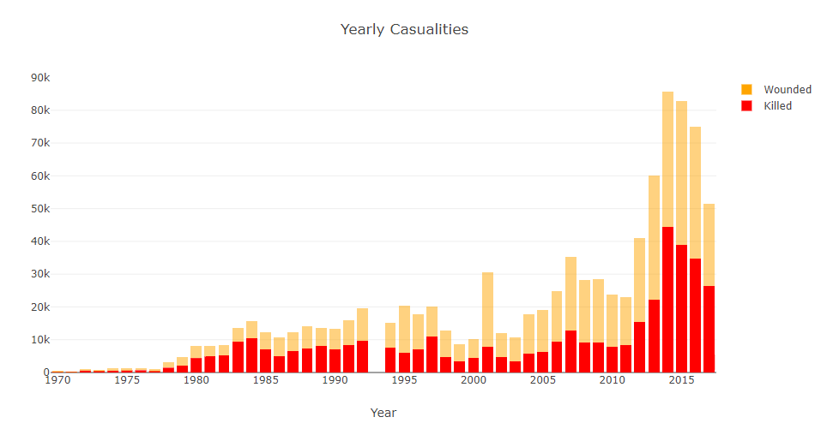

In the graph above we see the amount of deaths accumulated by district from fear-based oppressor attacks. We see that some districts have times of moderately elevated casualty figures over this multi-year period. We see that causalities have begun to increase over the past decade. It's mostly where more individuals were injured in 2015.

## **Bar Graph with mean line on the Terrorist mode of claim**

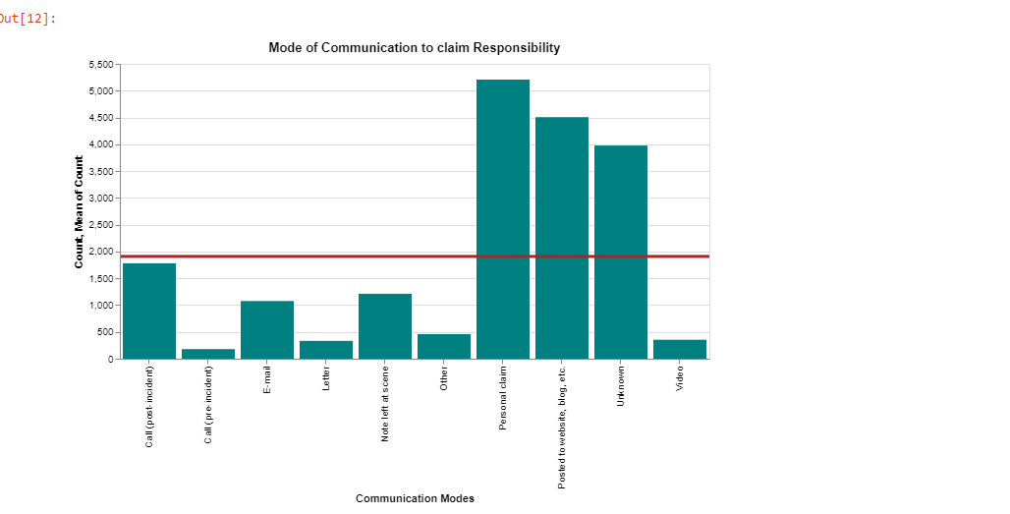

# Sim cards that can be dispensed. These can be bought namelessly over the counter, integrated in a cell phone, used once and then discarded, modestly and legally available for cash. Drops from the dead. An ancient method of the Cold War used by covert agents to drop physical bundles of information or pictures in places such as fences or dustbins. Instant message for email and SMS. Watchful militant psychological organizers would generally transmit illustrations in code or use them while speaking about goals, realizing that they could probably be blocked. Visit rooms and gaming online networking. They are also deeply defenseless against malware and infections, a little and attentive approach to conveying enormous quantities of data. Messenger by hand. The strategy that has worked for a long time.

## **Lollipop chart for Maximum Number on Attack Types and Maximum Number Weapon Types- Tableau**

# 

# In Lollipop chart, we are comparing the different attack types and the weapon types involved. On analyzing we can see that the maximum amount of weapon type is through explosives and firearms, this infers to terrorism. As there will be a mix and match of both weapon types.

# With respect to attack types, the maximum number goes to bombing and armed assassination. This has explicit inference with terrorism, as those are the most primary and most involved attack types.

# CONCLUSION

Interpreting the evaluation data in the interactive visualization is evident. In an interactive manner, we used different charts and graphs to capture audience participation and interest in traveling alongside it. We are more focused on the City, Country, Weapon, Victim, People Killed in the Terrorist Attack from the visualization. To sum up, we can obviously see the largest terrorist attack being carried out using Bombing / Explosives, and most of the target was attacks in government fields including markets, business roads, crowded junctions and pedestrian malls. Iraq is the nation with the greatest suffering and Baghdad City (Iraq Capital) suffered the most from the terrorist attack. We can say that Iraq is the world's most hazardous nation.