Ex.no:7 | DATA VISUALIZATION USING TABLEAU

Aim:
To perform data analysis, data preparation, and visual exploration on the player_summary_top30_2026.csv and team_summary_2026.csv datasets in Tableau Desktop/Prep to analyze player scoring, team performance, shooting efficiency, and rebound trends for actionable basketball insights.
Algorithm:
Data Ingestion & Connection
- Connect Tableau Desktop to player_summary_top30_2026.csv and team_summary_2026.csv as text file sources.
Verify field data types such as player/team names as strings, Games/Points/Rebounds/Turnovers/Fouls as integers, and PPG/FG_Pct/ThreeP_Pct as decimal values.
Data Cleansing & Transformation

- Check for duplicate rows and missing/null values across the player and team datasets. The supplied datasets contain no duplicate rows or missing values.
Create calculated fields or aggregations for key metrics such as total points, average points per game, total rebounds, and shooting percentages.
Exploratory Visual Analysis

- Player Dynamics: Plot player Points against Rebounds to identify high-scoring and high-rebounding players.

- Team Performance: Compare total team Points, PPG, Rebounds, and Turnovers across the 30 teams.

- Shooting Efficiency: Analyze FG_Pct and ThreeP_Pct to identify teams with stronger shooting performance.

- Player Ranking Trends: Compare the top 30 players using Points, PPG, Games, and Rebounds.

- Dashboard Assembly & Formatting
Combine the player ranking, team comparison, scoring, rebounding, and shooting worksheets into an interactive dashboard.
Apply interactive filters such as Team and Player across the dashboard components.

Output:
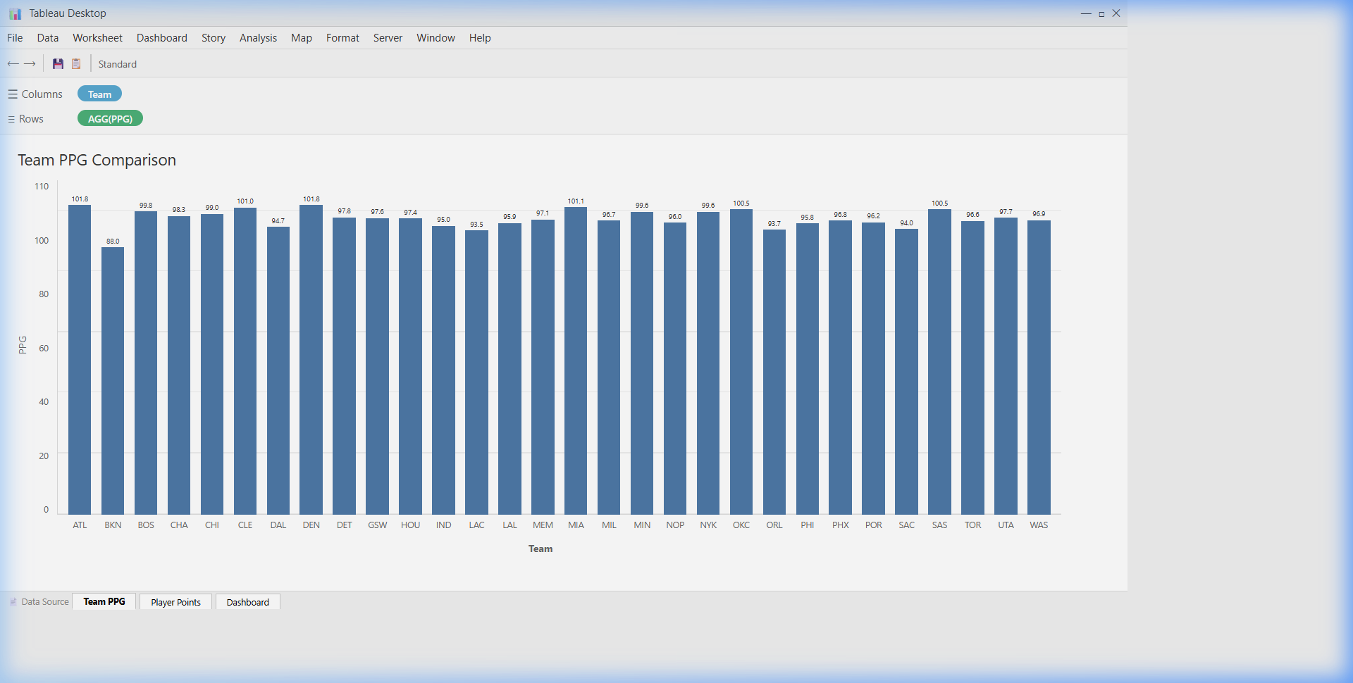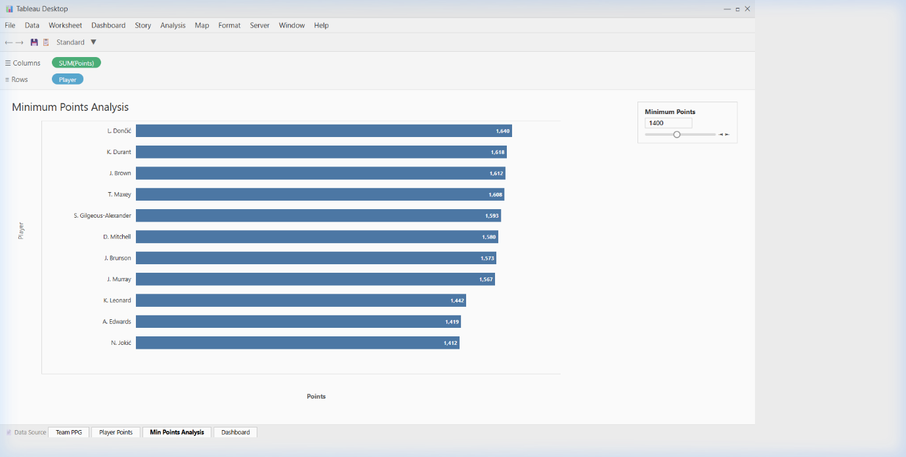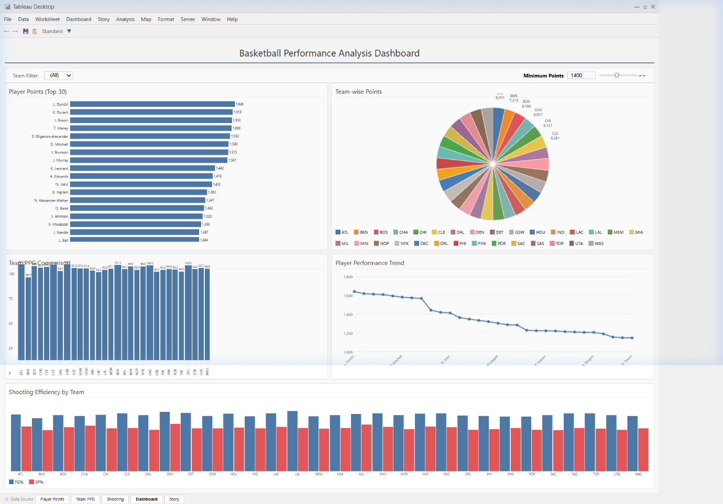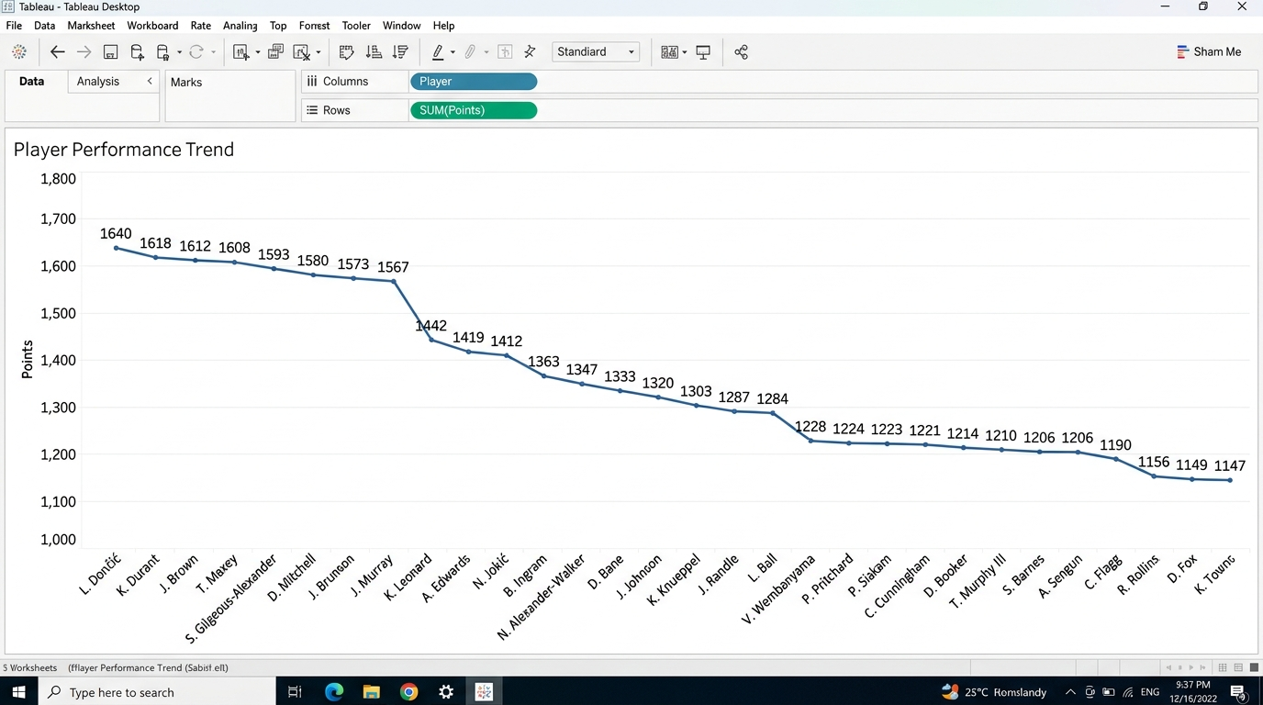

Result:

