Ex.no:7 | DATA VISUALIZATION USING TABLEAU

Aim:
To connect, analyze, visualize, and create interactive dashboards using Tableau for effective basketball performance intelligence and data analytics.
Algorithm:
Algorithm: Player and Team Performance Visualization using Tableau
Step 1: Data Loading
Connect player_summary_top30_2026.csv and team_summary_2026.csv to Tableau.
- Verify the imported fields: Player, Team, Games, Points, Rebounds, Turnovers, Fouls, and PPG.
- The player dataset contains 30 players and the team dataset contains 30 teams.
- Step 2: Player Points Bar Chart
Create a worksheet for player-wise points.
- Place Player on Columns.
- Place Points on Rows.
- Select the Bar Chart visualization.
- Enable data labels to display the points of each player.
- Sort the players in descending order of Points to highlight the leading scorers.
Step 3: Team-wise Points Visualization
- Create a worksheet using Team and Points from the team dataset.
- Aggregate Points using SUM.
- Visualize the contribution of each team using a Pie Chart.
- Display team names and corresponding points as labels.
Use the visualization to compare team scoring contribution.
- Step 4: Player Performance Trend
- Create a Line Chart using Player and Points/PPG.
- Place Player on Columns and the selected metric on Rows.
- Enable labels to display individual statistics.
Use the chart to compare the overall performance of the top 30 players.
- Step 5: PPG and Rebound Analysis
- Create calculated fields or aggregated measures for Points per Game and total Rebounds.
- Display Player, Points, Rebounds, and PPG in a worksheet.
Compare scoring output with rebounding contribution.
- Step 6: Team Filter
- Add Team to the Filters shelf.
- Select a specific team such as LAL, DEN, BOS, or OKC.
Observe the updated player statistics based on the selected team.
- Step 7: Minimum Points Parameter
- Create a parameter named Minimum Points.
- Set the required minimum points value.
- Apply the parameter to display only players whose Points meet or exceed the selected value.
For example, when Minimum Points = 1400, display players scoring 1400 or above.
- Step 8: Dashboard Creation
- Create a new Tableau Dashboard.
- Add the Player Points, Team Contribution, Performance Trend, PPG/Rebound Analysis, and Minimum Points visualizations.
- Arrange the worksheets clearly.
- Add the Team filter and Minimum Points parameter.
Format the dashboard with suitable titles and labels.
- Step 9: Story Creation
- Create a Tableau Story using the completed dashboard.
  - Add story points for:
  - Overall Player Performance
  - Team-wise Scoring Analysis
  - Top Performing Players
- Final Basketball Performance Analysis
Present the visual insights using the story.
- Step 10: Analysis
- Analyze the charts to identify the highest and lowest scoring players.
- Compare total points, PPG, rebounds, and shooting efficiency among teams.
- Observe how the Team filter and Minimum Points parameter dynamically change the visualizations.

Output:
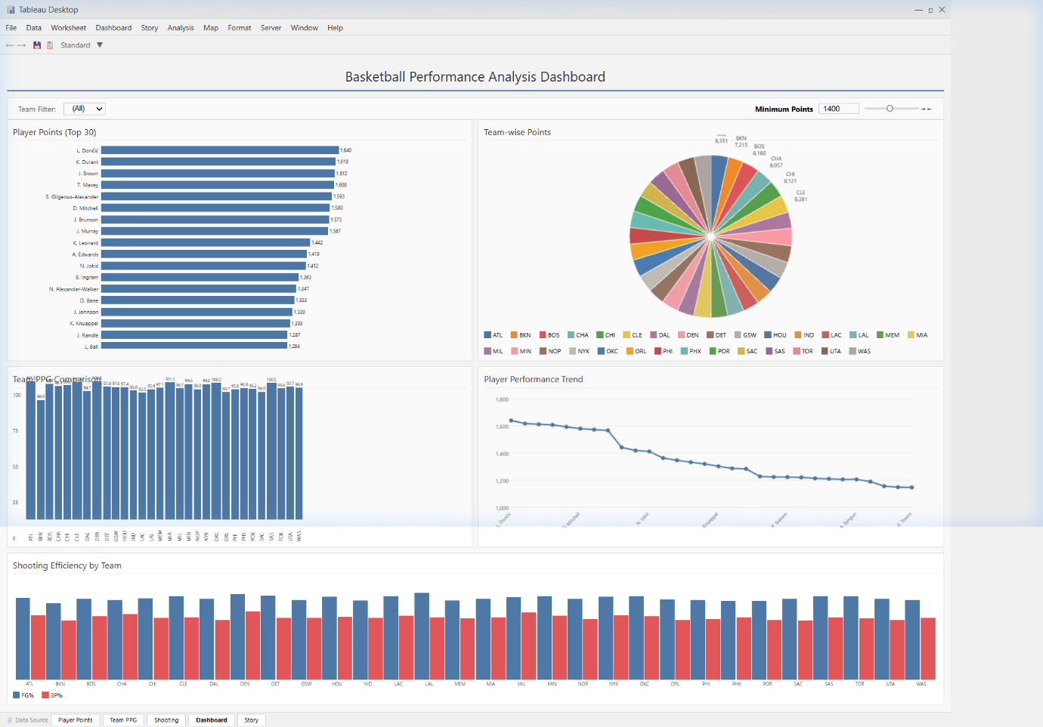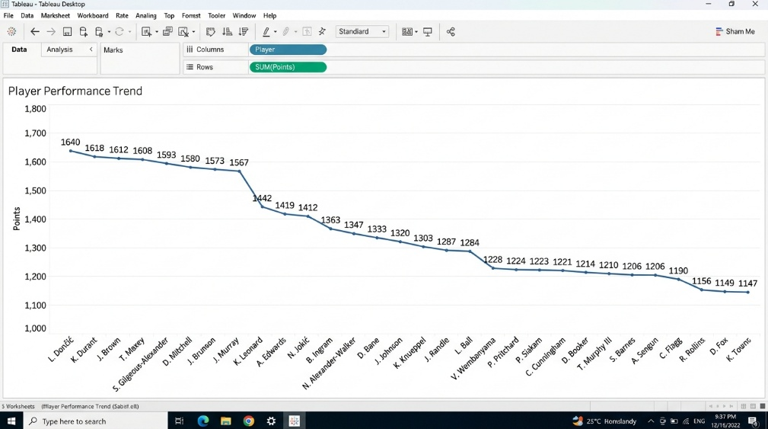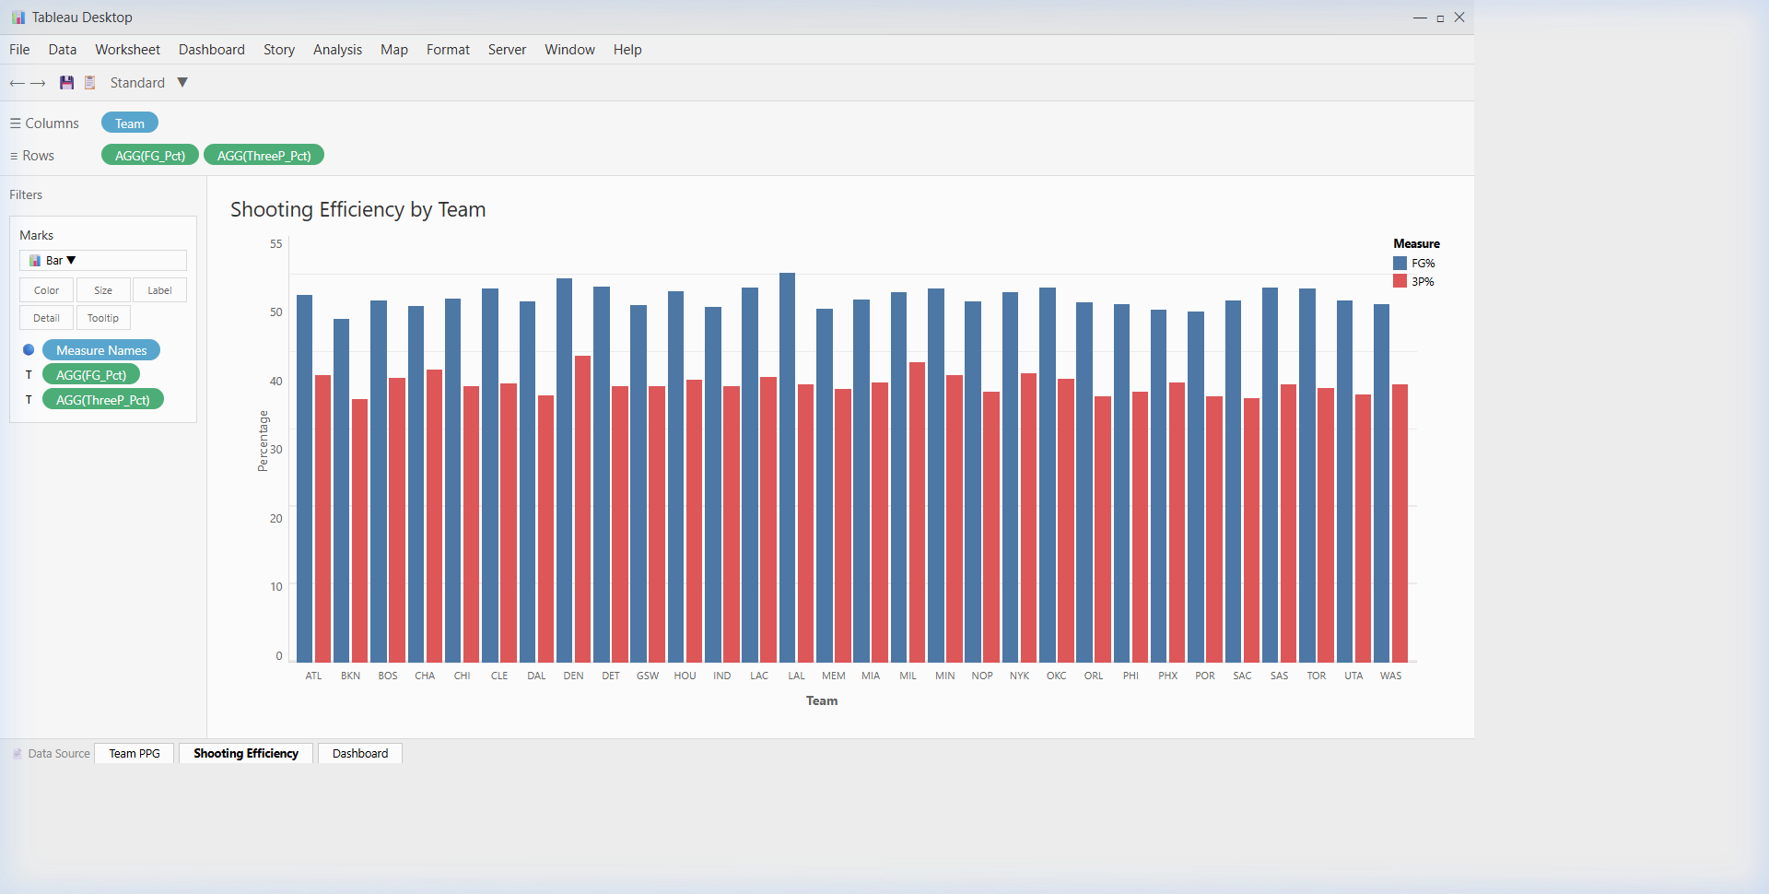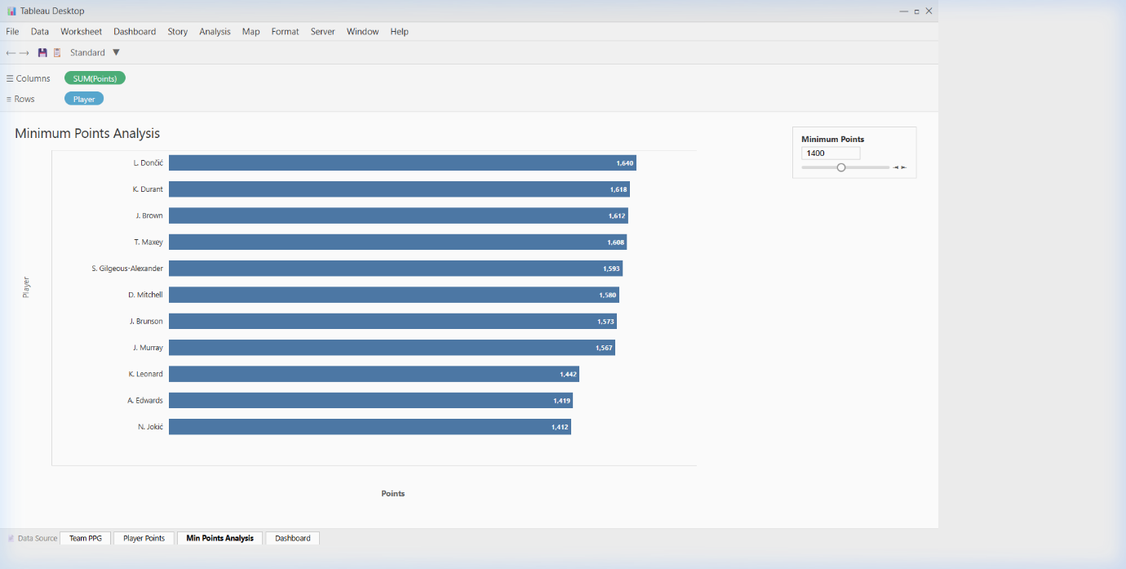

Result:

