EX No: 1 | EDA - DATA CLEANING

Aim:
To perform Exploratory Data Analysis (EDA) and data cleaning on an NBA play-by-play dataset (2025–26 season) using standard data science frameworks (CRISP-DM, SEMMA, and KDD) by handling missing values, removing duplicate records, standardizing inconsistent categorical text, creating derived features, and analyzing play and scoring patterns.
Algorithm:
1. Import pandas, numpy, re, and matplotlib.pyplot.
2. Load pbp2026.csv and inspect dataset structure, missing values, and duplicates.
3. Clean data by removing duplicate rows, standardizing inconsistent text casing in the type and subtype columns, and imputing missing values in team, player, type, x, y, and dist.
4. Convert the clock column to seconds remaining, forward-fill the running score (h_pts, a_pts) within each game, and engineer new features (time_left_sec, score_margin, total_points).
5. Plot frequency distributions for key variables (play type, team, period, player) and display a correlation matrix heatmap.
6. Summarize business insights and end execution.

Program:
import pandas as pd
import numpy as np
import matplotlib.pyplot as plt
import re

# CRISP-DM FRAMEWORK
# ============================================================
# 1. BUSINESS UNDERSTANDING
# Objective:
# Analyze NBA play-by-play data to understand play-type frequency,
# scoring patterns, and team/player involvement across a season.

# 2. DATA UNDERSTANDING
df = pd.read_csv("pbp2026.csv")
print(df.head())
print(df.shape)
print(df.info())
print(df.describe())
print(df.isnull().sum())
print(df.duplicated().sum())

# 3. DATA PREPARATION
df.drop_duplicates(inplace=True)
top_players = df['player'].dropna().value_counts().head(10)
df['type'] = df['type'].str.strip().str.title()
df['subtype'] = df['subtype'].str.strip().str.title()
df['team'] = df['team'].fillna('N/A')
df['player'] = df['player'].fillna('N/A')
df['type'] = df['type'].fillna('Unknown')
df['x'] = df['x'].fillna(0)
df['y'] = df['y'].fillna(0)
df['dist'] = df['dist'].fillna(0)
df[['h_pts','a_pts']] = df.groupby('gameid')[['h_pts','a_pts']].ffill()
df[['h_pts','a_pts']] = df[['h_pts','a_pts']].fillna(0)

def clock_to_seconds(t):
m = re.match(r"PT(\d+)M([\d.]+)S", str(t))
if m:
return int(m.group(1))*60 + float(m.group(2))
return np.nan

df['time_left_sec'] = df['clock'].apply(clock_to_seconds)
df['score_margin'] = df['h_pts'] - df['a_pts']
df['total_points'] = df['h_pts'] + df['a_pts']

# 4. MODELING (EDA)
df['type'].value_counts().head(10).plot(kind='bar')
plt.title("Play Type Frequency")
plt.show()

df['team'].value_counts().plot(kind='bar')
plt.title("Event Count by Team")
plt.show()

df['period'].value_counts().sort_index().plot(kind='bar')
plt.title("Events by Period")
plt.show()

top_players.plot(kind='bar')
plt.title("Top 10 Most Involved Players")
plt.show()

corr = df[['period','h_pts','a_pts','x','y','dist',
'time_left_sec','score_margin','total_points']].corr()
plt.figure(figsize=(10,8))
plt.imshow(corr)
plt.colorbar()
plt.xticks(range(len(corr.columns)),corr.columns,rotation=90)
plt.yticks(range(len(corr.columns)),corr.columns)
plt.title("Correlation Heatmap")
plt.show()

# 5. EVALUATION
print("Business insights generated successfully.")

# 6. DEPLOYMENT
print("Insights can be deployed through live-game dashboards.")

# SEMMA FRAMEWORK
# ============================================================
# SAMPLE
df = pd.read_csv("pbp2026.csv")

# EXPLORE
print(df.head())
print(df.info())
print(df.describe())
print(df.isnull().sum())

# MODIFY
df.drop_duplicates(inplace=True)
df['type']=df['type'].str.strip().str.title()
df['subtype']=df['subtype'].str.strip().str.title()
df['team']=df['team'].fillna('N/A')
df['player']=df['player'].fillna('N/A')
df['type']=df['type'].fillna('Unknown')
df['x']=df['x'].fillna(0)
df['y']=df['y'].fillna(0)
df['dist']=df['dist'].fillna(0)
df[['h_pts','a_pts']]=df.groupby('gameid')[['h_pts','a_pts']].ffill()
df[['h_pts','a_pts']]=df[['h_pts','a_pts']].fillna(0)
df['time_left_sec']=df['clock'].apply(clock_to_seconds)
df['score_margin']=df['h_pts']-df['a_pts']
df['total_points']=df['h_pts']+df['a_pts']

# MODEL
df['type'].value_counts().head(10).plot(kind='bar')
plt.show()
df['team'].value_counts().plot(kind='bar')
plt.show()
df['period'].value_counts().sort_index().plot(kind='bar')
plt.show()
df['player'].value_counts().head(10).plot(kind='bar')
plt.show()
corr=df[['period','h_pts','a_pts','x','y','dist',
'time_left_sec','score_margin','total_points']].corr()
plt.figure(figsize=(10,8))
plt.imshow(corr)
plt.colorbar()
plt.xticks(range(len(corr.columns)),corr.columns,rotation=90)
plt.yticks(range(len(corr.columns)),corr.columns)
plt.show()

# ASSESS
print("Patterns and trends successfully identified.")

# KDD FRAMEWORK
# ============================================================
# SELECTION
df=pd.read_csv("pbp2026.csv")

# PREPROCESSING
print(df.info())
print(df.isnull().sum())
print(df.duplicated().sum())
df.drop_duplicates(inplace=True)
df['type']=df['type'].str.strip().str.title()
df['subtype']=df['subtype'].str.strip().str.title()
df['team']=df['team'].fillna('N/A')
df['player']=df['player'].fillna('N/A')
df['type']=df['type'].fillna('Unknown')
df['x']=df['x'].fillna(0)
df['y']=df['y'].fillna(0)
df['dist']=df['dist'].fillna(0)

# TRANSFORMATION
df[['h_pts','a_pts']]=df.groupby('gameid')[['h_pts','a_pts']].ffill()
df[['h_pts','a_pts']]=df[['h_pts','a_pts']].fillna(0)
df['time_left_sec']=df['clock'].apply(clock_to_seconds)
df['score_margin']=df['h_pts']-df['a_pts']
df['total_points']=df['h_pts']+df['a_pts']

# DATA MINING
df['type'].value_counts().head(10).plot(kind='bar')
plt.show()
df['team'].value_counts().plot(kind='bar')
plt.show()
df['period'].value_counts().sort_index().plot(kind='bar')
plt.show()
df['player'].value_counts().head(10).plot(kind='bar')
plt.show()
corr=df[['period','h_pts','a_pts','x','y','dist',
'time_left_sec','score_margin','total_points']].corr()
plt.figure(figsize=(10,8))
plt.imshow(corr)
plt.colorbar()
plt.xticks(range(len(corr.columns)),corr.columns,rotation=90)
plt.yticks(range(len(corr.columns)),corr.columns)
plt.show()

# INTERPRETATION
print("Knowledge discovered from the dataset has been interpreted to")
print("support in-game and roster-management decisions.")
Output:
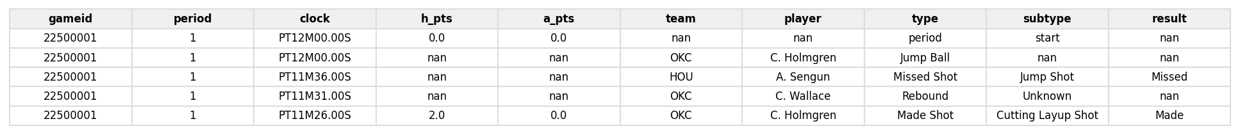
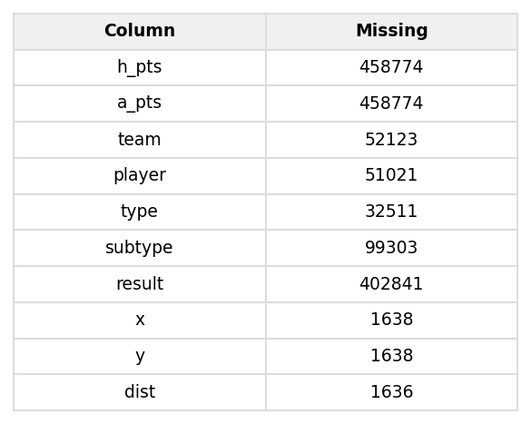
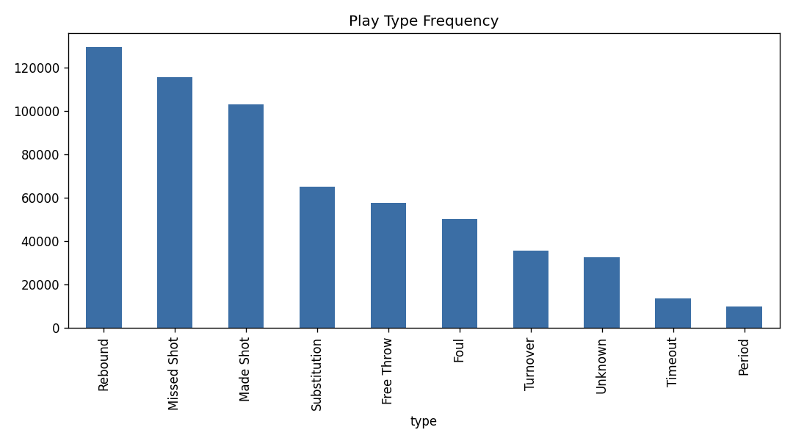
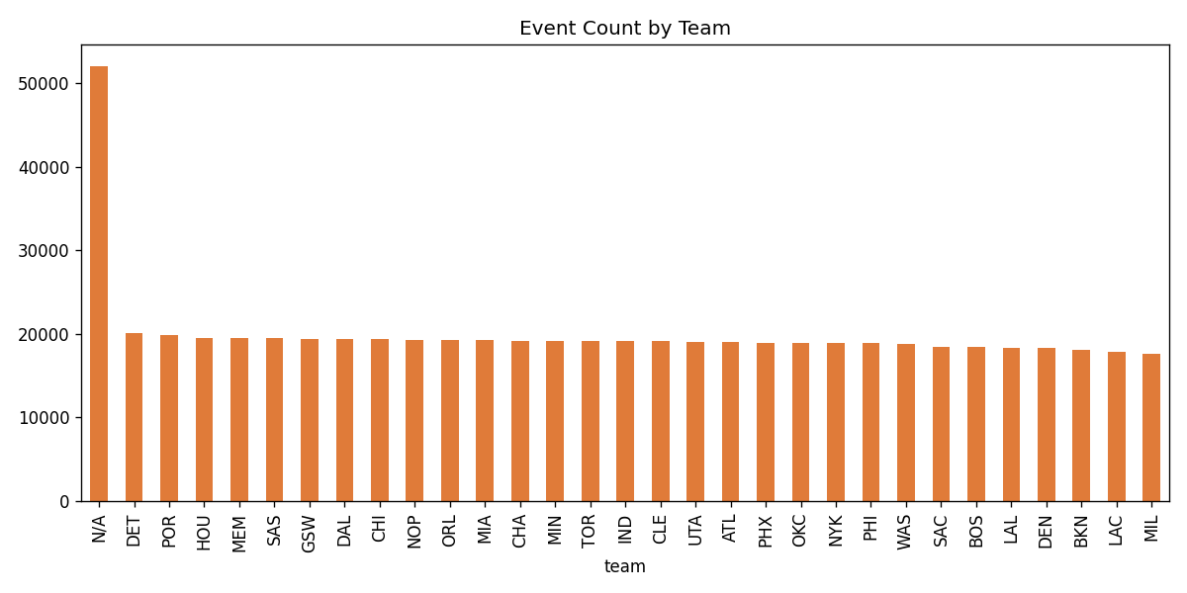
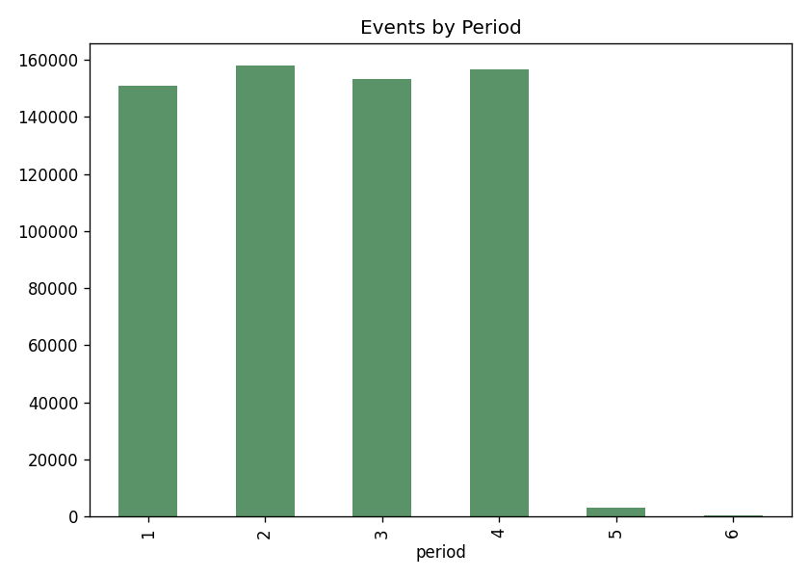
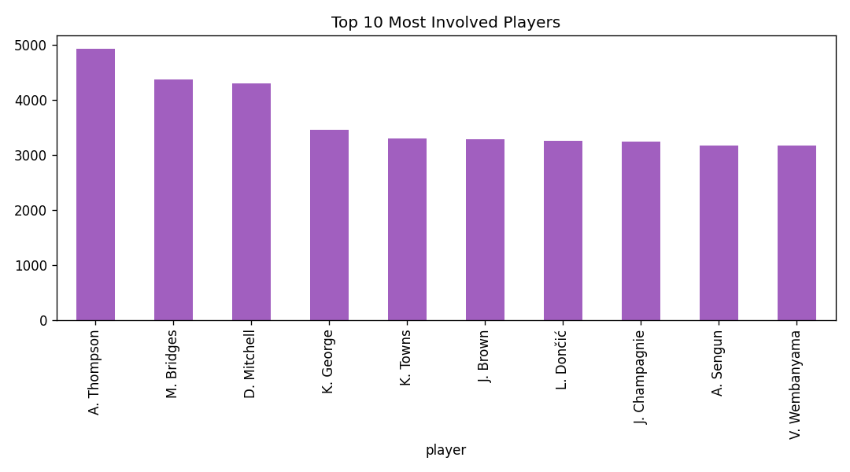
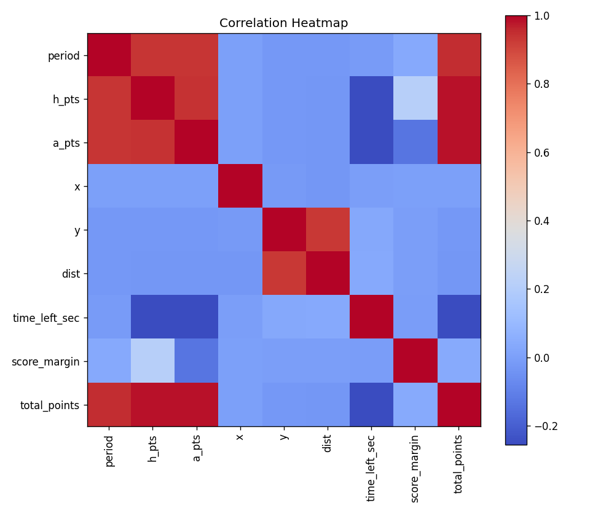
Result:
Exploratory Data Analysis and data cleaning were successfully performed on the NBA play-by-play dataset (622,189 rows × 16 columns, covering 1,230 games and 31 team codes for the 2025–26 season) using the CRISP-DM, SEMMA, and KDD frameworks. 159 duplicate rows were removed, inconsistent categorical text in the type and subtype columns was standardized, and missing values in team, player, type, and shot-location fields were imputed. New features — time_left_sec, score_margin, and total_points — were engineered from the clock and running-score columns. Frequency analysis showed Rebounds, Missed Shots, and Made Shots as the most common play types, event volume was fairly even across teams, and the correlation heatmap revealed a strong positive relationship between period progression and cumulative score, along with an expected negative relationship between period and time remaining on the clock.

