Ex.no:6 | DATA VISUALIZATION USING POWER BI (HOTEL BOOKING)

To clean, preprocess, and transform the player_summary_top30_2026.csv and team_summary_2026.csv datasets, load the clean data model into Power BI, and build an interactive visual dashboard to analyze player scoring, team performance, rebounds, and shooting metrics.
Algorithm:
Import Dataset: Load player_summary_top30_2026.csv and team_summary_2026.csv into Power BI.
- Deduplication: Identify and delete duplicate rows across all fields in both datasets.
- Missing Value Validation: Check critical fields such as Player, Team, Points, Rebounds, Games, and shooting percentages for null values.
- Data Quality Check: The supplied player and team datasets contain no duplicate rows and no missing/null values.
- Impute Missing Values: If future records contain missing numeric metrics, replace them with an appropriate value such as 0 or a suitable statistic after validation.
Handle Data Type & Syntax Errors:
Ensure Points, Rebounds, Turnovers, Fouls, Games, FGM, FGA, ThreePM, and ThreePA are Whole Number fields.
Format PPG, FG_Pct, and ThreeP_Pct as Decimal Number fields.
- Ensure Player and Team are stored as Text fields.
Load Clean Data: Load the validated tables into Power BI Desktop via Get Data > Text/CSV and Apply & Close from Power Query Editor.
Create Core Metrics:
- Right-click the player table and select New Measure.

- Define measure: Total Players = COUNTROWS(player_summary_top30_2026).
The supplied player dataset contains 30 player records, while the team dataset contains 30 team records.$→$

Output:
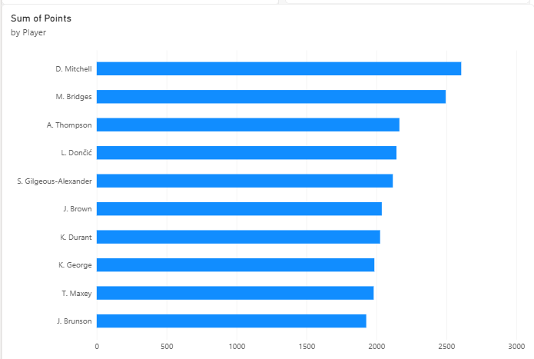
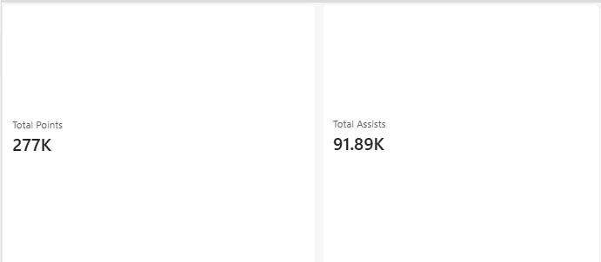

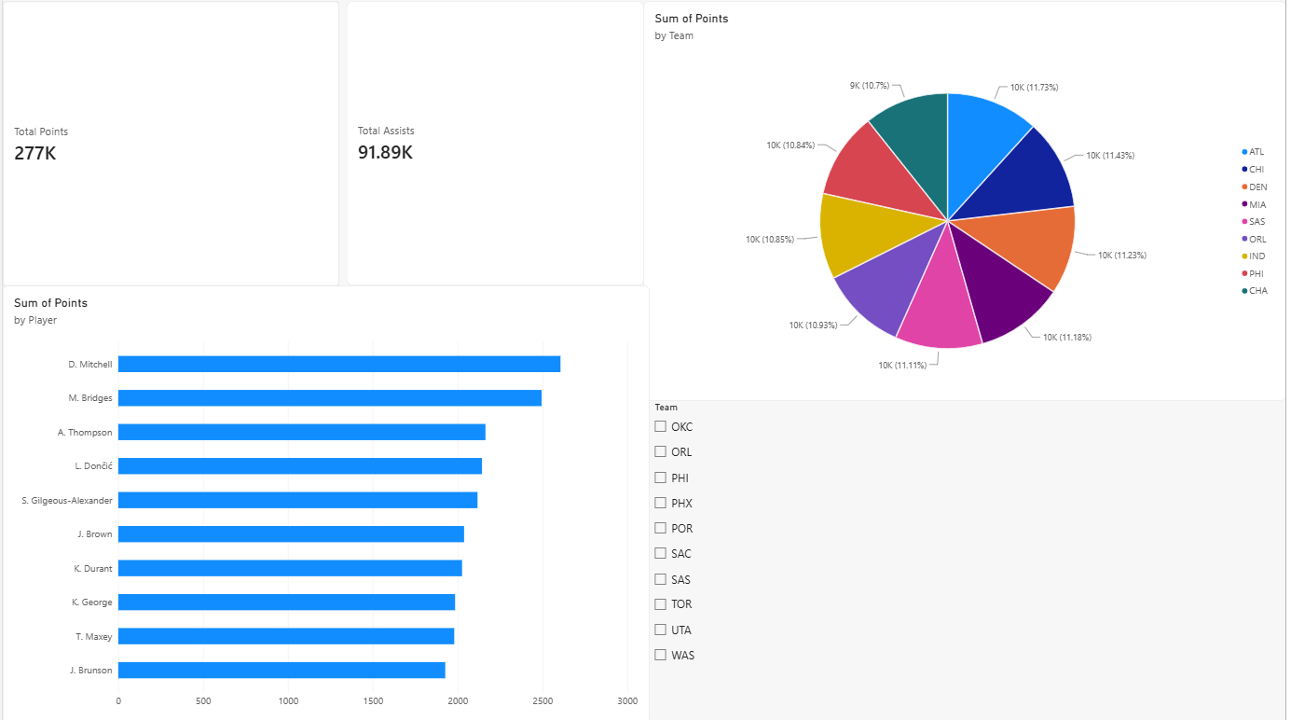

Result:

