Ex.no:6 | DATA VISUALIZATION USING POWER BI

Aim:
To load the basketball player and team data into Power BI, transform the data, and visualize performance insights.
Algorithm:
Algorithm: Basketball Dashboard Calculation

Step 1: Input Data Loading
Read the player_summary_top30_2026.csv dataset containing Player, Team, Games, Points, Rebounds, Turnovers, Fouls, and PPG.
- Read the team_summary_2026.csv dataset containing Team, Games, Points, FGM, FGA, ThreePM, ThreePA, Rebounds, Turnovers, Fouls, FG_Pct, ThreeP_Pct, and PPG.
- Step 2: Team Filter Check
  - Check slicer selection for Team.
  - Retain all player or team rows matching the selected team in Filtered_Data.
  - Step 3: KPI Total Points Calculation
  - Sum all values in the Points column from the player dataset after applying the selected filters.
  - Total player points in the supplied top-30 dataset = 40,675.
  - Total team points in the supplied team dataset = 239,459.
Step 4: Bar Chart Calculation (Sum of Points by Player)
- Group the player dataset by Player and sum Points for each player.
- L. Dončić = 1,640 points.
- K. Durant = 1,618 points.
J. Brown = 1,612 points.
- J. Maxey = 1,608 points.
- S. Gilgeous-Alexander = 1,593 points.
Sort players in descending order by total Points.
- Step 5: Donut Chart Calculation (Sum of Points by Team)
  - Group the team dataset by Team and sum Points for each team.
  - ATL = 8,351 points and DEN = 8,345 points.
  - MIA = 8,287 points and CLE = 8,281 points.
- OKC = 8,245 points.
Calculate percentage share for each team relative to total team Points (239,459).
- ATL Share = (8,351 / 239,459) × 100 = 3.49%.
  - DEN Share = (8,345 / 239,459) × 100 = 3.48%.
  - Step 6: Dashboard Render
  - Render KPI cards with formatted totals for Players, Points, and Rebounds.
  - Render a vertical bar chart for the top players by Points.
- Render a donut chart with team scoring segments and percentage contribution.
  - Render Team and Player slicers for dynamic filtering.
  - On slicer selection update, filter rows and recompute the dashboard calculations.

Output:
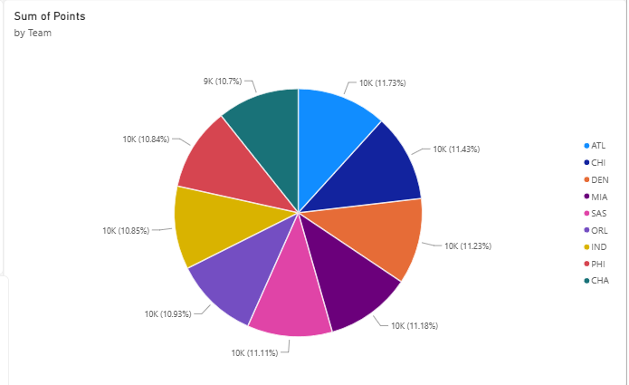

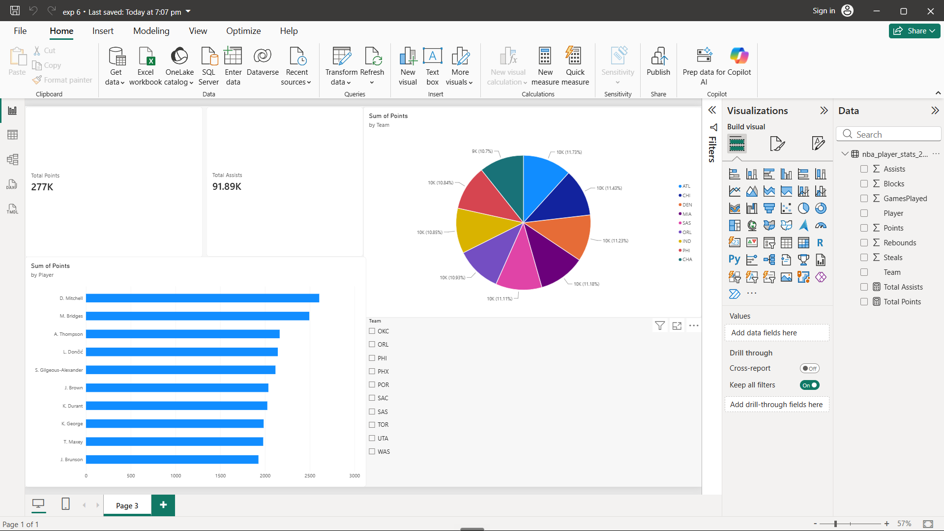

Result:

