Ex.no:6 | DATA VISUALIZATION USING POWER BI (ADVANCED SALES ANALYTICS)

Aim:
To load the basketball player and team datasets into Power BI, transform the data, and visualize player and team performance insights.
Algorithm:
Algorithm 1: Importing Data into Power BI
Step 1
Open Power BI Desktop
Step 2
Select:
Home → Get Data
Step 3
Choose Text/CSV
Step 4
Browse player_summary_top30_2026.csv and team_summary_2026.csv
Step 5
Click Load or Transform Data
Step 6
Verify the imported fields and table names
Algorithm 2: Data Transformation using Power Query
Step 1
Select Transform Data
Step 2
Open Power Query Editor
Step 3
Remove duplicate rows from both tables
Step 4
Check null values in Player, Team, Points, Rebounds, Games, and shooting metric columns
Step 5
Rename columns if required and standardize text fields such as Player and Team
Step 6
Apply changes & Close

Algorithm 3: Data Type Validation & Numeric Transformation
Step 1
Select the numeric performance columns and verify their data types
Step 2
Set Games, Points, Rebounds, Turnovers, Fouls, FGM, FGA, ThreePM, and ThreePA as Whole Number
Step 3
Set PPG, FG_Pct, and ThreeP_Pct as Decimal Number
Step 4
Verify that Player and Team are Text fields
Step 5
Check for invalid or missing numeric values before loading the model
Step 6
Click Close & Apply to load the clean dataset into the model

Algorithm 4: Creating Calculated Metric (PPG Check)
Step 1
Navigate to Report View or Table View
Step 2
Right-click the player table and select New Column
Step 3
Enter the calculated metric formula: PPG_Check = DIVIDE([Points],[Games])
Step 4
Press Enter to validate and compute values

Algorithm 5: Dashboard Visualization & Reporting
Step 1
Select a Bar Chart and map Player (X-axis) and Points (Y-axis)
Step 2
Select a Column Chart and map Team (X-axis) and Points (Y-axis)
Step 3
$$\text{Revenue}=\left[Quantity\right]×\left[UnitPrice\right]×\left(1-\left(\text{if }\left[Discount\right]=\text{null then }0\text{ else }\left[Discount\right]\right)\right)$$
Select a Donut Chart to break down team Points contribution
Step 4
Add Slicer visuals for Team and Player to enable interactive filtering
Step 5
Add KPI cards for Total Players, Total Points, and Total Rebounds
Step 6
Save the Power BI file (.pbix)

Output:
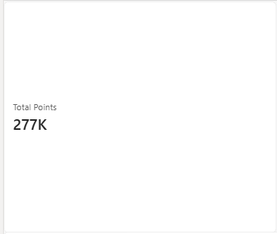
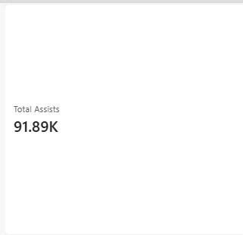
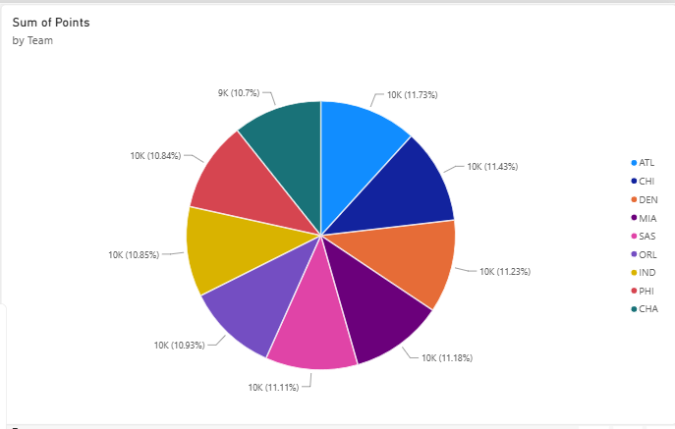
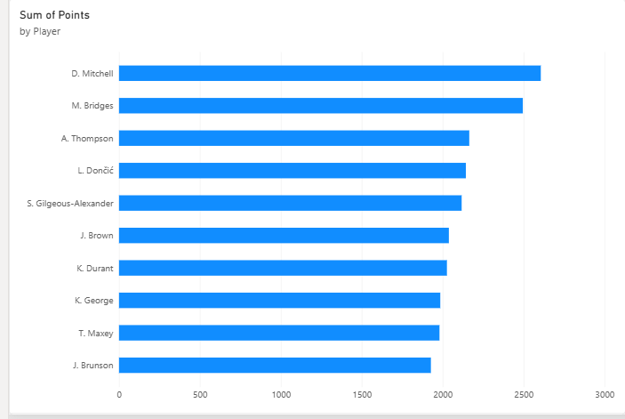
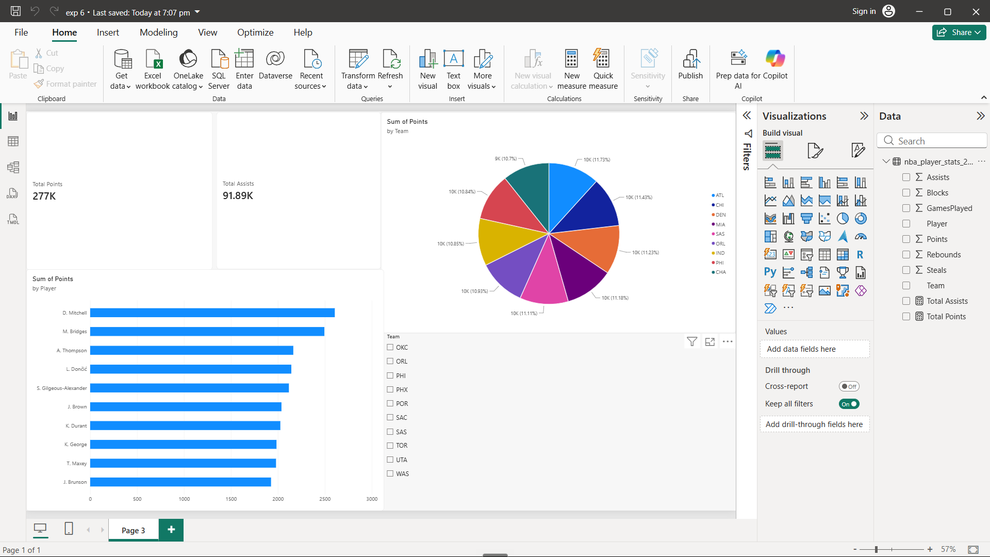

Result:

