EXPERIMENT 3
EXPLORATORY DATA ANALYSIS (EDA) – DATA CLEANING AND DATA TRANSFORMATION

Aim
To identify and handle missing values, duplicate records, outliers, inconsistent data, and perform data transformation techniques such as normalization and encoding using Python Pandas.

Software Requirements
- Python 3.x
- Jupyter Notebook
- Pandas
- NumPy
- Scikit-Learn
- Matplotlib

Theory
Real-world datasets often contain:
- Missing Values
- Duplicate Records
- Incorrect Data Types
- Outliers
- Inconsistent Formatting
Data cleaning improves data quality and increases the accuracy of analytical models.
Data transformation converts data into suitable formats for analysis and machine learning.

Learning Outcomes
After completing this experiment students will be able to:
✓ Detect missing values
✓ Handle null values
✓ Remove duplicates
✓ Identify outliers
✓ Normalize data
✓ Encode categorical variables
✓ Prepare datasets for analytics

Sample Dataset
Employee Dataset
EmpID | Name | Age | Salary | Department
101 | Arun | 25 | 25000 | HR
102 | Bala | NaN | 30000 | IT
103 | Divya | 28 | NaN | HR
104 | Priya | 25 | 25000 | HR
104 | Priya | 25 | 25000 | HR
105 | Ravi | 60 | 150000 | Finance

Algorithm 1
Identifying Missing Values
Step 1
Import pandas library
Step 2
Load dataset
Step 3
Use isnull() function
Step 4
Count missing values
Step 5
Display result

Program 1
import pandas as pd
df = pd.read_csv("employee.csv")
print(df.isnull())

Output
EmpID | Name | Age | Salary | Department
False | False | False | False | False
False | False | True | False | False
False | False | False | True | False
False | False | False | False | False
False | False | False | False | False
False | False | False | False | False

Program 2
Count Missing Values
print(df.isnull().sum())

Output
Column | Missing Values
EmpID | 0
Name | 0
Age | 1
Salary | 1
Department | 0

Algorithm 2
Replacing Missing Values
Step 1
Calculate mean value
Step 2
Replace null values
Step 3
Verify replacement

Program 3
df["Age"].fillna(df["Age"].mean(), inplace=True)
df["Salary"].fillna(df["Salary"].mean(), inplace=True)
print(df)

Output
EmpID | Name | Age | Salary | Department
101 | Arun | 25 | 25000 | HR
102 | Bala | 32.6 | 30000 | IT
103 | Divya | 28 | 51000 | HR
104 | Priya | 25 | 25000 | HR
104 | Priya | 25 | 25000 | HR
105 | Ravi | 60 | 150000 | Finance

Algorithm 3
Removing Duplicate Records
Step 1
Use duplicated()
Step 2
Count duplicate records
Step 3
Remove duplicates
Step 4
Verify dataset

Program 4
print(df.duplicated())
df.drop_duplicates(inplace=True)
print(df)

Output
Before Removal
Record Number | Duplicate
1 | False
2 | False
3 | False
4 | False
5 | True
6 | False
After Removal
Total Records
5

Algorithm 4
Detecting Outliers
Step 1
Calculate Quartiles
Step 2
Compute IQR
Step 3
Calculate lower and upper limits
Step 4
Identify outliers

Formula
Inter Quartile Range
$$IQR=Q_{3}-Q_{1}$$
Outlier Limits
Lower Limit = Q₁ − 1.5 × IQR
Upper Limit = Q₃ + 1.5 × IQR

Program 5
Q1 = df['Salary'].quantile(0.25)
Q3 = df['Salary'].quantile(0.75)
IQR = Q3 - Q1
lower = Q1 - 1.5*IQR
upper = Q3 + 1.5*IQR
outliers = df[(df['Salary'] < lower) |
(df['Salary'] > upper)]
print(outliers)

Output
EmpID | Name | Salary
105 | Ravi | 150000

Visualization of Outlier
Employee Salary Analysis
Salary distribution showing potential Outlier.
Algorithm 5
Normalization
Purpose
Convert numerical values into a common scale.
Formula
$$X_{norm}=\frac{X-X_{min}}{X_{max}-X_{min}}$$

Program 6
from sklearn.preprocessing import MinMaxScaler
scaler = MinMaxScaler()
df[['Salary']] = scaler.fit_transform(df[['Salary']])
print(df[['Salary']])

Output
Salary
0.00
0.04
0.21
0.00
1.00

Algorithm 6
Label Encoding
Purpose
Convert categorical data into numerical format.

Program 7
from sklearn.preprocessing import LabelEncoder
encoder = LabelEncoder()
df['Department'] = encoder.fit_transform(df['Department'])
print(df)

Output
Department | Encoded Value
Finance | 0
HR | 1
IT | 2

Program 8
One-Hot Encoding
pd.get_dummies(df['Department'])

Output
Finance | HR | IT
0 | 1 | 0
0 | 0 | 1
0 | 1 | 0
0 | 1 | 0
1 | 0 | 0

Data Transformation Summary
Technique | Purpose
Fill Missing Values | Handle null data
Drop Duplicates | Remove redundancy
Outlier Detection | Improve data quality
Normalization | Scale data
Label Encoding | Convert categories
One-Hot Encoding | Binary representation

Applications
Healthcare
Cleaning patient records
Banking
Removing duplicate transactions
Education
Student performance analysis
Retail
Sales data preprocessing
Social Media
User behavior analysis

Advantages
- Improves Data Quality
- Increases Model Accuracy
- Reduces Errors
- Removes Noise
- Enables Better Analytics

Viva Questions
1. What is Data Cleaning?
The process of correcting inaccurate or incomplete data.
2. What are Missing Values?
Values that are absent from the dataset.
3. What is the purpose of fillna()?
To replace missing values.
4. What is a duplicate record?
A repeated row in a dataset.
5. Which function removes duplicates?
drop_duplicates()
6. What is an outlier?
An observation significantly different from others.
7. What is normalization?
Scaling numerical values to a standard range.
8. What is Min-Max Scaling?
A normalization technique that converts values between 0 and 1.
9. What is Label Encoding?
Converting categorical values into numeric labels.
10. What is One-Hot Encoding?
Representing categories as binary columns.
11. Why is data cleaning important?
To improve the quality and reliability of data analysis.
12. Which library provides MinMaxScaler?
Scikit-Learn.

Result
Thus, missing values, duplicate records, and outliers were identified and handled successfully. Data transformation techniques such as normalization and encoding were performed, and the dataset was prepared for further exploratory data analysis and machine learning applications.

EXPERIMENT 4
EXPLORATORY DATA ANALYSIS (EDA) – DATA INSPECTION, FILTERING, STATISTICAL ANALYSIS AND CORRELATION

Aim
To perform data inspection, filtering, grouping, aggregation, descriptive statistical analysis, and correlation analysis using Pandas and visualize the results using Matplotlib.

Software Requirements
- Python 3.x
- Jupyter Notebook
- Pandas
- NumPy
- Matplotlib

Theory
Data Inspection is the process of understanding the structure, content, and quality of a dataset before performing advanced analytics.
Statistical analysis helps in understanding:
- Distribution of data
- Central tendency
- Variability
- Relationships among variables
EDA provides meaningful insights that help in decision making and predictive analytics.

Learning Outcomes
After completing this experiment, students will be able to:
✓ Inspect datasets
✓ Filter records
✓ Sort data
✓ Group data
✓ Calculate statistical measures
✓ Find correlations
✓ Visualize analytical results

Sample Dataset
Student Performance Dataset
Roll No | Name | Department | Marks | Attendance
101 | Arun | CSE | 85 | 92
102 | Bala | IT | 78 | 88
103 | Divya | CSE | 95 | 96
104 | Priya | AI&DS | 90 | 94
105 | Ravi | IT | 72 | 85
106 | Karthik | AI&DS | 88 | 91

Algorithm 1
Dataset Inspection
Step 1
Import dataset
Step 2
Display dataset
Step 3
Check dimensions
Step 4
Display data types
Step 5
Generate summary

Program 1
import pandas as pd
df = pd.read_csv("student.csv")
print(df.head())

Output
Roll No | Name | Department | Marks | Attendance
101 | Arun | CSE | 85 | 92
102 | Bala | IT | 78 | 88
103 | Divya | CSE | 95 | 96
104 | Priya | AI&DS | 90 | 94
105 | Ravi | IT | 72 | 85

Program 2
Shape of Dataset
print(df.shape)

Output
(6,5)
Meaning:
- 6 Rows
- 5 Columns

Program 3
Data Types
print(df.dtypes)

Output
Column | Type
Roll No | int64
Name | object
Department | object
Marks | int64
Attendance | int64

Algorithm 2
Filtering Data
Step 1
Specify condition
Step 2
Apply filter
Step 3
Display records

Program 4
Students Scoring More Than 85
high_marks = df[df["Marks"] > 85]
print(high_marks)

Output
Roll No | Name | Marks
103 | Divya | 95
104 | Priya | 90
106 | Karthik | 88

Program 5
Students from IT Department
it_students = df[df["Department"]=="IT"]
print(it_students)

Output
Roll No | Name | Department
102 | Bala | IT
105 | Ravi | IT

Algorithm 3
Sorting Data
Step 1
Select column
Step 2
Apply sort_values()
Step 3
Display sorted result

Program 6
Sort Marks in Descending Order
sorted_df = df.sort_values(
by="Marks",
ascending=False
)
print(sorted_df)

Output
Name | Marks
Divya | 95
Priya | 90
Karthik | 88
Arun | 85
Bala | 78
Ravi | 72

Visualization
Student Marks Ranking
Student Marks Ranking
Marks obtained by students sorted in descending order.
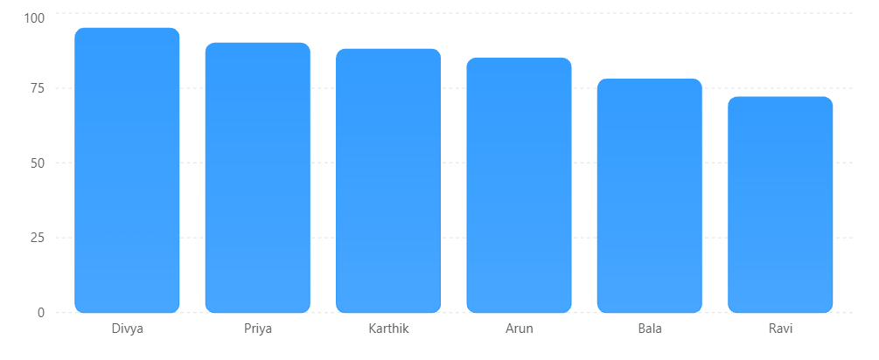
Algorithm 4
Statistical Analysis
Step 1
Select numerical column
Step 2
Calculate Mean
Step 3
Calculate Median
Step 4
Calculate Mode
Step 5
Calculate Standard Deviation

Program 7
print("Mean =",
df["Marks"].mean())
print("Median =",
df["Marks"].median())
print("Mode =",
df["Marks"].mode())
print("Standard Deviation =",
df["Marks"].std())

Output
Statistic | Value
Mean | 84.67
Median | 86.5
Mode | No Repetition
Standard Deviation | 8.52

Important Formula
Mean
$$\overset{ˉ}{x}=\frac{∑x}{n}$$

Program 8
Descriptive Statistics
print(df.describe())

Output
Statistic | Marks
Count | 6
Mean | 84.67
Std | 8.52
Min | 72
25% | 79.75
50% | 86.5
75% | 89.5
Max | 95

Algorithm 5
Grouping and Aggregation
Step 1
Select Department Column
Step 2
Apply groupby()
Step 3
Calculate Average Marks
Step 4
Display Result

Program 9
dept_avg = df.groupby(
"Department"
)["Marks"].mean()
print(dept_avg)

Output
Department | Average Marks
AI&DS | 89
CSE | 90
IT | 75

Visualization
Department-wise Average Marks
Department Average Marks
Average marks obtained by students in each department.
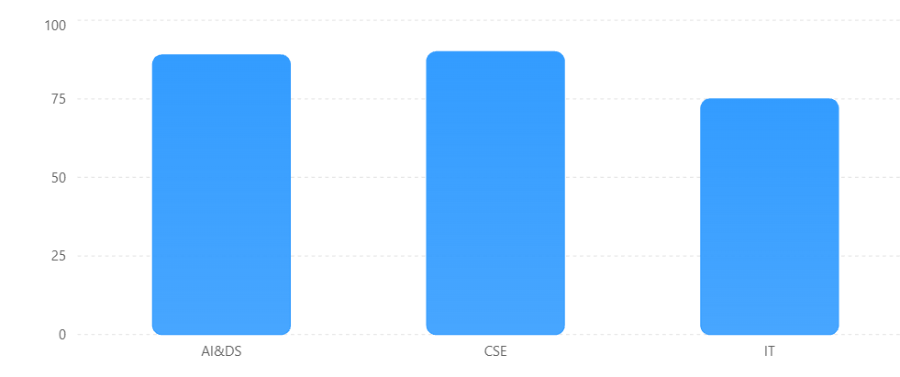

Algorithm 6
Correlation Analysis
Step 1
Select numerical columns
Step 2
Apply corr()
Step 3
Interpret correlation coefficient

Program 10
corr = df[[
"Marks",
"Attendance"
]].corr()
print(corr)

Output
 | Marks | Attendance
Marks | 1.00 | 0.95
Attendance | 0.95 | 1.00

Interpretation
Correlation = 0.95
This indicates:
✓ Strong Positive Correlation
✓ Higher Attendance → Higher Marks

Visualization
Marks vs Attendance Relationship
Marks vs Attendance
Relationship between attendance percentage and marks scored.
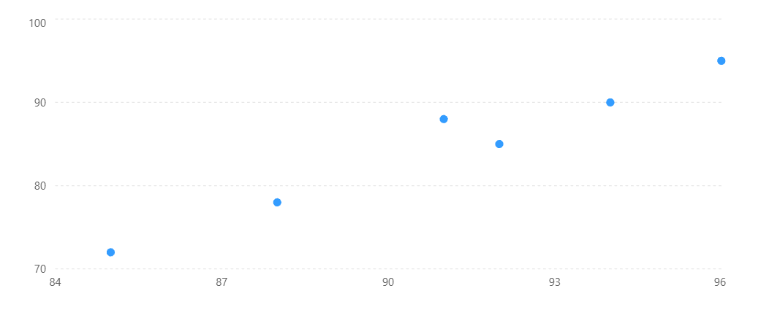

Applications
Education
Student Performance Analysis
Healthcare
Patient Health Monitoring
Banking
Customer Transaction Analysis
Retail
Sales Performance Evaluation
Social Media
User Engagement Analysis

Advantages
- Better Understanding of Data
- Improved Decision Making
- Trend Identification
- Relationship Discovery
- Enhanced Predictive Modeling

Viva Questions
1. What is EDA?
EDA is the process of analyzing and summarizing datasets.
2. Which function displays dataset dimensions?
shape
3. Which function gives statistical summary?
describe()
4. What is filtering?
Selecting records based on conditions.
5. Which function sorts data?
sort_values()
6. What is grouping?
Combining records with similar values.
7. Which function performs grouping?
groupby()
8. What is correlation?
A measure of relationship between variables.
9. What does correlation value +1 indicate?
Perfect positive relationship.
10. What does correlation value 0 indicate?
No relationship.
11. What is mean?
Average of values.
12. What is standard deviation?
Measure of dispersion from the mean.
13. Why is EDA important?
To understand data before modeling.
14. Which library is used for data analysis?
Pandas.
15. Which library is used for visualization?
Matplotlib.

Result
Thus, data inspection, filtering, sorting, descriptive statistical analysis, grouping, aggregation, and correlation analysis were successfully performed using Pandas. The analytical results were visualized and interpreted successfully.

