CB23731-DATA VISUALIZATION TECHNIQUES LAB MANUAL

EXPERIMENT 1
SETTING UP PYTHON ENVIRONMENT AND LIBRARIES – JUPYTER NOTEBOOK

Aim
To install Python, configure Jupyter Notebook, understand the notebook environment, execute Python programs, create Markdown cells, and use basic Jupyter Notebook features for Data Analytics applications.

Software Requirements
- Python 3.11 or above
- Jupyter Notebook
- Anaconda Distribution (Optional)
- Web Browser (Chrome/Edge/Firefox)

Theory
Python is a high-level, interpreted programming language widely used in Data Analytics, Machine Learning, Artificial Intelligence, Scientific Computing, and Data Visualization.
Jupyter Notebook is an open-source web-based interactive computing platform that enables users to create and share documents containing:
- Live Code
- Equations
- Visualizations
- Narrative Text
Jupyter Notebook supports multiple programming languages, but Python is the most commonly used.

Features of Jupyter Notebook
- Interactive Computing
- Real-Time Code Execution
- Data Visualization
- Markdown Documentation
- Export to PDF and HTML
- Integration with AI and Widgets

Applications
  - Data Analysis
  - Machine Learning
  - Deep Learning
  - Statistical Analysis
  - Scientific Research

Algorithm
Algorithm 1: Installing Python
Step 1: Download Python from python.org Step 2: Run the installer
Step 3: Select "Add Python to PATH" Step 4: Click Install Now
Step 5: Verify installation using: python --version
Step 6: Observe installed Python version.

Algorithm 2: Installing Jupyter Notebook
Step 1: Open Command Prompt Step 2: Install Jupyter
pip install notebook
Step 3: Launch Jupyter Notebook jupyter notebook
Step 4: Browser automatically opens Notebook Dashboard.

Algorithm 3: Creating a Notebook Step 1: Open Jupyter Dashboard Step 2: Select New → Python 3 Step 3: Create Notebook
Step 4: Rename Notebook
Step 5: Create Code and Markdown Cells

Step 6: Execute cells using Shift + Enter

Program 1
Simple Python Program
print("Welcome to Data Analytics Lab")

Output
Welcome to Data Analytics Lab

Program 2
Arithmetic Operations
a = 20
b = 10

print("Addition =",a+b) print("Subtraction =",a-b) print("Multiplication =",a*b) print("Division =",a/b)

Output
Addition = 30
Subtraction = 10
Multiplication = 200
Division = 2.0

Program 3
Display Student Details
name = "John" dept = "AI&DS" cgpa = 8.9

print("Name:",name) print("Department:",dept) print("CGPA:",cgpa)

Output
Name: John Department: AI&DS CGPA: 8.

Program 4
Creating Markdown Cell
Type the following in Markdown Cell: # Data Analytics Lab
## Experiment 1

### Jupyter Notebook

Output
Rendered Output: Data Analytics Lab Experiment 1 Jupyter Notebook

Program 5
Using NumPy Library
import numpy as np
a = np.array([10,20,30,40,50])
print(a)
print("Mean =",np.mean(a))
print("Sum =",np.sum(a))

Output
[10 20 30 40 50]
Mean = 30.0
Sum = 150

Program 6
Using Pandas Library
import pandas as pd
data = {
'Name':['John','David','Alex'], 'Marks':[85,90,95]
}

df = pd.DataFrame(data) print(df)
Output Name Marks John 85
David 90
Alex 95

Program 7
Data Visualization
import matplotlib.pyplot as plt x=[1,2,3,4,5]
y=[10,20,15,25,30]

plt.plot(x,y)
plt.title("Sample Line Graph") plt.xlabel("X Axis") plt.ylabel("Y Axis") plt.show()

Output Visualization
Expected Graph:
Sample Line Graph
Line graph generated using Matplotlib.
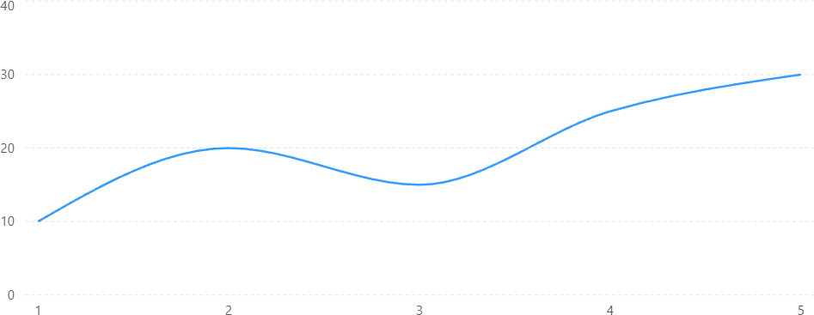

Advantages
- Easy to Learn
- Interactive Programming
- Supports Visualization
- Open Source
- Widely Used in Industry

Applications in Data Analytics
  - Data Cleaning
  - Data Transformation
  - Data Visualization
  - Machine Learning
  - Statistical Analysis
  - Predictive Analytics

Precautions
- Save notebook frequently.
- Use meaningful file names.
- Restart Kernel when necessary.
- Verify library installation before execution.

Viva Questions
- What is Python?
Python is a high-level programming language used for analytics and AI.
- What Is Jupyter Notebook?
An interactive environment for coding and documentation.
- What is a Kernel?
A computational engine that executes notebook code.

What is Markdown?
A lightweight markup language used for formatting text.

What is NumPy?
A library used for numerical computing.

What is Pandas?
A library used for data manipulation and analysis.

What is Matplotlib?
A library used for data visualization.

What is the shortcut to execute a cell?
Shift + Enter.

Why is Jupyter popular in Data Analytics?
It supports code, visualization, and documentation in a single environment.

What is the extension of a notebook file?
.ipynb

EXPERIMENT 2
EXPLORATORY DATA ANALYSIS (EDA) – DATA IMPORT AND EXPORT

Aim
To import data from various sources such as CSV, Excel, SQL, and Web, perform basic inspection using Pandas, and export the processed data into different file formats.

Software Requirements
- Python 3.x
- Jupyter Notebook
- Pandas Library
- OpenPyXL Library
- SQLite Database
- Internet Connection (for Web Data)

Theory
Data Import and Export is the first step in Exploratory Data Analysis (EDA). Real-world data is stored in different formats such as:
- CSV Files
- Excel Files
- SQL Databases
- JSON Files
- Web APIs
Pandas provides powerful functions to load and save data efficiently.
Common Data Sources Source File Type Spreadsheet .xlsx
CSV .csv
Database SQL Web API JSON
Text File .txt

Learning Outcomes
After completing this experiment, students will be able to:
- Import CSV files
- Import Excel files
- Read data from SQL databases
- Import data from Web URLs
- Export DataFrames to CSV and Excel
- Inspect imported datasets

Algorithm 1: Importing CSV File Step 1
Import Pandas library

Step 2
Load CSV file using read_csv()

Step 3
Display first few records

Step 4
Check data structure

Step 5
Analyze imported data

Program 1 Reading CSV File
Sample Dataset: student.csv

RollNo Name Marks
- Arun 85
- Bala 90
- Divya 95
- Priya 88
- Ravi 92
import pandas as pd

df = pd.read_csv('student.csv') print(df)

Output
RollNo Name Marks
- Arun 85
- Bala 90
- Divya 95
- Priya 88
- Ravi 92

Program 2
Display First Five Records
print(df.head())

Output
RollNo Name Marks
- Arun 85
- Bala 90
- Divya 95
- Priya 88
- Ravi 92

Program 3
Display Dataset Information
print(df.info())

Output
<class 'pandas.core.frame.DataFrame'> RangeIndex: 5 entries, 0 to 4

Data columns: RollNo int64 Name object Marks int64

memory usage: 252 bytes

Program 4 Statistical Summary print(df.describe())

Output
Statistics RollNo Marks

Count | 5 | 5
Mean | 103 | 90
Std | 1.58 | 3.81
Min | 101 | 85
Max | 105 | 95

Algorithm 2: Importing Excel File Step 1
Create Excel file

Step 2
Use read_excel()

Step 3
Display records

Step 4
Verify imported data

Program 5
import pandas as pd
df = pd.read_excel('student.xlsx') print(df)

Output
RollNo Name Marks
- Arun 85
- Bala 90
- Divya 95
- Priya 88
- Ravi 92

Algorithm 3:

Importing SQL Data

Step 1
Create SQLite Database

Step 2
Insert records

Step 3
Retrieve records using SQL Query

Program 6
import sqlite3 import pandas as pd

conn = sqlite3.connect('student.db') query = "SELECT * FROM students" df = pd.read_sql(query, conn) print(df)

Output
RollNo Name Marks
- Arun 85
- Bala 90
- Divya 95
- Priya 88
- Ravi 92

Algorithm 4: Importing Data from Web

Step 1
Specify URL

Step 2
Load data using read_csv()

Step 3
Display imported records

Program 7
url = "student_data.csv" df = pd.read_csv(url) print(df.head())

Output
RollNo Name Marks
- Arun 85
- Bala 90
- Divya 95
- Priya 88
- Ravi 92

Data Export
Pandas allows exporting data into:

Format Function CSV to_csv() Excel to_excel() JSON to_json() SQL to_sql()

Program 8 Export to CSV
df.to_csv('output.csv', index=False) print("CSV File Exported")

Output
CSV File Exported

Program 9 Export to Excel
df.to_excel('output.xlsx', index=False) print("Excel File Exported")

Output
Excel File Exported

Program 10 Export to JSON
df.to_json('output.json') print("JSON File Exported")

Output
JSON File Exported

Visualization of Imported Data
Student Marks Dataset
Student Marks Analysis
Marks obtained by students after importing data from CSV.
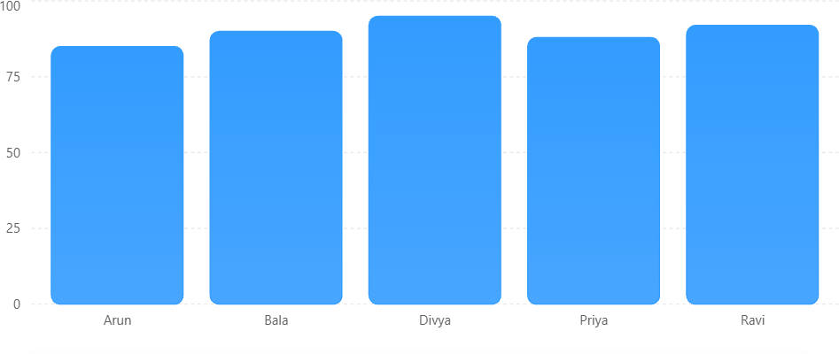

Applications Healthcare
Patient Records Import

Banking
Transaction Data Analysis

Education
Student Performance Analysis

Retail
Sales Data Analytics

Social Media
User Engagement Analysis

Advantages of Pandas Import Functions
  - Fast Processing
  - Supports Multiple Formats
  - Easy Data Manipulation
  - Handles Large Datasets
  - Integration with Visualization Tools

Viva Questions
- What is Pandas?
Pandas is a Python library used for data manipulation and analysis.
- Which function is used to read CSV files?
read_csv()
- Which function is used to read Excel files?
read_excel()
- What is a DataFrame?
A two-dimensional labeled data structure in Pandas.
- Which function exports data to CSV?
to_csv()
- Which function exports data to Excel?
to_excel()

Which function gives statistical summary?
describe()

Which function displays first records?
head()

Which library is used to connect SQL databases?
sqlite3

Why is data import important?
It enables analysis of data from different sources.

Precautions
  - Verify file paths before importing.
  - Check file format compatibility.
  - Handle missing values after import.
  - Validate imported records.
  - Use correct delimiters for CSV files.

Result
Thus, data was successfully imported from CSV, Excel, SQL, and Web sources using Pandas, and exported into different formats. The imported data was analyzed and visualized successfully.

