Ex.no:5 | DATA VISUALIZATION USING MATPLOTLIB – NBA PLAY-BY-PLAY DATA

Aim:
To visualize dataset features and distributions using line charts, bar charts, pie charts, histograms, scatter plots, and box plots on the NBA play-by-play dataset (pbp2026.csv) using Matplotlib.
ALGORITHM 1: LINE CHART
Objective: To visualize the total points scored across different periods of play.
Steps
1. Load the NBA play-by-play dataset.
2. Derive points_scored for each play (2/3-point field goals and free throws made).
3. Sum points_scored for each period and arrange periods in chronological order.
4. Plot the period-wise point totals using a line chart.
5. Add title and axis labels.
6. Display the graph.
Interpretation
The line chart shows how total scoring volume changes as a game progresses through regulation periods and any overtimes, and helps identify periods with unusually high or low scoring.
periods_order = [1, 2, 3, 4, 5, 6]
pts_by_period = df.groupby("period")["points_scored"].sum()
pts_by_period = pts_by_period.reindex(periods_order).fillna(0)

plt.figure(figsize=(10,5))
plt.plot([str(p) for p in periods_order], pts_by_period.values, marker="o")
plt.title("Total Points Scored by Period")
plt.xlabel("Period")
plt.ylabel("Total Points Scored")
plt.grid(True)
plt.show()
ALGORITHM 2: BAR CHART
Objective: To compare the number of made shots across different teams.
Steps
1. Select the rows where type equals “Made Shot”.
2. Count the number of made shots for each team.
3. Create a bar chart using the team codes and their made-shot counts.
4. Add title and axis labels.
5. Display the chart.
Interpretation
The bar chart provides a comparison of shot-making volume between the different teams in the dataset.
made_by_team = df[df["type"] == "Made Shot"]["team"].value_counts()

plt.figure(figsize=(11,5))
plt.bar(made_by_team.index, made_by_team.values)
plt.title("Made Shots by Team")
plt.xlabel("Team")
plt.ylabel("Number of Made Shots")
plt.xticks(rotation=90)
plt.show()
ALGORITHM 3: PIE CHART
Objective: To visualize the distribution of different play types.
Steps
1. Select the type column.
2. Count the occurrences of each play type.
3. Keep the top 5 play types and group the rest into an “Other” category.
4. Create a pie chart.
5. Display percentage labels.
6. Add a suitable title.
Interpretation
The pie chart shows the percentage contribution of each play type to the total number of recorded events.
type_counts = df["type"].value_counts()
top5 = type_counts.head(5)
other = type_counts.iloc[5:].sum()
pie_data = pd.concat([top5, pd.Series({"Other": other})])

plt.figure(figsize=(8,6))
plt.pie(
pie_data.values,
labels=pie_data.index,
autopct="%1.1f%%"
)
plt.title("Play Type Distribution")
plt.show()
ALGORITHM 4: HISTOGRAM
Objective: To visualize the distribution of shot distance.
Steps
1. Restrict the data to shot-attempt records (Made Shot / Missed Shot).
2. Select the dist column.
3. Divide the distance values into bins.
4. Create a histogram using Matplotlib.
5. Add title and axis labels.
6. Display the histogram.
Interpretation
The histogram shows the frequency distribution of shot distance in feet. It helps understand how far from the basket players generally attempt their shots, with a visible spike near the three-point line.
shots = df[df["type"].isin(["Made Shot", "Missed Shot"])]

plt.figure(figsize=(8,5))
plt.hist(shots["dist"], bins=30)
plt.title("Distribution of Shot Distance")
plt.xlabel("Shot Distance (ft)")
plt.ylabel("Frequency")
plt.show()
ALGORITHM 5: SCATTER PLOT
Objective: To visualize where shots are taken on the court.
Steps
1. Select x as the X-axis variable.
2. Select y as the Y-axis variable.
3. Plot the shot-attempt observations using a scatter plot.
4. Add title and axis labels.
5. Display the graph.
Interpretation
The scatter plot recreates a shot chart of the court, revealing dense clusters near the rim and along the three-point arc, showing where shot attempts are concentrated.
plt.figure(figsize=(8,7))
plt.scatter(shots["x"], shots["y"], alpha=0.05, s=5)
plt.title("Shot Chart: X vs Y Court Position")
plt.xlabel("X Coordinate")
plt.ylabel("Y Coordinate")
plt.show()
ALGORITHM 6: BOX PLOT
Objective: To visualize the distribution and identify possible outliers in shot distance.
Steps
1. Select the dist column from the shot-attempt subset.
2. Remove missing values if present.
3. Create a box plot using Matplotlib.
4. Add a suitable title and axis label.
5. Display the plot.
Interpretation
The box plot shows the central distribution of shot distance and helps identify unusually long attempts, such as full-court heaves, as outliers.
plt.figure(figsize=(7,5))
plt.boxplot(shots["dist"].dropna())
plt.title("Shot Distance Box Plot")
plt.ylabel("Distance (ft)")
plt.show()
ALGORITHM 7: MULTIPLE LINE CHART
Objective: To compare home team and away team scoring across different periods.
Steps
1. Compute the point-to-point increase in h_pts and a_pts within each game.
2. Sum the home-team scoring increase for each period.
3. Sum the away-team scoring increase for each period.
4. Plot home-team points using a line chart.
5. Plot away-team points using another line on the same graph.
6. Add labels and a legend.
7. Display the graph.
Interpretation
The multiple line chart allows comparison of home-team and away-team scoring across periods and helps identify whether one side tends to score more heavily in particular parts of the game.
df["h_pts_prev"] = df.groupby("gameid")["h_pts"].shift(1).fillna(0)
df["a_pts_prev"] = df.groupby("gameid")["a_pts"].shift(1).fillna(0)
df["h_delta"] = (df["h_pts"] - df["h_pts_prev"]).clip(lower=0)
df["a_delta"] = (df["a_pts"] - df["a_pts_prev"]).clip(lower=0)

home_by_period = df.groupby("period")["h_delta"].sum().reindex(periods_order).fillna(0)
away_by_period = df.groupby("period")["a_delta"].sum().reindex(periods_order).fillna(0)

plt.figure(figsize=(10,5))
plt.plot([str(p) for p in periods_order], home_by_period.values, marker="o", label="Home Points")
plt.plot([str(p) for p in periods_order], away_by_period.values, marker="o", label="Away Points")
plt.title("Home vs Away Points Scored by Period")
plt.xlabel("Period")
plt.ylabel("Total Points Scored")
plt.legend()
plt.show()
Output:
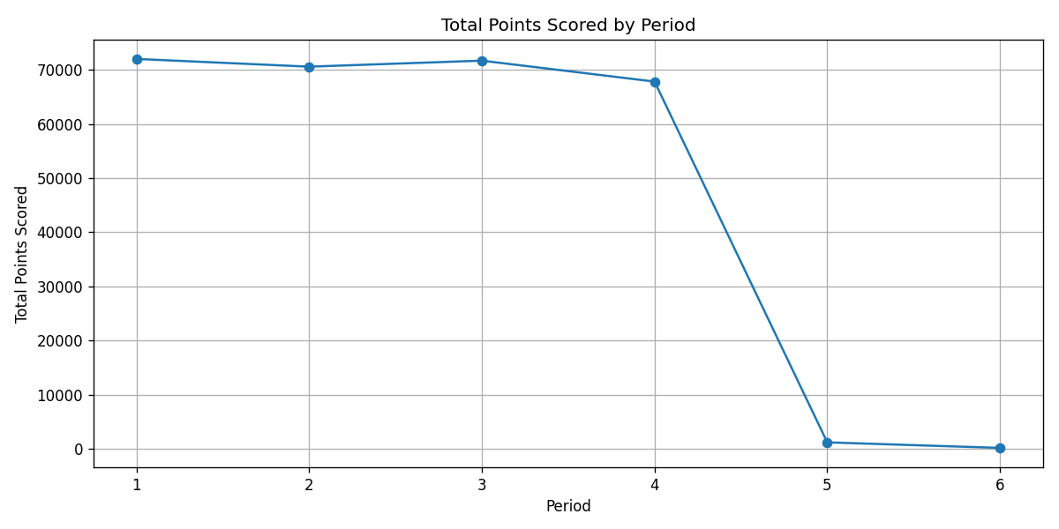
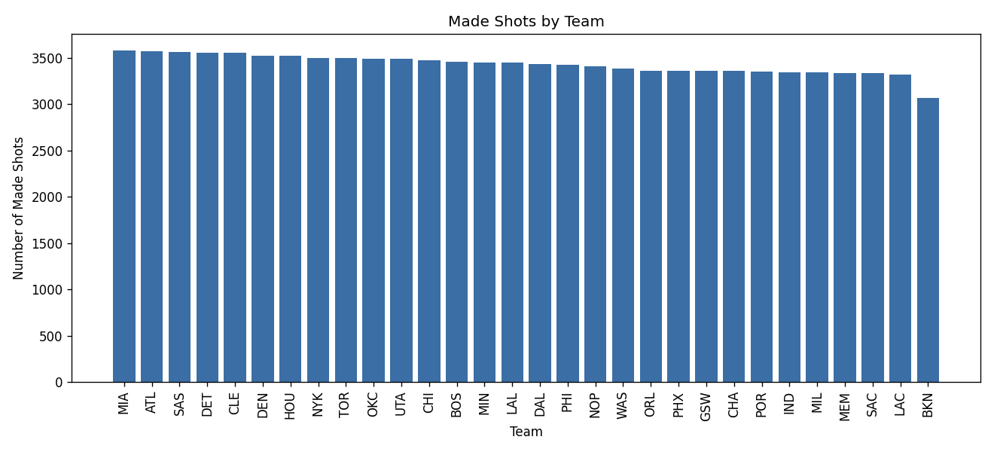
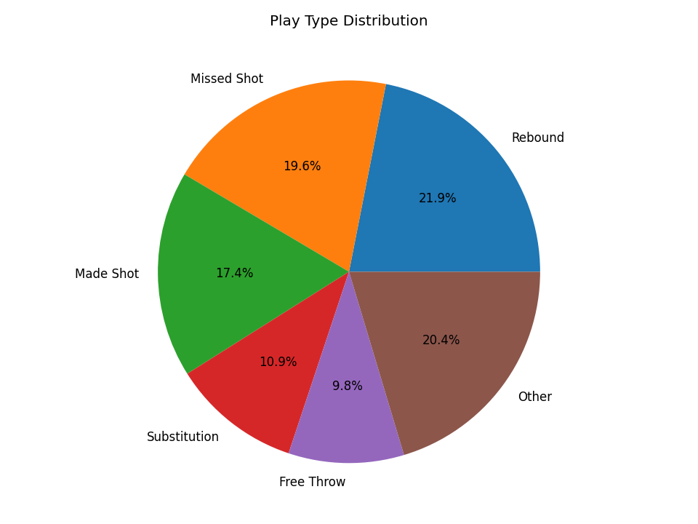
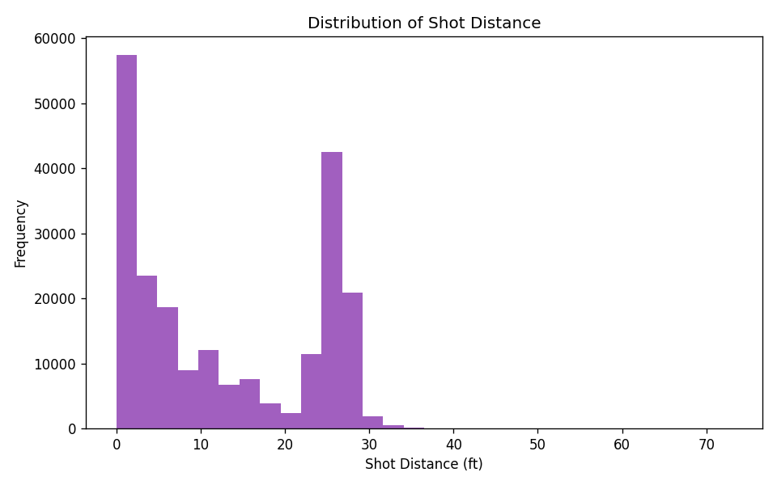
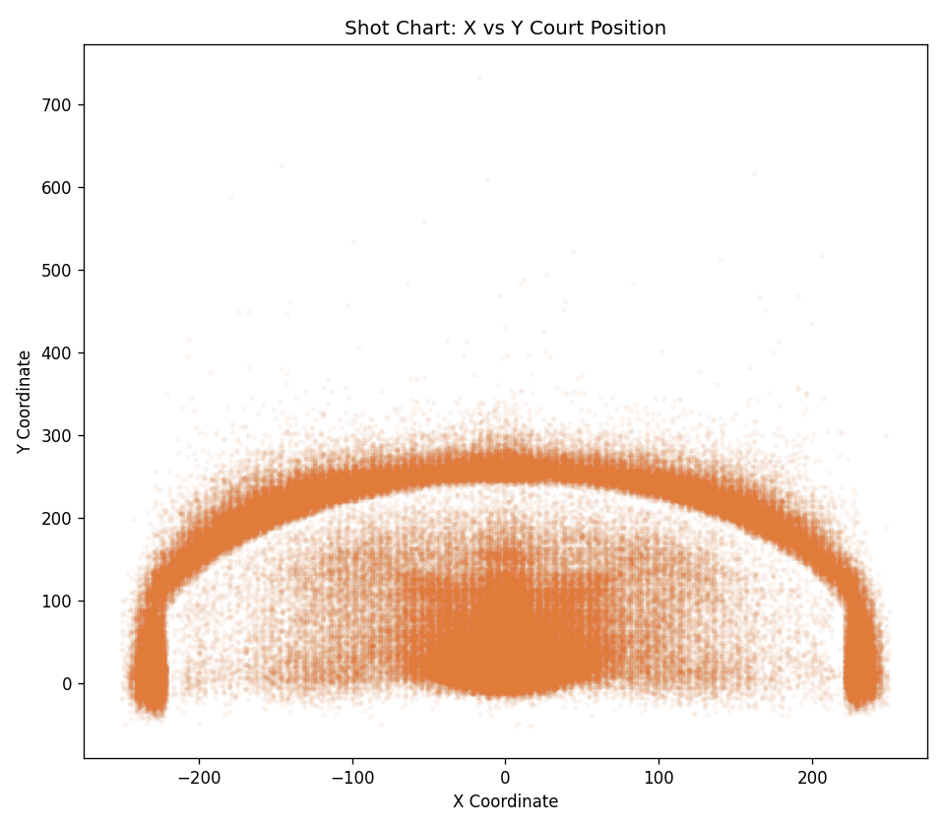
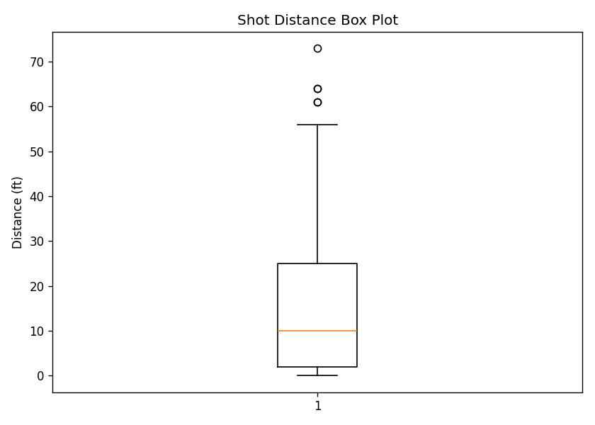
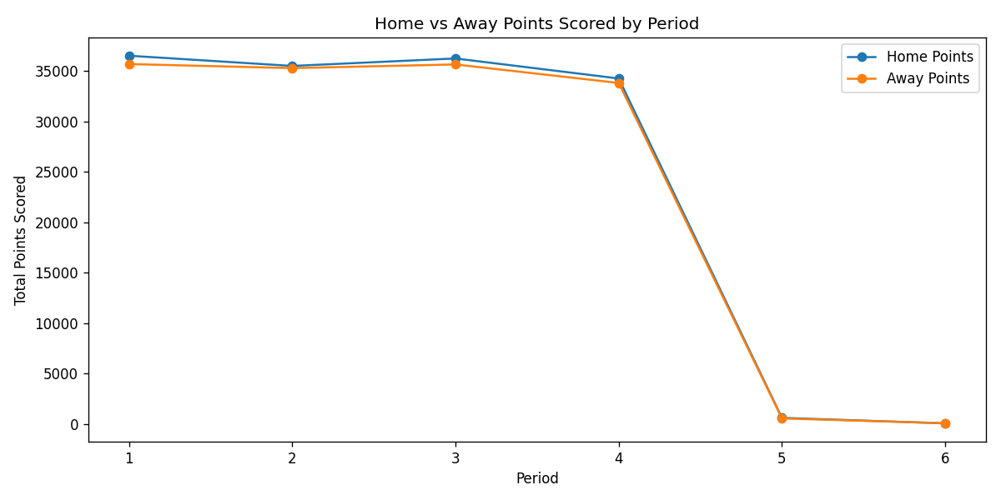
Result:
Line, bar, pie, histogram, scatter, box, and multiple-line visualizations were successfully created on the NBA play-by-play dataset. Scoring was heaviest in regulation periods 1–4 and dropped sharply in the two overtime periods. Rebounds (21.9%), Missed Shots (19.6%), and Made Shots (17.4%) made up the largest shares of recorded play types. The shot-distance histogram and box plot showed a typical attempt inside 15 ft with a secondary cluster beyond the three-point line (~23–26 ft) and a small number of extreme long-range outliers (over 60 ft). The shot chart (x vs y scatter) clearly traced out the restricted area, mid-range zones, and the three-point arc, and the home-vs-away line comparison showed closely matched scoring between the two sides in every period, consistent with competitive, evenly-fought games.

