Ex.no:5 | DATA VISUALIZATION USING MATPLOTLIB – NBA GAME SCORING DATA

Aim:
To visualize dataset features and distributions using line charts, bar charts, pie charts, histograms, scatter plots, and box plots using Matplotlib.
Algorithm:
Per-period home and away scoring totals for one NBA game (gameid 0022500001, OKC vs HOU, a double-overtime game) were extracted from the play-by-play dataset and stored as the following lists, used throughout this exercise:
periods = ["1", "2", "3", "4", "OT1", "OT2"]
home_points = [27, 24, 24, 29, 11, 10]
away_points = [30, 27, 22, 25, 11, 9]
ALGORITHM 1: LINE CHART
Objective: To visualize the home team's scoring trend across periods.
Steps
1. Load the period and home_points values.
2. Plot the home-team points using a line chart.
3. Add title and axis labels.
4. Display the graph.
Interpretation
The line chart shows how the home team's scoring output changed across regulation and overtime periods.
# Program 1: Line Chart
plt.plot(periods, home_points)
plt.title("Home Team Points by Period")
plt.xlabel("Period")
plt.ylabel("Points")
plt.show()
ALGORITHM 2: BAR CHART
Objective: To compare home team points across periods.
Steps
1. Select the period and home_points values.
2. Create a bar chart using the period-wise point values.
3. Add title and axis labels.
4. Display the chart.
Interpretation
The bar chart helps compare the home team's point totals across the different periods of the game.
# Program 2: Bar Chart
plt.bar(periods, home_points)
plt.title("Home Team Points by Period")
plt.xlabel("Period")
plt.ylabel("Points")
plt.show()
ALGORITHM 3: PIE CHART
Objective: To visualize the distribution of the home team's points across periods.
Steps
1. Select the home_points values.
2. Create a pie chart using the point values.
3. Display percentage labels.
4. Add a suitable title.
5. Display the chart.
Interpretation
The pie chart shows what percentage of the home team's final score came from each period.
# Program 3: Pie Chart
plt.pie(home_points, labels=periods, autopct="%1.1f%%")
plt.title("Home Points Distribution by Period")
plt.show()
ALGORITHM 4: HISTOGRAM
Objective: To visualize the distribution of the home team's period point values.
Steps
1. Select the home_points values.
2. Divide the values into bins.
3. Create a histogram.
4. Add title and axis labels.
5. Display the histogram.
Interpretation
The histogram shows the frequency distribution of the home team's period-by-period point totals.
# Program 4: Histogram
plt.hist(home_points, bins=5)
plt.title("Home Points Distribution")
plt.xlabel("Points")
plt.ylabel("Frequency")
plt.show()
ALGORITHM 5: SCATTER PLOT
Objective: To visualize the home team's points for each period.
Steps
1. Select period as the X-axis variable.
2. Select home_points as the Y-axis variable.
3. Create a scatter plot.
4. Add title and axis labels.
5. Display the graph.
Interpretation
The scatter plot shows the variation in home-team scoring across the different periods.
# Program 5: Scatter Plot
plt.scatter(periods, home_points)
plt.title("Home Team Points by Period")
plt.xlabel("Period")
plt.ylabel("Points")
plt.show()
ALGORITHM 6: BOX PLOT
Objective: To visualize the distribution of the home team's period point values.
Steps
1. Select the home_points values.
2. Create a box plot.
3. Add a suitable title and axis label.
4. Display the plot.
Interpretation
The box plot shows the distribution of the home team's period scoring and helps identify possible outliers, such as an unusually high or low period.
# Program 6: Box Plot
plt.boxplot(home_points)
plt.title("Home Points Box Plot")
plt.ylabel("Points")
plt.show()
ALGORITHM 7: MULTIPLE LINE CHARTS
Objective: To compare home team and away team points across periods.
Steps
1. Store the away_points values.
2. Plot the home_points values using a line chart.
3. Plot the away_points values using another line chart.
4. Add title, axis labels and legend.
5. Display the graph.
Interpretation
The multiple line chart compares the home and away teams' scoring across periods and shows how tightly the two sides were matched, including through both overtime periods.
# Program 7: Multiple Line Charts
away_points = [30, 27, 22, 25, 11, 9]

plt.plot(periods, home_points, label="Home")
plt.plot(periods, away_points, label="Away")
plt.title("Home vs Away Points")
plt.xlabel("Period")
plt.ylabel("Points")
plt.legend()
plt.show()
Output:
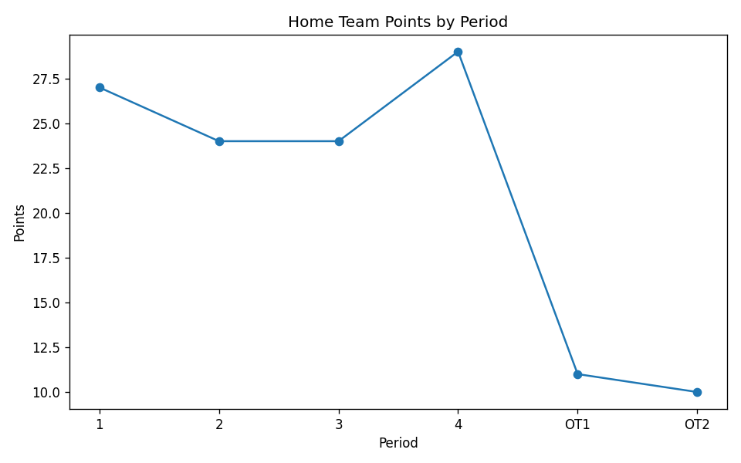
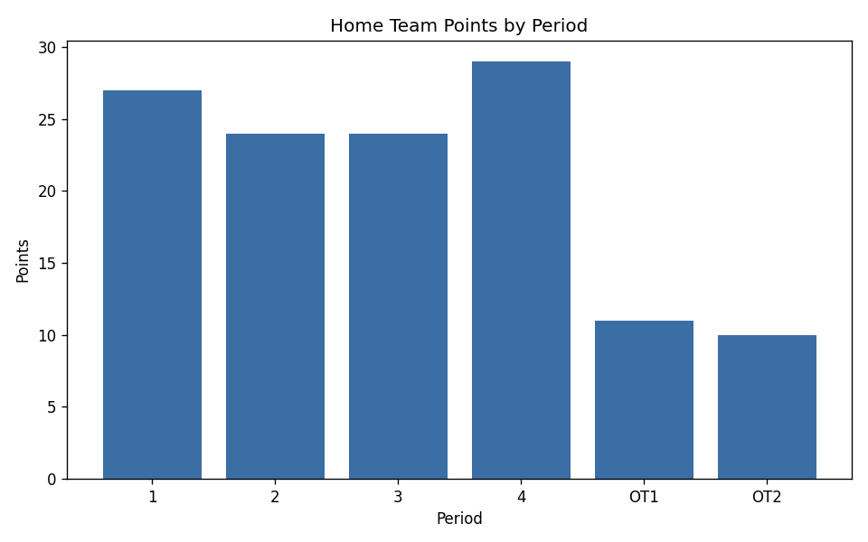
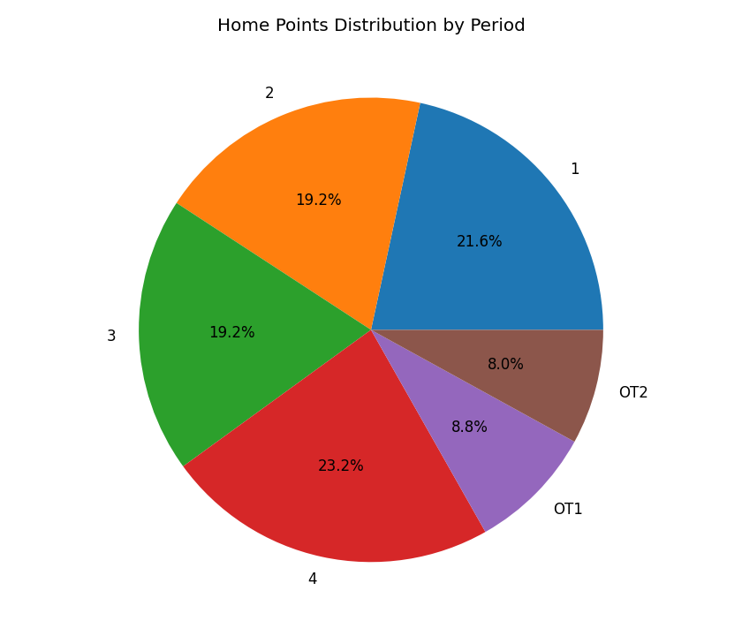
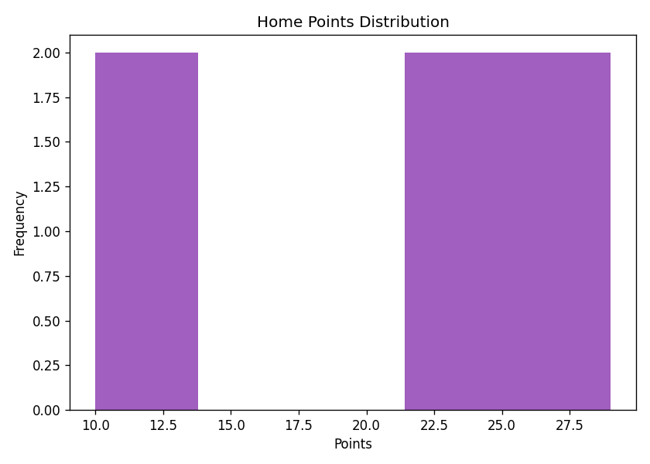
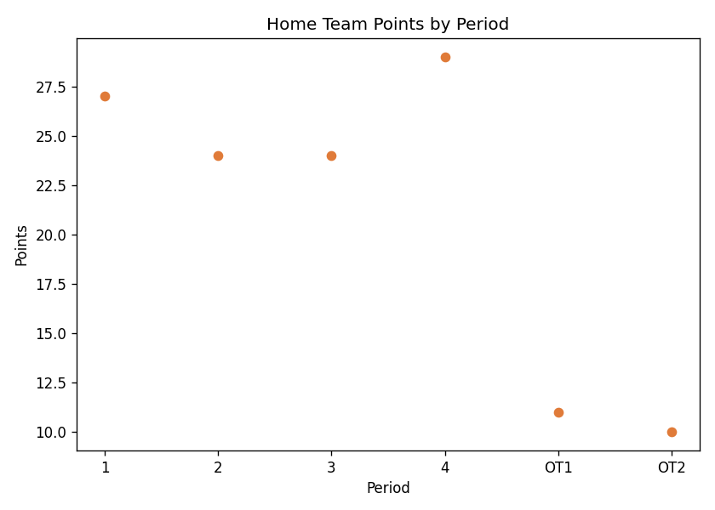
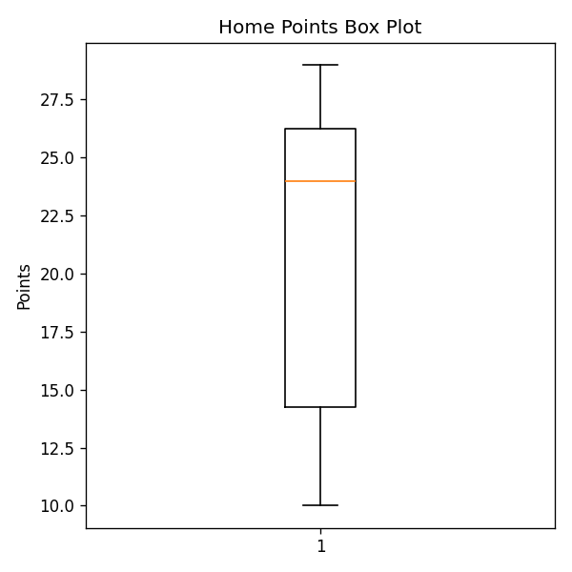
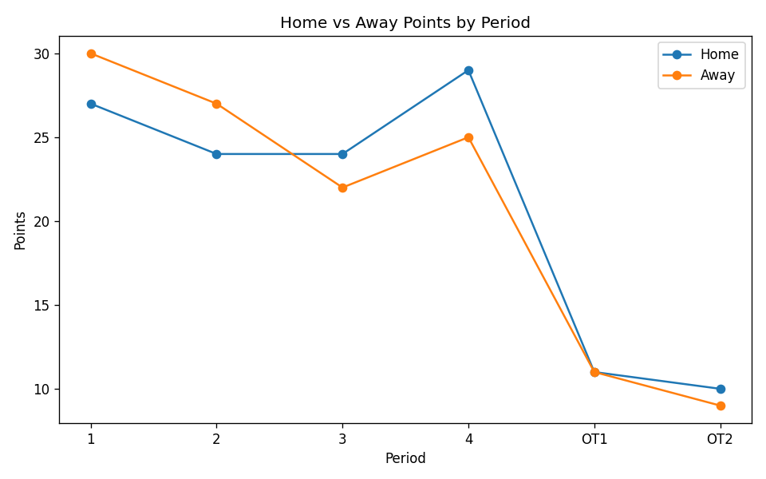
Result:
Line, bar, pie, histogram, scatter, box, and multiple-line visualizations were successfully created for the home and away scoring of a single NBA game (OKC vs HOU, final score 125–124 after two overtimes). The home team's scoring was fairly even across regulation periods (27, 24, 24, 29) and dropped off in overtime (11, 10). The multiple line chart showed the home and away teams closely matched in every period, reflecting the narrow one-point final margin.

