Ex.no:4 | EXPLORATORY DATA ANALYSIS (EDA) – DATA INSPECTION, FILTERING, STATISTICAL ANALYSIS AND CORRELATION

Aim:
To perform data inspection, conditional filtering, sorting, statistical summary, group aggregation, correlation analysis, and data visualization on an NBA play-by-play dataset (2025–26 season) using Pandas and Matplotlib.
Algorithm:
1. Start.
2. Import the required Python libraries: pandas, numpy and matplotlib.pyplot.
3. Load the dataset pbp2026.csv into a pandas DataFrame using pd.read_csv().
4. Inspect the basic structure, initial records, shape, column data types, and numerical summaries using df.head(), df.shape, df.dtypes, and df.describe().
5. Forward-fill the running score (h_pts, a_pts) within each game and restrict analysis to shot-attempt records (type = “Made Shot” / “Missed Shot”).
6. Filter rows based on specific conditions (e.g., dist > 24 for long-range attempts, and type == “Made Shot”).
7. Sort the dataset by dist in descending order using df.sort_values().
8. Compute statistical metrics for dist including mean, median, mode, and standard deviation.
9. Group data by team and aggregate to find the average dist using df.groupby().
10. Calculate the pairwise correlation matrix for numerical features using df.corr().
11. Generate a bar plot for average shot distance by team and a scatter plot of period versus dist using Matplotlib.

Program:
import pandas as pd
import matplotlib.pyplot as plt
import numpy as np

# Import Dataset
df = pd.read_csv("pbp2026.csv")

# Dataset Inspection
print("===== FIRST FIVE RECORDS =====")
display(df.head())
print("\n===== SHAPE OF DATASET =====")
print(df.shape)
print("\n===== DATA TYPES =====")
print(df.dtypes)
print("\n===== SUMMARY =====")
display(df.describe())

# Prepare running score (forward-fill within each game)
df[['h_pts','a_pts']] = df.groupby('gameid')[['h_pts','a_pts']].ffill()
df[['h_pts','a_pts']] = df[['h_pts','a_pts']].fillna(0)
df['is_made'] = np.where(df['result']=='Made', 1,
np.where(df['result']=='Missed', 0, np.nan))

# Restrict to shot-attempt records (Made Shot / Missed Shot)
shots = df[df['type'].isin(['Made Shot','Missed Shot'])].copy()

# Filtering Data
# Long-range attempts (shot distance greater than 24 ft)
print("\n===== SHOTS WITH DIST > 24 =====")
long_range = shots[shots["dist"] > 24]
display(long_range.head())

# Made shots only
print("\n===== MADE SHOTS =====")
made = shots[shots["type"] == "Made Shot"]
display(made.head())

# Sorting Data
print("\n===== SORT BY DIST (DESCENDING) =====")
sorted_df = shots.sort_values(by="dist", ascending=False)
display(sorted_df.head())

# Statistical Analysis
print("\n===== SHOT DISTANCE STATISTICS =====")
print("Mean :", shots["dist"].mean())
print("Median :", shots["dist"].median())
print("Mode :")
print(shots["dist"].mode())
print("Standard Deviation :", shots["dist"].std())
print("\n===== DESCRIPTIVE STATISTICS =====")
display(shots.describe())

# Grouping and Aggregation
print("\n===== AVERAGE SHOT DISTANCE BY TEAM =====")
team_avg = shots.groupby("team")["dist"].mean().sort_values(ascending=False)
display(team_avg)

# Correlation Analysis
print("\n===== CORRELATION =====")
corr = shots[[ "period", "x", "y", "dist",
"h_pts", "a_pts", "is_made" ]].corr()
display(corr)

# Visualization 1
team_avg.plot(kind="bar")
plt.title("Average Shot Distance by Team")
plt.xlabel("Team")
plt.ylabel("Average Distance (ft)")
plt.show()

# Visualization 2
plt.figure(figsize=(8,5))
plt.scatter(shots["period"], shots["dist"], s=4, alpha=0.15)
plt.title("Shot Period vs Distance")
plt.xlabel("Period")
plt.ylabel("Shot Distance (ft)")
plt.show()

Output:
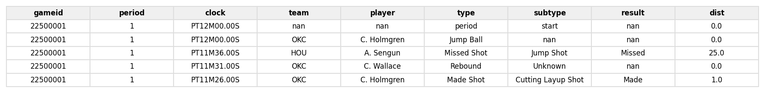
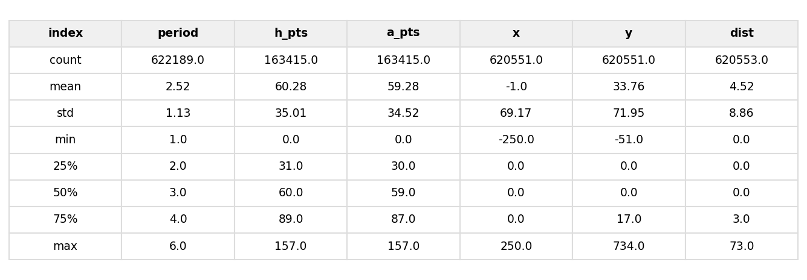
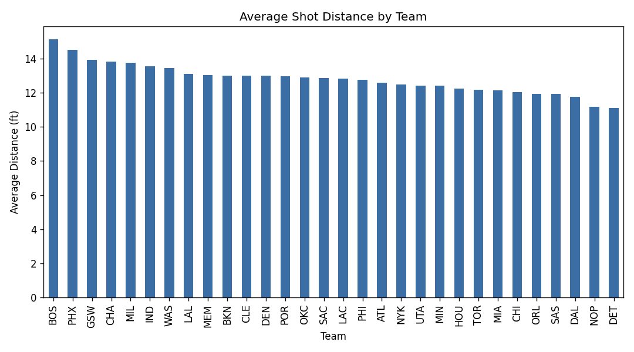
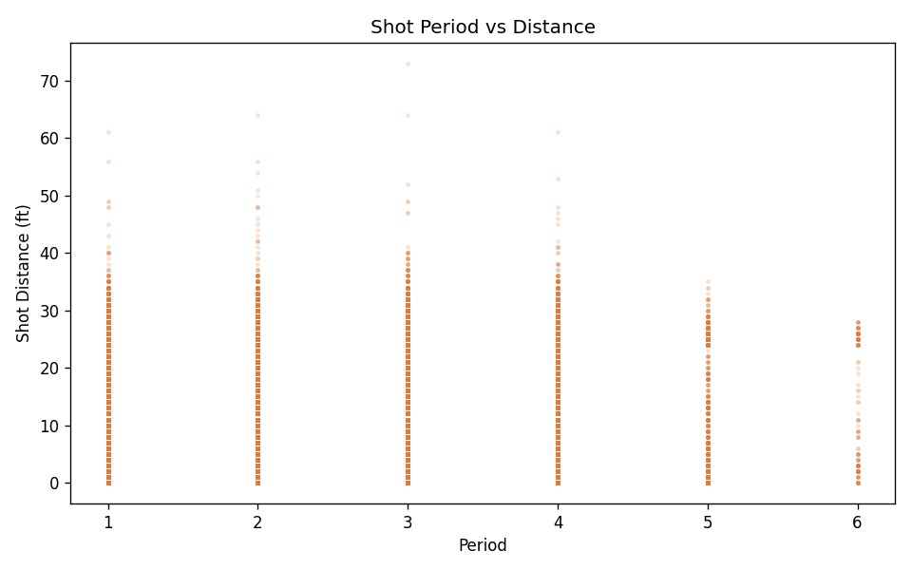
Result:
Data inspection, filtering, sorting, statistical analysis, and correlation analysis were successfully performed on the NBA play-by-play dataset (622,189 records). Restricting the data to the 218,443 shot-attempt records, 65,971 attempts were taken from beyond 24 feet and 102,886 shots were made. The mean shot distance was 12.80 ft (median 10.0 ft, mode 26.0 ft, std. dev. 10.79 ft). Boston (BOS), Phoenix (PHX), and Golden State (GSW) recorded the highest average shot distance by team, and the correlation matrix showed shot distance (dist) strongly correlated with the y-coordinate (0.88) and mildly negatively correlated with shot success (is_made, –0.21), while period showed a strong positive correlation with the running score (h_pts/a_pts, ≈0.94), as expected.

