Ex.no:4 | EXPLORATORY DATA ANALYSIS (EDA) – DATA INSPECTION, FILTERING, STATISTICAL ANALYSIS AND CORRELATION

Aim:
To perform data inspection, filtering, grouping, aggregation, descriptive statistical analysis, and correlation analysis on a per-player season summary built from NBA play-by-play data using Pandas, and visualize the results using Matplotlib.
Algorithm:
1. Import the required Pandas, NumPy and Matplotlib libraries.
2. Read the pbp2026.csv play-by-play file using Pandas.
3. Build a per-player season summary: total Points scored (from made shots and free throws), primary Team, and Attendance (% of the 82-game season played).
4. Display the dataset and inspect the first few records.
5. Find the number of rows and columns and display the data types.
6. Generate the statistical summary of the dataset.
7. Filter the players based on points and attendance conditions.
8. Sort the player records based on points and attendance.
9. Group the data based on team and calculate average points and attendance.
10. Calculate mean, median, minimum, maximum and standard deviation of points.
11. Calculate the correlation between points and attendance.
12. Create bar chart, line chart, scatter plot, histogram and box plot using Matplotlib.
13. Display the results and interpret the obtained data.

Program:
# Import libraries
import pandas as pd
import numpy as np
import matplotlib.pyplot as plt

# Read raw play-by-play data and build a per-player season summary
raw = pd.read_csv("pbp2026.csv")
raw = raw[raw['player'].notna()].copy()

is_3pt = raw['desc'].str.contains('3PT', na=False)
is_made_shot = raw['type'] == 'Made Shot'
is_made_ft = (raw['type'] == 'Free Throw') & \
(raw['desc'].str.contains(r'\(\d+ PTS\)', na=False))

raw['points_scored'] = np.where(is_made_shot & is_3pt, 3,
np.where(is_made_shot & ~is_3pt, 2,
np.where(is_made_ft, 1, 0)))

primary_team = raw.groupby('player')['team'].agg(
lambda s: s.mode().iloc[0] if not s.mode().empty else 'N/A')
games_played = raw.groupby('player')['gameid'].nunique()
total_points = raw.groupby('player')['points_scored'].sum()

SEASON_GAMES = 82
df = pd.DataFrame({
'Player': total_points.index,
'Team': primary_team.reindex(total_points.index).values,
'Points': total_points.values,
'GamesPlayed': games_played.reindex(total_points.index).values,
})
df['Attendance'] = (df['GamesPlayed'] / SEASON_GAMES * 100).clip(upper=100).round(1)
df = df[df['GamesPlayed'] >= 20]
df = df.sort_values('Points', ascending=False).head(20).reset_index(drop=True)
df = df[['Player','Team','Points','Attendance']]

# Display dataset
print(df)

# Display first five records
print(df.head())

# Display shape
print(df.shape)

# Display data types
print(df.dtypes)

# Display statistical summary
print(df.describe())

# Filter players with points greater than 2000
print(df[df["Points"] > 2000])

# Filter players with attendance greater than 90
print(df[df["Attendance"] > 90])

# Sort players by points
print(df.sort_values("Points", ascending=False))

# Sort players by attendance
print(df.sort_values("Attendance", ascending=False))

# Team-wise average points
print(df.groupby("Team")["Points"].mean())

# Team-wise average attendance
print(df.groupby("Team")["Attendance"].mean())

# Calculate mean
print("Mean Points:", df["Points"].mean())

# Calculate median
print("Median Points:", df["Points"].median())

# Calculate minimum
print("Minimum Points:", df["Points"].min())

# Calculate maximum
print("Maximum Points:", df["Points"].max())

# Calculate standard deviation
print("Standard Deviation:", df["Points"].std())

# Display correlation matrix
print(df[["Points", "Attendance"]].corr())

# Display correlation between points and attendance
print("Correlation:", df["Points"].corr(df["Attendance"]))

# Bar chart
plt.bar(df["Player"], df["Points"])
plt.title("Player Points")
plt.xlabel("Player")
plt.ylabel("Points")
plt.xticks(rotation=75)
plt.show()

# Line chart
plt.plot(df["Player"], df["Attendance"], marker="o")
plt.title("Player Attendance")
plt.xlabel("Player")
plt.ylabel("Attendance")
plt.xticks(rotation=75)
plt.show()

# Scatter plot
plt.scatter(df["Attendance"], df["Points"])
plt.title("Points vs Attendance")
plt.xlabel("Attendance")
plt.ylabel("Points")
plt.show()

# Histogram
plt.hist(df["Points"], bins=5)
plt.title("Points Distribution")
plt.xlabel("Points")
plt.ylabel("Number of Players")
plt.show()

# Box plot
plt.boxplot(df["Points"])
plt.title("Points Box Plot")
plt.ylabel("Points")
plt.show()

Output:
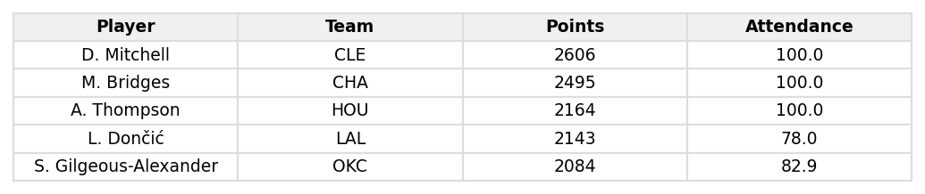
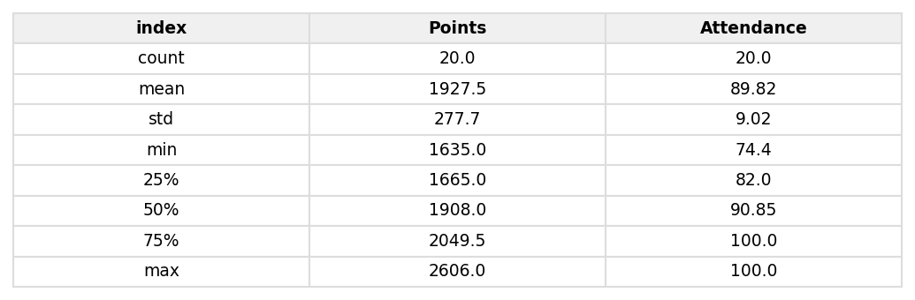
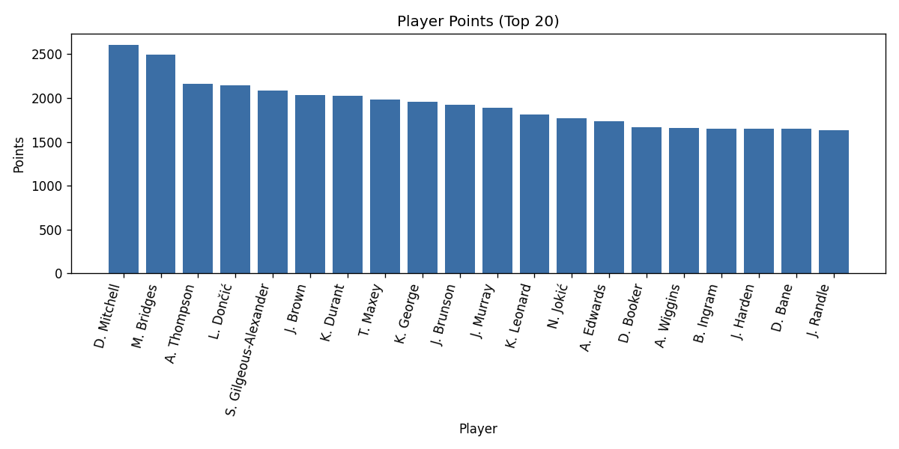
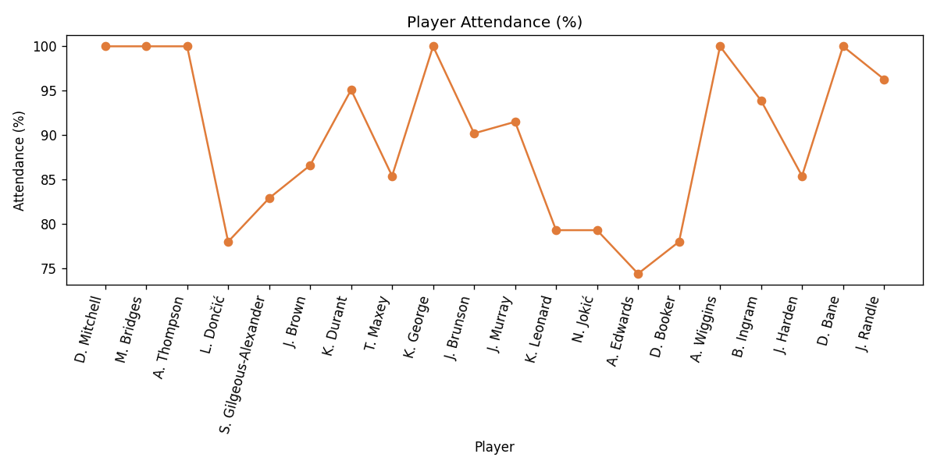
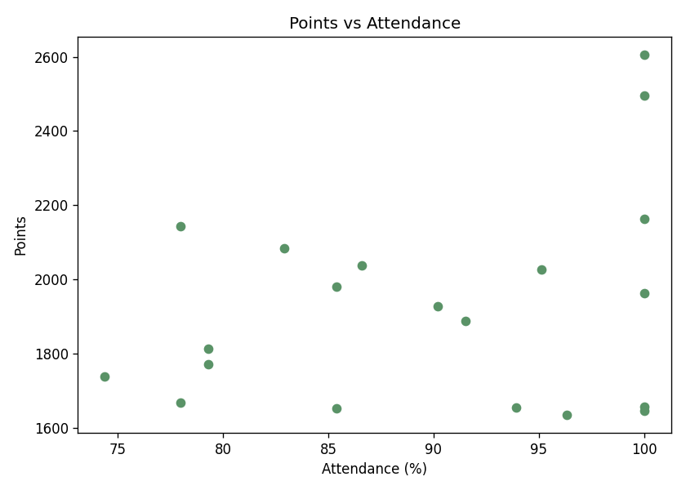
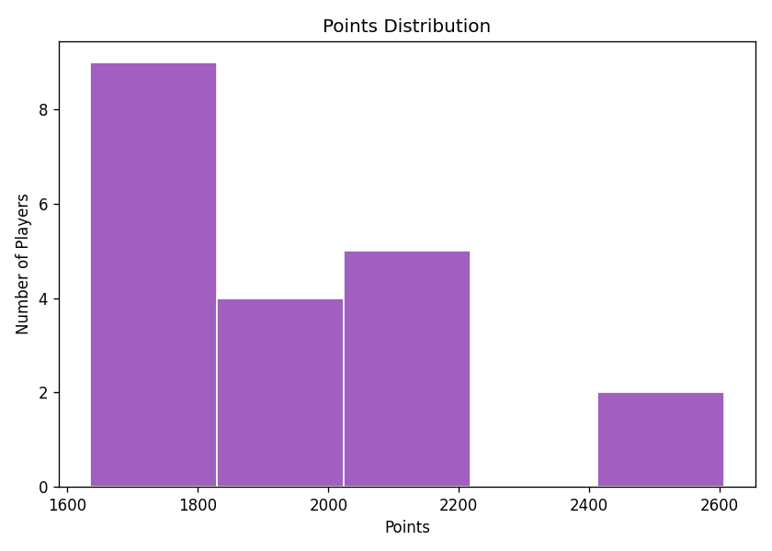
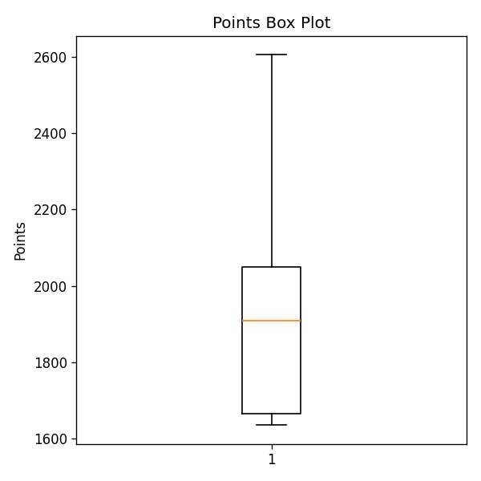
Result:
Data inspection, filtering, grouping, statistical analysis, and correlation analysis were successfully performed on a 20-player season summary built from the NBA play-by-play dataset. D. Mitchell led the group with 2,606 points, followed by M. Bridges (2,495) and A. Thompson (2,164). Mean points scored was 1,927.5 (median 1,908, min 1,635, max 2,606, std. dev. 277.7), and average attendance across the group was 89.8%. The correlation between Points and Attendance was 0.275, indicating only a weak positive relationship — players who appeared in more of the season's games did not necessarily score proportionally more points.

