Task 4:

NAME: ELANKUMARAN R

Roll No: 22CSR053

1. **Create the Kubernetes Deployment and Service Definition File**
   * Open a terminal and navigate to the desired directory.
   * Create a YAML file (t4.yaml) using a text editor: nano t4.yaml
   * Add the following Kubernetes configuration:

apiVersion: apps/v1

kind: Deployment

metadata:

labels:

app: springboot-app

name: springboot-app

spec:

replicas: 1

selector:

matchLabels:

app: springboot-app

template:

metadata:

labels:

app: springboot-app

spec:

containers:

- name: my-springboot-app

image: elankumaran21/sample:latest

imagePullPolicy: Always

ports:

- containerPort: 80

name: http

protocol: TCP

---

apiVersion: v1

kind: Service

metadata:

labels:

app: springboot-app

k8s-app: springboot-app

name: springboot-app

spec:

ports:

- name: http

port: 80

protocol: TCP

targetPort: 80

type: NodePort

selector:

app: springboot-app

Save and exit the file.

1. **Apply the Kubernetes Configuration**
   * Run the following command to deploy the application:

kubectl apply -f t4.yaml

* + You should see the following output: 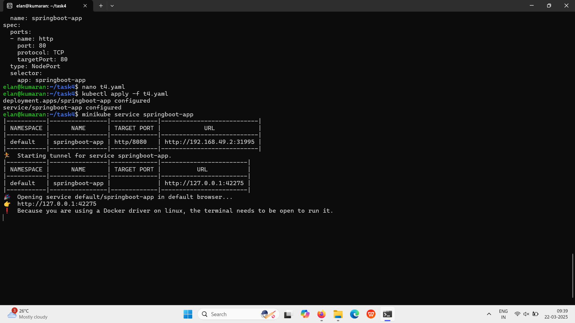

1. **Expose the Service Using Minikube**
   * Run the command:

❗ Because you are using a Docker driver on Linux, the terminal needs to be open to run it.

* + Access the application in the browser using the displayed URL, e.g., http://127.0.0.1:42275.

This process successfully deploys the Spring Boot application on Minikube and makes it accessible via a browser.

Output: 