
Spirit & Life — Website Rebuild Reference
Page-by-page screenshot reference for Codex rebuild
Follow the screenshots below strictly for layout, wording, section order, and styling on every page. Only improvise (colors, spacing, minor structure) in places explicitly marked “improvise” or where a screenshot is not provided. The Study Center page has no screenshot and no guideline yet — leave it as it currently is; do not redesign it.

1. Home Page
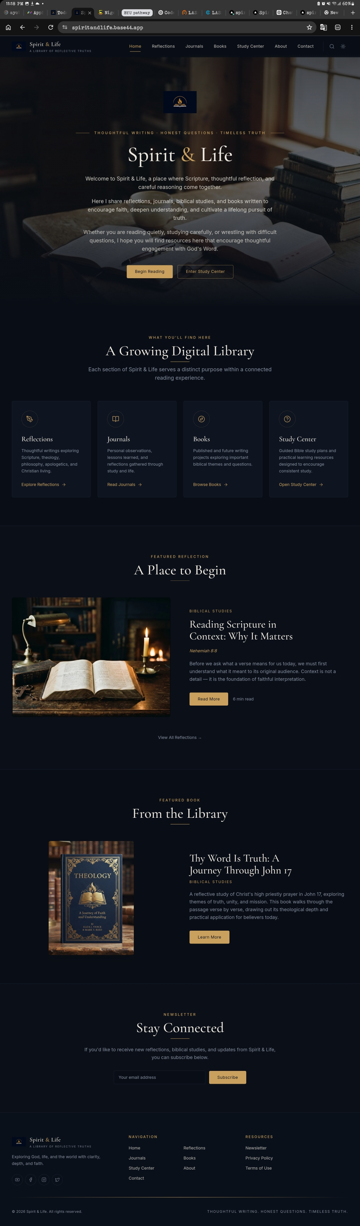
- Dark navy background with hero image of an open Bible and stacked books, softly overlaid.
- Logo mark centered above the hero text; site name “Spirit & Life” in serif type with the tagline “THOUGHTFUL WRITING · HONEST QUESTIONS · TIMELESS TRUTH” above it.
- Three intro paragraphs, centered, welcoming the reader.
- Two buttons: “Begin Reading” (filled gold) and “Enter Study Center” (outlined).
- “A Growing Digital Library” section: 4 equal cards (Reflections, Journals, Books, Study Center), each with an icon, short description, and a text link.
- “Featured Reflection” section: image left, text right (title, verse reference, excerpt, Read More button, read time).
- “Featured Book” section: book cover image left, text right (title, category, description, Learn More button).
- Newsletter “Stay Connected” section: centered heading, one line of copy, email input + Subscribe button.
- Footer: logo + tagline + short description, Navigation links, Resources links, social icons, copyright line, bottom tagline strip.

2. Reflections Page
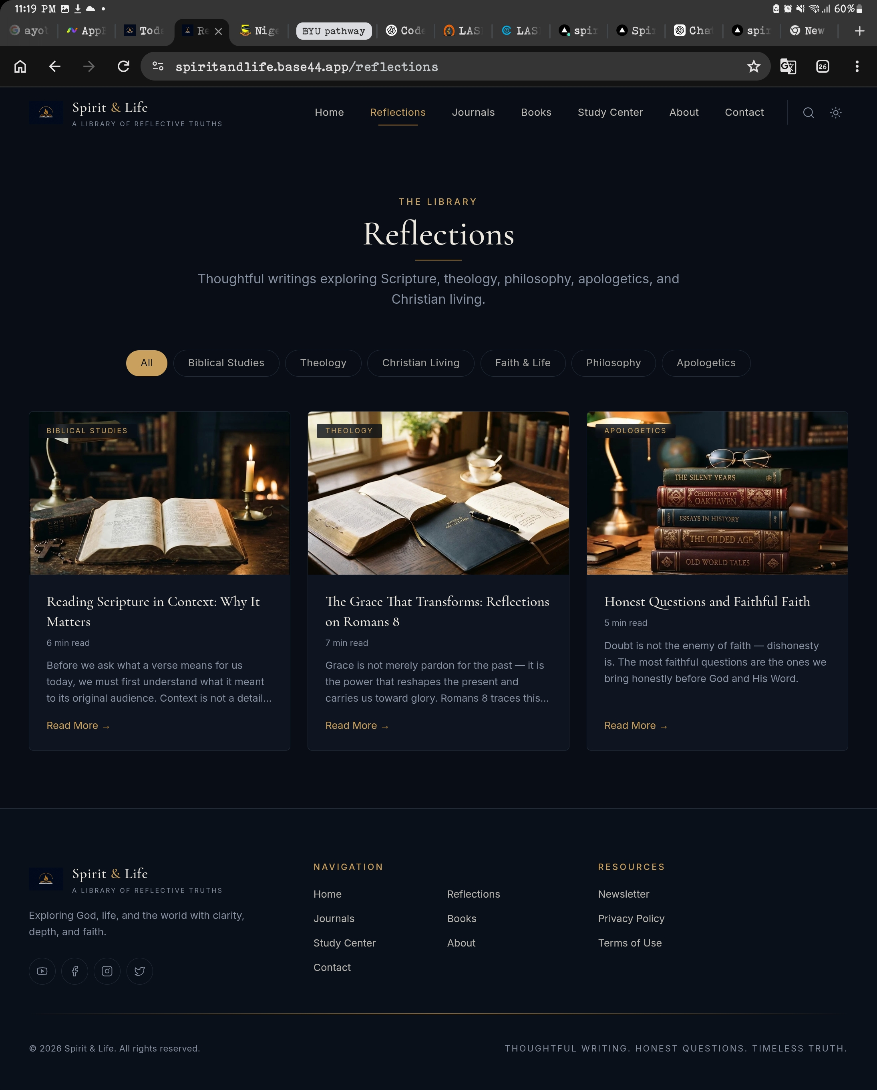
- Same header/nav and footer as Home.
- Page title “Reflections” under eyebrow label “THE LIBRARY”, centered, with a short descriptive subtitle.
- Filter pill row: All, Biblical Studies, Theology, Christian Living, Faith & Life, Philosophy, Apologetics — “All” selected/highlighted by default.
- 3-column card grid of reflection posts: category tag on image, title, read time, 2‑3 line excerpt, “Read More →” link.
- Cards use the same dark card style as the Home page feature cards.

3. Journals Page
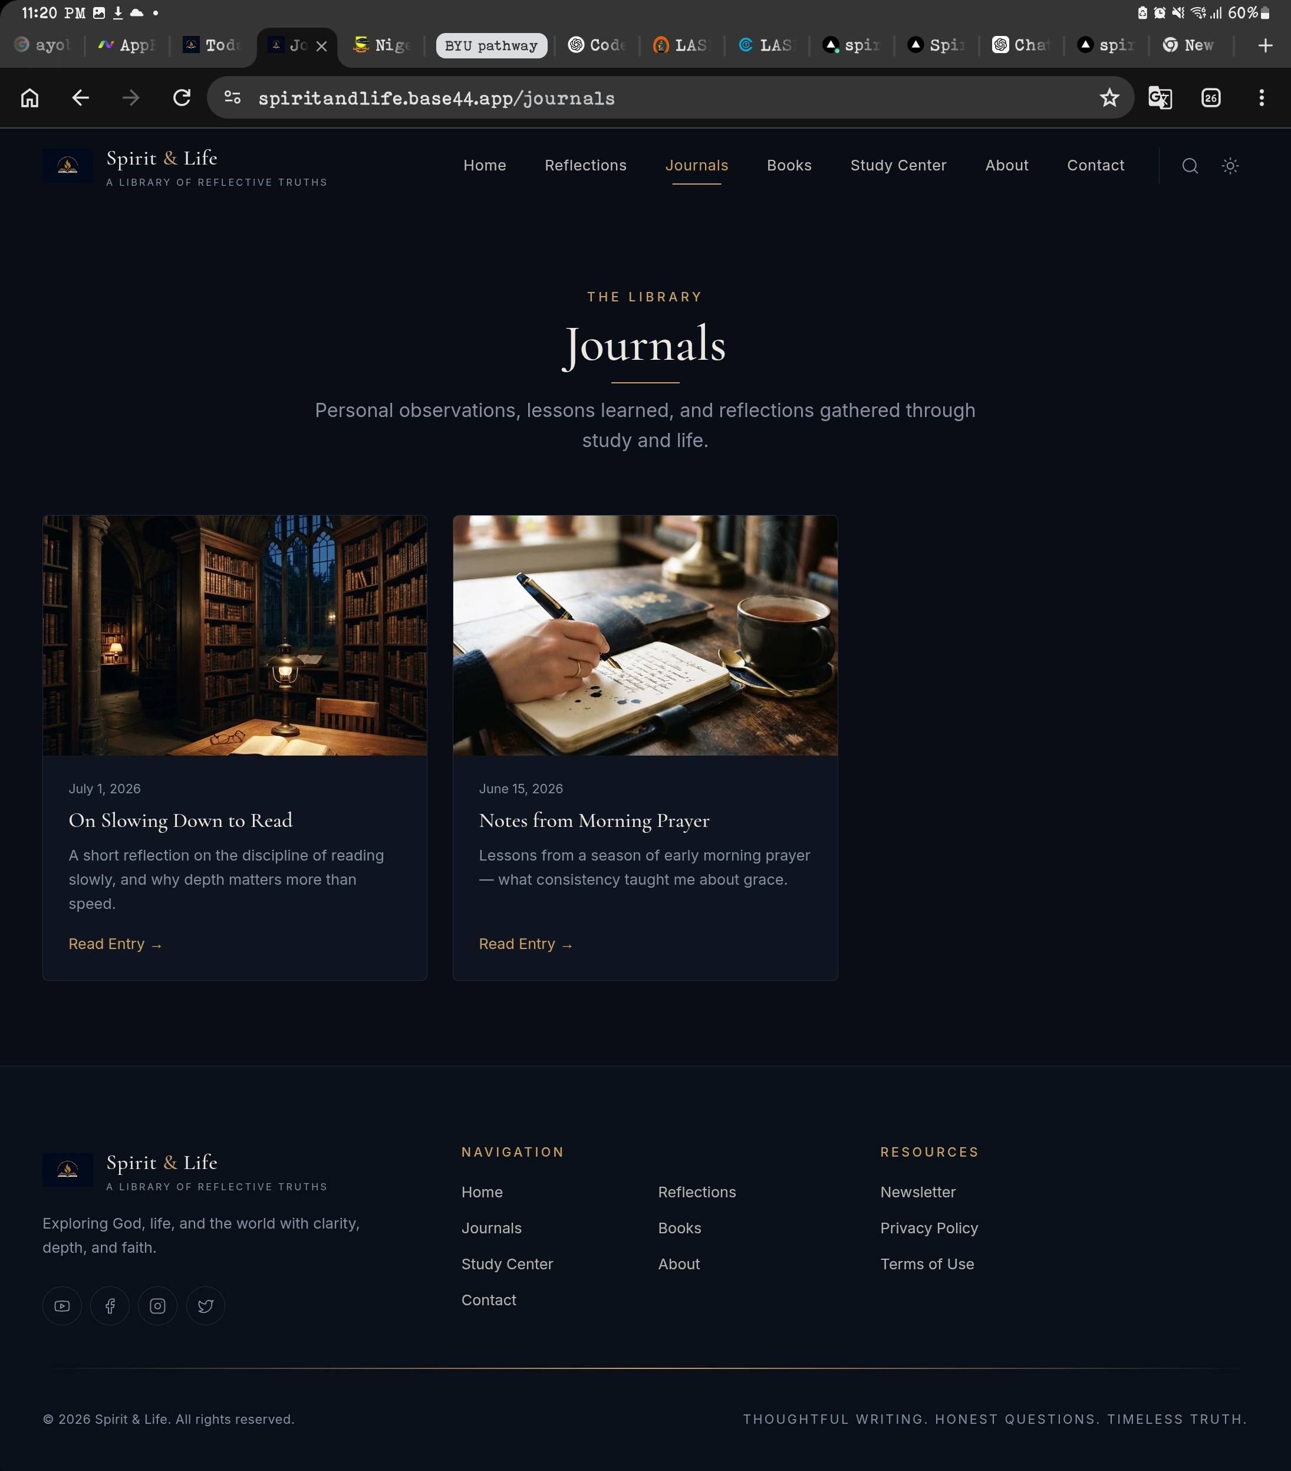
- Same header/nav, footer, and “THE LIBRARY” eyebrow/title pattern as Reflections, title “Journals” with its own subtitle.
- No filter pills on this page.
- 2-column card grid of journal entries: image, date, title, short excerpt, “Read Entry →” link.

4. Books Page
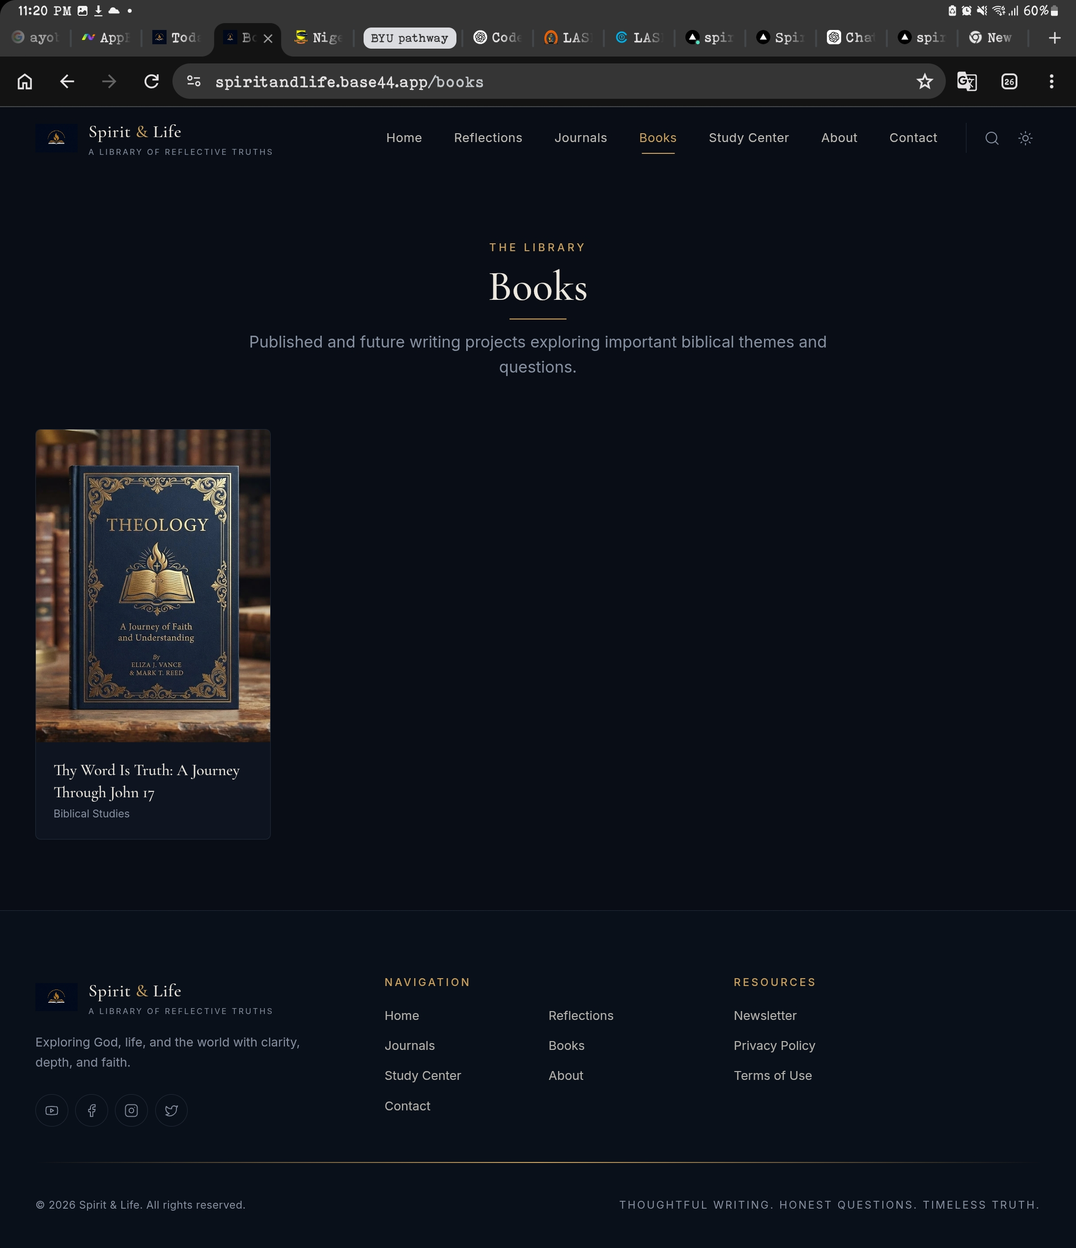
- Same header/nav, footer, and “THE LIBRARY” eyebrow/title pattern, title “Books” with its own subtitle.
- Single-column card grid (grows as books are added): book cover image, title, category label underneath.
- Currently only one book: “Thy Word Is Truth: A Journey Through John 17” (Biblical Studies).

5. Study Center
No screenshot and no styling guideline for this page yet — leave the Study Center exactly as it currently is. Do not rebuild or restyle it in this pass.

6. About Page
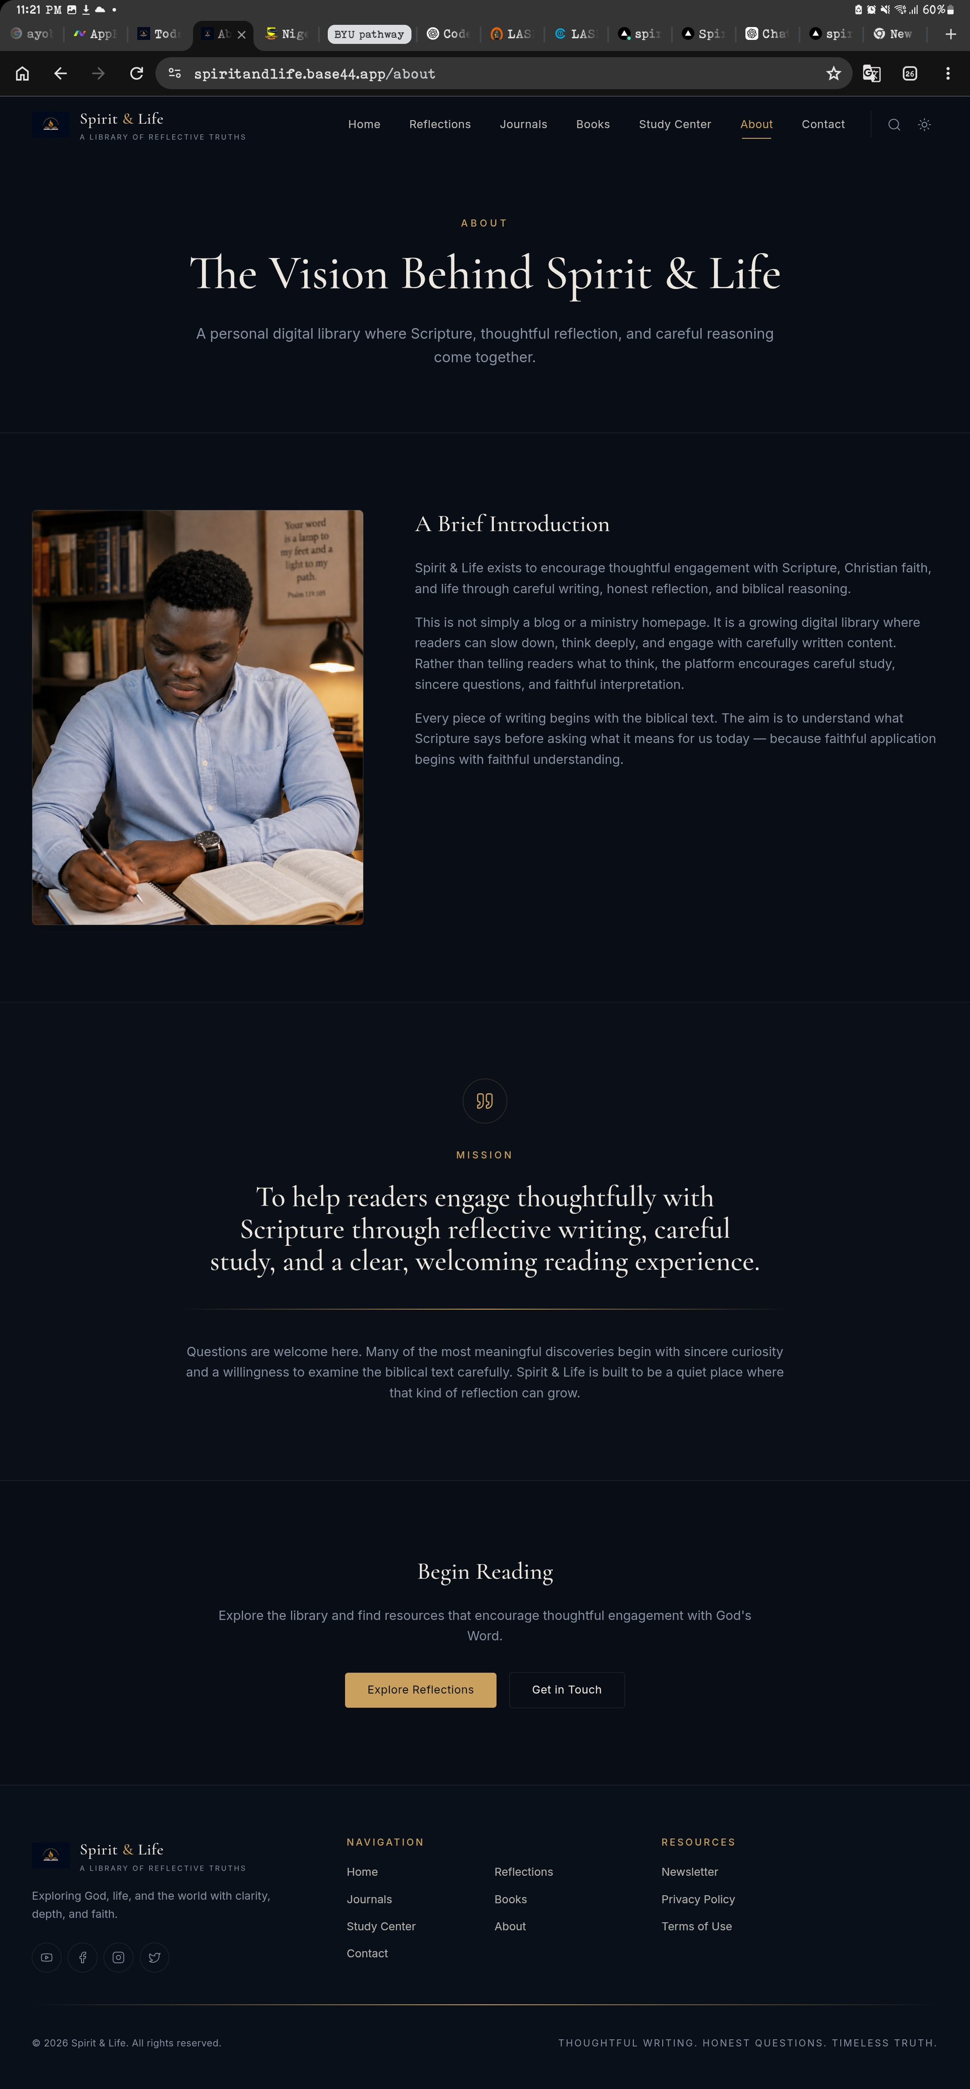
- Eyebrow “ABOUT”, title “The Vision Behind Spirit & Life”, centered subtitle.
- Two-column “A Brief Introduction” section: photo left, 3 paragraphs of body text right.
- Centered “MISSION” section with quote-mark icon, large centered mission statement, and a follow-up paragraph below a divider line.
- “Begin Reading” closing section: centered heading, short line of copy, “Explore Reflections” (filled) and “Get in Touch” (outlined) buttons.

7. Contact Page
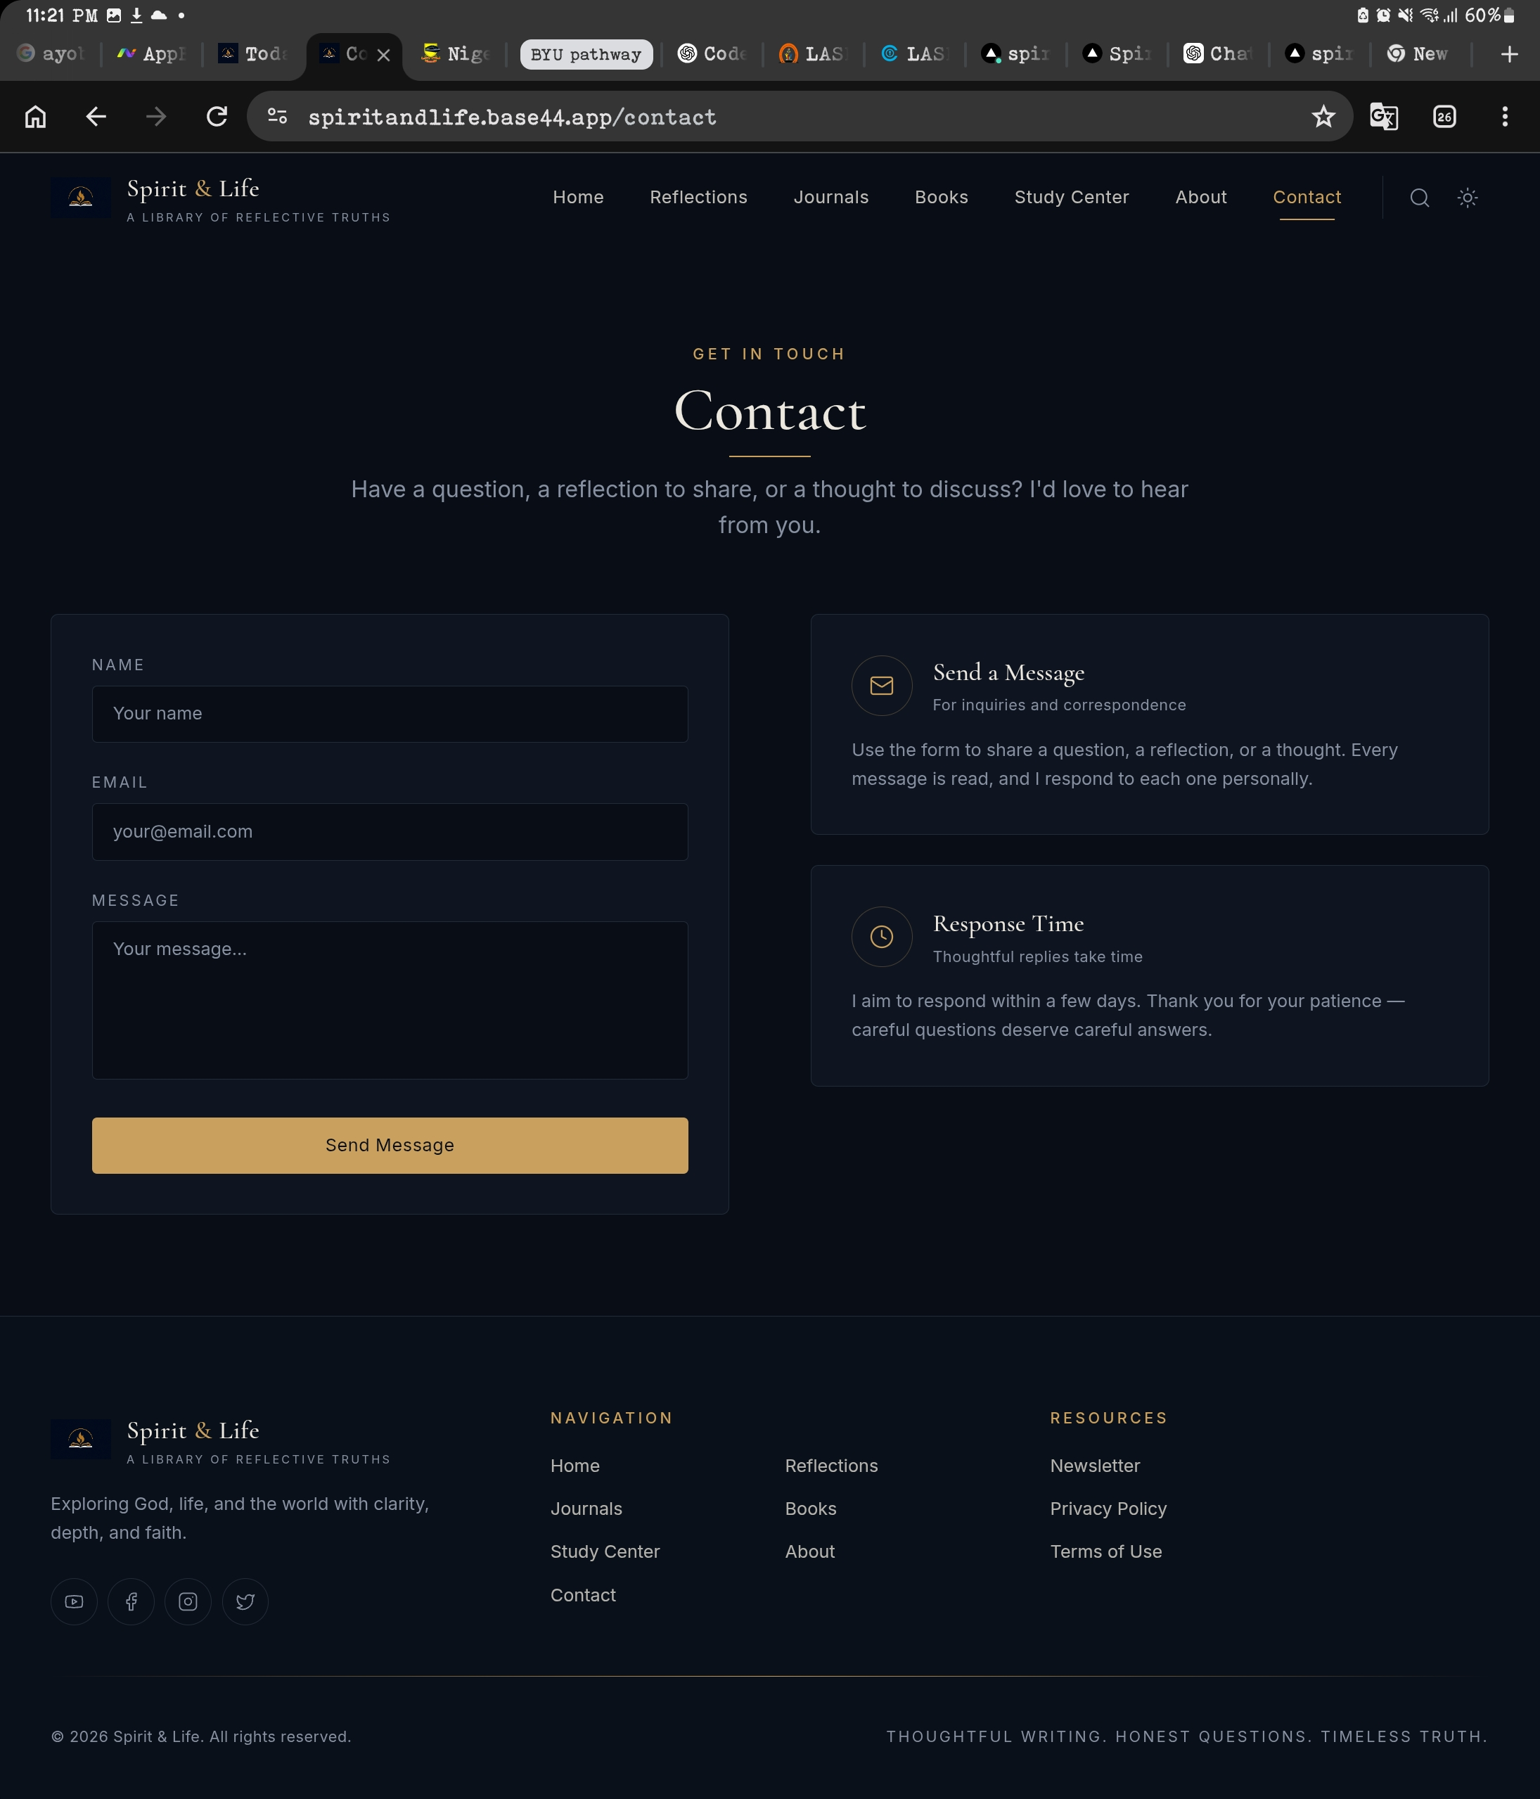
- Eyebrow “GET IN TOUCH”, title “Contact”, centered subtitle.
- Two-column layout: left is a form card (Name, Email, Message fields, filled “Send Message” button); right stacks two info cards (“Send a Message” and “Response Time”), each with an icon, short heading, and 1‑2 lines of copy.

General Notes for Codex
- Global styling: dark navy/near-black background throughout, warm gold/bronze accent color, serif display type for headings, sans-serif body text.
- Every inner page repeats the same header (logo + 7 nav links + search icon + theme toggle) and footer (logo/blurb, Navigation column, Resources column, social icons, copyright + tagline strip).
- Reuse the same card, button, and section-heading (eyebrow label + serif title + underline) components across all pages instead of rebuilding them per page.
Reminder: match the screenshots as closely as possible on every page listed above. Improvise only where a detail is not visible in the screenshot or for the Study Center page, which is intentionally left untouched.

