June 3, 2026

To: OFFICE OF THE VICE PRESIDENT FOR ACADEMIC AFFAIRS

Subject: ENDORSEMENT AND REQUEST FOR PERMISSION TO COLLECT INSTITUTIONAL DOCUMENTS FOR RESEARCH PURPOSES

Greetings of peace and excellence.

The College of Computing and Information Sciences (CCIS) respectfully endorses the request of Mr. Jay Michael C. Elape and Mr. Edward Kennedy D. Pero, third-year Bachelor of Science in Information Technology (BSIT) students of Caraga State University, who are currently conducting their capstone study entitled:

"Deep Learning-Driven OCR System for Attribute Extraction in Non-Standardized Documents"
The study aims to develop and evaluate an intelligent document processing system that utilizes deep learning-based Optical Character Recognition (OCR), semantic segmentation, and attribute extraction techniques to automatically identify, extract, and organize information from non-standardized institutional documents. Through this research, the proponents seek to develop a system capable of assisting future document digitization, information retrieval, and administrative workflow automation by reducing the time and effort required in manual document processing.
In line with the approved methodology of the study, the researchers require a diverse dataset consisting of a maximum of six hundred (600) document instances, primarily soft-copy documents, sourced from various offices and operational units of Caraga State University. To ensure that the dataset adequately represents actual institutional document workflows and structural variations, the requested documents shall cover the period from 2020 to 2025.
The documents requested may include, but are not limited to:

- Memoranda (Memos)
- Request Letters
- Special Orders
- Thesis-Related Forms
- Course Syllabi
- Other non-confidential administrative and academic documents

The collected documents shall be used solely for academic research purposes, specifically for dataset construction, annotation, model training, validation, and system evaluation. All documents will undergo anonymization procedures prior to processing, ensuring that personally identifiable information and sensitive institutional data are removed or replaced in compliance with applicable data privacy and research ethics standards.
In view thereof, the College respectfully seeks your approval to allow the aforementioned researchers to coordinate with the concerned offices and units of the University for the collection of the aforementioned non-confidential documents necessary for the successful completion of their study.
We highly appreciate your continued support for student research initiatives and innovation within the University.

Noted by:
Digitally signed by Nakazato Takeyasu Villa
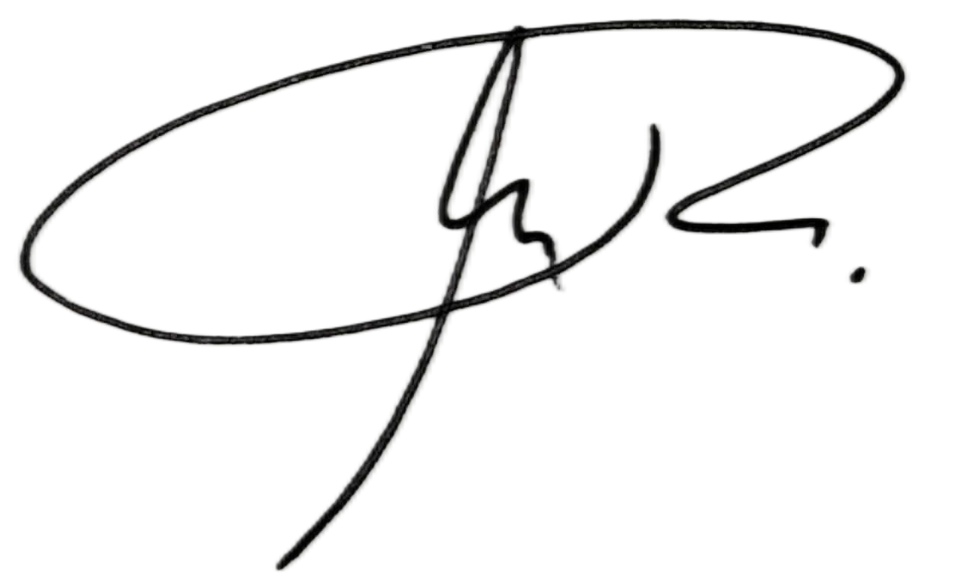
Date:

TAKEYASU V. NA²K⁰²A^{6.}Z⁰⁶A^{.0}T³ O, MSc.
15:13:15
Capstone Adviser +0800

Recommending Approval:

JENELYN R. ASIS, MSc. JAYMER M. JAYOMA, ITD
Chair, Department of Information Technology College Dean

Approved by:

DR. VICENTE A. PITOGO
Vice President For Academic Affairs
Caraga State University

