Recommended topology: Kali Linux VM -> VirtualBox Host-Only/Internal Network -> Authorized Target VM. Keep the lab isolated from production or public systems.
IT113 LABORATORY ACTIVITY 03
Nmap Network Discovery and Port Scanning
Authorized Network Reconnaissance, Service Identification, and Scan Reporting

Name: Jay Michael C. Elape Section: GWHP1 Date:
LABORATORY RULE: Perform all Nmap scans only against your own Kali Linux VM, an instructor-assigned target VM, or an explicitly authorized isolated laboratory network. Do not scan public networks, campus production systems, or third-party hosts without written authorization.

Laboratory Overview
Nmap (Network Mapper) is a widely used network discovery and security auditing tool. In this activity, students will use Nmap inside a controlled VirtualBox laboratory to discover hosts, identify open TCP ports, recognize services, estimate an operating system, and save scan results for analysis. The emphasis is on responsible, authorized reconnaissance and accurate interpretation - not exploitation.

Learning Objectives
  - Explain the purpose of Nmap in network discovery and security assessment.
  - Identify the Kali Linux VM network address, subnet, and default route.
  - Perform host discovery within an instructor-authorized isolated subnet.
  - Run basic TCP port scans and interpret open, closed, and filtered port states.
  - Use service/version detection and basic OS detection against an assigned target VM.
  - Use selected safe Nmap Scripting Engine (NSE) scripts for service information gathering.
  - Save scan output in normal, XML, and combined formats for documentation.
  - Prepare a concise security observation report without attempting exploitation.

Requirements and Laboratory Topology

 | Requirement | Recommended Setup
 | Virtualization | Oracle VirtualBox with Kali Linux installed
 | Scanner VM | Kali Linux from Laboratory Activity 01
 | Target VM | Instructor-authorized Linux/Windows VM, Metasploitable 2, or another controlled training target
 | Network | VirtualBox Host-Only Adapter or Internal Network preferred
 | Nmap | Preinstalled in Kali Linux; verify using nmap --version
 | Privileges | Standard Kali user with sudo privileges for scans that require raw packets

Nmap Command Reference

Command / Option | Purpose | Example
nmap --version | Display Nmap version and build information | nmap --version
-sn | Host discovery only; no port scan | nmap -sn 192.168.56.0/24
<target> | Default scan of common TCP ports | nmap 192.168.56.101
-p | Scan specified ports or port ranges | nmap -p 22,80,443  <TARGET_IP>
-sT | TCP connect scan | nmap -sT <TARGET_IP>
-sS | TCP SYN scan; usually requires sudo | sudo nmap -sS <TARGET_IP>
-sV | Detect service names and versions | nmap -sV <TARGET_IP>
-O | Attempt operating-system detection | sudo nmap -O <TARGET_IP>
-sC | Run Nmap default NSE scripts | nmap -sC <TARGET_IP>
--script http-title | Retrieve HTTP page titles on assigned web ports | nmap -p 80,443 --script http-title <TARGET_IP>
-oN | Save normal human-readable output | nmap -sV <TARGET_IP> -oN scan.txt
-oX | Save XML output | nmap -sV <TARGET_IP> -oX scan.xml
-oA | Save normal, XML, and grepable outputs | nmap -sV <TARGET_IP> -oA lab03_scan

Laboratory Procedure

Part A - Verify Nmap and Identify Your Kali Network
- Start the Kali Linux VM and open a Terminal window.
- Verify that Nmap is available:
nmap --version

- Identify your current IP addresses and network interfaces:
ip addr

- Display the routing table and default route:
ip route
Record: Your Kali IPv4 address, interface name, subnet/prefix, and default gateway. Do not proceed with subnet scanning until your instructor confirms which network is authorized.

Part B - Scan Your Own Kali VM First
- Perform a basic scan of the local loopback interface:

nmap 127.0.0.1
- Scan your Kali VM using its assigned IPv4 address:
nmap <KALI_IP>

- Compare the results. Record any open ports and the service names displayed by Nmap.
Interpretation reminder: An open port indicates that a service is accepting connections. A closed port is reachable but has no listening service. A filtered port means Nmap cannot determine whether it is open because traffic appears to be blocked or dropped.

Part C - Discover Live Hosts on the Isolated Lab Network
- Ask the instructor for the authorized Host-Only/Internal Network subnet. Example only: 192.168.56.0/24.
- Perform host discovery without a port scan:
nmap -sn <AUTHORIZED_SUBNET>
# Example only:
nmap -sn 192.168.56.0/24

- Record only the hosts that belong to the assigned laboratory environment.

Host / Role | IP Address | Status / Notes
Kali VM | 192.168.199.165 | open
Target VM | 192.168.196.32 | open

Part D - Perform Basic Port Scanning on the Assigned Target
- Set the instructor-assigned target IP. In the commands below, replace <TARGET_IP> with that address.
- Run the default TCP scan:
nmap <TARGET_IP>

- Scan a small set of commonly encountered service ports:
nmap -p 21,22,23,25,53,80,110,139,143,443,445,3306,3389 <TARGET_IP>

- Scan the first 1024 TCP ports:
nmap -p 1-1024 <TARGET_IP>

- Record the port number, state, and service name for each open port.

Port | Protocol | State | Service / Observation
21 | tcp | open | ftp
22 | tcp | open | Ssh

23 | tcp | open | telnet
25 | tcp | open | Smtp
53 | tcp | open | Domain
80 | tcp | open | http
111 | tcp | open | rpcbind
139 | tcp | open | Netbios-ssn
445 | tcp | open | Microsoft-ds
512 | tcp | open | Exec
513 | tcp | open | Login
514 | tcp | open | shell

Part E - Compare TCP Connect and SYN Scans
- Run a TCP connect scan against the assigned target:
nmap -sT <TARGET_IP>

- Run a TCP SYN scan. This usually requires elevated privileges:
sudo nmap -sS <TARGET_IP>

- Compare the visible results. Note whether the same ports appear open and whether scan timing differs.
Concept: A TCP connect scan asks the operating system to complete a normal TCP connection. A SYN scan sends raw TCP SYN packets and infers port state from the responses. Both must be used only against authorized targets.

Part F - Identify Services and Versions
- Run service/version detection:
nmap -sV <TARGET_IP>

- For each open port, record the detected product or service and any version information.
- Explain why version information can be useful during authorized vulnerability assessment, without attempting exploitation.

Port | Service | Detected Version | Security Observation
21 | ftp | Vsftpd 2.3.4 | Cleartext ftp
22 | Ssh | OpenSSH 4.7p1 Debian 8ubuntu1 (protocol 2.0) | Legacy ssh
23 | telnet | Linux telnetd | Insecure telnet
25 | Smtp | Postfix smtpd | Smtp exposed
53 | Domain | ISC BIND 9.4.2 | Dns exposed
80 | http | Apache httpd 2.2.8 ((Ubuntu) DAV/2) | Unencrypted http
111 | Rpcbind | 2 ((RPC #100003) | Rpc exposed
139 | Netbias-ssn | Samba smbd 3.x – 4.x (workgroup: WORKGROUP) | Smb exposed
445 | Netbios-ssn | Samba smbd 3.x – 4.x (workgroup: WORKGROUP) | Smb exposed
512 | Exec | NETKIT-RSH REXED | insecure rexec
513 | Login | OpenBSD or Solaris rlogin | insecure rlogin
514 | Tcpwrapped |  | Insecure rsh
1099 | Java-rmi | Gnu classpath grmigregistry | Java rmi exposed
1524 | Bindshell | Metasploitable root shell | Root shell exposed
2049 | Nfs | 2-4 (RPC #100003) | Nfs exposed
2121 | ftp | ProFTPD 1.3.1 | Cleartext ftp
3306 | Mysql | MySQL 5.0.51a-3ubuntu5 | Mysql exposed
5432 | Postgresql | PostgreSQL DB 8.3.0 – 8.3.7 | Postgresql exposed
5900 | Vnc | VNC (protocol 3.3) | Vnc exposed
6000 | X11 | (access denied) | X11 exposed
6667 | Irc | UnrealIRCd | Irc exposed
8009 | Ajp13 | Apache Jsery (Protocol v1.3) | Ajp exposed
8180 | http | Apache Tomcat/Cayote JSP engine 1.1 | Tomcat exposed

Part G - Attempt Basic Operating-System Detection
- Run OS detection against the assigned target:
sudo nmap -O <TARGET_IP>

- Record Nmap's best OS guess and any confidence or device-type information shown.
Important: OS detection is an estimate based on network responses and may be inaccurate, especially

when the target is filtered, virtualized, or does not expose enough useful ports. Treat the result as evidence to evaluate, not absolute proof.

Part H - Use Selected Safe NSE Scripts
- Run Nmap's default script set against the assigned target:
nmap -sC <TARGET_IP>

- If the instructor-assigned target has a web service, retrieve its page title:
nmap -p 80,443 --script http-title <TARGET_IP>

- If SSH is open and the instructor allows it, display the SSH host key information:
nmap -p 22 --script ssh-hostkey <TARGET_IP>
Scope restriction: Use only the scripts listed in this activity unless the instructor explicitly authorizes additional NSE scripts. Do not use scripts designed to exploit, brute-force, disrupt, or evade systems.

Part I - Save and Review Scan Results
- Create a dedicated output directory:
mkdir -p ~/it113_lab03_nmap cd ~/it113_lab03_nmap

- Save a service/version scan in normal text format:
nmap -sV <TARGET_IP> -oN service_scan.txt

- Save the same type of scan in all major output formats using one basename:
nmap -sV <TARGET_IP> -oA lab03_target

- List the generated files and inspect the normal output:
ls -lh
cat service_scan.txt

- Keep these files as evidence for your laboratory report.

Part J - Final Analysis Challenge
Using only the assigned target VM and commands authorized in this guide, prepare a one-page technical summary that answers the following:
  - What is the target IP address and was it discovered as online? 192.168.199.32
  - Which TCP ports are open? 21,22,23,25,53,80,111,139,445,513,514,1099,1524,2049,2121,3306,5432,5900,6000,6667,8009,8180
  - Which services and versions were identified? ftp, ssh, telnet, smtp, dns, http, smb, mysql, postgresql, vnc, tomcat, and others were identified.
  - What operating system or device type does Nmap estimate? Linux/Unix-based system
  - What useful information did the selected NSE scripts reveal?
Web page titile and ssh host-key information were revealed

  - Identify at least three security observations or hardening recommendations based only on the scan evidence. Do not claim a vulnerability unless the evidence actually supports it.
Security observation: Disable unnecessary services, restrict exposed ports, and replace insecure services such as telnet, rlogin, and rsh

Understanding Nmap Results

Port State | Meaning | Example Interpretation
open | An application is actively accepting TCP connections or UDP datagrams on the port. | A web server may be listening on TCP/80 or TCP/443.
closed | The target is reachable, but no application is listening on the port. | The host responded, but the requested service is not running there.
filtered | Nmap cannot determine whether the port is open because packet filtering blocks the probes or responses. | A firewall or network filter may be dropping traffic.
open|filtered | Nmap cannot distinguish between open and filtered for some scan types. | Common in certain UDP or firewall conditions.

Verification Checklist
- Nmap version was verified.
- Kali IP address, subnet, interface, and route were identified.
- Localhost and Kali VM scans were completed.
- Host discovery was performed only on the authorized isolated subnet.
- Default and selected-port scans were completed on the assigned target.
- TCP connect and SYN scan results were compared.
- Service/version detection was completed.
- OS detection was attempted and interpreted cautiously.
- Only the approved NSE scripts were used.
- Scan output files were saved and reviewed.
- No exploitation, brute force, evasion, or unauthorized scanning was performed.

Guide Questions

What is the difference between host discovery and port scanning?

Host discovery finds which devices are online, while port scanning checks which ports are open on a discovered device.

What is the difference between an open, closed, and filtered port?

Open means a service is accepting connections, closed means no service is listening, and filtered means Nmap cannot determine the port's state because of filtering.

Why might Nmap report a service version incorrectly?

Nmap may report a service version incorrectly because services can hide, modify, or closely resemble another version.

Why does OS detection sometimes require multiple open and closed ports?

OS detection may require multiple open and closed ports because Nmap compares the target's network responses to identify its OS more accurately.

How can service/version information support risk assessment without proving that a vulnerability exists?

Service/version information helps identify outdated or unnecessary services and possible risks, but it does not prove a vulnerability exists.

Why is an isolated Host-Only/Internal Network preferable to Bridged mode for a classroom scanning exercise?

An isolated Host-Only/Internal Network prevents accidental scanning or disruption of real devices outside the classroom lab.

Why must network scanning be authorized even when the command itself does not exploit the target?

Network scanning must be authorized because it interacts with other systems and can generate traffic, trigger security controls, or affect network operations.

Required Submission
- A PDF laboratory report named: IT113_Lab03_Nmap_Lastname_Firstname.pdf
- Screenshot showing nmap --version.
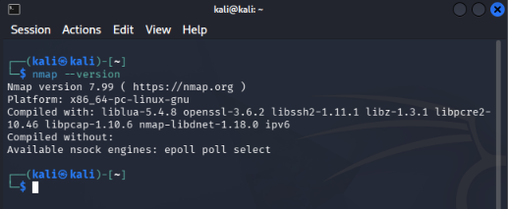
- Screenshot showing the Kali IP address and authorized subnet information.
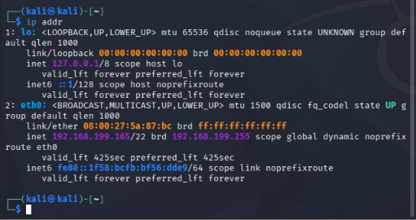
- Screenshot of host discovery results.
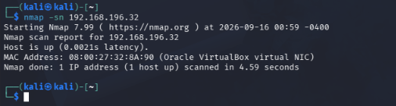

- Screenshot of the default port scan of the assigned target.
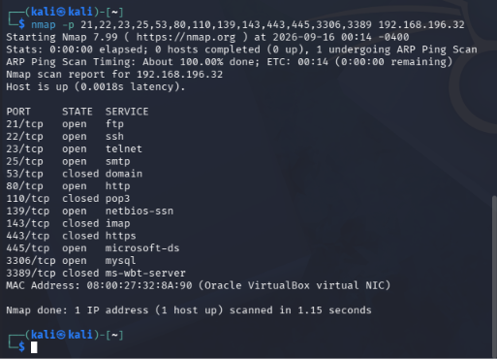
- Screenshot of service/version detection.
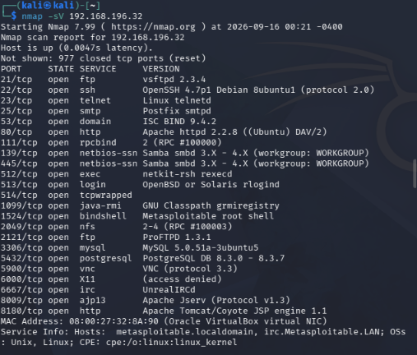
- Screenshot of OS detection or a short explanation if Nmap could not identify the OS.
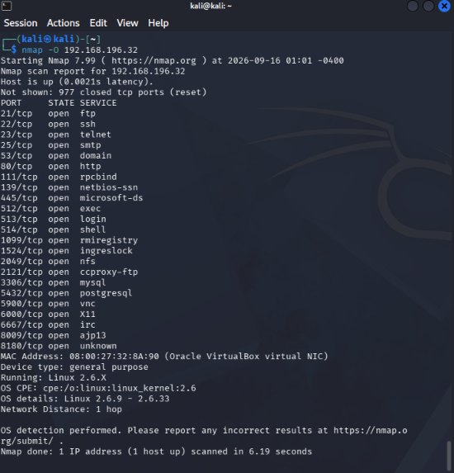
- Screenshot/output from one approved NSE script.
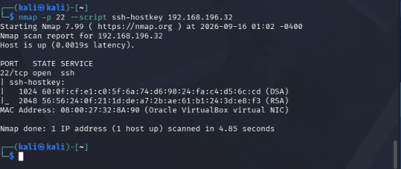
- The saved normal Nmap output file (service_scan.txt) or its contents embedded in the report.
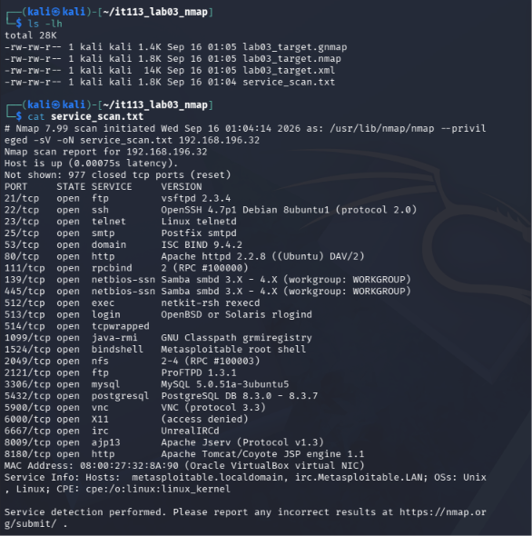
- Completed open-port/service table, guide questions, final analysis, and reflection.

Reflection
In 150-250 words, explain how Nmap supports Information Assurance and Security. Discuss how host discovery, port scanning, service identification, and documentation can help an organization understand its attack surface and prioritize security controls. Also explain why authorization and scope are essential when using network scanning tools.
Nmap supports Information Assurance and Security by helping organizations identify and understand the devices and services exposed on their networks. Host discovery determines which devices are active, giving administrators an overview of the network environment. Port scanning identifies open ports and the services accessible through them, helping reveal the organization’s attack surface. Service identification provides information about the applications and versions running on those ports, which can help administrators identify outdated, unnecessary, or potentially risky services for further review. Documentation of scan results creates a record of the network’s configuration and can support security assessments, monitoring, and prioritization of security controls. Nmap results should be treated as evidence rather than proof that a vulnerability exists. Organizations can use the information to determine which services need stronger access controls, updates, or removal. However, network scanning must always follow authorization and defined scope. Scanning systems without permission can disrupt services, trigger security alerts, or expose information that the scanner is not authorized to access. In a classroom environment, restricting scans to an assigned and isolated target helps ensure that the activity remains controlled, legal, and safe.

Assessment Rubric (60 points)

Criterion | Description | Points
Environment and scope | Correct isolated network setup; target clearly identified and authorized. | 6
Network identification and host discovery | Accurate IP/subnet information and correct host discovery evidence. | 8
Port scanning | Correct execution and interpretation of default, selected-port, and comparison scans. | 12
Service and OS identification | Accurate use and cautious interpretation of -sV and -O results. | 10
NSE and output management | Approved script used correctly; scan files saved and organized. | 8

Analysis and security observations | Evidence-based observations and practical hardening recommendations. | 8
Documentation and reflection | Complete screenshots/tables, guide questions, professional report, and reflection. | 8
TOTAL |  | 60

References
- Lyon, G. F. Nmap Network Scanning: The Official Nmap Project Guide to Network Discovery and Security Scanning.
- Nmap Project. Nmap Reference Guide / manual page (man nmap).
- Kali Linux documentation for package and networking administration.
- Course laboratory policies and instructor-provided scope/rules of engagement.

