AEROO Space AI Competition 2026

“Second Stage, Second Life: An AI Concept for
Repurposing Falcon 9 Boosters as Orbital Cleaners”

Participants: Nurlanqyzy Ayazhan,
Raimzhan Satbike
Supervisor: Mustafa Zhalgas

Shymkent, 2026
Second Stage, Second Life: An AI Concept for Repurposing Falcon 9 Boosters as Orbital Cleaners.
In a century of deep focus on exploring space we do numerous flights and launches. Satellites and rockets now are flying across Earth’s orbit. But what many of us don’t know is that there are also pieces and debris of them orbiting on Earth’s orbit like trash, more accurately “space junk”. It also can be dead satellites or “boosters of rockets” that were left in free orbiting. Currently, there are 2,000 active satellites orbiting Earth, more concerningly, 3,000 dead satellites and 34,000 pieces that are over size of 10 cm, also millions of smaller pieces. Such space junk can be dangerous to working satellites and in the future, can become a cause of Kessler Effect.
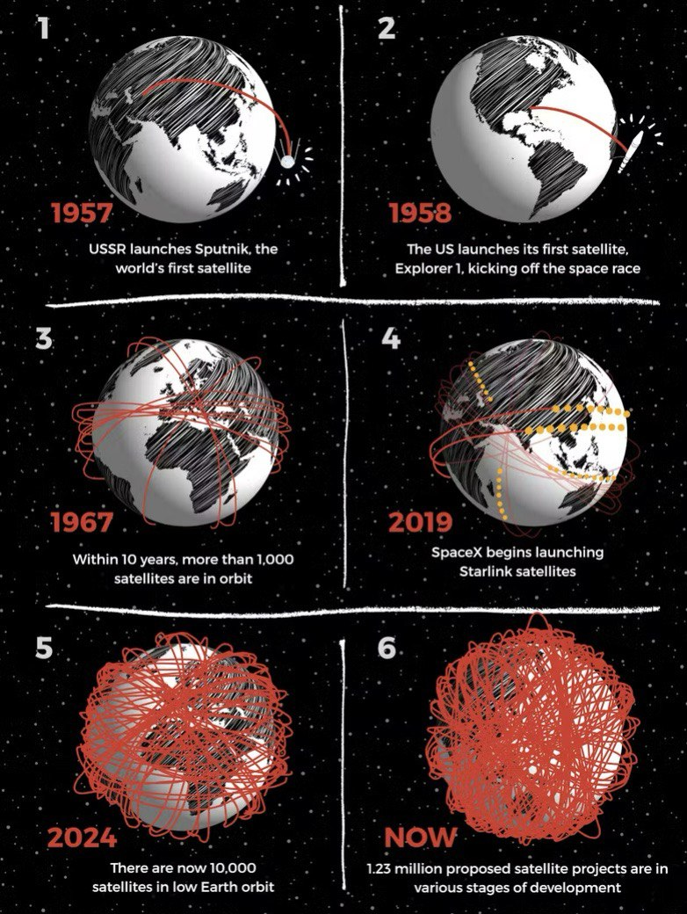

Estimated number of satellites orbiting Earth’s orbit

So, our project “second stage, second life” is aimed to make an impact on cleaning Earth’s orbit by modifying the existing technology: to design the second stage (booster stage) of a rocket so, that after finishing its main purpose it will grab the nearby piece of space junk and take it with itself back to Earth.
Rocket is a tall and thin vehicle used to carry cargo into space (people, satellites, supplies, etc.). Rocket has parts, each performing own functions: Payload system-main part with cargo into it, guidance system-controlling part with computers and such systems, body-holds propulsion systems and overall structure, propulsion systems-boosters of the rocket with engines, tanks and fuel, and fins and nose.

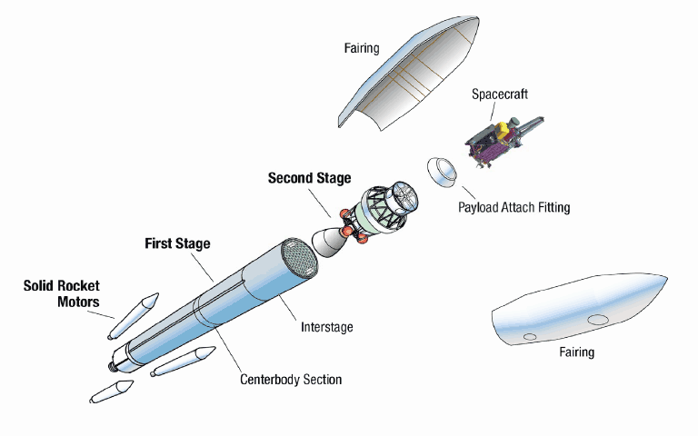

Also, the rocket separates into stages (2 to 4) and the second stage is just what we are aiming for. The second stage’s main function is to boost and push rocket, but after that, basically, it will float aimlessly in orbit.
For our project we chose the model Falcon 9 as it exactly fits the requirements. Falcon 9 (SpaceX) is a 2 staged rocket. To push the payload part-Dragon-second stage separates from it in orbit (around 200 km to 400 km). Its burnout time is 397 seconds. Basically, it is designed to reenter the atmosphere and burn fully, but why wouldn’t modify this to grab the junk and burn altogether?
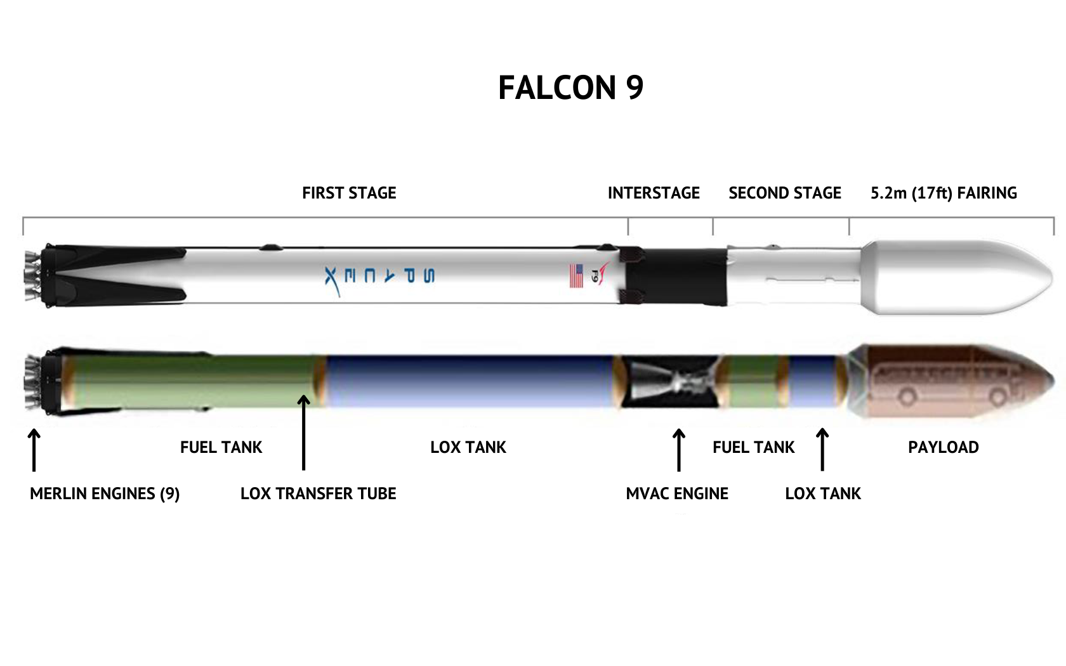

The additional components that should be added are ‘small engines for maneuvering, additional fuel tanks, grabbing system with string net and regulating mechanisms, power generating system, sensor suite for navigation and recognition, and the main part-AI controlling system.’
Engines and fuel tanks
-to let this system maneuver in orbit we need to supply it with small engines. For reference, we looked at “Baseline Orbital Maneuvering System” from NASA. Our engines can be simpler and does not require human supervision for controlling, so we can remove redundant system and use lighter material than titanium.
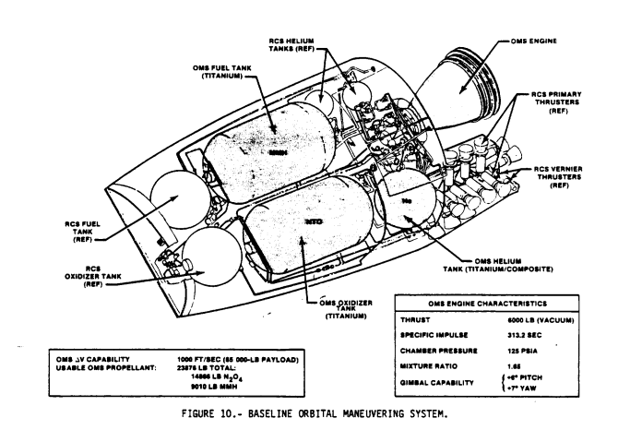

The system requires:

-Primary RCS thrusters-870N thrust each (4 units)

-Vernier RCS thrusters-110 N thrust each, for precision approach (6 units)

-Pressurization-Helium-fed system (no turbopumps, increased reliability)

-Propellant-Hypergolic (N₂O₄/MMH) — ignites on contact, no ignition system needed.

Estimated parameters:
-Total delta-V required range 100-500 m/s
-Thruster size range 100-1000 N
-Fuel mass range 500-2000 kg
-Tank volume range 1-5 m^3

Grabbing system
-We considered some options to capture debris (magnets, mechanical hands, etc.) and decided to use net as grabbing technology. Net technology, as we evaluated, is most suitable for our idea. Less needed control and simpler structure can be implemented in our favor. 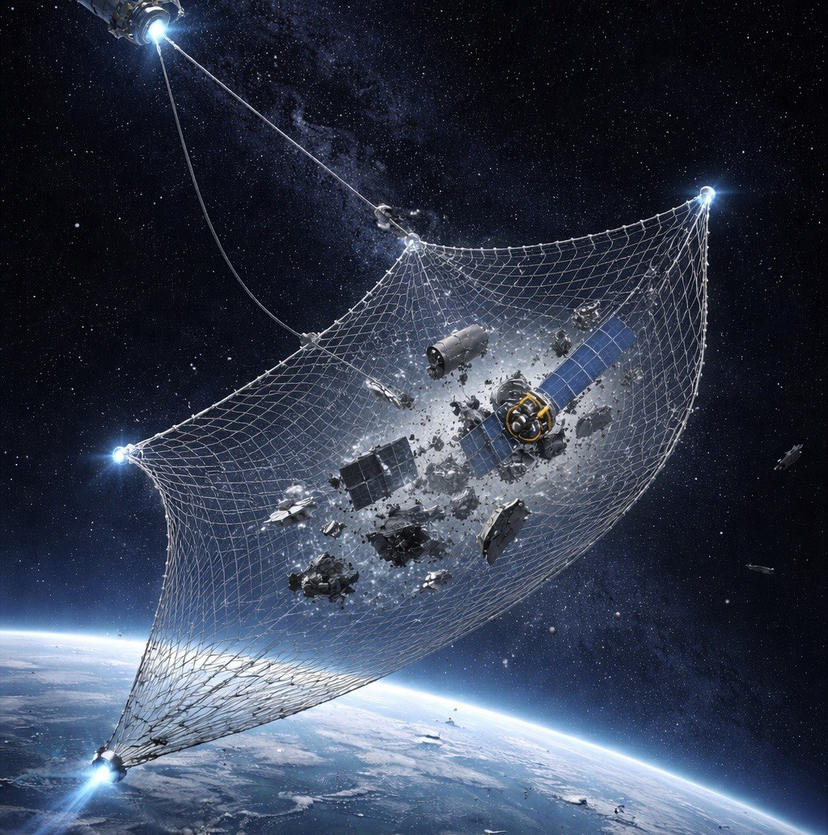

The system requires:
-Net-strong enough (Zylon, Vectran) to capture debris (7-8 km/h). Deployed diameter 5-10 m, mesh size 10-50m.
-Deployment-thrusters to push net toward target, housing container to store folded net before deployment, release system, tethers to connect net to stage after capture.
-Capture confirmation system-force sensors to detect when debris contacts net, cameras to visual confirmation, light radar to calculate the distance.
-Retraction system-winch mechanism to reel in tethers after capture, motor drive for retraction power, locking mechanism to secure debris during deorbit.
Power Generation system
For our modified second stage we need additional power as batteries in Falcon 9 itself has limited power. The power has to supply AI, sensors, thrusters, and capturing mechanism. Big batteries are what we are considering due to simplicity and duration of operation.

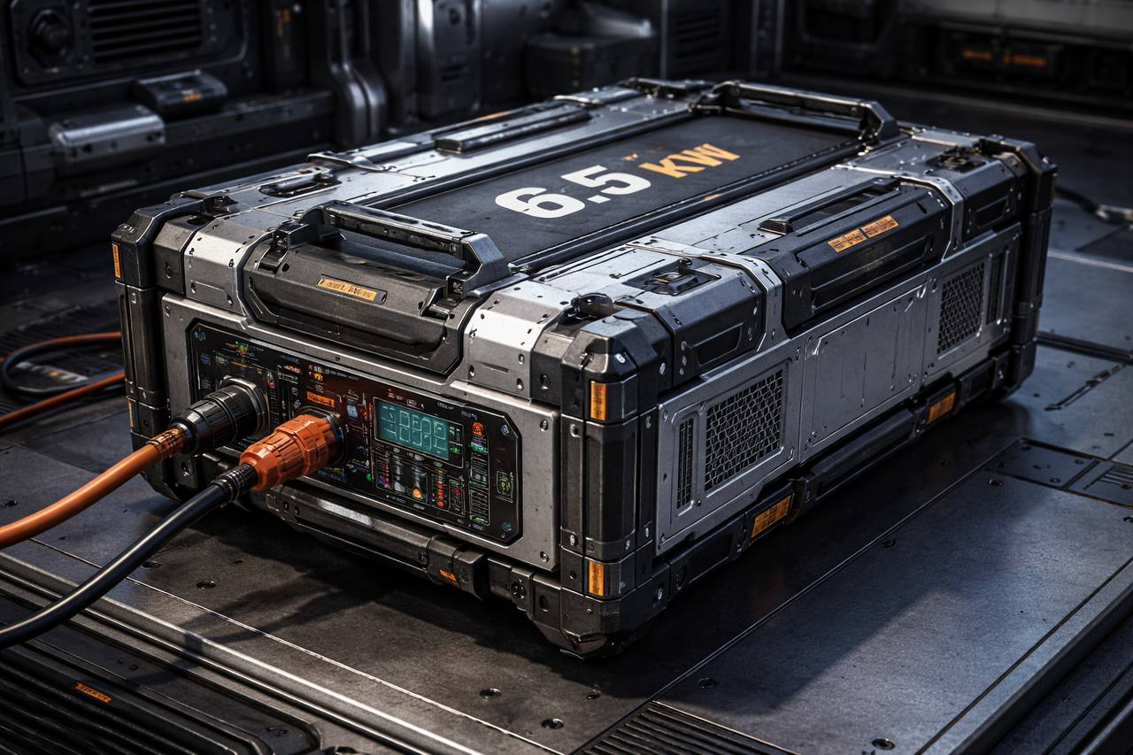

-Big batteries-power range 5-6.5kW, 10-20 kg, duration hours to days.

AI Automation system
The brain of our operation AI integrates everything-sensors, navigation, decision-making, capture execution.
For real-time requirement it ranges about 0.1-1000 Hz.
IEEE research in 2025 used by us as a reference by its breakthrough approach using Graph Attention Networks (GAT) for debris missions.

-Linear Quadratic Regulator (LQR)-for coarse trajectory following.
-Model Predictive Control (MPC)-for precise positioning.
-Sliding Mode Control-for millimeter precision.
-Adaptive control-to stabilize and capture the debris.

Multimodal fusion framework
SUPERVISOR LAYER: Mission management, safety monitoring, abort decisions.
PLANNING LAYER: Trajectory optimization, capture strategy, task allocation.
FUSION LAYER: Multi-sensor fusion, state estimation.
PERCEPTION LAYER: Object detection, pose estimation, motion tracking.
HARDWARE ABSTRACTION: Sensor drivers, actuator commands, time sync.

Role of AI in our project
Artificial intelligence plays a crucial role in our project and it has to work with limited time, fuel and rapidly changing environment. Functions of AI:
- Computer Vision
- AI analyses images from cameras and radars
- Differs valuable debris such as old satellite from dangerous, useless ones
- Trajectory Optimization
- AI calculates best way to approach debris without bumping, accidents, way of minimizing fuel and way of approaching to open the mesh
- Mission planning
- In space there are a lot of debrises, AI should decide order of collecting it
- It considers size, outcomes and available size
- Robotic control
- Moment of capturing a fractures, it evaluates shape and velocity, commands degree, sides to approach
- In case of sharp or heavy space object, it can stop its attempt
- Cost, benefit
- AI always calculates amount of fuel sufficient for returning back
- In case of little fuel, it will analyse cost and benefits considering all condition and return if necessary.
Hardships with legal permission
Ownership of a space objects is a complex question and according to international rights, such objects continue belonging to the country, that launched the object. Even if satellite broke down, or became wreckage, country still has control over it, there is no legal definition of space litter, only space objects. In case of finding such objects in foreign country, that country must return it to owner. That’s why it is mandatory to have a legal permission for grabbing space litter. However, experts offer to create an international organization which will make process of permission for simple. Requirements for collecting:
- Permission of a country for registration of an object
- Process for using UN diplomacy to create safe, legal environment for removing debris
- Potentially payment to owner for utilization

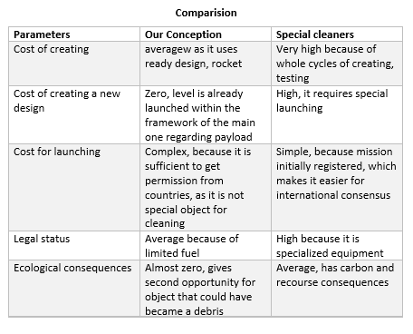
Relevance
- The problem has reached a critical point. There are more than 36,500 objects larger than 10 cm and over 330 million fragments smaller than 1 cm in Low-Earth orbit. We are on the verge of Kessler syndrome—an effect in which collisions generate new debris, making orbit unusable for decades.
- Economic losses are growing. Every year, satellite operators spend billions of dollars on hanced hull protection, and insurance.
- Resource recycling. Our project is unique in that it solves the debris problem without creating new debris.
Trends
First of all, spaceflight operated on the principle of not delving deeply into the remains of a rocket in space. Now the trend is changing. SpaceX is returning the first stages. Secondly modern missions can no longer rely solely on ground control. Signal latency makes manual debris capture impossible. Thirdly, reducing launch costs thanks to reusable rockets (Falcon 9, Starship) makes missions previously considered science fiction economically viable. Our idea takes full advantage of this advantage. Fourthly insurance companies are losing billions due to space debris. They are beginning to require operators to prove a clean-up plan before issuing policies.

Total Estimated cost of our project
Component category | Estimated cost range
AI flight Computer | $500,000-2,000,000
Net capture system | $1,000,000-3,000,000
RCS thrusters (4-6) | $500,000-1,500,000
Propellant Tanks | $200,000-800,000
Solar Arrays (2-5kW) | $1,000,000-2,500,000
Sensor package | $1,000,000-2,000,000
Integration | $1,000,000-3,000,000

Comparison of alternatives
Approach | Cost | Notes
Our modified debris | $5-15 million | One-time modification
Dedicated debris mission | $100-350 million | Separate launch + spacecraft
EDDE campaign | $70-90 million /year | Continuous

Conclusion
It is technically feasible. Upgrading the stage with a grid, sensors, and AI is within the capabilities of current technology. Using a such platform reduces the cost significantly compared to building a specialized vehicle from scratch. The launch has already been paid for by the client. Modification costs ($15-$33 million) are recouped with a contract price of $20-$50 million for the clean-up of a large object. Despite the complexities of ownership, the world is moving toward the creation of international payment mechanisms for clean-up. Early market entry will allow for customized standards. The project also gives a second life to an object doomed to become debris, while simultaneously cleaning up orbit.

Sources

https://ru.wikipedia.org/wiki
https://share.google/GX8pWRTtYAjFeAaqC
https://share.google/AwN6FSQKTTTO6gDME
https://www.aerospacetestinginternational.com/news/research-calls-for-operator-fees-to-pay-for-space-debris-clean-up.html
http://journal.yiil.org/home/archives_v18n2_04
https://conference.sdo.esoc.esa.int/proceedings/sdc6/paper/86
https://amostech.space/year/2010/electrodynamic-debris-eliminator-edde-design-operation-and-ground-support/
https://www.taylorwessing.com/en/interface/2025/space-legal-and-industry-frontiers/from-orbit-to-courtroom
https://libcat.slu.edu/search~S5?/aKarn/akarn/-903%2C1%2C1%2CB/frameset&FF=akarcz+john&0%2C0%2C
https://www.law.nyu.edu/news/ideas/space-law-wyman-kingsbury
https://www.nhm.ac.uk/discover/what-is-space-junk-and-why-is-it-a-problem.html
https://aerospaceamerica.aiaa.org/features/understanding-the-misunderstood-kessler-syndrome/
https://www.spacex.com/vehicles/falcon-9
https://airandspace.si.edu/learn/programs/soar-together/rockets-2

