Firstly keep some good and attractive colours or graphics to the user interface (like when we drop-down the students it shows as add student and views students, there the used colours are not visible efficiently and etc.,) - Done  
  
  
**Studentspage bugs:-**

* we need a profile menu for students by displaying all the details of the student. Done

* we need a extra contact us menu where we have this photo given below Done

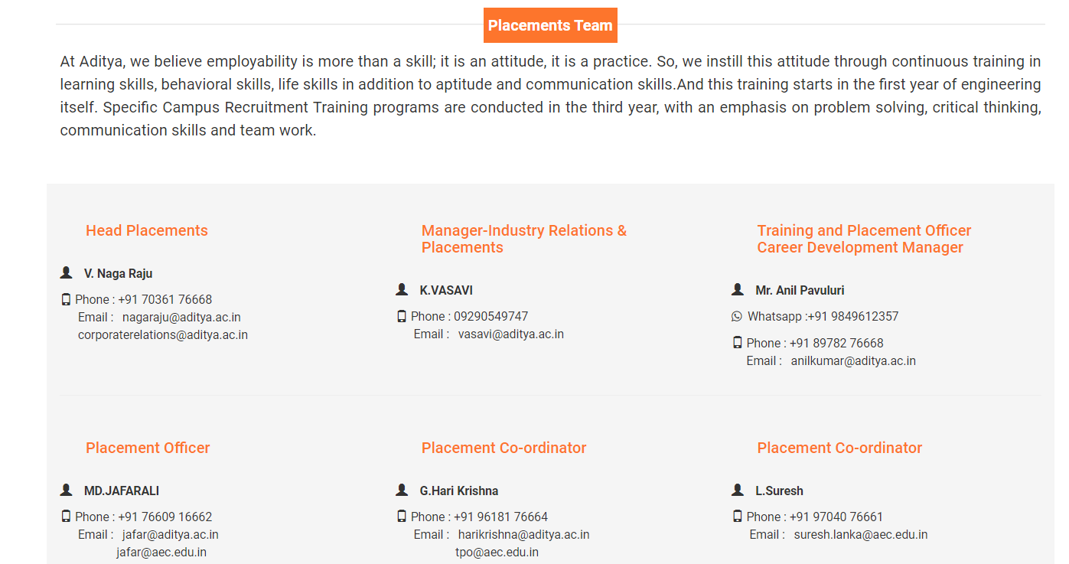

* In the view drive page at the individual post the description of the drive is not showing instead it is showing the dummy number. We want the solution such that the description must be shown such way that we mentioned in the add drive by maintaining spaces and the next line properties. ( if possible keep a show more as a link such that it can open a popup widget by displaying the description of the concern job ). Done (Didn’t add Pop up widget)

* As we asked to place the file upload option in the add drive menu at admin port, it must be accessable at the individual drive post. Done

* In a view drive page we need apply button to function in such a way that it should redirect torespected company registration page that given and after returning to the portal again we need pop-up to confirm their registration by choosing between registered or not registered pop-up widget to get the accurate count.

* As we stated we must want individual what’sapp group link button for the individual job post, add the button.

* Pls check the operation where some time without entering login credentials it is getting logged in automatically. Done

**Admin page Bugs:**

* For view students, view company, view drive, applied jobs give the accessable operation at the top of the frame such that the data can be converted to the any format like excel, pdf, docx, print, etc., options (where we already have this option at the shared UI file as shown below in picture)

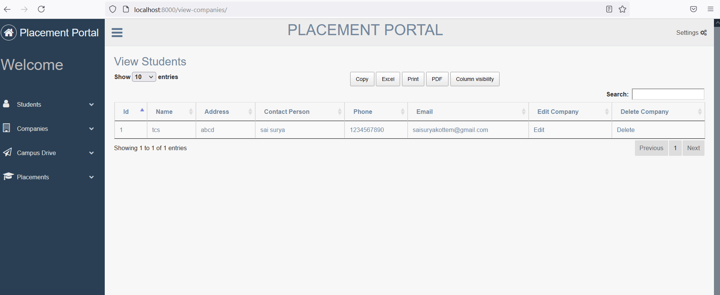

* In add student modules (page) each and every field need to have required field with validation & verification. If Validation not satisfied give a pop-up notification. Done (cannot to pop up widget)

* In add student page it must have email field. Done

* In add student page the field gender mustchoose any one (keep radio button). Done

* In add student page replace the field ‘year’ as passout_year&mention the years like 2020,2021,2022,2023… Done

* In view students when we click on edit option some of the fields data was not fetching and username, password fields also not showing do resolve the issue such that we can edit the username and password too. Done

* In add drive menu, For degree field and passout_year field we must want multiple selections for the drop-down. Such that the same post can be delivered to multiple students with different degree and passout_year’s simultaneously. (if we change this means whole project will affected it is double work for us. Have to separate tables if you need this na we need one week time to do)

* In add drive menu we need upload file field (supporting docs,pdf,spreadsheet,etc.,) so that it can be show at the job posts of student page. Done

* In add drive menu at admin portal we need apply url and whatsapp group link url fields such that it can be used in the view drives(at individual posts) for student portal

* In view drive page we need edit access to edit the fileds. Done

* In placement menu when we choose the company the eligible and student count should shown in good view to have clear appearance. Done

**optional field:-  
If possible Do keep the email service such that whenever we post a job the student must recieve the email stating the company name and descrptionas a alert to the student.(for the code u can refer the shared file to use them)**