DAY 2

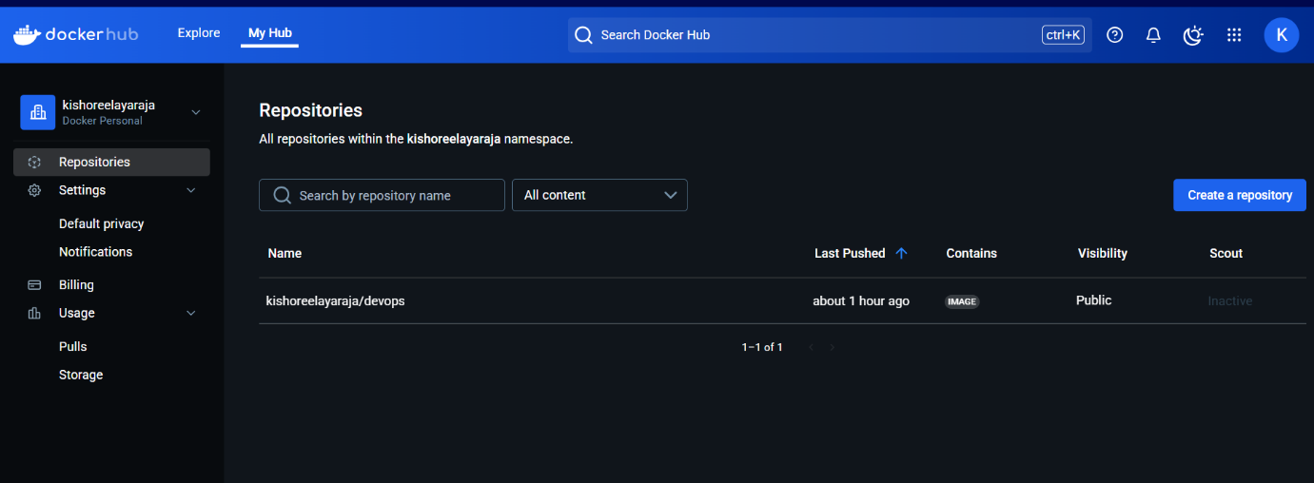

2.PIPELINE SCRIPT:
pipeline {
agent any
tools {
jdk 'jdk21' // Use the correct JDK name from Jenkins
nodejs 'node' // Use 'node' as per Jenkins configuration
}
stages {
stage('Clean Workspace') {
steps {
script {
echo "Cleaning workspace..."
deleteDir()
}
}
}
stage('Git Checkout') {
steps {
script {
git branch: 'main',
credentialsId: 'github_secred',
url: 'https://github.com/Elayarajakishore/Devops.git'
}
}
}
stage('Install Dependencies') {
steps {
script {
sh '''
echo "Checking Node.js version..."
node -v
if [ -f package.json ]; then
echo "package.json found. Running npm install..."
npm install
else
echo "ERROR: package.json is missing. Exiting..."
exit 1
fi
'''
}
}
}
stage('Docker Build & Push') {
steps {
script {
withDockerRegistry(credentialsId: 'docker', toolName: 'docker') {
def imageName = "kishoreelayaraja/devops"
def tag = "latest"
sh "docker build -t ${imageName}:${tag} ."
sh "docker push ${imageName}:${tag}"
}
}
}
}
stage('Deploy Docker Container') {
steps {
script {
sh "docker stop devops_container || true"
sh "docker rm devops_container || true"
sh "docker run -d --name devops_container -p 3001:3000 kishoreelayaraja/devops:latest"
}
}
}
}
}

3. TOOLS CONFIG:
Java
Nodejs
Docker
4.Plugins:
Nodejs
Docker related(except build)
Eclipse
Pipeline
5.credentials:
Github&docker
For docker build &deploy
Sudo usemod -aG docker Jenkins
Sudo chmod 666 /var/run/docker.sock
Sudo systemctl restart Jenkins
Sudo systemctl status Jenkins

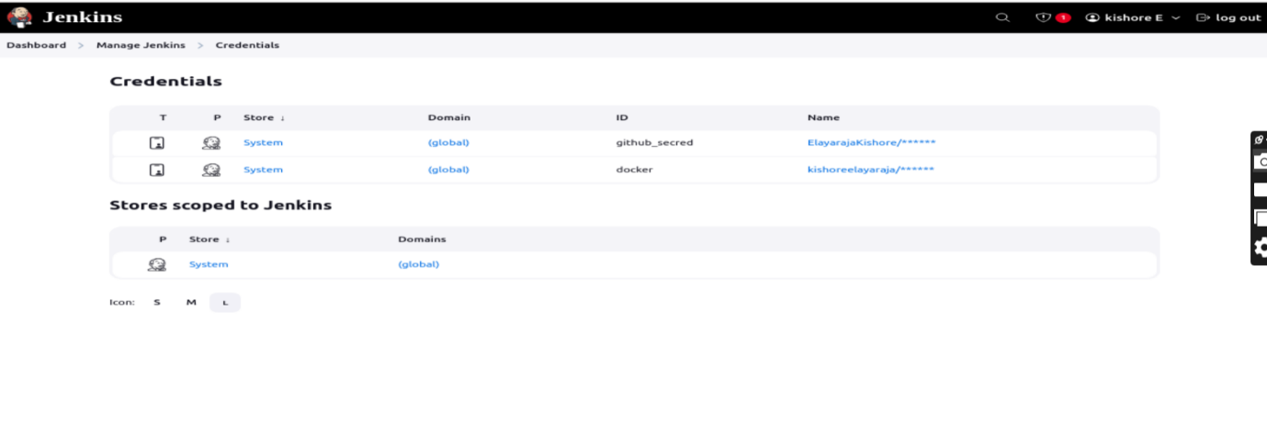

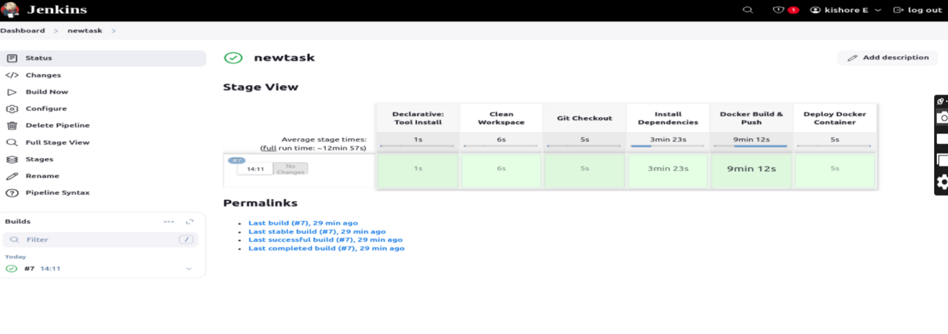

localhost:3001


