**Type:- 1**

**Enqueue Operation & Display**  **Dequeue Operation:**

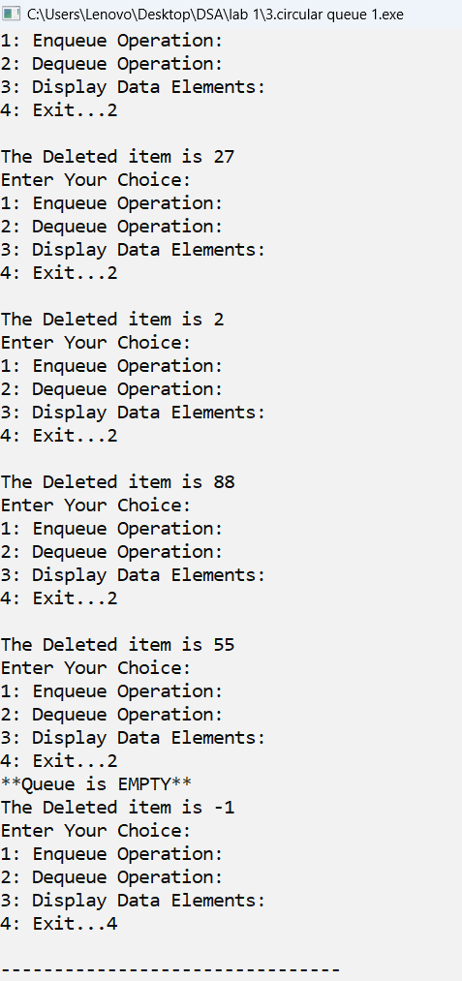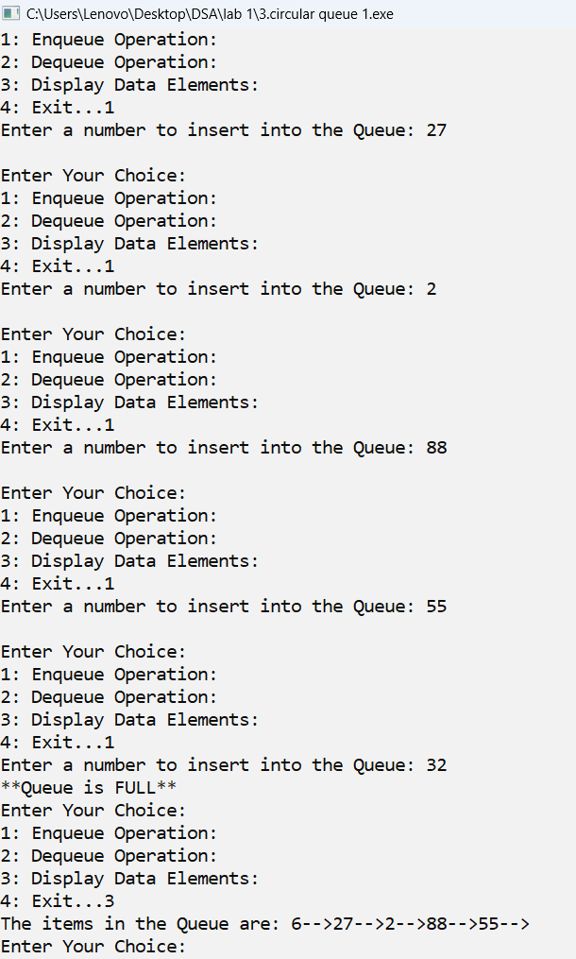

**Type:- 2**

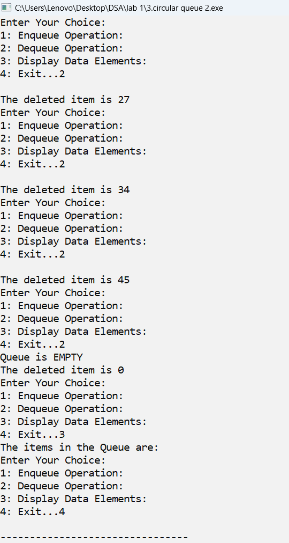**Enqueue Operation & Display**  **Dequeue Operation:**

