COURSEWORK SUBMISSION FORM
STUDENT USE |  | STAFF USE
Module Name | Fundamentals of Information Technology | First Marker’s  (acts as signature)
Module Code | 4BUISO12C | Second Marker’s  (acts as signature)
Lecturer Name | Olga Yugay | Agreed Mark
UoW Student IDs |  | For Registrar’s office use only (hard copy submission)
WIUT Student IDs | 00007977
Deadline date | 16 March, 2020
Assignment Type | Group Individual

SUBMISSION INSTRUCTIONS

COURSEWORKS must be submitted in both HARD COPY (to the Registrar’s Office) and ELECTRONIC unless instructed otherwise.
For hardcopy submission instructions refer to: http://intranet.wiut.uz/Shared%20Documents/Forms/AllItems.aspx - Coursework hard copy submission instructions.doc
For online submission instructions refer to: http://intranet.wiut.uz/Shared%20Documents/Forms/AllItems.aspx - Coursework online submission instructions.doc

MARKERS FEEDBACK (Continued on the next page)
Contents
Introduction 3
Review 3
1. Software Solutions and tools 4
2. Computers hardware 3
Justification and recommendation 10
Conclusion 11
Links 11
References 11

Introduction
Our client is the start-up company that develops both Android and IOS mobile application. Our goal is to provide consultancy on relevant hardware and software tools for the company to operate properly. All team members, including designers, developers, project managers and testers, need to receive a guidance regarding computers and software solutions necessary to do their jobs.
The report provides an extensive analysis of possible hardware and software solution for each category of staff and recommends the most optimal set of options in order for the start-up to operate efficiently.

Review

Computers hardware
Server
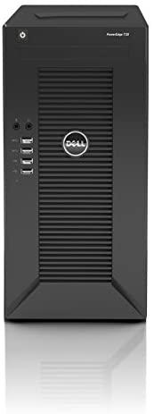
The most appropriate server for the start-up should be robust to cope with the intense workload as well as expandable in case of the business decides to get upgraded or expanded (Athow, 2019). The following server is the result of 20 years of experience that Dell Company has been gaining in server production field.

 | Specifications
Title | Dell PowerEdge T20 [barebones]
CPU | Intel Pentium G3220
Graphics | Intel HD Graphics
RAM | 4GB
Storage | No drivers included
Connectivity | Up to 12 x USB ports (4 x USB 3.0), 2 x DisplayPort, VGA, serial, 2 x PS2, Gigabit Ethernet
Dimensions (W x D x H) | 17.5 x 43.5 x 36 cm

Benefits: PRICE + SHIPPING:
1. Affordable $371.49
2. Compact mini-tower with easy access to internals
Drawbacks:
- G3220 is more a desktop than server CPU
- No drivers or OS

Desktop and Laptops
Processor | 7th Generation AMD A6 9225 Processor, dual core, 2.60GHz.
Monitor | 10-point touch enabled 23.8" Diagonal widescreen FHD (1920x1080) IPS WLED backlit micro edge monitor.
Memory | 4 GB DDR4 2133 SDRAM (upgradable to 16 GB)
Hard Drive | 1 TB 7200Rpm SATA.
Operating System | Windows 10 Home
Keyboard and Mouse: | HP White wired Keyboard with volume control and white wired Optical Mouse.
Specifications for Project manager
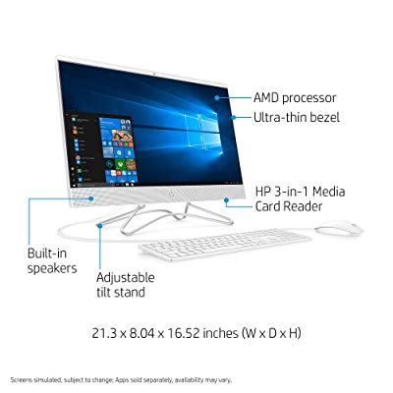

PRICE + SHIPPING: $1459.49

Specifications for Designers and IOS developers
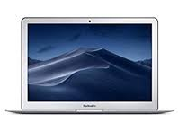
Processor | 2.2GHz Dual Intel Core i7
Monitor | Intel HD Graphics 6000 4K UHD Screen,
Memory | 8GB 1600MHz LPDDR3 memory
Hard Drive | 256GB SSD storage
Operating System | MacOS
Battery life | 12 hours
Apple MacBook Air Z0UU3LL

PRICE: $899.99
*Alternatively, the company can buy desktop with similar configurations. The price will not significantly vary in this case.

Specifications for Android Developers
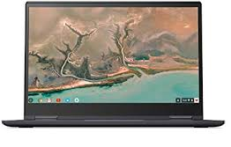
Lenovo Yoga C630 2-in-1 15.6 “Touchscreen Chromebook”
Processor | 8th Generation Intel® Core™ i5-8250U Processor (1.60GHz, up to 3.40GHz with Turbo Boost Technology, 6MB Cache)
Monitor | Integrated Intel® UHD 620 Graphics
Memory | 8GB DDR4 2133MHz
Hard Drive | 128GB eMMC
Operating System | Chrome OS
Dimensions (W x D x H) | 14.2" x 9.8" x 0.7" / 361.5 x 248.5 x 17.8 (mm)
Ports | 2 x USB-C, USB 3.0, MicroSD slot, headphone/mic combo
Battery life | 10 hours

Price: $699 $ 499

Specifications for tester
Acer Aspire 5 Slim Laptop
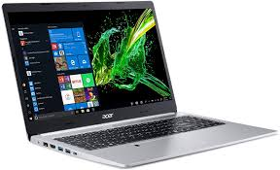
Processor | AMD Ryzen 3 3200U Dual Core Processor (Up to 3.5GHz);
Monitor | 15.6 inches Full HD (1920 x 1080) Widescreen LED backlit IPS Display; AMD Radeon Vega 3 Mobile Graphics
Memory | 4GB DDR4 Memory;
Hard Drive | 128GB PCIe NVMe SSD
OS | Windows 10 in S mode.
Ports | 1 USB 3.1 Gen 1 Port, 2 USB 2.0 Ports & 1 HDMI Port with HDCP support
Battery life | Up to 7.5 Hours

Price: $313.49

Software Solutions and tools
Option A – “on premises oriented”
Name | Price |  |  | OS/ Browser Support |  | Short Description |  | Benefits | Limitations
Design and Prototyping
Photoshop  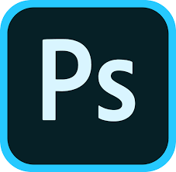 | US$20.99/month |  |  | Platform:  MacOS/Windows  iOS/Android mobile |  | Photoshop is Adobe's photo editing, image creation and graphic design software |  | - wide range of tools;  - all-purpose software;  - different image formats; | - overwhelming interface ;  - poor vector support;
Sketch   | US$99 (personal)  US$99/  year  (team) |  |  | Platform:  MacOS |  | Sketch is a design toolkit built to create best work from the earliest ideas, through to final artwork |  | - powerful vector editing;  - intuitive interface;  - lightning fast; | - fairly new in design;  - no windows support;
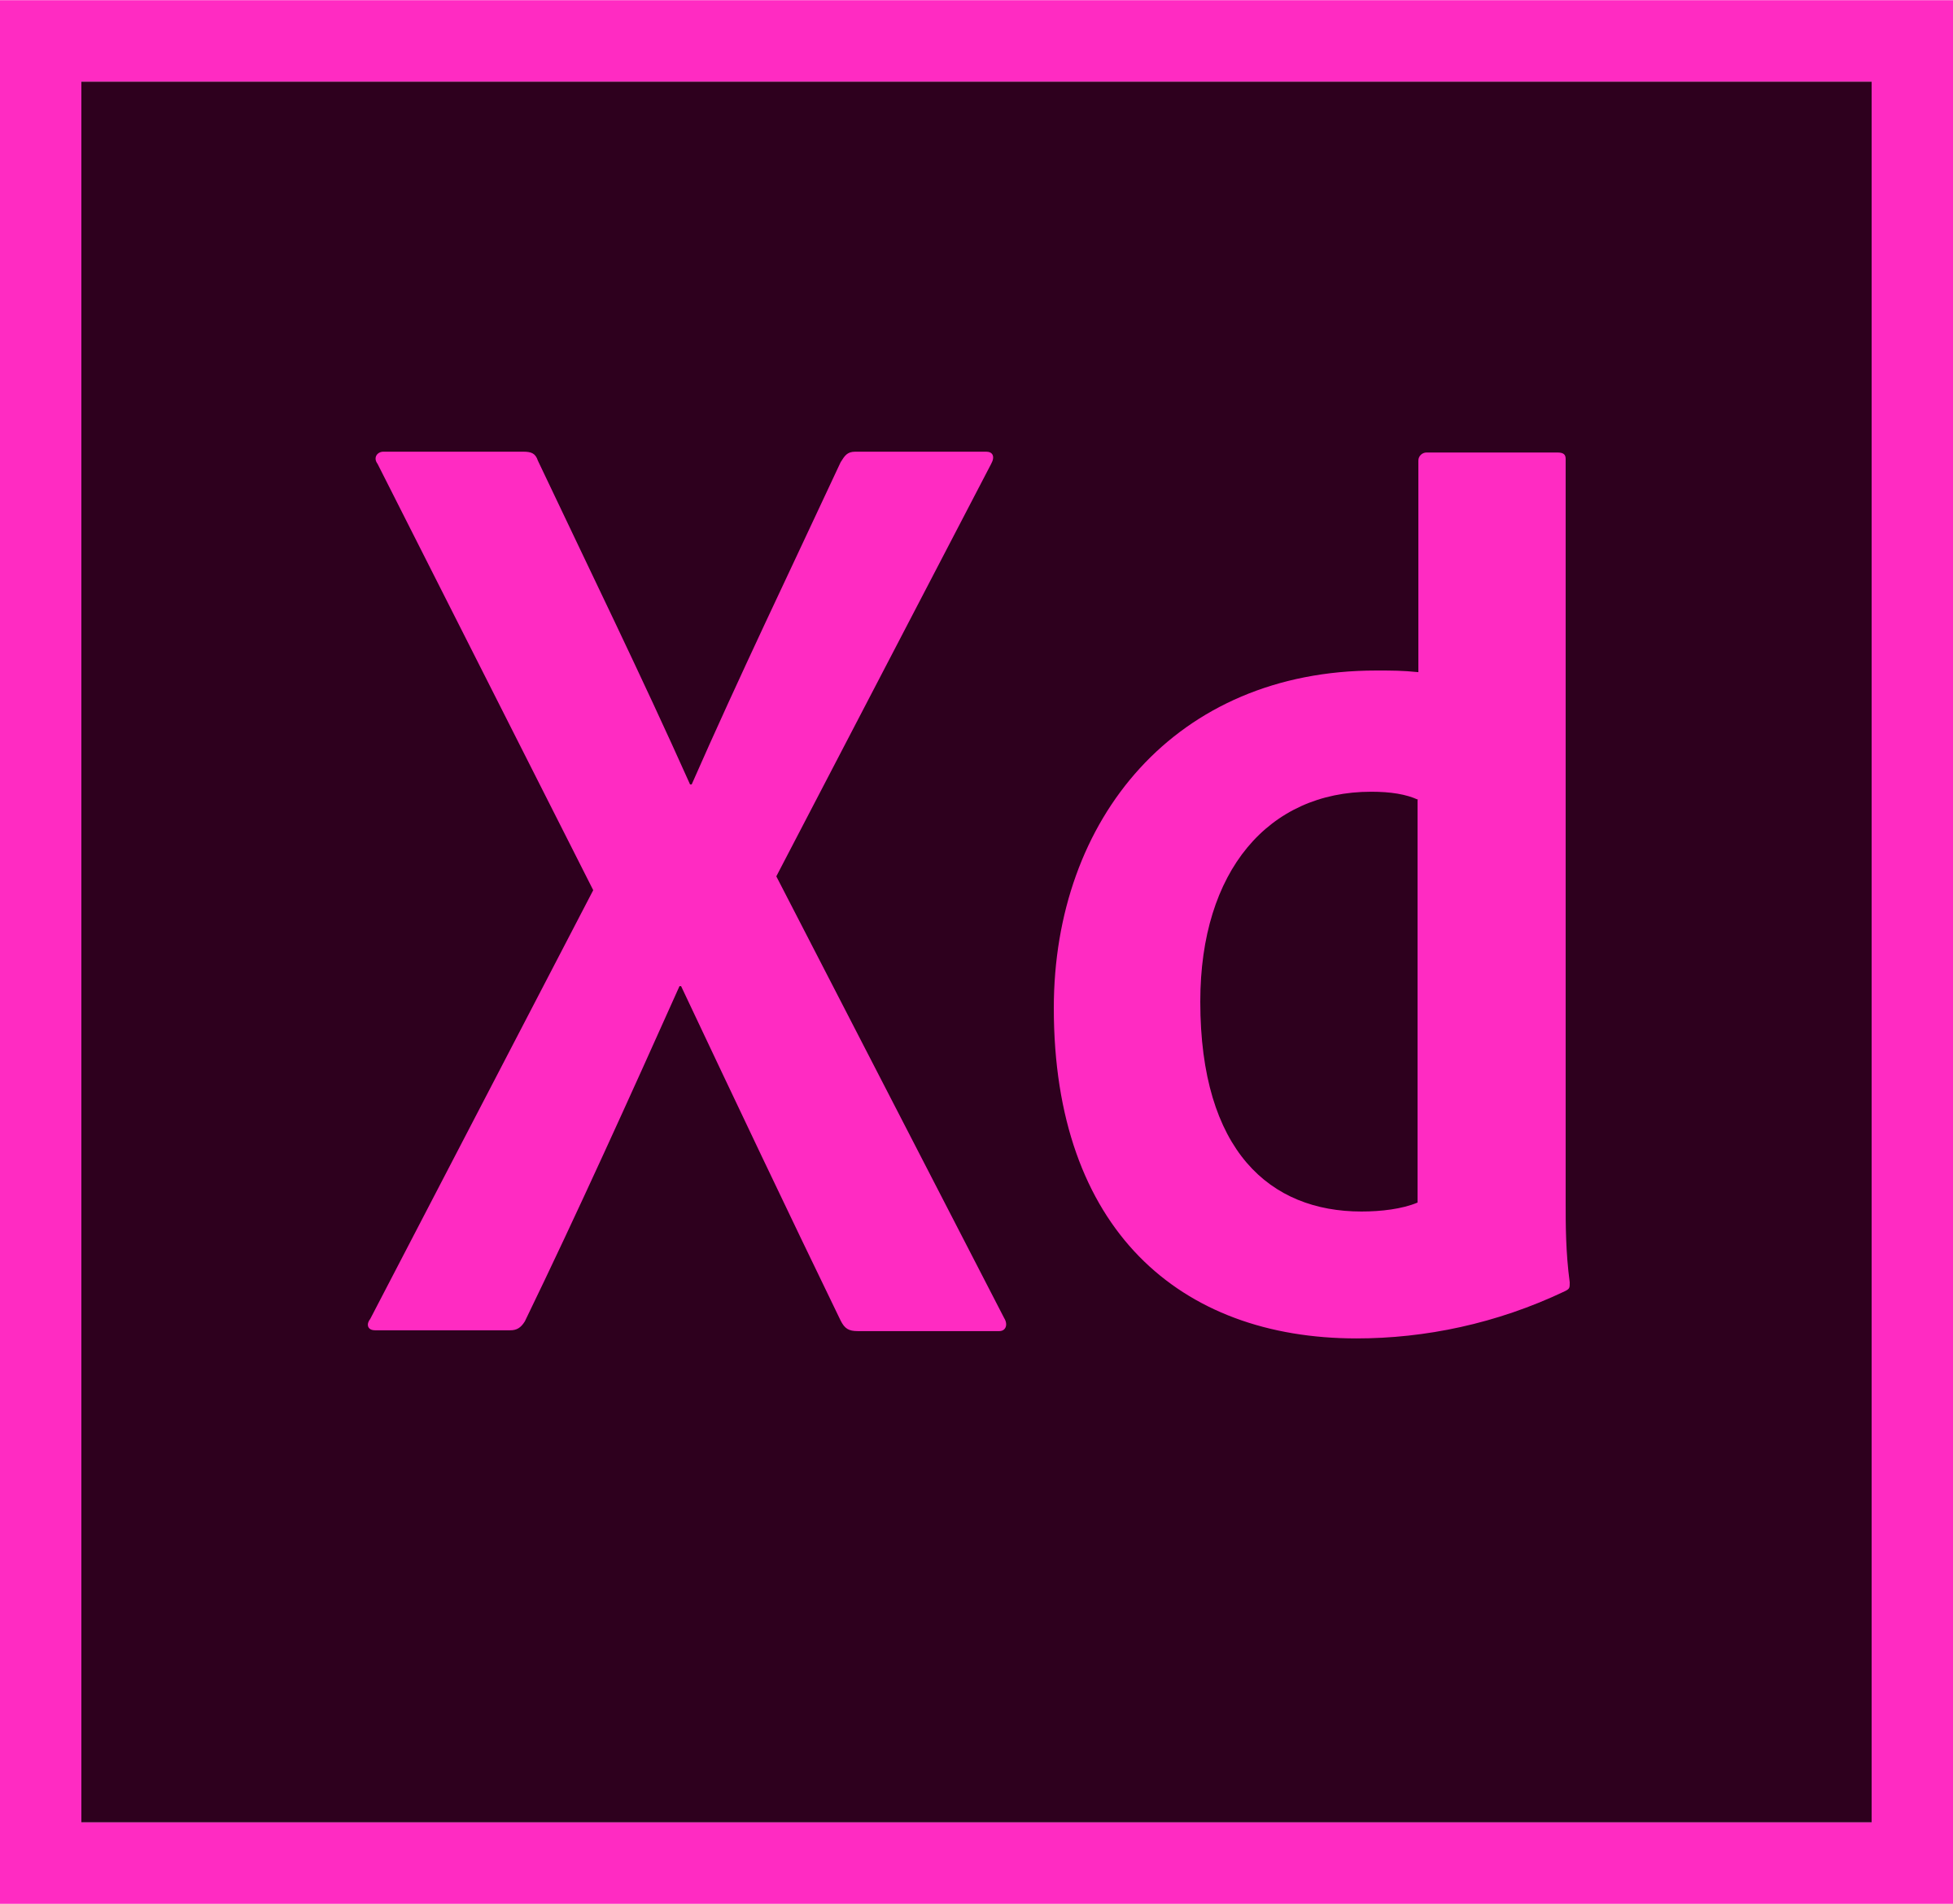  Adobe XD | Free |  |  | Platform:  MacOS/Windows  iOS/Android |  | The designer can draw, edit, create any format of graphic art |  | - Integration with other Adobe products;  - Client feedback when shared directly; | No recorded drawbacks
Software Development
Android Studio   |  | Free |  | Platform:  Windows (32-, 64-bit)  Mac, Chrome OS, Linux |  | It provide the fastest tools for building app on every type of Android device |  | - intelligent code editor;  - realtime profilers;  - apk analyzer;  - flexible build system | - not specified for IOS apps development
Code Runner  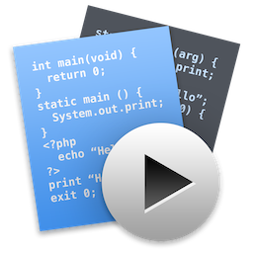 |  | US$14.99 |  | Platform:  MacOS |  | A lightweight multi-language editor for macOS |  | - Multilanguage support;  - Advanced code completion;  - Web inspector and web tools; | - No Windows/  Linux support
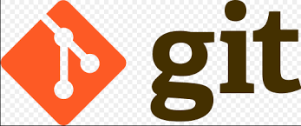 |  | Free |  | Platform:  MacOS/  Windows |  | A source control platform to enable the developers to keep track of multiple version of the same project |  | - Works along with every editing platform;  - Large product ecosystem (e.g. GitHub, GitLab); | - Not so simple to learn for beginners
Testing
Test Complete   |  | US$5,803 |  |  | Platform:  Windows  MacOS  Linux |  | Automated functional testing platform | - Free training & support;  - Keyword-driven testing;  - Automated test reporting & analysis; | - Considerably expensive;
 |  | Free |  |  | Platform:  Windows  MacOS  Linux |  | A free, open-source, cross-platform mobile UI automation platform | - Free, open-source, easily downloadable from GitHub;  - Compatible with any testing platform;  - Supports a range of programming languages; | - Testing of android lower than 4.2 is not possible;  - Requires time to configure it for both IOS and Android
  Appachchi |  | US$200/month |  |  | Mobile IOS Native  Android Native |  | The tool to automate the unit testing of start-up mobile development teams | - Able to test all installed apps in the device;  - Great user experience | - No support for IOS
Project Management
Pivot Tracker   |  |  | US$7/month | Platforms:  Desktop-  Mac/Windows  Mobile:  IOS/Android |  | It is an easy to use, agile project management tool that brings focused collaboration to software development teams |  | - User-friendly;  - Easy to track the progress and changes;  - Customizable templates; | - A lot of drag and drop;
  CoSchedule |  |  | US$ 40 | Mobile:  IOS/Android |  | Effective software to schedule the marketing project of the firm |  | - Free trial  - Online training to get experienced to use the software  - Idea management | - Cannot reschedule the tasks on the queue when priorities change
  GanttProject |  |  | US$5/  One-time | Platform:  Windows  MacOS  Linux |  | Free project management software for windows, OS X and Linux |  | - Open-source;  - Perfect for small businesses | - Not visually appealing  - Hard to handle overloading and complex tasks

Option B – “cloud oriented”
Name |  | Price |  |  | OS/ Browser Support |  |  |  | Short Description |  | Benefits |  |  | Limitations
Design and Prototyping
Adobe Stock   |  | US$29.99/month |  |  | Platform:  Mac/Windows  iOS/Android mobile;  Cloud based SaaS solution |  |  |  | High-resolution, royalty-free image collections |  | - top quality images;  - powerful Adobe support;  - global network of professionals using this tool; |  |  | - quite expensive for beginners;
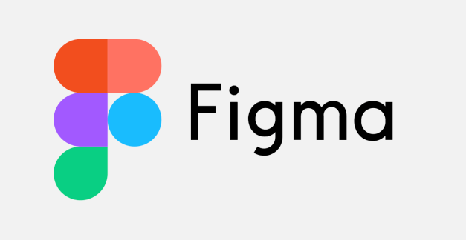 |  | Free
Software Development
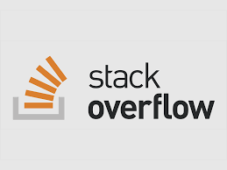 | Free |  |  |  | Universal browser support;  Cloud based SaaS solution |  |  |  | This is a question-and-answer (Q&A) website for professional and enthusiastic programmers |  |  |  | - perfect source for receiving community support;  - questioner get humane answers rather than computer-generated explanations | - sometimes the questioner does not get instant response
 | US$7/month |  |  |  | Platform:  Saas, web |  |  |  | Software development platform for all developers |  |  |  | - Access controls/ Permissions  - Reporting/ analytics  - Source control  - Saving code versions | No drawback are reported
 | Free |  |  |  | Platform:  Saas, web |  |  |  | Open-source application development environment that mobile developer can take great advantage of |  |  |  | - Ease of use  - Great customer service | - Slow startup time  - High RAM usage
Testing
TestFlight  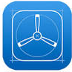 |  |  | Free |  |  | Platform:  MacOS |  | Cloud-based service for on-the-air installation and testing of mobile applications, currently owned by Apple Inc and only offered to developers within IOS Developer Program |  |  | - Excellent customer service;  - Makes testing simple;  - User-friendly, simple interface; |  |  |  | - No windows support;  - Limited size of beta feedback;
 |  |  | US$69/month |  |  | Saas, Web |  | Online platform for load testing |  |  | - Straightforward interface;  - Easy to use layout; |  |  |  | - Trial version is short to experience the taste of the software
Project Management
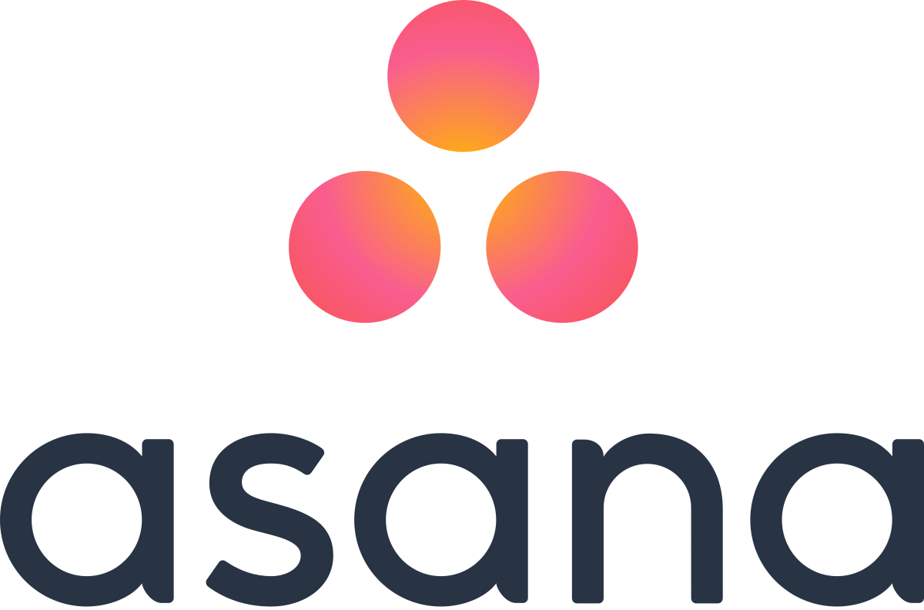 |  |  |  | US$ 10.99/month |  |  | Chrome, Safari for Mac, Firefox,  Microsoft Edge |  |  | Asana is a work management platform that enables teams to manage their projects and task |  | - Real-time communications;  - Highly visual platform; |  |  |  | - Does not support old versions of browsers;
 |  |  |  | Free |  |  | Browser: Chrome, Safary for Mac, Firefox, Micrasoft Edge |  |  | Trello is cloud-based web app to keep track of business changes and plans |  | - Large community using the software;  - Ready templates for the teams; |  |  |  | No drawbacks are recorded

Option C – “hybrid”
Name |  | Price |  |  | OS/ Browser Support |  |  | Short Description |  |  | Benefits |  |  | Limitations
Design and Prototyping
IconJar   | US$29.99/year |  |  | Platforms:  MacOS,  Saas,  Web: Chrome, Firefox, Micrasoft Edge, Safari for Macs |  |  | The personal icon organizer is just one click away and offers everything designer need to get the job done |  |  | - export icons in custom sizes;  - strong cooperation with Sketch;  - bundle similar icons with Smart Sets |  |  | - no windows support;  - expensive
 | US$19/  Month/  User |  |  | Platforms:  MacOS, Windows,  Saas,  Web: Chrome, Firefox, Micrasoft Edge, Safari for Macs |  |  | It helps to create mobile app interface with a quite ease |  |  | - 24/7 support;  - Full training courses;  - Intuitive interface;  - All the tools are in hand; |  |  | - Can get expensive as the number of designer increase
Software Development
 |  |  | US$83/month |  |  | Windows (32-, 64-bit)  Mac, Chrome OS, Linux |  |  | It provides teams with comprehensive bug and crash reports, in-app surveys and real-time user feedback |  |  | - detect bugs before each release;  - reproduce and fix bugs faster; |  |  | - considerably experience;
  Visual Studio |  |  | US$45/ month  License: US$499  Cloud Subscription:  US$45/month |  |  | Platforms:  MacOS, Windows,  Saas,  Web: Chrome, Firefox, Micrasoft Edge, Safari for Macs |  |  | A powerful platform that enables the businesses to build, edit and test apps |  |  | - Micrasoft support  - Large community  - Quality customer service |  |  | - Requires a lot of storage (more than 25 GB)
  Swiftify |  |  | US$29.99 /month/user  (free version also available) |  |  | Platform:  MacOS  Saas, Web, Cloud |  |  | #1 Objective-C to Swift Converter |  |  | - Straightforward to use;  - User specified version conversion |  |  | - No Windows support
Testing
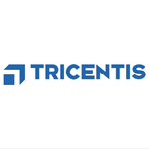  Tosca TestSuite |  |  | Not provided |  |  | Platforms:  Cloud, Saas, Web,  Windows, |  |  | The tools is used for optimization, automation as well as management of testing |  |  | - In-person tutorials  - Cross-browser support |  |  | - No support for MacOS
  Apica LoadTest |  |  | US$2000/month |  |  | Platforms:  Cloud, Saas, Web, |  |  | The tool is designed to facilitate scalability of projects |  |  | - Free trial  - 24/7 support |  |  | - Considerably expensive for small- and medium-sized businesses
Project Management
  Sympli |  |  | US$4.5/user/month |  |  | Platforms:  Cloud, Saas, Web,  Windows, MacOS |  |  | The platform is designed to facilitate the collaboration process between developers and managers |  |  | - Ease to use (no code);  - Fast share among teams;  - Effective feedback system; |  |  | - Hard to use the same project for both Android and IOS development
 |  |  | US$14/month |  |  | Saas, Web,  Platforms: Windows  Mobile:  IOS Native  Android Native |  |  | Deltek is a cloud-based platform that allows organizations of all sizes to plan, capture, manage, automate, and report on work across the business |  |  | - Track the time and expense on project basis  - Three in one: Tracking, billing and general ledger |  |  | - Not always suitable for small businesses;

Justification and recommendation
The desktop suggestions provided above can alternatively be replaced with laptop solutions since laptop in this day and age are powerful enough to supplement desktop computers. The laptop has the following advantages over desktop in case of this star-up:
- Easily portable;
- Requires minimal space as well as furniture;
The desktop computers shown in hardware section can be replaced with a laptop with the similar configurations, or vice versa.
It is highly recommended for designers as well as IOS developers to have same model MacBook, as the device is strong to handle complicated apps that both specialists have to use. Furthermore, Lenovo Yoga is the best option that the company can buy for this price. This laptop is affordable as well as powerful enough to be able to work with development software listed in the development software apps section above. This device was recommended in the official website of Android Studio, which developers will be frequently working with (Lenovo.com, 2020).
It is highly suggested that the company should use “hybrid” or “cloud based” applications rather than “on premises oriented” ones simply because the start-up does not have to shoulder the upfront financial burden than the latter create. This applies for paid applications. In term of testing, for example, instead of TestComplete sofware for testing, other alternatives can be used such as TestFlight and InstaBug.
To draw a clear picture, recommendations on software usage per user is defined below:
- Designer: Photoshop/Sketch + IconJar;
- Developer:
- IOS Specialist: Code Runner + Git + Stack Overflow + Swiftify + Github;
- Android Developer: Android Studio + Git + Stack Overflow + Visual Studio + GitHubs;
3. Tester: TestFlight/Appium
4. Project Manager: Trello + Pivot Tracker

Conclusion

Links
Link to Google Docs:
https://docs.google.com/document/d/1yghla6A0J9ub9535Sl5hsNT68nGqxUH7J_p16uPc3jU/edit?usp=sharing
Link to GitHub:
https://github.com/ElbekDeveloper/CW1.FunIT.7977.git

References

