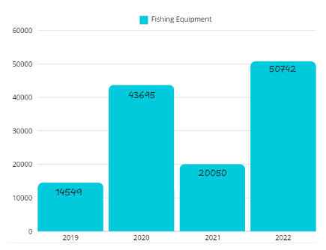

Today I'm going to talk about sales of fishing equipment.

In 2019, compared to the following years, little fishing equipment was sold, fourteen thousand, five hundred and forty nine pieces of equipment.

In 2020, there was an increase in sales, thus increasing the popularity of fishing. Forty three thousand, six hundred and ninety five pieces of equipment were sold, a big jump compared to the previous year.

In 2021, there was a decrease in sales, with Twenty thousand and twenty pieces of equipment sold. Higher value compared to 2019.

And in 2022, being the best year for sales, reaching Fifty thousand, seven hundred and forty two pieces of equipment sold. And according to studies, in 2023 this value could increase