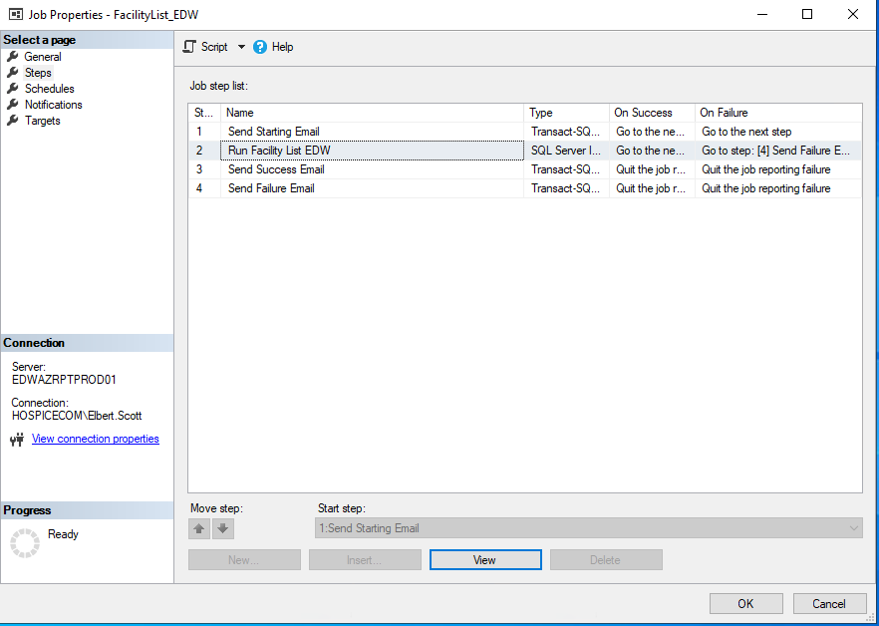

--Send Starting Email

Send Starting Email

EXEC msdb.dbo.sp_send_dbmail

@recipients = N'elbert.scott@ctipartners.co; trustaff@etljob.com ',

@body = N'The Margin Calculator job on SQLAZUProd01 has Started processing.',

@Body_Format = 'HTML',

@Subject = '[CO999] Margin Calculator job on SQLAZUProd01 has Started.'

--Send Success Email

EXEC msdb.dbo.sp_send_dbmail

@recipients = N' elbert.scott@ctipartners.co; trustaff@etljob.com ',

@body = N'The Margin Calculator job on SQLAZUProd01 has Finished.',

@Body_Format = 'HTML',

@Subject = '[CO999] Margin Calculator job on SQLAZUProd01 has Finished.'

--Send Failure Email

EXEC msdb.dbo.sp_send_dbmail

@recipients = N' elbert.scott@ctipartners.co; trustaff@etljob.com ',

@body = N'The Margin Calculator job on SQLAZUProd01 has Failed.',

@Body_Format = 'HTML',

@Subject = '[CO999] Margin Calculator job on SQLAZUProd01 has FAILED!!!.'

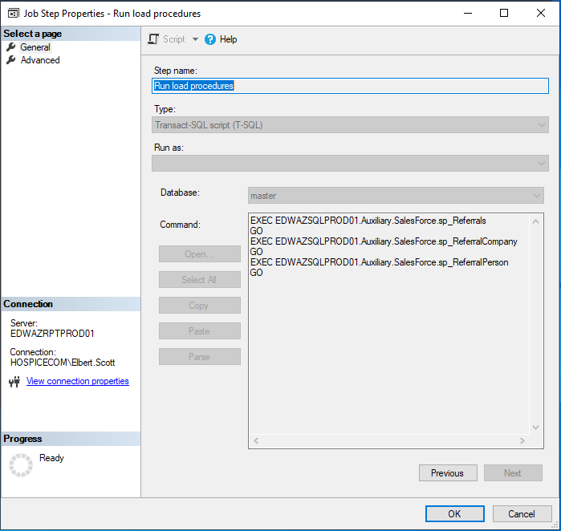

EXEC EDWAZSQLPROD01.Auxiliary.SalesForce.sp_Referrals

GO

EXEC EDWAZSQLPROD01.Auxiliary.SalesForce.sp_ReferralCompany

GO

EXEC EDWAZSQLPROD01.Auxiliary.SalesForce.sp_ReferralPerson

GO