 

**Addis Ababa Institute of Technology**

**Center of Information Technology and Scientific Computing**

**Department of IT/SW Eng.**

**eMazon**

**Software Requirements Specification**

Submitted to: Instructor Natnael

Team Members

1. Elbetel Gezahegn ATR/3445/08
2. Kimiya Mohammed ATR/2765/08
3. Lulit Mulugeta ATR/3806/08
4. Rahel Getachew ATR/0621/08
5. Yeabsira Gashaw ATR/6749/08
6. Yonas Alem ATR//08
7. Abel Girma ATR/1442/08

**DATE: 24/03/2018Table of Contents**

List of Tables 3

List of figures 4

Acronyms 5

DECLARATION 6

1. Introduction 7

1.1 Background 7

1.2 Scope 7

1.3 Overview 8

2. General Description 9

2.1 Product Perspective 9

2.2 Product Functions 9

2.3 User Characteristics 10

2.4 General Constraints 11

2.5 ASSUMTIONS AND DEPENDENCIES………………………………………………....11

3. Specific Requirements 12

3.1 External Interface Requirements 12

3.1.1 User Interfaces 12

3.1.2 Hardware Interfaces 20

3.1.3 Software Interfaces 20

3.1.4 Communications Interfaces 21

3.2 Functional Requirements 21

3.3 Use Cases 29

3.4 ER DIAGRAM…………………………………………………………………………………… 41

3.5 Non-Functional Requirements 42

3.5.1 Performance 42

3.5.2 Reliability 42

3.5.3 Availability 42

3.5.4 Security 42

3.5.5 Maintainability 43

3.5.6 Portability 43

3.6 Inverse Requirements 43

3.7 Design Constraints 43

4. Change Management Process 44

**Reference…………………………………………………………………………45**

**List of Tables**

Table 1 FR 1 ............................................................ 21

Table 2 FR 2 ............................................................ 21

Table 3 FR 3 ............................................................ 22

Table 4 FR 4 ............................................................ 22

Table 5 FR 5 ............................................................ 23

Table 6 FR 6 ............................................................ 23

Table 7 FR 7 ............................................................ 23

Table 8 FR 8 ............................................................ 24

Table 9 FR 9 ............................................................ 24

Table 10 FR 10 ............................................................25

Table 11 FR 11 ............................................................ 25

Table 12 FR 12 ............................................................25

Table 13 FR 13 ............................................................26

Table 14 FR 14 ............................................................26

Table 15 FR 15 ............................................................27

Table 16 FR 16 ............................................................27

Table 17 FR 17 ............................................................27

Table 18 FR 18 ............................................................28

Table 19 FR 19 ............................................................28

Table 19 FR 20 ............................................................29

List of figures

Fig 1: ER Diagram………………………………………..41

**Acronyms**

FR → Functional Requirement

UC → Use case

i.e. → that means

**DECLARATION**

We declare that this written document represents our ideas in our own words and where others’ ideas or words have been included. We have adequately cited and referenced the original sources. We also declare that we have adhered to all principles of academic honesty and integrity and haven’t fabricated any idea in our document. We understand that any violation of the above will be cause for disciplinary action by the Institute and can evoke penal action from the sources which have thus not been properly cited or from whom proper permission has not been taken when needed.

1. **INTRODUCTION**

This section provides the purpose, a scope description and overview of everything included in this Software Requirements Specification document.

**1.1 Background**

Over the past few years, Internet has become more and more popular. At the same time, it produces a new way of doing business between business and business, business and consumers.

A common use of business to consumer ecommerce is our project eMazon. In many aspects, eMazon changes the traditional ways of doing businesses.

This project is to study the requirements and design of the customer-friendly online shopping for a computer company.

Therefore, why we build customer-friendly online shopping, what is customer-friendly online shopping, how can we build it, how can we get requirements and how can we design are the topics of the report.

**1.2 Scope**

This project targets people who have access to internet and basic understanding of website navigation. It is mainly designed to help customers shop items online and thus, user engagement is necessary to fully benefit from the website application project.

Features:

* eMazon is customer friendly online shopping site.
* eMazon supports either online payment or cash in delivery i.e. one can pay in person.
* eMazon refund items within 3 days.
* eMazon help customers choose the best items by letting them compare between items.
* eMazon lets signed up customer put items in a wishlist so that they can buy it another time.
* eMazon also lets customers give feedbacks about items and services.

**1.3 Overview**

The rest of this document includes three chapters. Chapter two provides an overview of the product perspective and product functions. Product perspective gives a brief description on the uniqueness of the project and the product functions about the exact functions of the end product.

The second chapter also describes the user characteristics - a detailed description of the user profile. Further, the chapter also mentions the general constraints of the system.

The third chapter provides the requirements specifications and a description of the different system interfaces. It is mainly written for the developers and describes in technical terms the details of the functionality of the project.

The fourth and the last chapter presents the change management process which is a section that defines the set of activities that need to be performed when there are some new requirements or changes to new requirements.

2. **General Description**

2.1 Product Perspective

eMazon is an e-commerce website which is mostly used to sale products manufactured in Ethiopia. It allows the people in Ethiopia to know and purchase the products manufactured in their country. There are other e-commerce sites; our system mainly focuses on the products of Ethiopia, expanding Ethiopia’s market being its main purpose.

There are also a few other online shopping sites in Ethiopia that provide certain products mainly electronic devices. However these sites do not allow online payment. Some just provide information like areas or stores where we can find the products.

Online payment has not been started in Ethiopia yet. eMazon aims to connect the payment system to the bank systems or use any other online payment system. We have used a simulation to demonstrate the payment system by using a sample database as a bank.

Although this system is a sample, if it ever expands, it could also be integrated with delivery systems.

2.2. Product Functions

eMazon will be used by three main different groups of people. The classification of the functionalities while using the system depends up on who is behind the desk and the one who asks for a request of treatment.

Initially there is an Administrator of the system. The Administrator is responsible for tracking orders, checking if products are in stock or out of stock, handle posts and feedbacks from users.

The system allows the user to choose a category from which he/she can buy from.

The second group is the customer, a user with an account, who can view his profile, purchase a product and checkout. Customer also has other privileges like adding a product to a wish list, edit profile, request refund.

The third group is a guest, a user with no account, who can also purchase a product and checkout.

If a user just wants to buy and get out he/she can continue as a guest. This will allow the user to select a product and purchase it.

One of the problems that people face when they want to buy stuff is searching for the thing they want.

eMazon lets the user choose a category he/ she wants and provides a Varity of products available and allow the user select a product to purchase.

2.3. User Characteristics

Once eMazon is up and running, the users of the system can be anyone, user with an account or a guest. In order to use eMazon the user should have a basic understanding of the English language and a basic knowledge on how to work on the internet and access a website.

2.4. General Constraints

While developing eMazon, there will be constraints that will limit the system from full implementation.

- Regulatory policy – we are obliged to follow the rules and policies imposed by the government.

- Safety and security considerations- since eMazon will be responsible for handling banking information of individuals we need to implement safety and security precautions so that eMazon will be a secured and protected system to use.

2.5. Assumptions and Dependencies

To run the eMazon system hardware and a software applications are needed.

Since eMazon is a web based system a computer that allows the user to browse the internet and updated browsers which support like HTML5 and CSS3 are required.

It is assumed that the user has a decent internet connection.

A database table is used to store the bank account information as a simulation for the bank system.

1. **SPECIFIC REQUIREMENT**
   1. **External Interface Requirement**
      1. User Interfaces

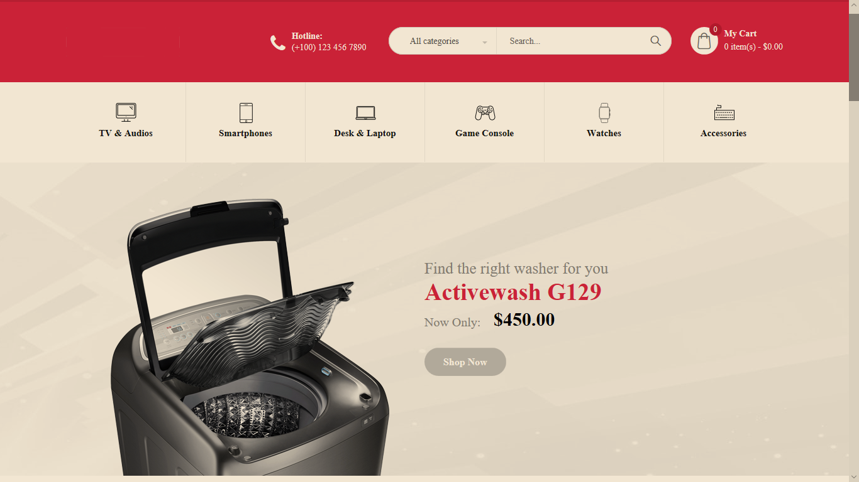

Homepage

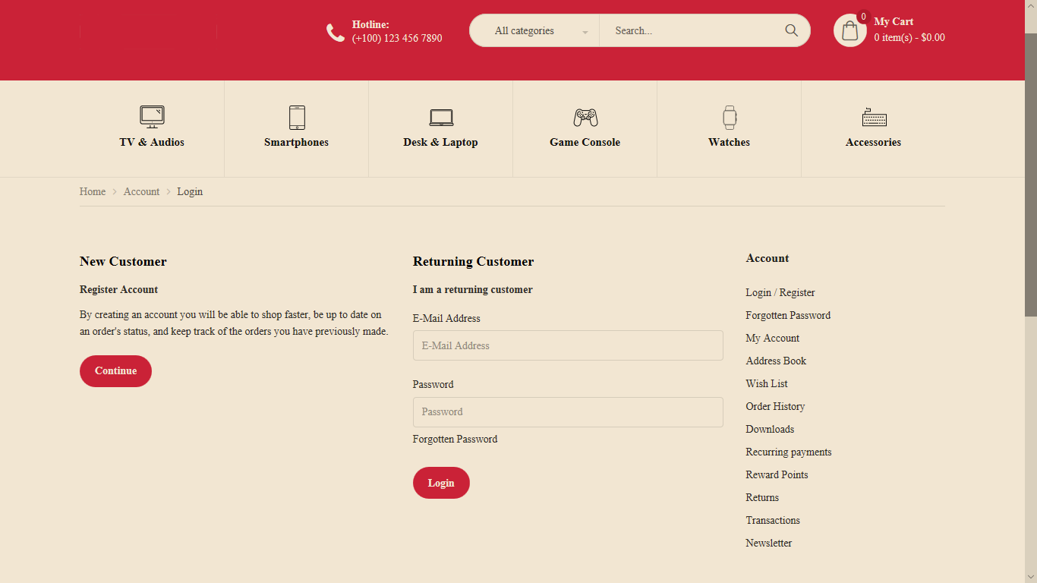

Login and Signup Page

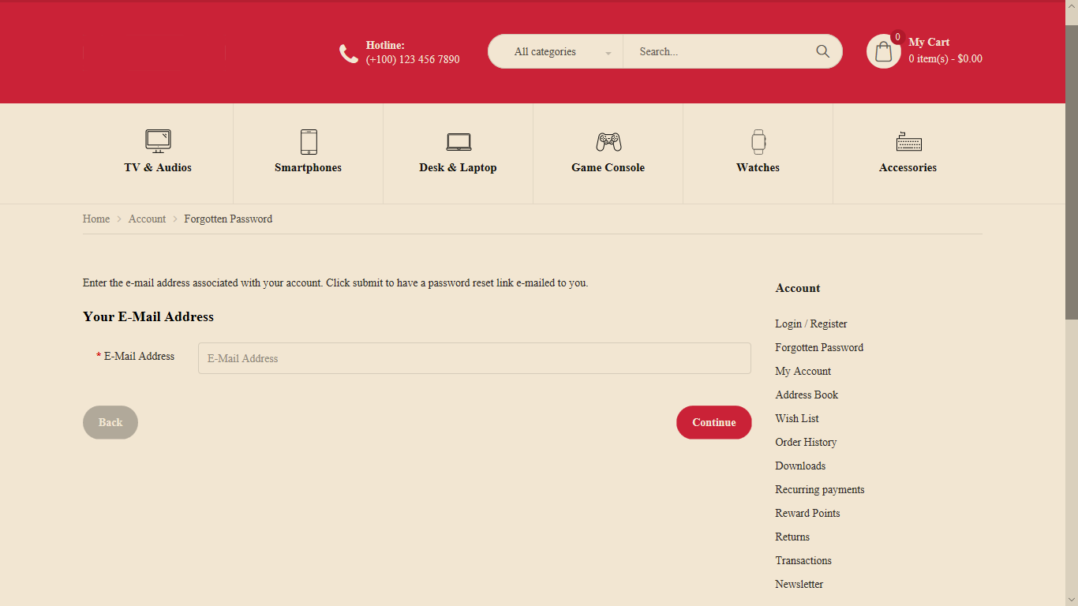

Forgot Password Page

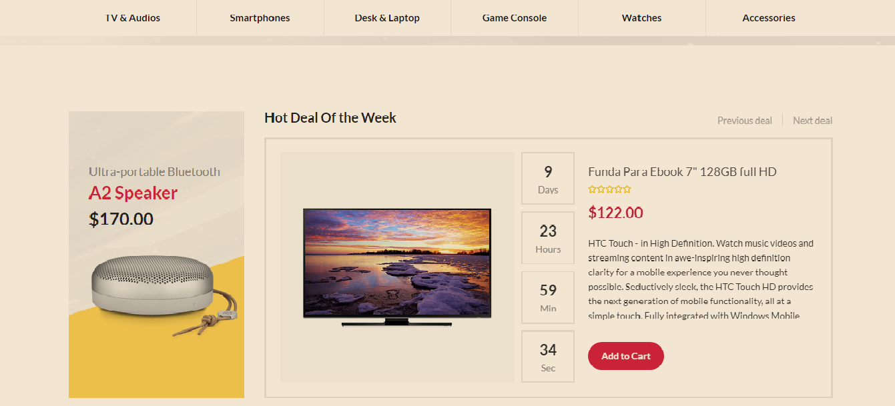

Hot deal of the week Page

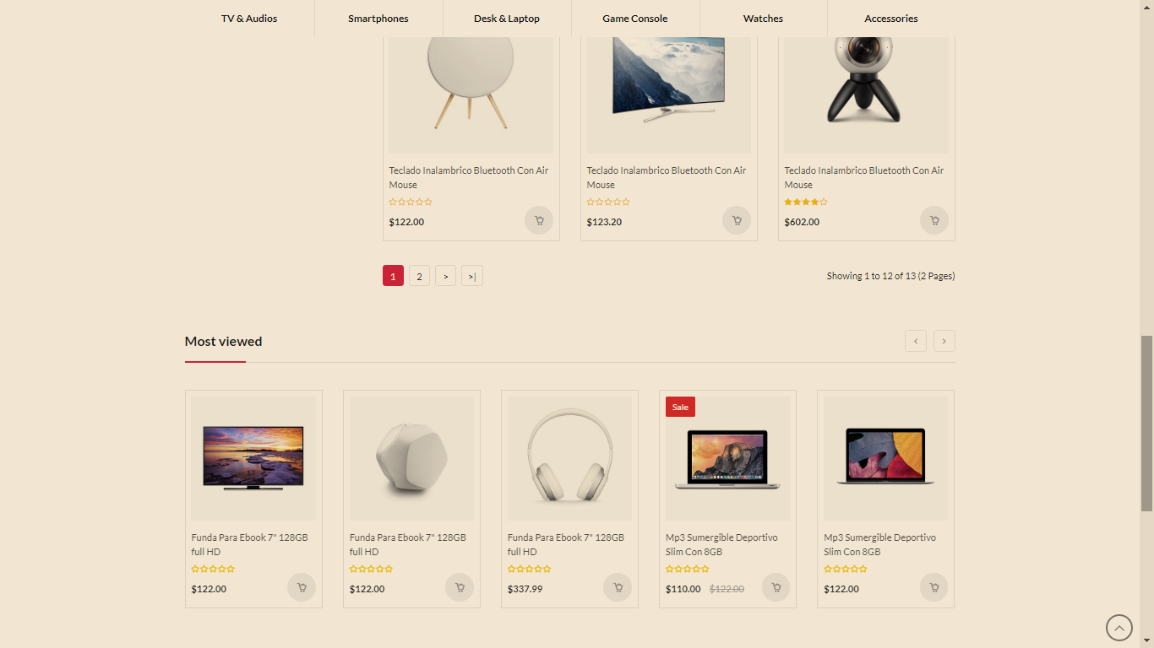

Most viewed product Page

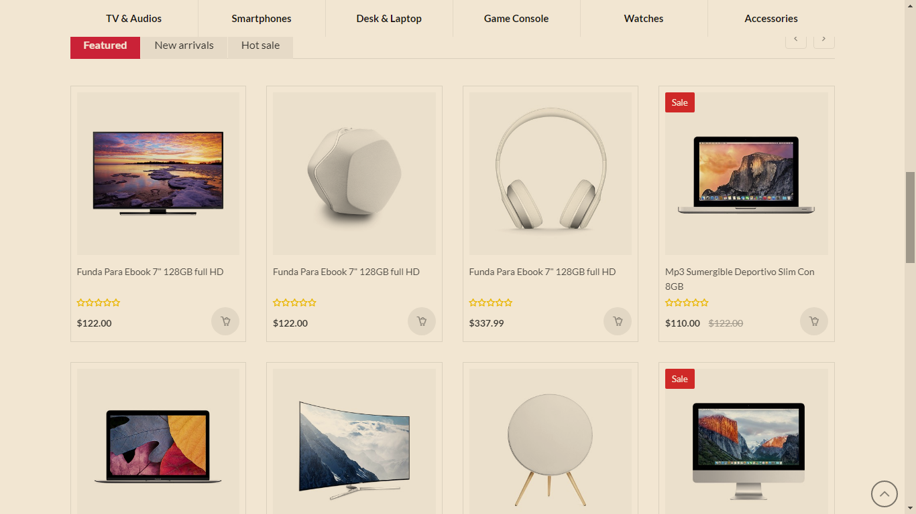

Product Page

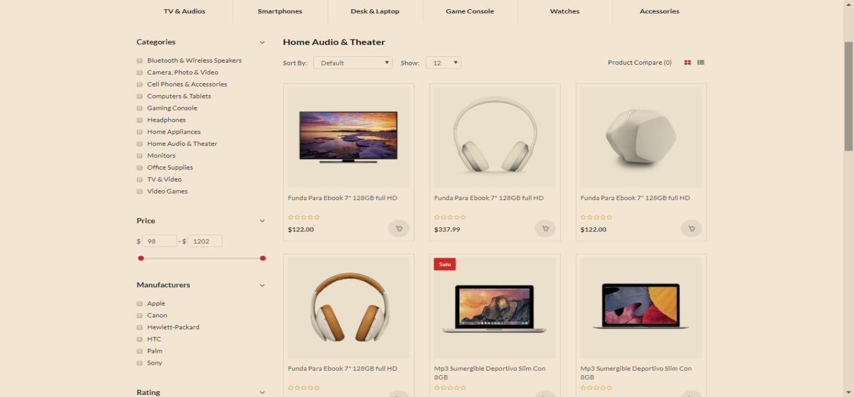

Product Display based on product category Page

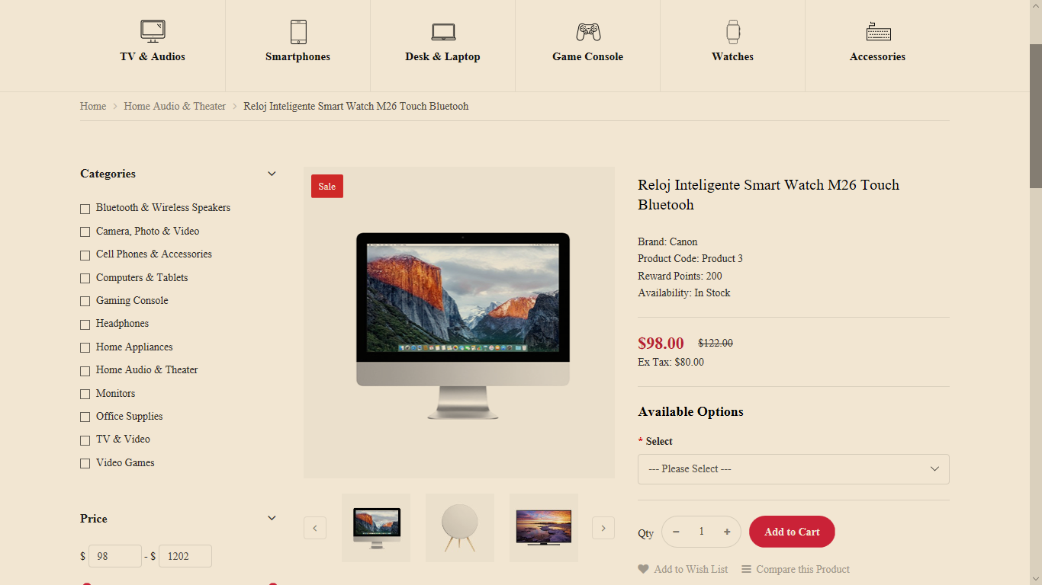

Product Detail page

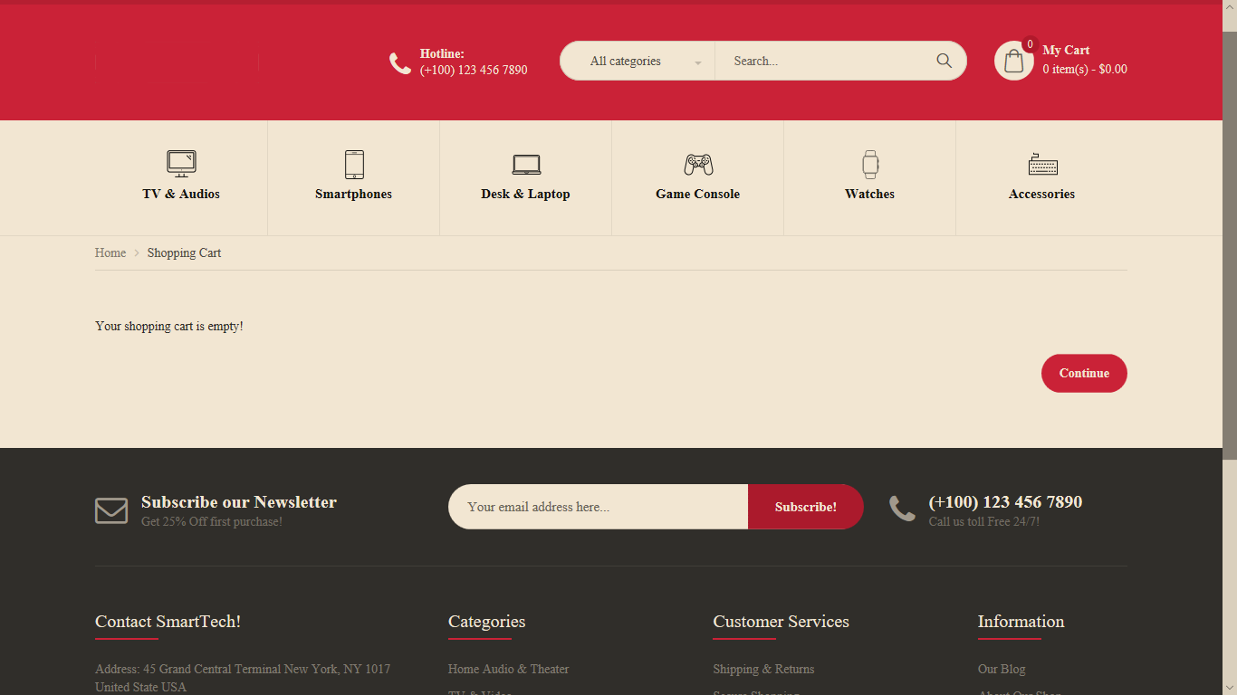

Shopping Cart Page

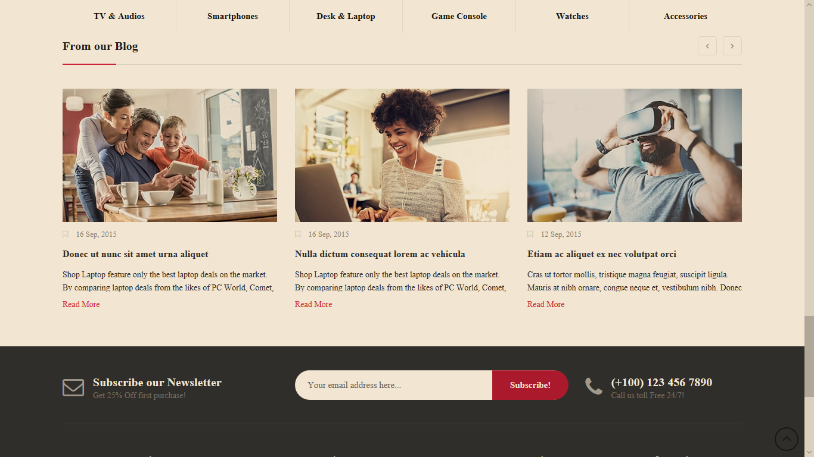

Subscribe Page

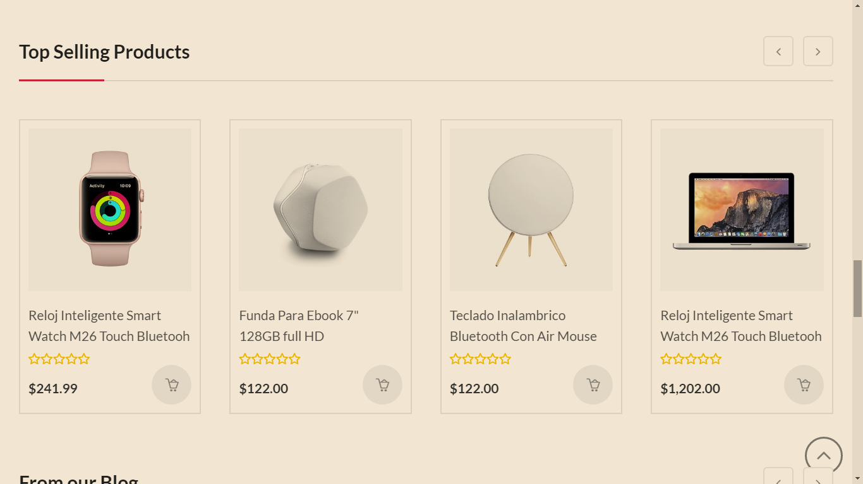Top Selling Product Page

* + 1. Hardware Interface

The system is not dependent on the hardware specifications.

* + 1. Software Interface

eMazon is planned as a web-based system and is therefore dependent on the specifications of the desktop, tablet PC or mobile browser it would be accessed with. The browser in question should support HTML 5, CSS 3, PHP, different frameworks such as AJAX and JQuery and be capable of running JavaScript.

* + 1. Communication Interface

Since eMazon is delivered in a web-based system, it will use HTTP for all communications over the internet.

* 1. **Functional Requirement**

1. Sign up for an account

|  |  |
| --- | --- |
| ID | FR-01 |
| Name | Sign up |
| Summary | The system gives account to patron |
| Description | The system should provide the patron with a form to  be filled. The system should make sure if the entered  Information meets the prerequisites. Then, after  checking the inserted form with the existing database,  the system will be able to assign new account to the  patron. The database will then be updated with the  new information containing password and user name  and other relevant information. |
| Dependency | None |
| References | UC-01 |

1. Login to an account

|  |  |
| --- | --- |
| ID | FR-02 |
| Name | Login |
| Summary | After logged in, the system redirects patron to the homepage. |
| Description | The system provides area to input the Username (email) and password for the account protection of the registered patron; password will be hashed upon saving into database. |
| Dependency | FR-01 |
| References | UC-02 |

1. Forgot Password

|  |  |
| --- | --- |
| ID | FR-02 |
| Name | Forgot Password |
| Summary | The patron should be able to reset his/her password if they forgot it. |
| Description | When the patron clicks” Forgot Password” button, the system should provide area to input email so that patron can receive temporary password. |
| Dependency | FR-01 |
| References | UC-16 |

1. Provide profile page

|  |  |
| --- | --- |
| ID | FR-03 |
| Name | Provide profile page |
| Summary | The system gives account to patron. |
| Description | Each patron should have a profile page. On his or her profile page the patron should have the privileges of changing his or her profile information including password and email. |
| Dependency | FR-01, FR-02 |
| References | None |

1. Choose product category

|  |  |
| --- | --- |
| ID | FR-04 |
| Name | Choose product category |
| Summary | The patron should be able to choose category. |
| Description | The system provides the patron with the products of the selected categories page. |
| Dependency | None |
| References | UC-03 |

1. View Product Detail

|  |  |
| --- | --- |
| ID | FR-09 |
| Name | View Product Detail |
| Summary | The system should view product description to patron. |
| Description | The system should be able to view product detail so that patron can know the features of the product, where the product is found and the like. |
| Dependency | None |
| References | UC-06 |

1. Search item

|  |  |
| --- | --- |
| ID | FR-05 |
| Name | Search item |
| Summary | The patron should be able to search an item. |
| Description | When the patron login or continue as a guest the system should provide a search option. The patron should be able to search for by manually entering it or can choose from the given categories. |
| Dependency | None |
| References | UC-09 |

1. Display Search Result

|  |  |
| --- | --- |
| ID | FR-09 |
| Name | Displaying search result |
| Summary | The system should display the result of the searched item. |
| Description | The system should display the searched items to the patron. So that the patron can then view the details of the item. |
| Dependency | None |
| References | None |

1. Add to cart

|  |  |
| --- | --- |
| ID | FR-06 |
| Name | Add to cart |
| Summary | The patron should be able to put their selected items into the cart |
| Description | The system provides the patron to put selected items to cart so that checkout could be performed. |
| Dependency | FR-02 |
| References | UC-07 |

1. Checkout

|  |  |
| --- | --- |
| ID | FR-07 |
| Name | Checkout |
| Summary | The patron should be able to pay for their selected items |
| Description | The system provides the patron the payment area then the patron can enter account and pin into their respective place and proceed the payment after verifying the account and pin.. |
| Dependency | FR-09 |
| References | UC-08 |

1. Wishlist

|  |  |
| --- | --- |
| ID | FR-08 |
| Name | Wishlist |
| Summary | The patron should be able to put their desired items into the wishlist so that they can buy it another time. |
| Description | The system provides the patron a wishlist to put their selected and desired items so that they can purchase it when they want to or have enough money. This is only possible for signed up patrons. |
| Dependency | FR-02 |
| References | UC-12 |

1. Refund

|  |  |
| --- | --- |
| ID | FR-09 |
| Name | Refund |
| Summary | The system should refund items that a patron bought within the 72 hours.. |
| Description | The system should be able to refund product if a patron request the product that he/she bought to be refunded. This can be done by clicking “Refund” button. The refund is only possible within 72 hours only. |
| Dependency | FR-02 |
| References | UC-13 |

1. Deactivate account

|  |  |
| --- | --- |
| ID | FR-13 |
| Name | Deactivate account |
| Summary | The patron should have the option of deactivating their account. |
| Description | When the patron clicks the “Deactivate account” button, the patron will be removed from the system and his or her information is removed from database. |
| Dependency | FR-02 |
| References | UC-15 |

1. Logout

|  |  |
| --- | --- |
| ID | FR-14 |
| Name | Logout |
| Summary | The system should logout from the patrons account. |
| Description | When the patron click “Logout” button, the system should be able to logout from the patrons account. |
| Dependency | FR-02 |
| References | UC-13 |

1. Most viewed items

|  |  |
| --- | --- |
| ID | FR-15 |
| Name | Most Viewed |
| Summary | The patron should be able to see the most viewed items. |
| Description | The system displays the most viewed product to patron so that the patron can know products with a lot of views. |
| Dependency | FR-02 |
| References | None |

1. Best seller items

|  |  |
| --- | --- |
| ID | FR-16 |
| Name | Best seller |
| Summary | The patron should be able to view best-selling items. |
| Description | The system displays the best-selling items for the patron in order to get info about the current best-selling items. |
| Dependency | FR-02 |
| References | None |

1. New arrival of items

|  |  |
| --- | --- |
| ID | FR-17 |
| Name | New arrival of items |
| Summary | The patron should be able to view newly arrived items. |
| Description | The system displays the newly arrived items for the patron. |
| Dependency | FR-02 |
| References | None |

1. Send Feedback

|  |  |
| --- | --- |
| ID | FR-18 |
| Name | Send Feedback |
| Summary | The patron should be able to send feedback about the site. |
| Description | The system should be able to provide textarea to patron so that he/she can give feedback about the site. |
| Dependency | None |
| References | UC-11 |

1. Comment

|  |  |
| --- | --- |
| ID | FR-19 |
| Name | Comment |
| Summary | The patron should be able to give comment for the products purchased. |
| Description | The system should provide a textarea for the patron inorder for them to give comment for the products that they purchased but its only available for a patron logged in. This helps other patron to know the products quality. |
| Dependency | FR-02 |
| References | None |

1. Subscribe

|  |  |
| --- | --- |
| ID | FR-15 |
| Name | Subscribe |
| Summary | The system should provide patron to subscribe the site. |
| Description | The system should be able to provide patron to subscribe the site to get latest news, products and the like. |
| Dependency | FR-01,FR-02 |
| References | None |

**3.3 Use case**

**UC 01: Sign up**

Use case name: UC-01: Sign up

Primary Actors: Customer

Summary: Ordinary users can sign up as a customer.

Preconditions: The customer must have a bank account.

Post-conditions: The user successfully signs up as a customer.

Trigger: The user clicking the sign up button.

Main Success Scenario

1. The user chooses sign up option.

2. The system redirects to sign up page.

3. The user fills in the necessary data requested on the page

4. The user chooses the register option

5. The system displays a success message

Extensions

4a. The user chooses the cancel option

4a.1 The system displays cancelation message

4a.2 The system redirects to The home page

**UC 02: Log in**

Use case name: UC-02: Log in

Primary Actors: Users

Summary: users can log in as a Customer, Admin or blogger.

Preconditions: The user must have a registered account.

Post-conditions: The user successfully logs in into his/her account.

Trigger: The user clicking the login button.

Main Success Scenario

1. The user chooses login option.

2. The system redirects to login page.

3. The user fills in the necessary data requested on the page

4. The user chooses the login button.

5. The system redirects to the respective page.

Extensions

5a. The user entered incorrect information

5a.1 The system displays error message

5a.2 The system redirects to the home page.

**UC 03: Choose product category**

Use case name: UC-03: Choose product category

Primary Actors: Customer, Third party

Summary: user can choose a category from which to shop from.

Preconditions: The user must login.

Post-conditions: The user successfully selects the category he/she wants.

Trigger: The user choosing a category.

Main Success Scenario

1. The user chooses a certain category.

2. The system redirects to that category’s page.

**UC 04: View profile page**

Use case name: UC-04: View profile page

Primary Actors: Users

Summary: users can log in as a Customer, Admin or blogger.

Preconditions: The user must have a registered account.

Post-conditions: The user successfully logs in into his/her account.

Trigger: The user clicking the login button.

Main Success Scenario

1. The user logs in.

2. The user chooses the profile option..

3. The system displays the profile page.

**UC 05: Edit profile**

Use case name: UC-05: Edit profile

Primary Actors: Users

Summary: users can Edit his/her profile

Preconditions: The user must login.

Post-conditions: The user successfully edited his/her profile.

Trigger: The user clicking the edit profile button.

Main Success Scenario

1. The user chooses edit profile option.

2. The system redirects to profile page.

3. The user edits the profile.

4. The system saves the changes and displays a success message.

**UC 06: View product detail**

Use case name: UC-06: View product detail

Primary Actors: Customer, Third party

Summary: users can view the details of the products he/she selected.

Preconditions: The user must login.

Post-conditions: The user successfully viewed the details of the products he/she selected.

Trigger: The user clicking the view details button.

Main Success Scenario

1. The user chooses view details option.

2. The system displays the detail.

3. The user edits the profile.

4. The system saves the changes and displays a success message.

**UC 07: Buy / Add to cart**

Use case name: UC-07: Buy / Add to cart

Primary Actors: Customer

Summary: Ordinary users can select a product and add it to the cart.

Preconditions: The user must log in.

Post-conditions: The user successfully adds the products he bought to his/her cart.

Trigger: The user clicking the Add to cart button.

Main Success Scenario

1. The user chooses the Add to cart option.

2. The system adds the product to a list.

Extensions

**UC 08: Checkout**

Use case name: UC-08: checkout

Primary Actors: Ordinary user

Summary: Ordinary users can buy the product he selected

Preconditions: The user must have an enough amount in his bank account.

Post-conditions: The user successfully buys the product.

Trigger: The user clicking the Checkout button.

Main Success Scenario

1. The user chooses the checkout option.

2. The system redirects to the payment page.

3. The user fills in the necessary data requested on the page

4. The user chooses the pay button.

5. The system displays a success message.

Extensions

3a. The user entered incorrect information

3a.1 The system displays error message

3a.2 The system redirects to the home page

4a. The user does not have enough money in his account.

4a.1 The system displays a message.

**UC 09: Search**

Use case name: UC-09: Search

Primary Actors: Users, Third party

Summary: Ordinary users can search for a specific categories or products.

Preconditions: The user must visit the site or log in.

Post-conditions: The user successfully retrieves the products he/she searched for.

Trigger: The user clicking the search button.

Main Success Scenario

1. The user types a word in the textfield.

2. The user clicks the search option.

3. The system displays the result.

Extensions

2a. The search result does not exist.

2a.1 The system displays a message notifying the user that no results were found.

**UC 10: View updates**

Use case name: UC-10: View updates

Primary Actors: Ordinary user

Summary: Ordinary users can view updated news about a certain category or store.

Preconditions: The user must log in.

Post-conditions: The user successfully views the updates.

Trigger: The user clicking the View updates button.

Main Success Scenario

1. The user clicks the View updates.

2. The system displays the updates.

Extensions

2a.The updates does not exist.

2a.1 The system displays a message.

**UC 11: Send Feedback**

Use case name: UC-11: Send Feedback

Primary Actors: Customer, Third party

Summary: The customer or any third party can send a feedback on the provided area.

Preconditions: The user must visits the site or log in.

Post-conditions: The user successfully sent his/her feedback.

Trigger: The user clicking the send feedback button.

Main Success Scenario

1. The user clicks the Send feedback button .

2. The system submits the message and display a success message to the user.

**UC 12: Add to wishlist**

Use case name: UC-12: Add to wishlist

Primary Actors: Customer

Summary: Customer can add products he/she wants to buy in the future to a wishlist.

Preconditions: The user must log in.

Post-conditions: The user successfully added the items he/she selected in his/her wish list.

Trigger: The user clicking the Add to wish list button.

Main Success Scenario.

1. The user selects the Add to wishlist option.

2. The system checks if the product is in stock and adds the product to the wish list.

Extensions

2a. The product is out of stock.

2. 2a.1 The system notifies the user that the product is out of stock.

**UC 13: Refund**

Use case name: UC-13: Refund

Primary Actors: Customer

Summary: Customer can request a refund before three days.

Preconditions: The user must log in.

Post-conditions: The user successfully requested a refund.

Trigger: The user clicking the Refund option.

Main Success Scenario

1. The user selects the Refund option.

2. The system checks if the user is qualified for a refund.

3. The system returns 75% of the products cost to the bank account of the user.

Extensions

2a.The user is not qualified for a refund.

2a.1 The system notifies the user he/she is not qualified for a refund.

**UC 14: Logout**

Use case name: UC-14: Logout

Primary Actors: Users

Summary: Customer can log out of his account.

Preconditions: The user must log in.

Post-conditions: The user successfully logs out.

Trigger: The user clicking the Logout button.

Main Success Scenario

1. The user selects the Logout option.

2. The system logs out of the user’s account.

**UC 15: Deactivate an account**

Use case name: UC-15: Deactivate an account

Primary Actors: Ordinary user

Summary: Ordinary users can deactivate his/her account.

Preconditions: The user must log in.

Post-conditions: The user successfully deactivated his/her account.

Trigger: The user clicking the Deactivate account button.

Main Success Scenario

1. The user clicks the Deactivate account button.

2. The system removes the account from the database.

**UC 10: Forgot password**

Use case name: UC-10: Forgot password

Primary Actors: Users

Summary: Customer can request new password if he/she forgets his/her password.

Preconditions: The user must have an account.

Post-conditions: The user successfully resets his/her password.

Trigger: The user clicking the Forgot password option.

Main Success Scenario.

1. The user selects the Forgot password option.

2. The system checks if the user has a valid account.

3. The system sends email to the user with a link to reset his/her password.

Extensions

2a.The user does not have a valid account.

2a.1 The system notifies the user the account does not exist or is not valid.

**3.4. ER DIAGRAM**

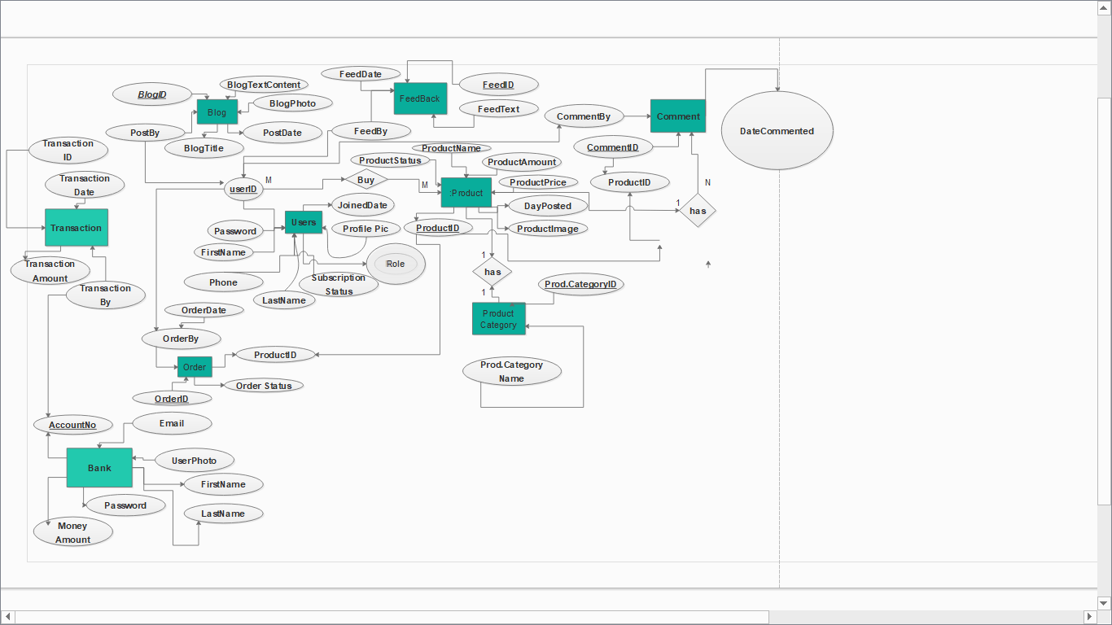

**Fig 1: ER Diagram**

**3.5 Non-Functional Requirement**

**3.5.1 Performance**

* The e-commerce w0ebsite should be able to respond in a minimum time of 15sec.
* The response times i.e. application loading, screen open and refresh times etc. should take about a few seconds.

**3.5.2 Reliability**

* The e-commerce should be able to backup if broken or data loss from its database.

**3.5.3 Availability**

* The e-commerce website is available 24/7 even during holidays.
* It is available in Ethiopia (Addis Ababa) for now.

**3.5.4 Security**

* In order for user to login, the password needs to be of 8 length character containing 1 uppercase letter, 1 special character numbers and lowercase letters.
* If the users forgot their password, there will be a “Forgot Password” button so that the user can click it, enter their email and then send verification on their email.
* The application shall identify all of its client applications before allowing them to use its capabilities.

**3.5.5 Maintenance**

* Modification on the website should be easy, flexible and adapt changes done on it.
* The code should be structured, readable and understandable for others programmers.
* eMazon should be able to handle any updates done on it.
* When the system is updated, it shall leave all database contents and all personal settings unchanged.

**3.5.6 Portability**

* The website should be able to work on any browser.
* Also, it is good mobile friendly.

**3.6 Inverse Requirements**

The system does not have an actual online payment system; instead we used a sample database as a bank system in order to demonstrate how it would work.

It denies a user visiting as a guest most privileges. A user has to be a customer, have an account, in order to enjoy privileges like requesting refund, having a wish list etc.

**3.7 Design constraints**

Simplicity is a very difficult milestone to hit when trying to couple it with the functional requirements. Users of any system in general tend to lean to services that their interfaces are stuffed with less contents than those with robust functionalities but not following the modern line of elegance. As a result, we have been trying to reach a middle ground between all the functional requirements of a certain page and the principle of simplicity alongside. A balance between the two is attempted and is to be seen in the user interface design of the web application.

1. **Change Management Process**

Any requests to change the project scope and requirements shall be discussed by all the members of the team. A change will be made only when the majority of the team agrees on the change. In this case, the SRS document shall be updated by the team members in order to reflect the changes, and a date of change shall be noted in the file. If this change request is made by the client or anyone outside of the team, he or she will have to contact the team. If a change request is made by a team member, he or she can raise it during the weekly team meeting or contact other team members. During any of these requests, the team will assess the feasibility of the proposed changes considering the time constraints and structural constraints of the implemented modules and develop an implementation strategy. A change plan will be created for the implementation of the change. The team will then continue implementing the new requirements.

**References**

amazon.co.uk

Software-Engineering-Ian-Sommerville

Whiteley, David: E-commerce: strategy, technologies and applications / David Whiteley. : McGraw-Hill, 2000