Name of stored procedure: sp_AddAddress

Definition: This stored procedure is written to add a new address information to the address table.

Below are the screenshots respectively:

* Stored procedure
* The table before the stored procedure is called
* Call stored procedure
* The table after the stored procedure call.

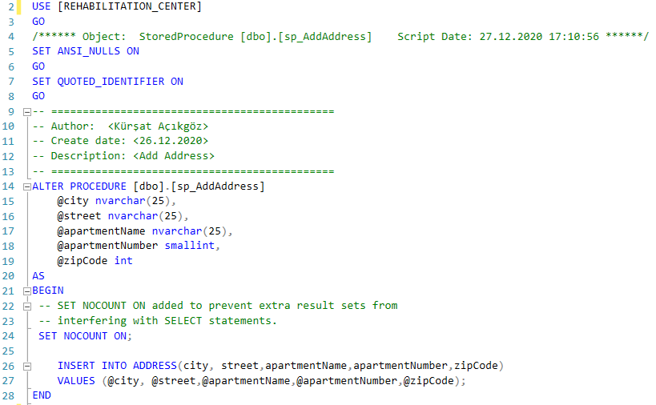

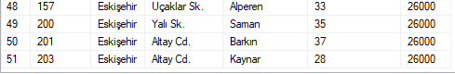



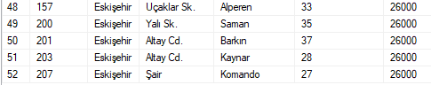

Name of stored procedure: sp_AddDisabledStudent

Definition: This stored procedure takes address, parent, disabled student, health report, ram report information as arguments. After adding to tables with this information, additions are made to report list and student list. The main purpose of this stored procedure, which is very frequently associated with foreign keys, is to add students.

* Stored procedure
* The table before the stored procedure is called
* Call stored procedure
* The table after the stored procedure call.

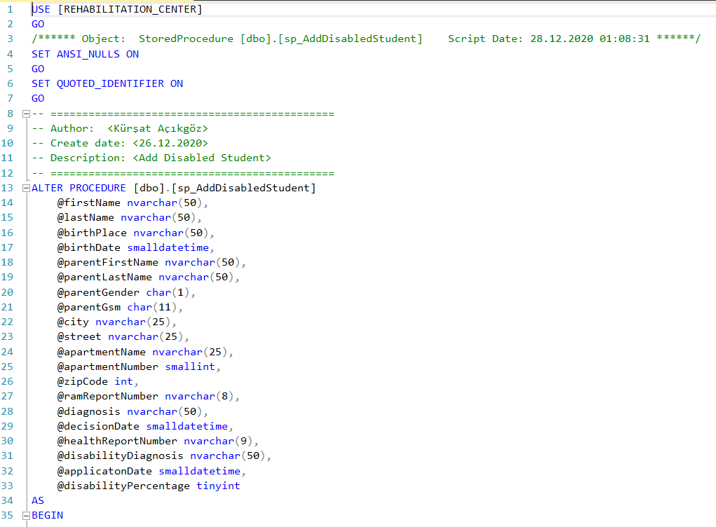

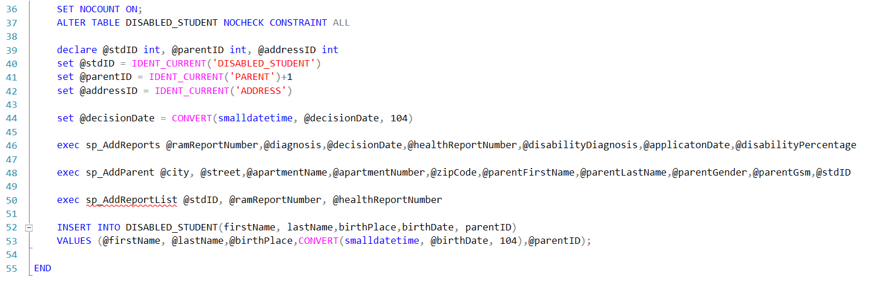

Address Table

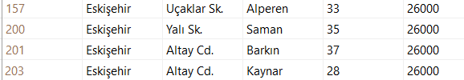

Disabled Student Table

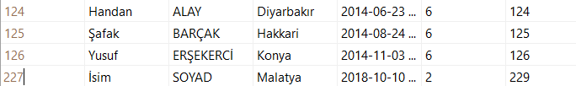

Parent Table

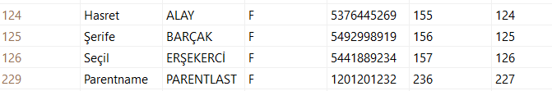

Ram Report Table

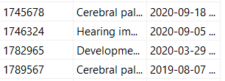

Health Report Table

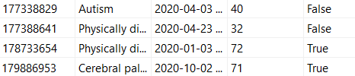

Report List Table

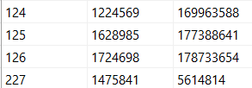



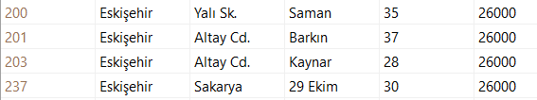

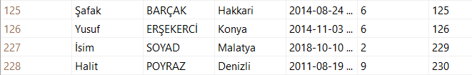

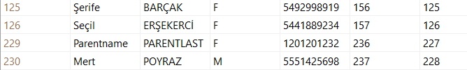

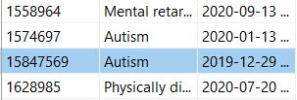

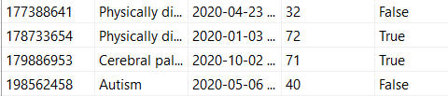

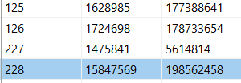

Name of stored procedure: sp_ListAppropriateInstructors

Definition: This stored procedure lists instructors with expertise suitable for the patient's disease.

* Stored procedure
* The table before the stored procedure is called
* Call stored procedure
* The table after the stored procedure call.

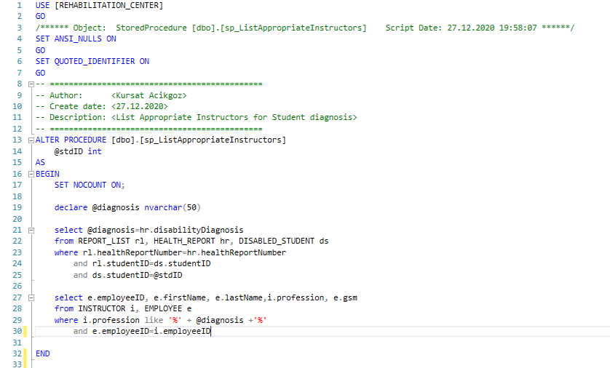

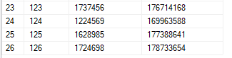

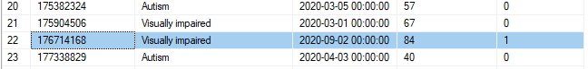



Name of stored procedure: sp_EditRamReport

Definition: This stored procedure used to edit ram report’s content.

* Stored procedure
* The table before the stored procedure is called
* Call stored procedure
* The table after the stored procedure call.

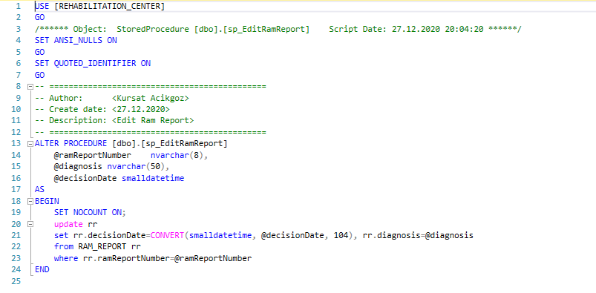

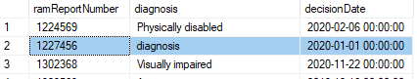



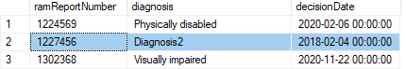

Name of stored procedure: sp_EditHealthReport

Definition: This stored procedure used to edit health report’s content.

* Stored procedure
* The table before the stored procedure is called
* Call stored procedure
* The table after the stored procedure call.

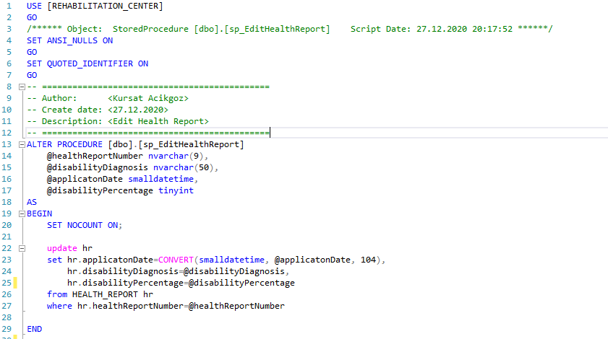

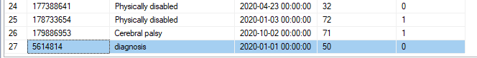





Name of stored procedure: sp_EditCompanyInformation

Definition: This stored procedure used to edit company information.

* Stored procedure
* The table before the stored procedure is called
* Call stored procedure
* The table after the stored procedure call.

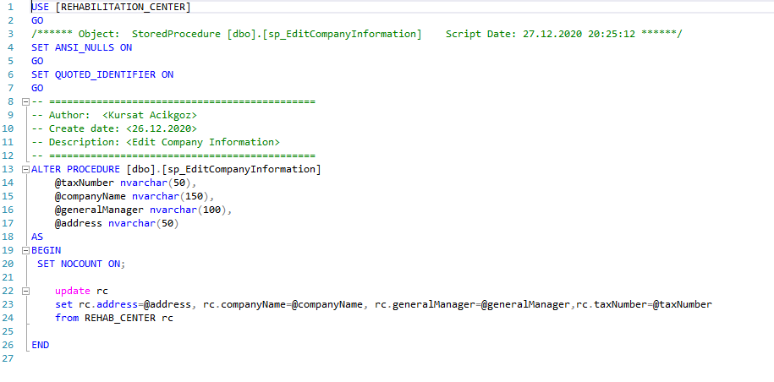







Name of stored procedure: sp_AddHealthReport

Definition: This stored procedure used to add health report.

* Stored procedure
* The table before the stored procedure is called
* Call stored procedure
* The table after the stored procedure call.

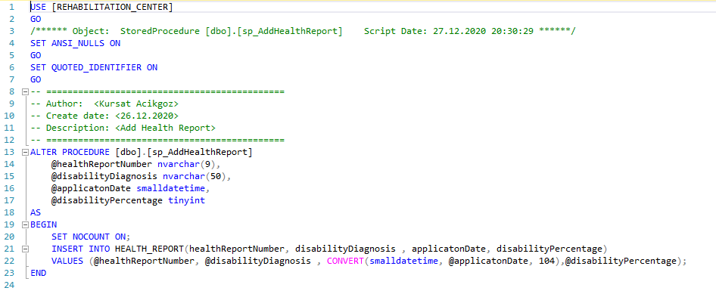

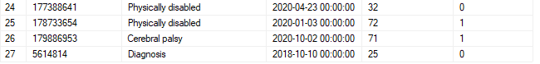





Name of stored procedure: sp_AddInstructor

Definition: This stored procedure used to add instructor.

* Stored procedure
* The table before the stored procedure is called
* Call stored procedure
* The table after the stored procedure call.

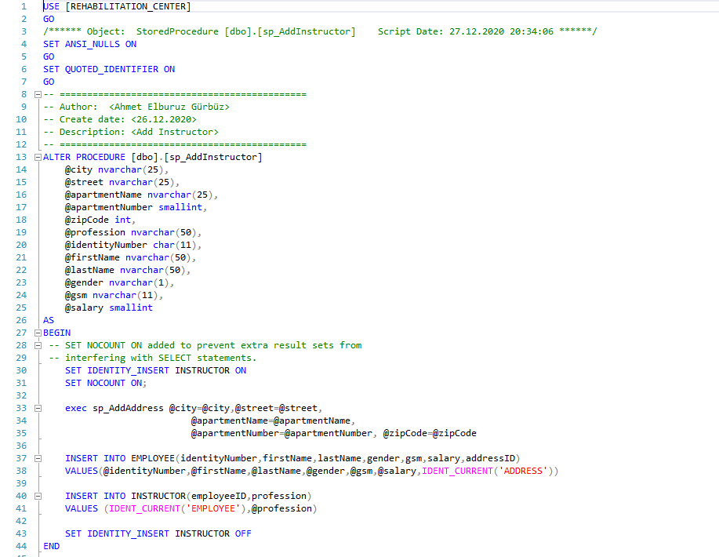

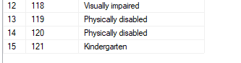

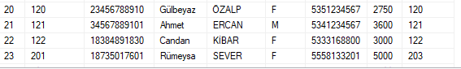

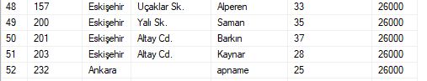



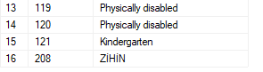

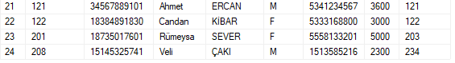

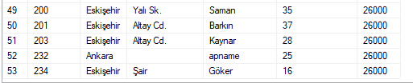

Name of stored procedure: sp_AddInstructorList

Definition: This stored procedure used to add instructor.

* Stored procedure
* The table before the stored procedure is called
* Call stored procedure
* The table after the stored procedure call.

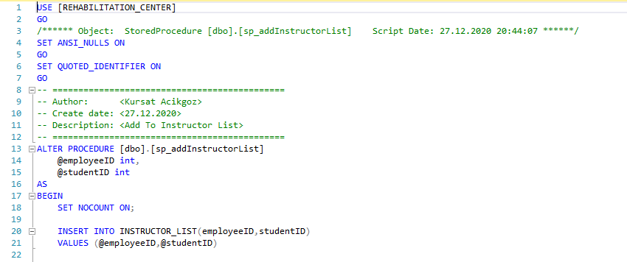

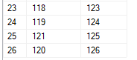



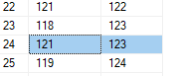

Name of stored procedure: sp_AddParent

Definition: This stored procedure used to add parent.

* Stored procedure
* The table before the stored procedure is called
* Call stored procedure
* The table after the stored procedure call.

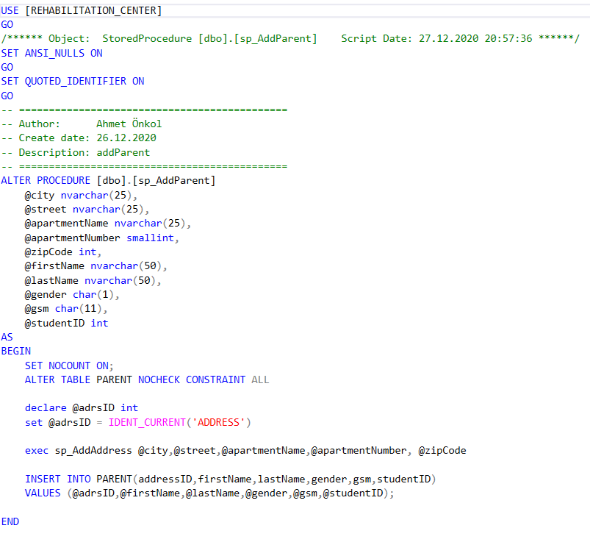

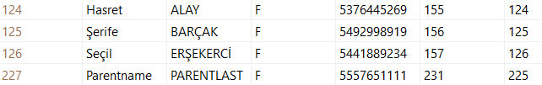



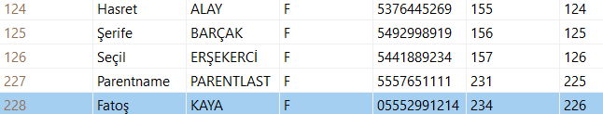

Name of stored procedure: sp_AddPsyhchologist

Definition: This stored procedure used to add psyhchologist.

* Stored procedure
* The table before the stored procedure is called
* Call stored procedure
* The table after the stored procedure call.

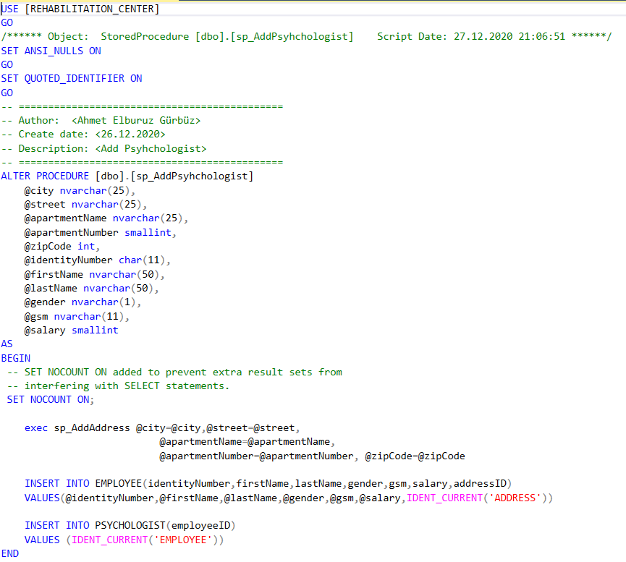

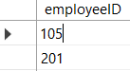

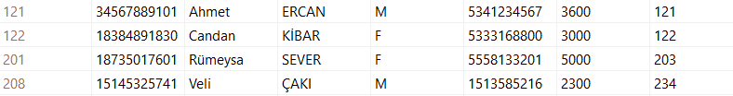



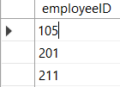 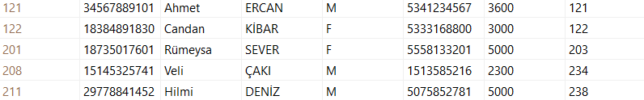

Name of stored procedure: sp_AddRamReport

Definition: This stored procedure used to add ram report.

* Stored procedure
* The table before the stored procedure is called
* Call stored procedure
* The table after the stored procedure call.

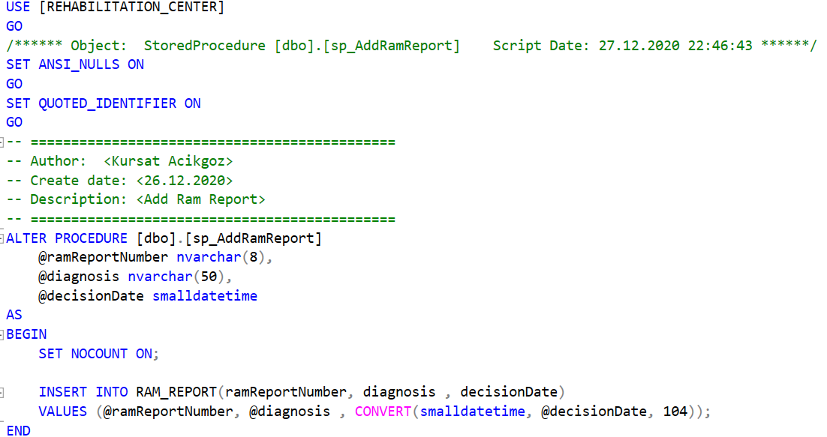

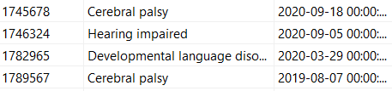



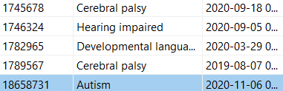

Name of stored procedure: sp_AddReportList

Definition: This stored procedure used to add reports to report list

* Stored procedure
* The table before the stored procedure is called
* Call stored procedure
* The table after the stored procedure call.

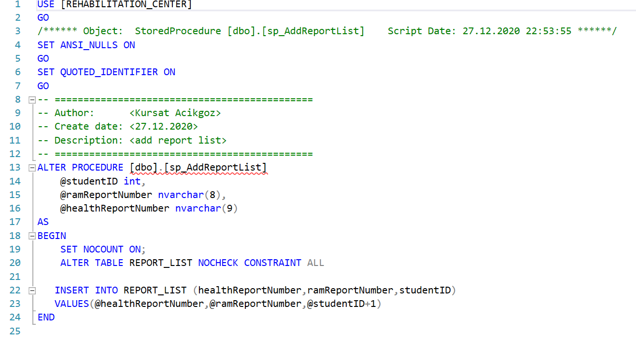

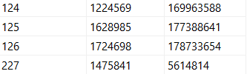



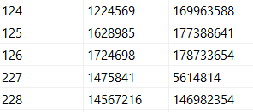

Name of stored procedure: sp_AddReports

Definition: This stored procedure used to add report

* Stored procedure
* The table before the stored procedure is called
* Call stored procedure
* The table after the stored procedure call.

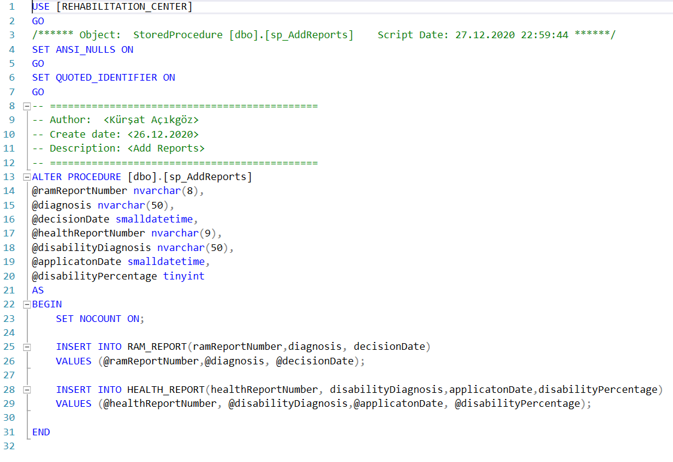

*Ram_Report*

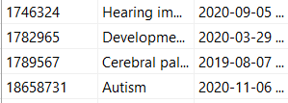

*Health_Report*

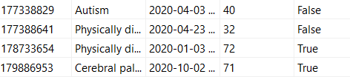



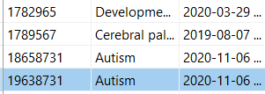

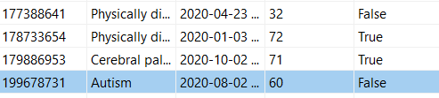

Name of stored procedure: sp_AddStaff

Definition: This stored procedure used to add staff

* Stored procedure
* The table before the stored procedure is called
* Call stored procedure
* The table after the stored procedure call.

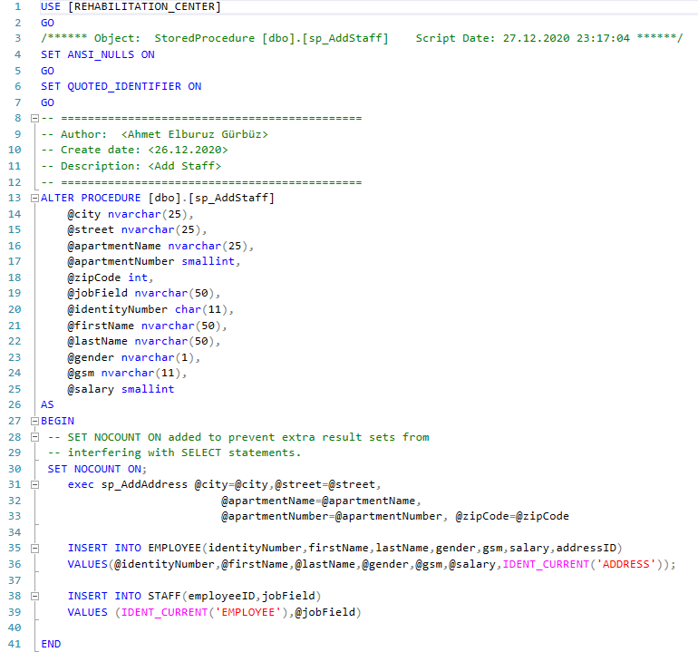

*Address Table*

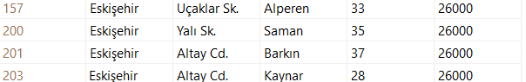

*Staff Table*

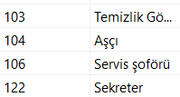

*Employee Table*

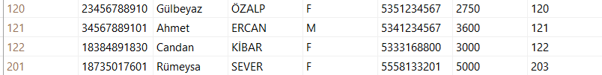



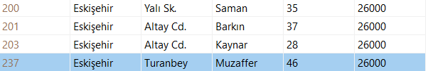

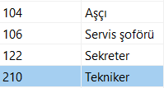

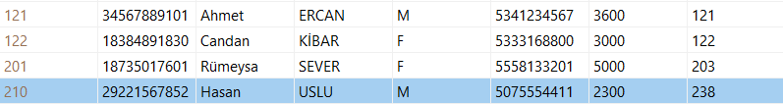

Name of stored procedure: sp_AddTherapy

Definition: This stored procedure used to add therapy

* Stored procedure
* The table before the stored procedure is called
* Call stored procedure
* The table after the stored procedure call.

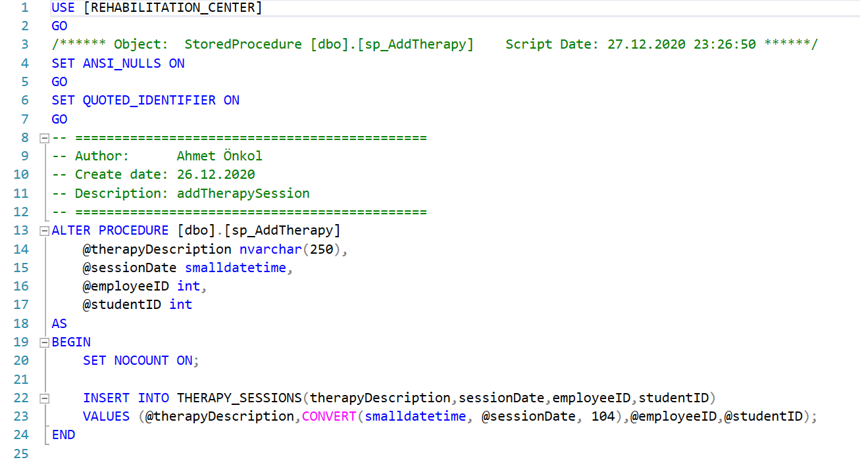

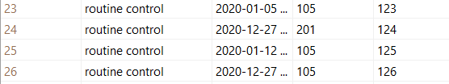



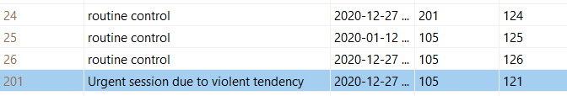

Name of stored procedure: sp_DeleteInstructor

Definition: This stored procedure used to delete instructor

* Stored procedure
* The table before the stored procedure is called
* Call stored procedure
* The table after the stored procedure call.

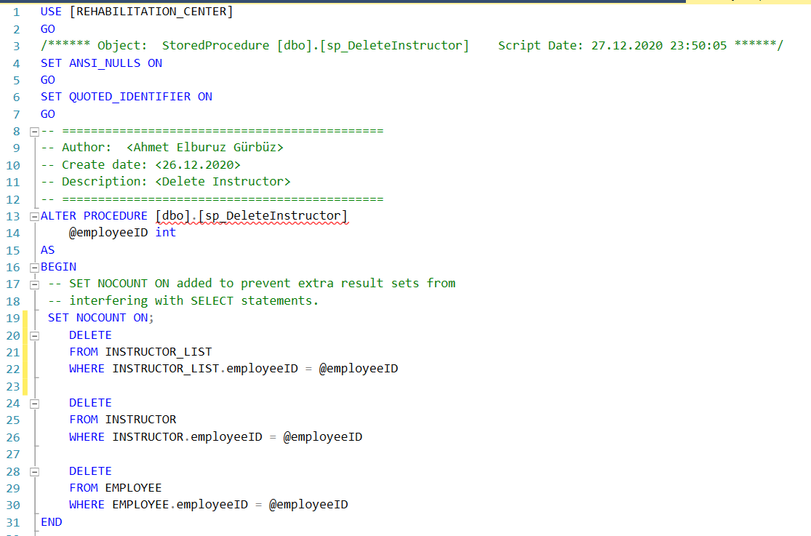

*Instrutor Table*

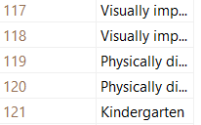

*Instructor_List Table*

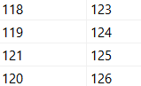

*Employee*

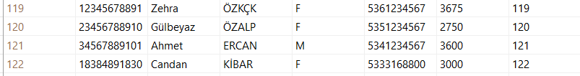



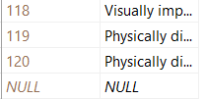

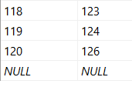



Name of stored procedure: sp_DeletePsyhchologist

Definition: This stored procedure used to delete psyhchologist

* Stored procedure
* The table before the stored procedure is called
* Call stored procedure
* The table after the stored procedure call.

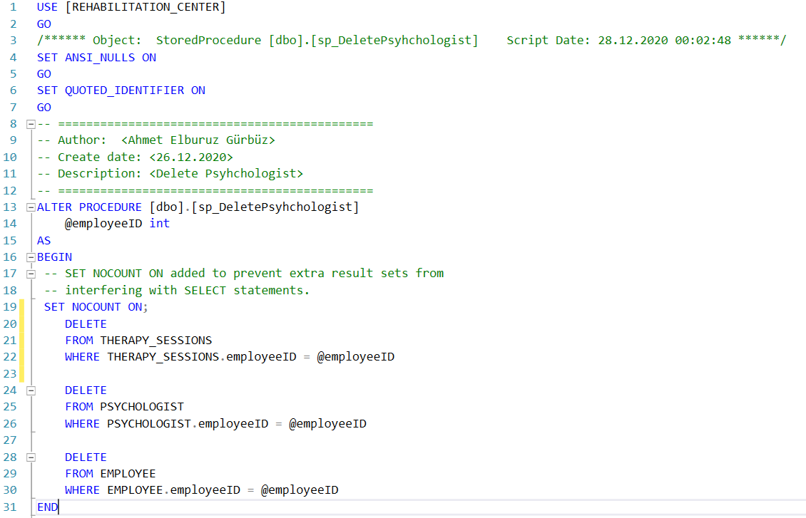

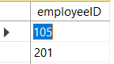

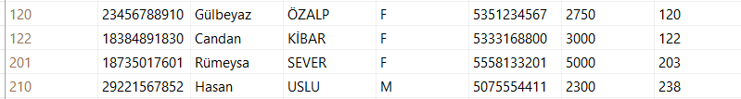

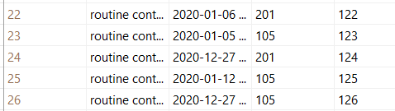



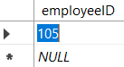

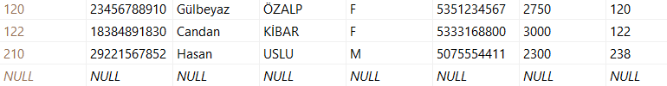

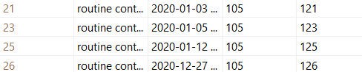

Name of stored procedure: sp_DeleteStaff

Definition: This stored procedure used to delete staff

* Stored procedure
* The table before the stored procedure is called
* Call stored procedure
* The table after the stored procedure call.

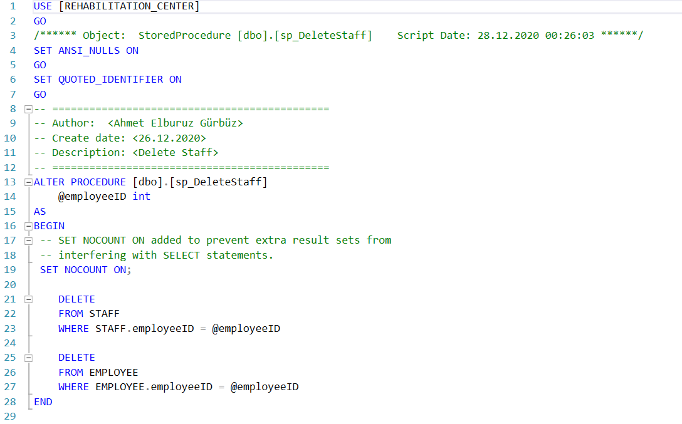

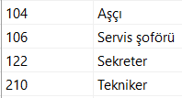

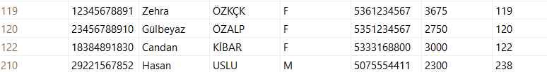



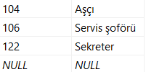

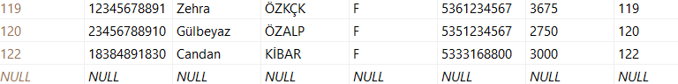

Name of stored procedure: sp_DeleteStudent

Definition: This stored procedure used to delete disabled student

* Stored procedure
* The table before the stored procedure is called
* Call stored procedure
* The table after the stored procedure call.

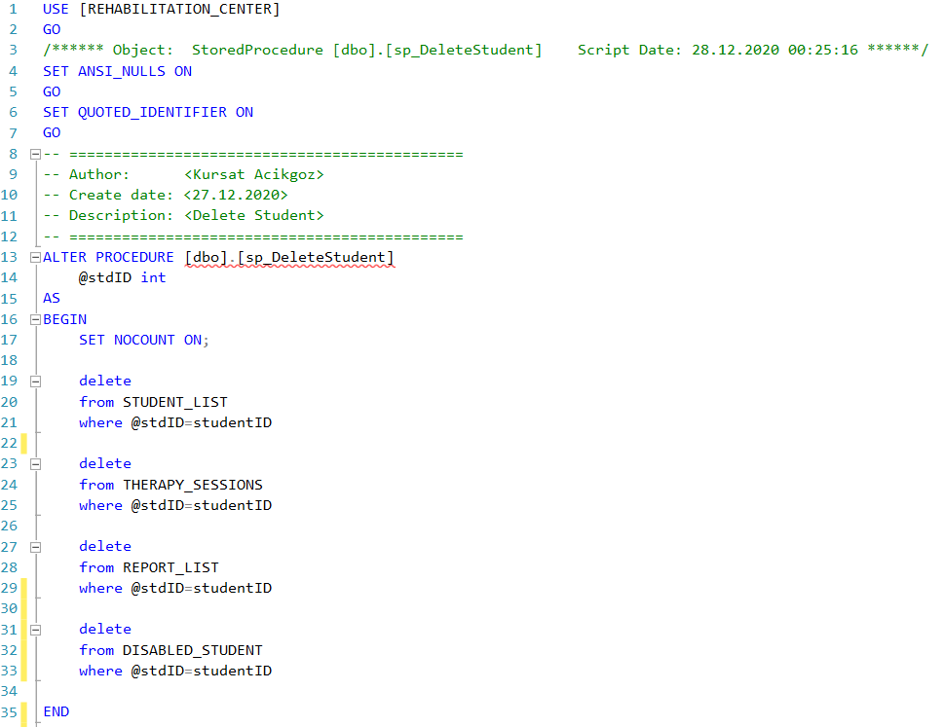

*Disabled Student Table*

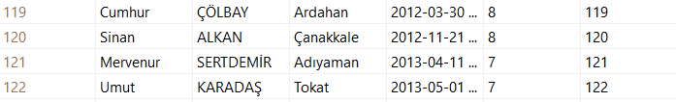

*Student List Table*

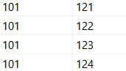

*Therapy Session Table*

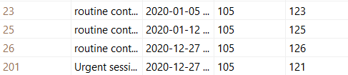

*Report List Table*

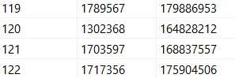



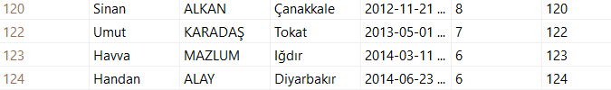

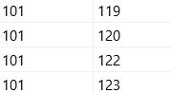

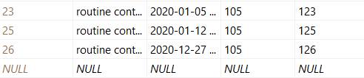

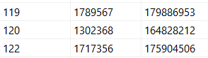

Name of stored procedure: sp_DeleteTherapySession

Definition: This stored procedure used to delete therapy session

* Stored procedure
* The table before the stored procedure is called
* Call stored procedure
* The table after the stored procedure call.

