Supplementary Material
Cellular Automata–Deep Learning Modelling of Urban Growth in Windhoek, Namibia
This document contains the supplementary sections, tables and figures cited in the manuscript.
Section S1. 2010 composite and post-classification correction
No suitable dry-season imagery was available for 2010 because of the Landsat 7 Scan Line Corrector (SLC) failure and cloud cover, so a temporal median composite of April, October and November 2010 scenes was classified. The transitional-season composite inflated the raw urban estimate to 108.56 km² (municipal extent), mainly by assigning bare and sparsely vegetated surfaces to Urban; the 3 × 3 majority filter alone reduced this only to about 107.5 km². After the spectral-contextual rules and targeted editing, the corrected 2010 urban area was 81.49 km² (80.57 km² on the correction mask), close to the 77.98 km² obtained by linear interpolation between the 2005 and 2015 dry-season estimates. On the correction mask, the correction reassigned 35.66 km² of raw Urban to Bare Ground, 6.17 km² to Vegetation and 0.11 km² to Water, and 13.05 km² of raw Vegetation, 1.50 km² of raw Bare Ground and 0.37 km² of raw Water to Urban (Table S3b). The difference between the raw and corrected estimates (27.1 km²) indicates the magnitude of uncertainty attached to the 2010 urban area.
Section S2. Classification rule, accuracy measures and area estimators
Random Forest classification rule (Breiman, 2001):
$\overset{ˆ}{C}\left(x\right)=\operatorname{Mode}\left\{h_{1}\left(x\right),h_{2}\left(x\right),...,h_{T}\left(x\right)\right\}$ (S1)
C (×) represents the simulated land cover class for pixel x, h1​(x), h2​(x), ..., hT​(x) represent simulations from individual decision trees, T represents the number of trees in the Random Forest model, and the mode represents the class chosen by the majority vote of all trees (Breiman, 2001). The Random Forest (RF) classifier was used in Google Earth Engine (GEE) to classify Landsat-derived spectral features into four land-cover classes. The RF algorithm builds multiple decision trees using randomly selected subsets of training samples and predictor variables, with the final class assignment determined through predominant voting among all trees (Phan et al., 2020).
Overall accuracy, producer’s accuracy, user’s accuracy and Cohen’s kappa (Congalton & Green, 2019; Stehman, 1997; Cohen, 1960):
$OA=\frac{\sum_{i=1}^{r}{x_{ii}}}{N}×100$ (S2)
The symbols $'x_{ii}'$ stands for the number of classified samples that are classified correctly along the diagonal of the confusion matrix, $r'$stands for the number of land-cover classes, and $N$stands for the number of validation samples in total (Congalton & Green, 2019; Phan et al., 2020).
Producers' accuracy was computed to measure omission errors by calculating the probability that a reference pixel was classified correctly:
$PA_{i}=\frac{x_{ii}}{x_{+i}}×100$ (S3)
The $x_{+i}$ in the equation shows the total number of reference samples for class $i$ (Stehman, 1997).
User’s Accuracy was measured to quantify commission errors by determining the accuracy of each classified class:
$UA_{i}=\frac{x_{ii}}{x_{i+}}×100$ (S4)
The unit $x_{i+}$ stands for the total number of samples assigned to the class $i'$in the classified maps (Congalton & Green, 2019).
Cohen’s Kappa coefficient (κ)
Cohen’s Kappa coefficient (κ) was measured for classification agreement, while standing for agreement occurring by chance. This is supported by the following equation:
$κ=\frac{N\sum_{i=1}^{r}{x_{ii}}-\sum_{i=1}^{r}{\left(x_{i+}x_{+i}\right)}}{N^{2}-\sum_{i=1}^{r}{\left(x_{i+}x_{+i}\right)}}$ (S5)
The symbols $x_{i+}$and $x_{+i}$ represent variables marginal totals of the confusion matrix, respectively (Cohen, 1960; Congalton & Green, 2019).
Kappa under equal allocation by reference class. With n points per reference class and K classes, every reference marginal proportion is p₊ⱼ = 1/K. The expected chance agreement is pₑ = Σⱼ pⱼ₊ p₊ⱼ = (1/K) Σⱼ pⱼ₊ = 1/K, whatever the map marginals pⱼ₊, so κ = (OA − 1/K)/(1 − 1/K); with K = 4, κ = (OA − 0.25)/0.75. In the same design OA = Σⱼ nⱼⱼ/(Kn) = (1/K) Σⱼ PAⱼ, the unweighted mean of the producer’s accuracies. Both statistics therefore describe the sample design rather than the map (Foody, 2020; Pontius & Millones, 2011).
Classical calibration estimator (original sample). Let nⱼₖ be the number of reference points of reference class j mapped as class k, and C the K × K matrix with elements cₖⱼ = nⱼₖ/nⱼ₊, the estimated probability that a location of reference class j is mapped as k. If m is the vector of mapped class proportions and π the vector of true proportions, then m = Cπ, so π̂ = C⁻¹m, constrained to non-negative values summing to one (Czaplewski & Catts, 1992). Error-adjusted areas are Âⱼ = A·π̂ⱼ, where A is the area of the extent; area-weighted OA = Σⱼ π̂ⱼ cⱼⱼ; and UAₖ = π̂ₖ cₖₖ/mₖ. 95% confidence intervals are percentile intervals from 2,000 bootstrap replicates in which the points of each reference class are resampled with replacement. The estimator assumes that the points of each reference class are a random sample of that class. Applied to the original sample (about 50 points per reference class), it proved too imprecise to be informative, because a few commission errors in the 50-point Vegetation stratum are scaled up across about 70% of the municipality (Table S4).
Stratified estimator (independent 2025 sample). With map classes as strata, mapped area proportions Wᵢ and nᵢ₊ sample points in stratum i, the estimated area proportion of cell (i, j) is p̂ᵢⱼ = Wᵢ nᵢⱼ/nᵢ₊; the estimated area of class j is Âⱼ = A Σᵢ p̂ᵢⱼ with standard error A·[Σᵢ Wᵢ² (nᵢⱼ/nᵢ₊)(1 − nᵢⱼ/nᵢ₊)/(nᵢ₊ − 1)]^½; OA = Σⱼ p̂ⱼⱼ, UAᵢ = p̂ᵢᵢ/p̂ᵢ₊ and PAⱼ = p̂ⱼⱼ/p̂₊ⱼ (Olofsson et al., 2014).
Section S3. Algorithm 1: one CA iteration (t → t + 5)
(1) Input the LULC map Mₜ, the trained network, the demand D and the constraint layer. (2) Compute the predictor stack from Mₜ. (3) For every non-urban, non-water cell i, extract its 9 × 9 predictor patch and compute pₜ(i). (4) Convert the D cells with the highest pₜ(i) to Urban. (5) Output Mₜ₊₅, recompute the predictors and repeat until 2050.
Supplementary tables
Table S1. Spatial extents and class areas (km²). (a) Municipal extent (final maps; used for Table 2). (b) Correction mask (cells valid in all eight raw and final maps; 531.23 km²). The modelling mask (cells classified in all eight final maps; 533.63 km²) is used for all CA analyses (2025 urban area 117.12 km²; observed 2020–2025 gain 30.73 km²)
Epoch | (a) Urban | Vegetation | Bare Ground | Water | Total | (b) Urban | Vegetation | Bare Ground | Water
1990 | 37.86 | 432.26 | 62.51 | 1.28 | 533.91 | 37.46 | 430.25 | 62.25 | 1.27
1995 | 39.75 | 444.76 | 46.59 | 2.87 | 533.97 | 39.34 | 442.97 | 46.08 | 2.84
2000 | 51.94 | 424.24 | 53.39 | 4.40 | 533.97 | 51.44 | 422.38 | 53.06 | 4.36
2005 | 67.56 | 418.96 | 40.44 | 7.01 | 533.97 | 66.83 | 417.32 | 40.13 | 6.95
2010 | 81.49 | 378.31 | 72.47 | 1.69 | 533.96 | 80.57 | 376.93 | 72.06 | 1.67
2015 | 88.40 | 403.21 | 41.08 | 1.29 | 533.98 | 87.27 | 401.87 | 40.83 | 1.26
2020 | 94.82 | 360.63 | 73.94 | 4.30 | 533.69 | 93.91 | 359.40 | 73.66 | 4.26
2025 | 117.41 | 367.85 | 48.08 | 0.64 | 533.98 | 116.06 | 366.66 | 47.88 | 0.63

Note: municipal-extent values are pixel counts of the final rasters. Water 2025 is 0.64 km². Two further masks are used: the common valid pixels of each epoch (cells valid in that epoch’s raw and final maps), for the per-epoch raw-versus-corrected comparisons in the main text, and the common mask of Table S14 (cells valid in all raw, automated and final maps of 1990–2020; 531.29 km²), for the trajectory comparison.
Table S2. (a) Overall accuracy and kappa by epoch: final maps (P3) and the original assessment of the GEE classification before correction, at the original reference points
Epoch | Points (final) | Final OA (%) | Final κ | Before correction OA (%) | Before correction κ
1990 | 199 | 95.5 | 0.940 | 92.5ᵇ | 0.900
1995 | 195 | 97.4 | 0.966 | 92.0 | 0.893
2000 | 197 | 96.4 | 0.953 | 93.0 | 0.907
2005 | 199 | 96.5 | 0.953 | 94.5 | 0.927
2010 | 198 | 93.4 | 0.912 | 95.0 | 0.933
2015 | 198 | 96.5 | 0.953 | 90.0 | 0.867
2020 | 199 | 96.5 | 0.953 | 92.0 | 0.893
2025 | 199 | 88.9 | 0.853 | 90.0ᶜ | 0.867

Table S2. (b) Producer’s (PA), user’s (UA) accuracy and F1-score (%) by class: final maps and before correction
Epoch | Class | Final PA | Final UA | Final F1 | Before PA | Before UA | Before F1
1990 | Urban | 93.9 | 97.9 | 95.8 | 94.0 | 94.0 | 94.0
 | Vegetation | 96.0 | 92.3 | 94.1 | 92.0 | 85.2 | 88.5
 | Bare Ground | 100.0 | 92.6 | 96.2 | 98.0 | 94.2 | 96.1
 | Water | 92.0 | 100.0 | 95.8 | 86.0 | 97.7 | 91.5
1995 | Urban | 98.0 | 100.0 | 99.0 | 86.0 | 95.6 | 90.5
 | Vegetation | 92.0 | 97.9 | 94.8 | 84.0 | 87.5 | 85.7
 | Bare Ground | 100.0 | 92.2 | 95.9 | 98.0 | 86.0 | 91.6
 | Water | 100.0 | 100.0 | 100.0 | 100.0 | 100.0 | 100.0
2000 | Urban | 100.0 | 100.0 | 100.0 | 90.0 | 97.8 | 93.7
 | Vegetation | 91.7 | 93.6 | 92.6 | 92.0 | 86.8 | 89.3
 | Bare Ground | 94.0 | 92.2 | 93.1 | 90.0 | 88.2 | 89.1
 | Water | 100.0 | 100.0 | 100.0 | 100.0 | 100.0 | 100.0
2005 | Urban | 95.9 | 97.9 | 96.9 | 94.0 | 94.0 | 94.0
 | Vegetation | 90.0 | 97.8 | 93.8 | 86.0 | 97.7 | 91.5
 | Bare Ground | 100.0 | 92.6 | 96.2 | 98.0 | 89.1 | 93.3
 | Water | 100.0 | 98.0 | 99.0 | 100.0 | 98.0 | 99.0
2010 | Urban | 87.8 | 93.5 | 90.5 | 90.0 | 93.8 | 91.9
 | Vegetation | 94.0 | 92.2 | 93.1 | 96.0 | 92.3 | 94.1
 | Bare Ground | 91.8 | 88.2 | 90.0 | 94.0 | 94.0 | 94.0
 | Water | 100.0 | 100.0 | 100.0 | 100.0 | 100.0 | 100.0
2015 | Urban | 100.0 | 92.6 | 96.2 | 86.0 | 91.5 | 88.7
 | Vegetation | 89.8 | 100.0 | 94.6 | 80.0 | 87.0 | 83.4
 | Bare Ground | 96.0 | 94.1 | 95.0 | 94.0 | 82.5 | 87.9
 | Water | 100.0 | 100.0 | 100.0 | 100.0 | 100.0 | 100.0
2020 | Urban | 98.0 | 96.1 | 97.0 | 88.0 | 91.7 | 89.8
 | Vegetation | 95.9 | 94.0 | 94.9 | 86.0 | 89.6 | 87.8
 | Bare Ground | 92.0 | 95.8 | 93.9 | 94.0 | 87.0 | 90.4
 | Water | 100.0 | 100.0 | 100.0 | 100.0 | 100.0 | 100.0
2025 | Urban | 100.0 | 82.0 | 90.1 | 84.0 | 95.5 | 89.4
 | Vegetation | 76.0 | 95.0 | 84.4 | 88.0 | 78.6 | 83.0
 | Bare Ground | 90.0 | 83.3 | 86.5 | 88.0 | 89.8 | 88.9
 | Water | 89.8 | 100.0 | 94.6 | 100.0 | 98.0 | 99.0

Notes: final-map values use the original reference points after removing 1–5 duplicate locations per epoch. Before-correction values are the GEE Random Forest assessment from the archived validation tables. ᵇ 1990: recomputed from the archived table (185/200 points). ᶜ 2025: from the original GEE accuracy assessment. Full 4 × 4 error matrices are provided with the code release.
Table S3. (a) Effect of each correction stage by epoch (pixels valid in both the raw and the final map of the epoch): urban area, share of pixels changed, urban-area change and overall accuracy at the original reference points (P1 raw RF; P2 automated: majority filter + rules; P3 final after manual editing)
Epoch | Urban P1 (km²) | Urban P2 | Urban P3 | Pixels P1→P2 (%) | Pixels P2→P3 (%) | Pixels P1→P3 (%) | Δ urban P1→P2 | Δ urban P2→P3 | OA P1 (%) | OA P2 | OA P3
1990 | 48.26 | 45.49 | 37.82 | 5.0 | 5.4 | 4.8 | -2.78 | -7.66 | – | 96.5 | 95.5
1995 | 45.14 | 41.96 | 39.66 | 6.9 | 5.5 | 9.7 | -3.17 | -2.30 | 93.8 | 96.9 | 97.4
2000 | 53.95 | 51.20 | 51.85 | 7.2 | 7.8 | 12.3 | -2.75 | +0.65 | 92.4 | 95.9 | 96.4
2005 | 73.96 | 67.54 | 67.56 | 7.2 | 7.0 | 11.8 | -6.43 | +0.02 | 93.0 | 96.0 | 96.5
2010 | 108.55 | 107.96 | 81.49 | 5.0 | 13.9 | 15.3 | -0.59 | -26.48 | 93.9 | 94.9 | 93.4
2015 | 70.36 | 71.50 | 88.02 | 6.4 | 8.5 | 11.9 | +1.14 | +16.52 | 92.4 | 96.4 | 96.5
2020 | 91.75 | 90.09 | 94.15 | 7.7 | 3.4 | 9.2 | -1.66 | +4.07 | 94.0 | 97.0 | 96.5
2025 | 76.70 | 77.54 | 116.80 | 7.0 | 15.4 | 18.6 | +0.84 | +39.26 | 87.4 | 92.4 | 88.9

Table S3. (b) Raw (rows) versus corrected (columns) classification for 2010 and 2025, km² (correction mask)
Raw class | 2010 → Urban | Vegetation | Bare Ground | Water | 2025 → Urban | Vegetation | Bare Ground | Water
Urban | 65.65 | 6.17 | 35.66 | 0.11 | 71.64 | 3.82 | 0.60 | 0.00
Vegetation | 13.05 | 369.15 | 22.85 | 0.04 | 26.42 | 331.38 | 12.24 | 0.00
Bare Ground | 1.50 | 1.54 | 13.45 | 0.00 | 15.72 | 30.10 | 28.97 | 0.00
Water | 0.37 | 0.07 | 0.10 | 1.52 | 2.28 | 1.36 | 6.08 | 0.63

Table S4. Calibrated (error-adjusted) class areas (km²) from the original reference sample with the classical calibration estimator (Czaplewski & Catts, 1992), 95% bootstrap percentile CIs, and area-weighted OA. Water held at its mapped area. Reported for transparency only: with about 50 points per class the estimates are too imprecise to be informative, so the manuscript uses the independent 2025 sample (Table S8) for error-adjusted areas
Epoch | Urban | Vegetation | Bare Ground | Area-weighted OA (%)
1990 | 40.33 (37.86–44.17) | 448.56 (429.74–479.41) | 43.74 (13.18–62.51) | 96.2 (90.4–99.7)
1995 | 40.58 (27.17–42.34) | 482.53 (452.11–503.93) | 7.99 (0.00–37.55) | 92.6 (84.7–98.3)
2000 | 51.94 (41.79–51.94) | 461.77 (428.22–487.78) | 15.86 (0.00–49.41) | 92.6 (84.8–98.1)
2005 | 60.76 (34.25–73.57) | 454.85 (424.75–486.80) | 11.35 (0.00–39.22) | 91.0 (83.2–97.9)
2010 | 73.33 (42.10–96.66) | 396.82 (373.50–429.90) | 62.12 (38.27–78.23) | 92.9 (87.2–97.0)
2015 | 69.51 (37.97–88.18) | 449.03 (411.61–490.93) | 14.15 (0.00–42.79) | 91.3 (82.9–98.1)
2020 | 87.58 (68.17–98.77) | 371.58 (354.08–400.09) | 70.22 (47.46–84.02) | 95.8 (90.9–98.8)
2025 | 56.65 (0.00–98.36) | 476.69 (417.85–533.34) | 0.00 (0.00–34.77) | 78.6 (64.0–89.8)

Table S5. Network specifications (Keras implementation; input 9 × 9 × 6 patches)
Network | Layers | Trainable parameters
CA-CNN | 3 × [Conv2D 3 × 3 (32/64/128) + BatchNorm + ReLU] → GlobalAveragePooling → Dense 64 (ReLU) → Dropout 0.3 → Dense 1 (sigmoid) | 102,881
CA-U-Net | ZeroPadding to 16 × 16 → encoder 3 levels × [2 × (Conv 3 × 3 + BN + ReLU), MaxPool] (32/64/128) → bottleneck 2 × Conv 256 + Dropout 0.3 → decoder 3 levels × [ConvTranspose 2 × 2, additive attention gate on skip, concatenate, 2 × (Conv + BN + ReLU)] → Conv 1 × 1 (sigmoid) → centre cell | 1,951,124
CA-LSTM-CNN | TimeDistributed encoder [Conv 32 + BN + ReLU, Conv 64 + BN + ReLU, GlobalAveragePooling] over 3 epochs → Bidirectional LSTM 128 → concatenate with latest encoding → Dense 64 (ReLU) → Dropout 0.3 → Dense 1 (sigmoid) | 238,689

Table S6. Computational comparison (seed 42; Google Colab standard CPU runtime, no GPU; batch size 256). Times from the training logs
 | CA-CNN | CA-U-Net | CA-LSTM-CNN
Trainable parameters | 102,881 | 1,951,124 | 238,689
Training patches (tuning run) | ≈136,000 | ≈136,000 | ≈90,000
Mean time per epoch, tuning run (s) | 192 (533 batches) | 1,460 (533 batches) | 117 (352 batches)
Epochs run / selected | 15 / 9 | 10 / 4 | 10 / 4
Total tuning-run time (min) | 48 | 243 | 20
Final refit for 2030–2050 (min) | 46 (9 epochs × 304 s) | 159 (4 epochs × 2,380 s) | 15 (4 epochs × 226 s)
Peak memory (GB)ᵃ | 2.7 | – | –
Inference time per 100,000 cells (s) | 35–40 | – | 35–37

ᵃ Maximum resident memory of the Colab process during the first CA-CNN run; later values in the log are cumulative over several runs and are not model-specific.
Table S7. Urban land mapped as non-urban in the next epoch (km² and % of urban area at the start of the interval; correction mask)
Interval | Final maps (km²) | Final maps (%) | Raw maps (km²) | Raw maps (%)
1990–1995 | 7.33 | 19.6 | 15.40 | 32.2
1995–2000 | 6.90 | 17.5 | 13.80 | 30.8
2000–2005 | 4.42 | 8.6 | 7.73 | 14.4
2005–2010 | 13.34 | 20.0 | 21.56 | 29.4
2010–2015 | 14.14 | 17.5 | 54.95 | 51.1
2015–2020 | 8.80 | 10.1 | 7.80 | 11.2
2020–2025 | 8.40 | 8.9 | 23.88 | 26.1
Unstable cells (urban → non-urban → urban), final maps, modelling mask | 27.71 |  | –

Table S8. Independent 2025 validation (map-stratified random sample of 300 points, blind interpretation by the first author, after the maps had been frozen, of Google Earth Pro imagery from February 2026): error matrix in sample counts and stratified estimates (Olofsson et al., 2014)
Map class (stratum) | Ref. Urban | Ref. Vegetation | Ref. Bare | Ref. Water | nᵢ | Mapped area (km²) | UA (%) ± 95% CI
Urban | 70 | 24 | 6 | 0 | 100 | 117.41 | 70.0 ± 9.0
Vegetation | 3 | 77 | 19 | 1 | 100 | 367.85 | 77.0 ± 8.3
Bare Ground | 5 | 46 | 22 | 2 | 75 | 48.08 | 29.3 ± 10.4
Water | 0 | 0 | 0 | 25 | 25 | 0.64 | 100.0 ± 0.0
PA (%) ± 95% CI | 85.2 ± 11.3 | 83.1 ± 3.1 | 15.5 ± 6.8 | 11.4 ± 15.2
Error-adjusted area (km²) ± 95% CI | 96.43 ± 16.51 | 340.91 ± 32.50 | 91.04 ± 29.38 | 5.60 ± 7.42 |  |  | OA 71.2 ± 6.1
Notes: rows are map classes (strata) of the final 2025 map, columns the reference labels. The same points were used to evaluate the automated and raw 2025 maps with the estimators for strata that differ from the map classes (Stehman, 2014): automated map, OA 74.3%, urban UA 87.9%, urban PA 75.5% (mapped urban area 77.54 km²); raw map, OA 71.5%, urban UA 83.2%, urban PA 70.6% (76.71 km²). Of the 30 points mapped as Urban in the final map but not urban in the reference, 22 were non-urban in the automated map, i.e. they became Urban through manual editing. Estimates for Vegetation, Bare Ground and Water are of low confidence: the rainy-season reference imagery makes sparsely vegetated, dry-season bare surfaces appear vegetated, and three non-water points were labelled Water. 13 points were flagged as uncertain.

Table S9. Seed-level results (FoM; difference from the logistic-regression CA with 95% block-bootstrap CI) in the main test (withheld 2015–2020 transition; 4 km blocks) and the secondary test (2020–2025; 2 km blocks)
Model | Seed | Main: FoM | Main: hits (km²) | Main: FoM − logistic-regression CA [95% CI] | Secondary: FoM | Secondary: FoM − logistic-regression CA [95% CI]
CA-CNN | 42 | 0.202 | 5.23 | −0.005 [−0.013, +0.005] | 0.242 | +0.015 [+0.007, +0.024]
CA-CNN | 1 | 0.206 | 5.31 | −0.001 [−0.009, +0.008] | 0.223 | −0.003 [−0.014, +0.007]
CA-CNN | 2 | 0.196 | 5.10 | −0.010 [−0.025, +0.003] | 0.238 | +0.011 [+0.004, +0.019]
CA-CNN | 3 | 0.190 | 4.97 | −0.016 [−0.030, −0.003] | 0.241 | +0.015 [+0.007, +0.023]
CA-LSTM-CNN | 42 | 0.209 | 5.37 | +0.002 [−0.006, +0.010] | 0.221 | −0.005 [−0.021, +0.010]
CA-LSTM-CNN | 1 | 0.204 | 5.26 | −0.003 [−0.019, +0.020] | 0.239 | +0.012 [+0.003, +0.022]
CA-LSTM-CNN | 2 | 0.215 | 5.51 | +0.008 [−0.004, +0.022] | 0.243 | +0.016 [+0.001, +0.031]
CA-LSTM-CNN | 3 | 0.196 | 5.10 | −0.010 [−0.032, +0.017] | 0.246 | +0.019 [+0.007, +0.033]
CA-U-Net | 42 | 0.201 | 5.20 | −0.006 [−0.017, +0.005] | 0.240 | +0.014 [+0.007, +0.021]
CA-U-Net | 1 | 0.206 | 5.32 | −0.000 [−0.005, +0.004] | – | –
CA-U-Net | 2 | 0.181 | 4.75 | −0.026 [−0.048, −0.007] | – | –
CA-U-Net | 3 | 0.198 | 5.13 | −0.009 [−0.018, +0.001] | – | –
Logistic-regression CA | – | 0.207 | 5.33 | – | 0.226 | –

Table S10. 2010 sensitivity test (seed 42): FoM on the 2020–2025 test transition with and without the 2010 epoch
Model | With 2010 (five training transitions) | Without 2010 (three transitions, 1990–2005) | Difference
CA-CNN | 0.242 | 0.206 | −0.036
Logistic-regression CA | 0.226 | 0.225 | −0.001
CA-CNN − logistic-regression CA (without 2010) |  | −0.018 [−0.031, −0.007]
CA-LSTM-CNN | 0.221 | n.a. (requires three consecutive epochs)

Table S11. Logistic-regression diagnostics: penalised (original) and unpenalised coefficients, 2 km block-bootstrap 95% CIs (1,000 resamples) and VIF (transitions 1990–1995 to 2015–2020)
Predictor | Original (L2, C = 1) | Unpenalised (95% CI) | VIF
Urban density, 3 × 3 | +1.666 | +1.653 (1.407 to 2.164) | 2.99
Urban density, 9 × 9 | +4.405 | +4.428 (3.206 to 5.107) | 11.68
Vegetation density, 9 × 9 | −1.056 | −1.016 (−1.907 to −0.358) | 20.39
Bare-ground density, 9 × 9 | +0.886 | +0.920 (−0.117 to 1.529) | 11.11
Distance to urban | −11.807 | −12.075 (−15.385 to −9.256) | 1.34
Distance to water | −1.575 | −1.571 (−2.317 to −0.851) | 1.11

Table S11. (b) Pearson correlations between the six predictors (training samples)
 | Urban 3 × 3 | Urban 9 × 9 | Vegetation 9 × 9 | Bare 9 × 9 | Dist. urban | Dist. water
Urban 3 × 3 | 1.00 | 0.82 | -0.54 | 0.01 | -0.32 | -0.02
Urban 9 × 9 | 0.82 | 1.00 | -0.68 | 0.03 | -0.39 | -0.02
Vegetation 9 × 9 | -0.54 | -0.68 | 1.00 | -0.72 | 0.39 | -0.02
Bare 9 × 9 | 0.01 | 0.03 | -0.72 | 1.00 | -0.18 | 0.08
Dist. urban | -0.32 | -0.39 | 0.39 | -0.18 | 1.00 | 0.26
Dist. water | -0.02 | -0.02 | -0.02 | 0.08 | 0.26 | 1.00
Table S12. Robustness of the main test (withheld 2015–2020 transition; seed 42 unless stated): FoM with 95% spatial block-bootstrap CI (4 km blocks, 2,000 resamples) and difference from the logistic-regression CA of the same experiment
Experiment | Method | FoM (95% CI) | Hits (km²) | Difference from logistic-regression CA (95% CI)
(a) Automated (P2) maps, no manual editing; observed gain 23.81 km² | Logistic-regression CA | 0.273 (0.204–0.321) | 10.20 | –
 | CA-LSTM-CNN | 0.275 (0.213–0.324) | 10.27 | +0.002 (−0.025 to +0.035)
 | CA-U-Net | 0.257 (0.184–0.311) | 9.72 | −0.016 (−0.038 to +0.002)
 | CA-CNN | 0.233 (0.160–0.288) | 9.01 | −0.039 (−0.069 to −0.016)*
 | Neighbourhood rule | 0.233 (0.176–0.272) | 8.99 | −0.040 (−0.071 to −0.009)*
(b) Four-cell buffer at block boundaries (final maps); observed gain 15.54 km² | Logistic-regression CA | 0.207 (0.151–0.249) | 5.32 | –
 | CA-U-Net | 0.204 (0.149–0.245) | 5.27 | −0.003 (−0.013 to +0.009)
 | CA-LSTM-CNN | 0.198 (0.147–0.239) | 5.13 | −0.009 (−0.021 to +0.003)
 | CA-CNN | 0.196 (0.142–0.239) | 5.09 | −0.011 (−0.020 to −0.001)*
(c) Equal training transitions (2000–2005 and 2005–2010, as for the CA-LSTM-CNN; final maps) | Logistic-regression CA | 0.208 (0.153–0.249) | 5.35 | –
 | CA-CNN, seed 42 | 0.200 (0.141–0.246) | 5.19 | −0.008 (−0.020 to +0.004)
 | CA-CNN, seed 1 | 0.188 (0.132–0.233) | 4.91 | −0.020 (−0.043 to −0.001)*
 | CA-CNN, seed 2 | 0.200 (0.140–0.245) | 5.17 | −0.008 (−0.022 to +0.005)
 | CA-CNN, seed 3 | 0.195 (0.138–0.238) | 5.06 | −0.014 (−0.026 to −0.004)*
 | CA-CNN, mean ± SD of four seeds | 0.196 ± 0.006 | – | –
 | CA-U-Net, seed 42 | 0.195 (0.139–0.240) | 5.08 | −0.013 (−0.030 to +0.002)
Notes: * the 95% CI of the difference excludes zero. In (a), all epochs (1990–2020) are the automated P2 maps, so training, tuning and test data contain no manual edits; absolute FoM values are not comparable with the main test because the observed gain differs. In (c), the CA-LSTM-CNN is not listed because it uses these two transitions in the main test (0.206 ± 0.008 across four seeds; Table 6). No network significantly outperformed the logistic-regression CA in any experiment. The three CA-U-Net runs in this table used a T4 GPU runtime; all other runs used a standard CPU runtime, as for the timings in Table S6. In (b), every method was refitted without the boundary patches, so the hits and confidence interval of the logistic-regression CA differ slightly from Table 6, although its FoM is the same to three decimals.
Table S13. Independent 2025 sample with and without the 13 points flagged as uncertain by the interpreter (stratified estimators of Olofsson et al., 2014; municipal extent)
Sample | n | OA (%) ± 95% CI | Urban area (km²) ± 95% CI | Urban UA (%) | Urban PA (%)
All points | 300 | 71.2 ± 6.1 | 96.43 ± 16.51 | 70.0 | 85.2
Without the uncertain points | 287 | 73.6 ± 5.9 | 98.24 ± 17.13 | 70.7 | 84.5
Note: the mapped 2025 urban area (117.41 km²) lies above the upper 95% confidence limit in both cases (112.94 and 115.37 km²).
Table S14. Urban area (km²) in 1990–2020 from the automated (P2) and final (P3) maps on the common mask (cells valid in all raw, automated and final maps of 1990–2020; 531.29 km²) and from the final maps on the modelling mask (533.63 km²), with the 1990–2020 OLS trend and the central 2050 urban area it implies (2020 value + 30 × slope)
Series | 1990 | 1995 | 2000 | 2005 | 2010 | 2015 | 2020 | Slope (km² yr⁻¹) | R² | Implied 2050 (km²)
Automated (P2), common mask | 45.08 | 41.63 | 50.81 | 66.84 | 106.99 | 70.82 | 89.89 | 1.78 | 0.63 | 143.2
Final (P3), common mask | 37.46 | 39.34 | 51.44 | 66.84 | 80.58 | 87.30 | 93.96 | 2.10 | 0.97 | 157.1
Final (P3), modelling mask | 37.82 | 39.72 | 51.87 | 67.38 | 81.23 | 88.12 | 94.81 | 2.12 (1.72–2.52) | 0.97 | 158.5
Notes: the manual edits changed the series mainly in 2010 (−26.4 km²) and 2015 (+16.5 km²); without them, the series shows an implausible 2010 peak and 2015 decline. The implied 2050 values of the first two rows are simple extrapolations for comparison. The modelling-mask row is the series used for the scenario demand: its slope and 95% CI (1.72–2.52 km² yr⁻¹) define the central, low and high scenarios, and its implied 2050 value is the central scenario of Table 5. The common mask does not require valid 2025 cells and is therefore slightly larger than the correction mask of Table S1 (531.23 km²), so final-map values differ slightly between the two tables (e.g. 2020: 93.96 against 93.91 km²). Raw (P1) values are not shown because the archived raw 1990 classification could not be verified (Table 3). The raw maps are used here only to define which cells are valid; their classes do not enter this table.

Supplementary figures
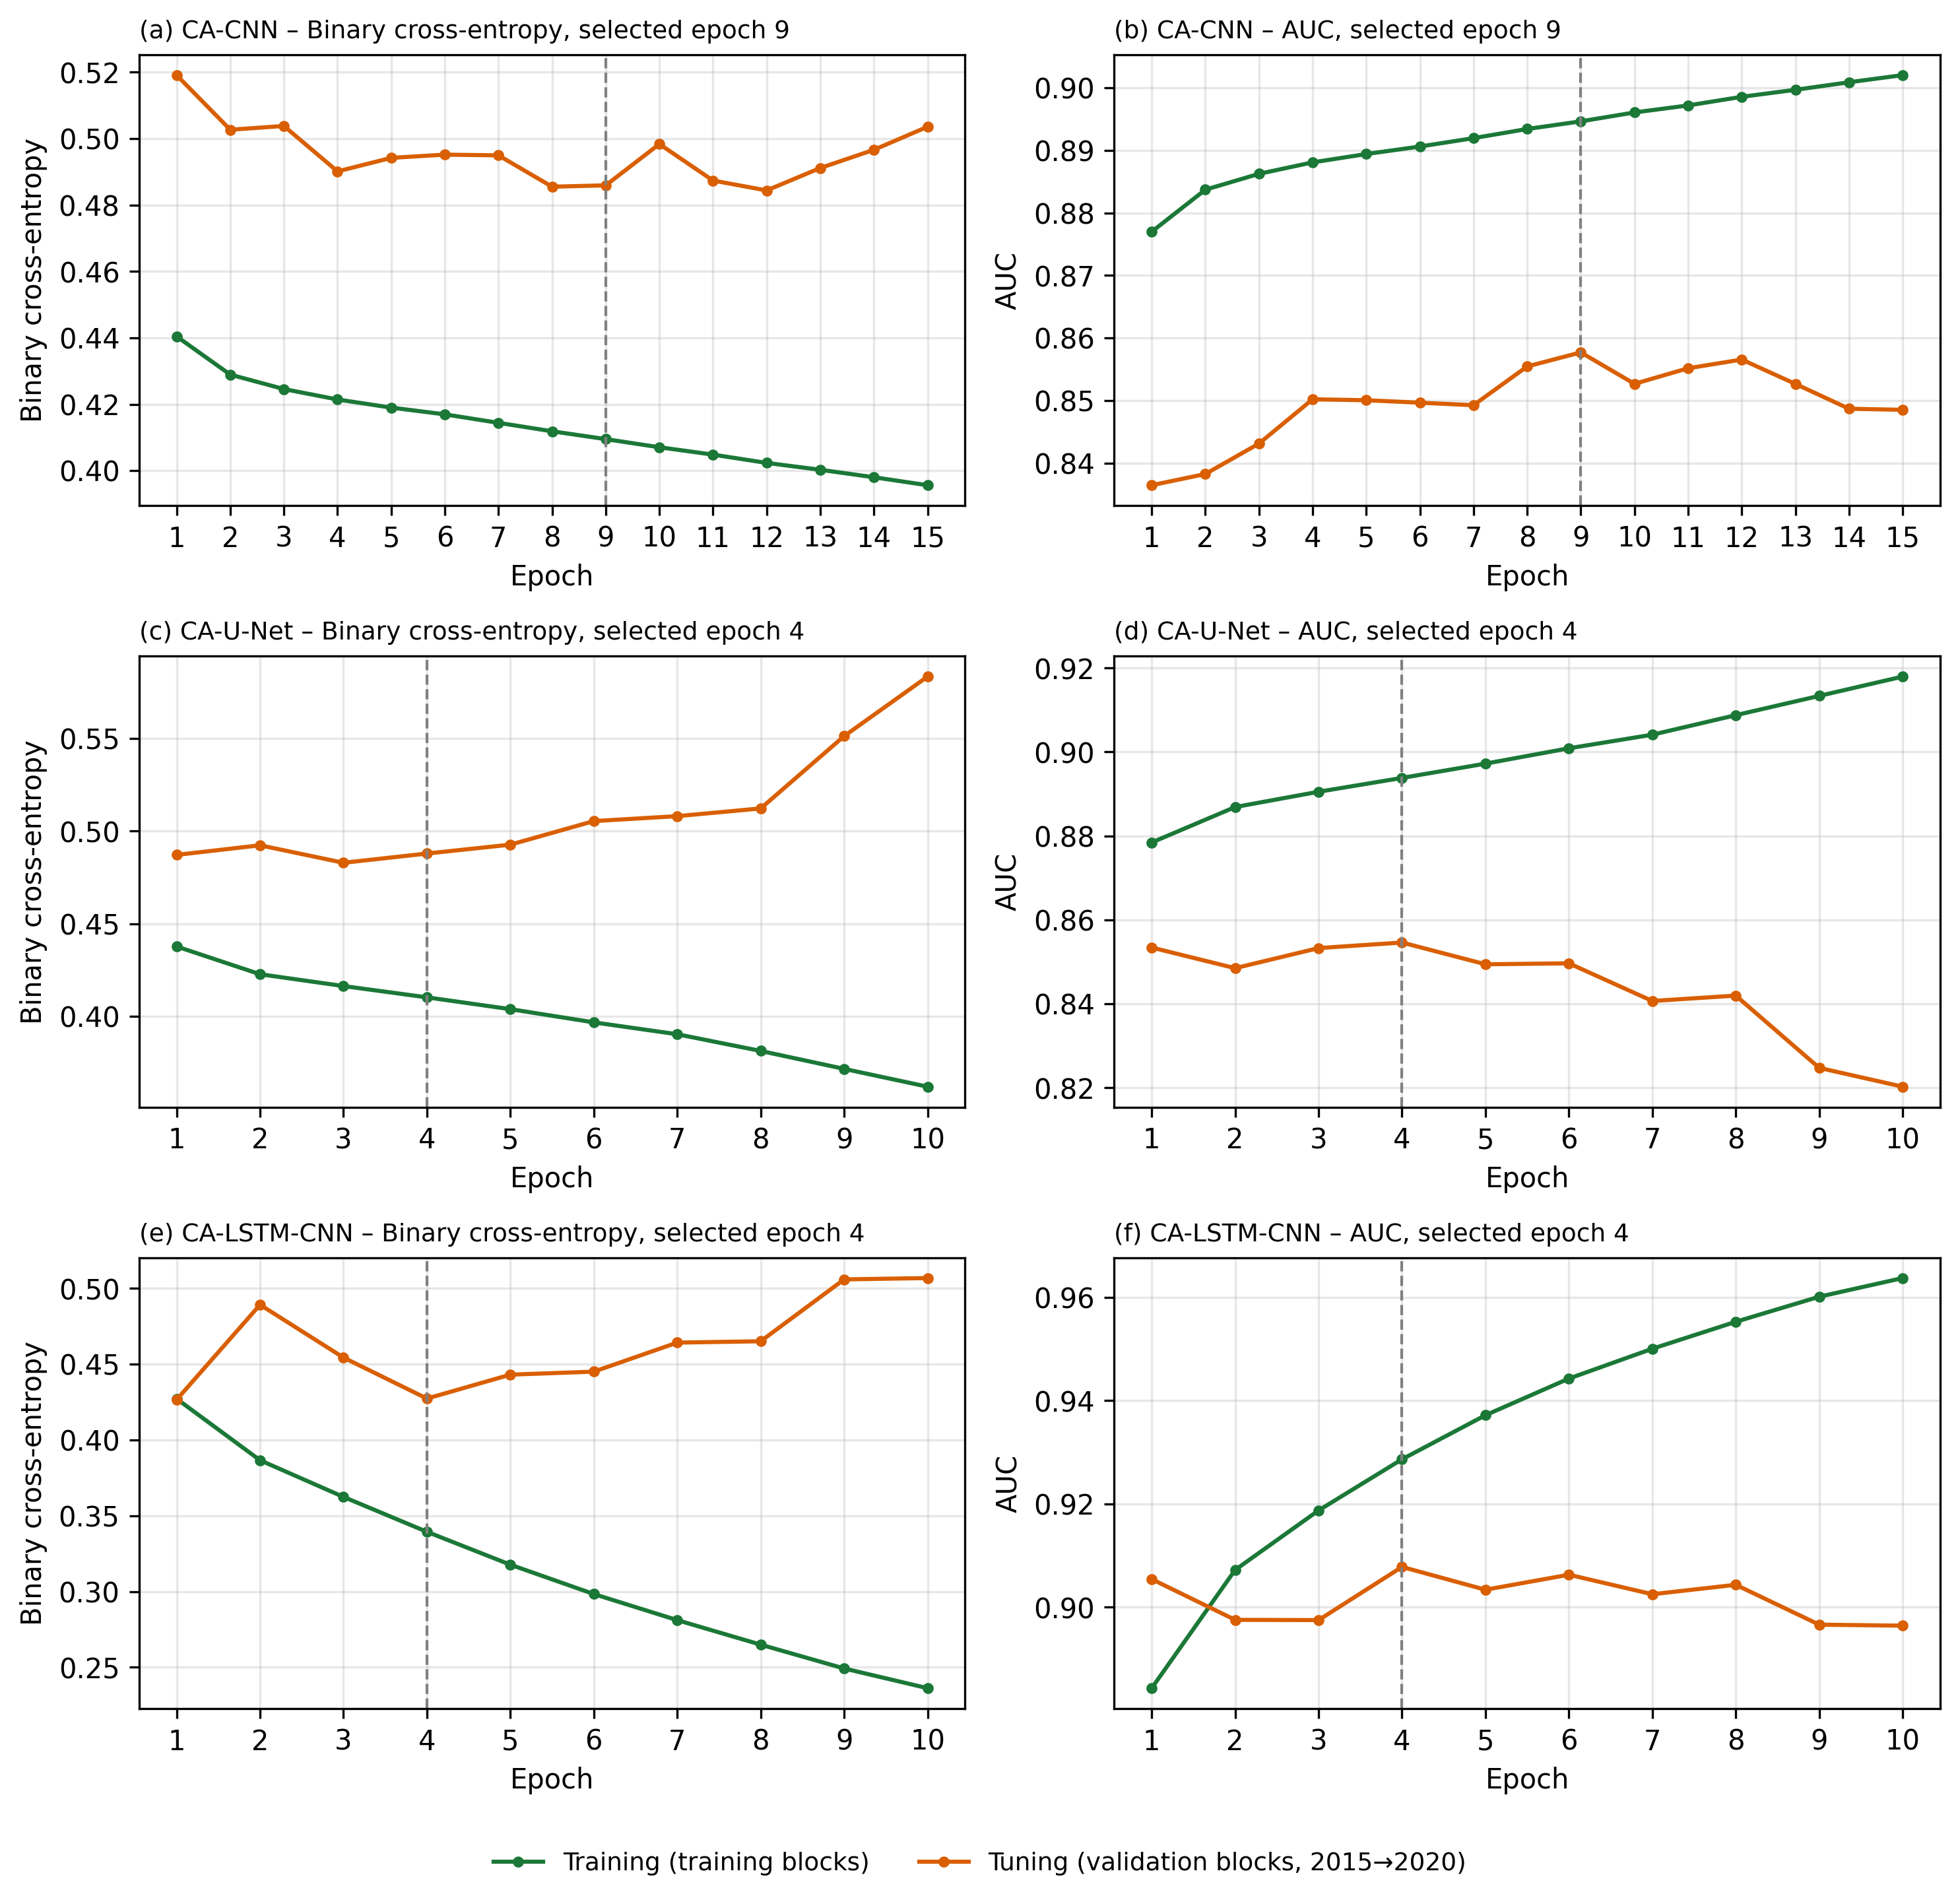
Figure S1. Training and tuning curves of (a–b) CA-CNN, (c–d) CA-U-Net and (e–f) CA-LSTM-CNN (seed 42) in the secondary-test design. Training used spatial blocks of the 1990–2015 transitions (CA-LSTM-CNN: 2000–2015); tuning used withheld blocks of the 2015–2020 transition; the 2025 map was not used. Dashed lines mark the epoch with the highest tuning AUC.
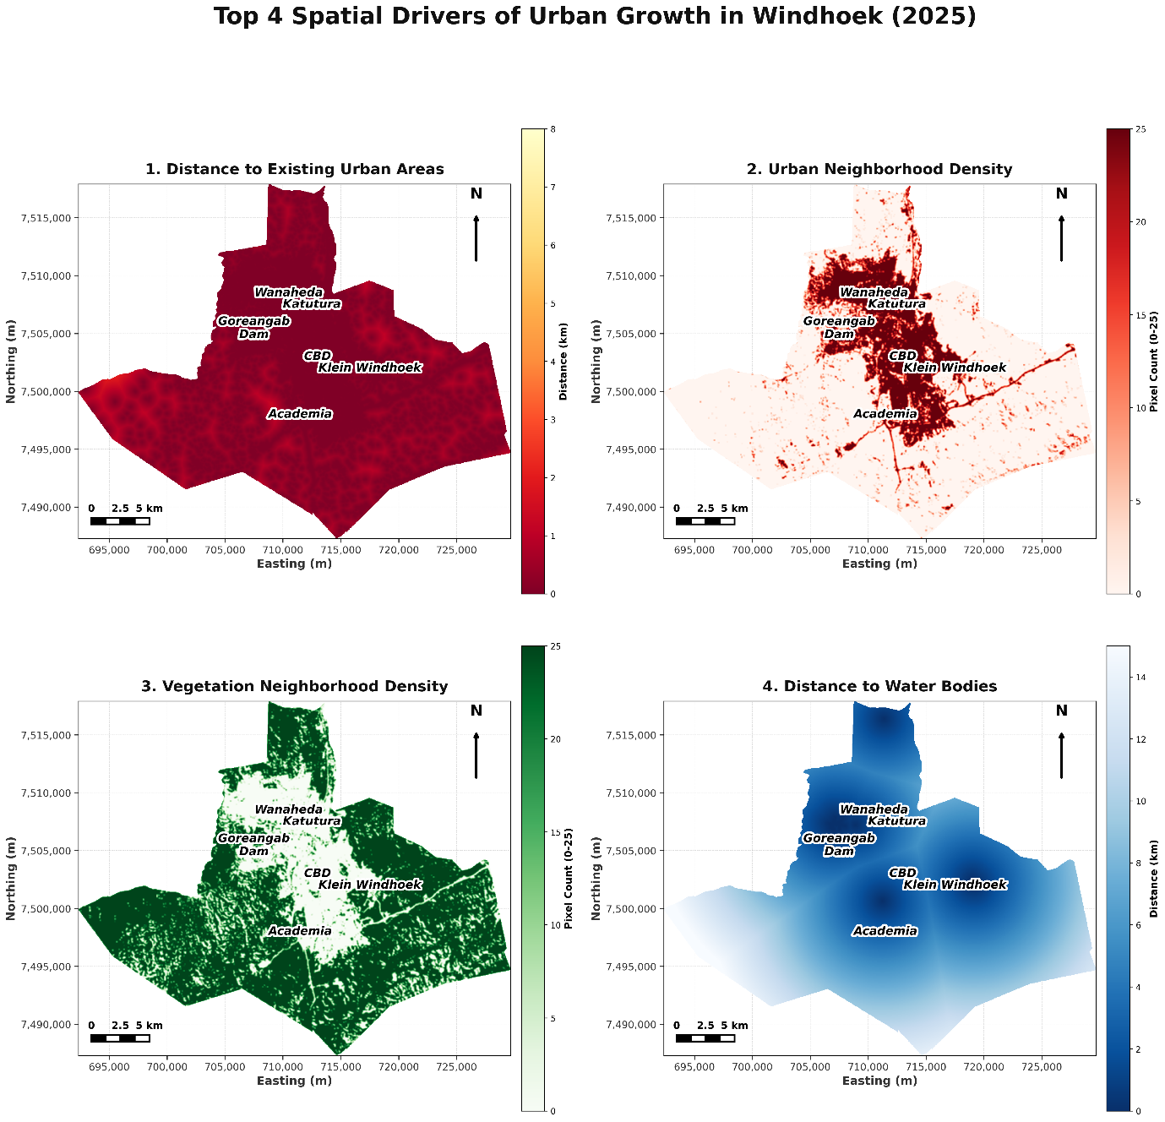
Figure S2. Spatial distribution of four of the predictors (2020): distance to existing urban land, urban neighbourhood density, vegetation neighbourhood density and distance to water bodies.
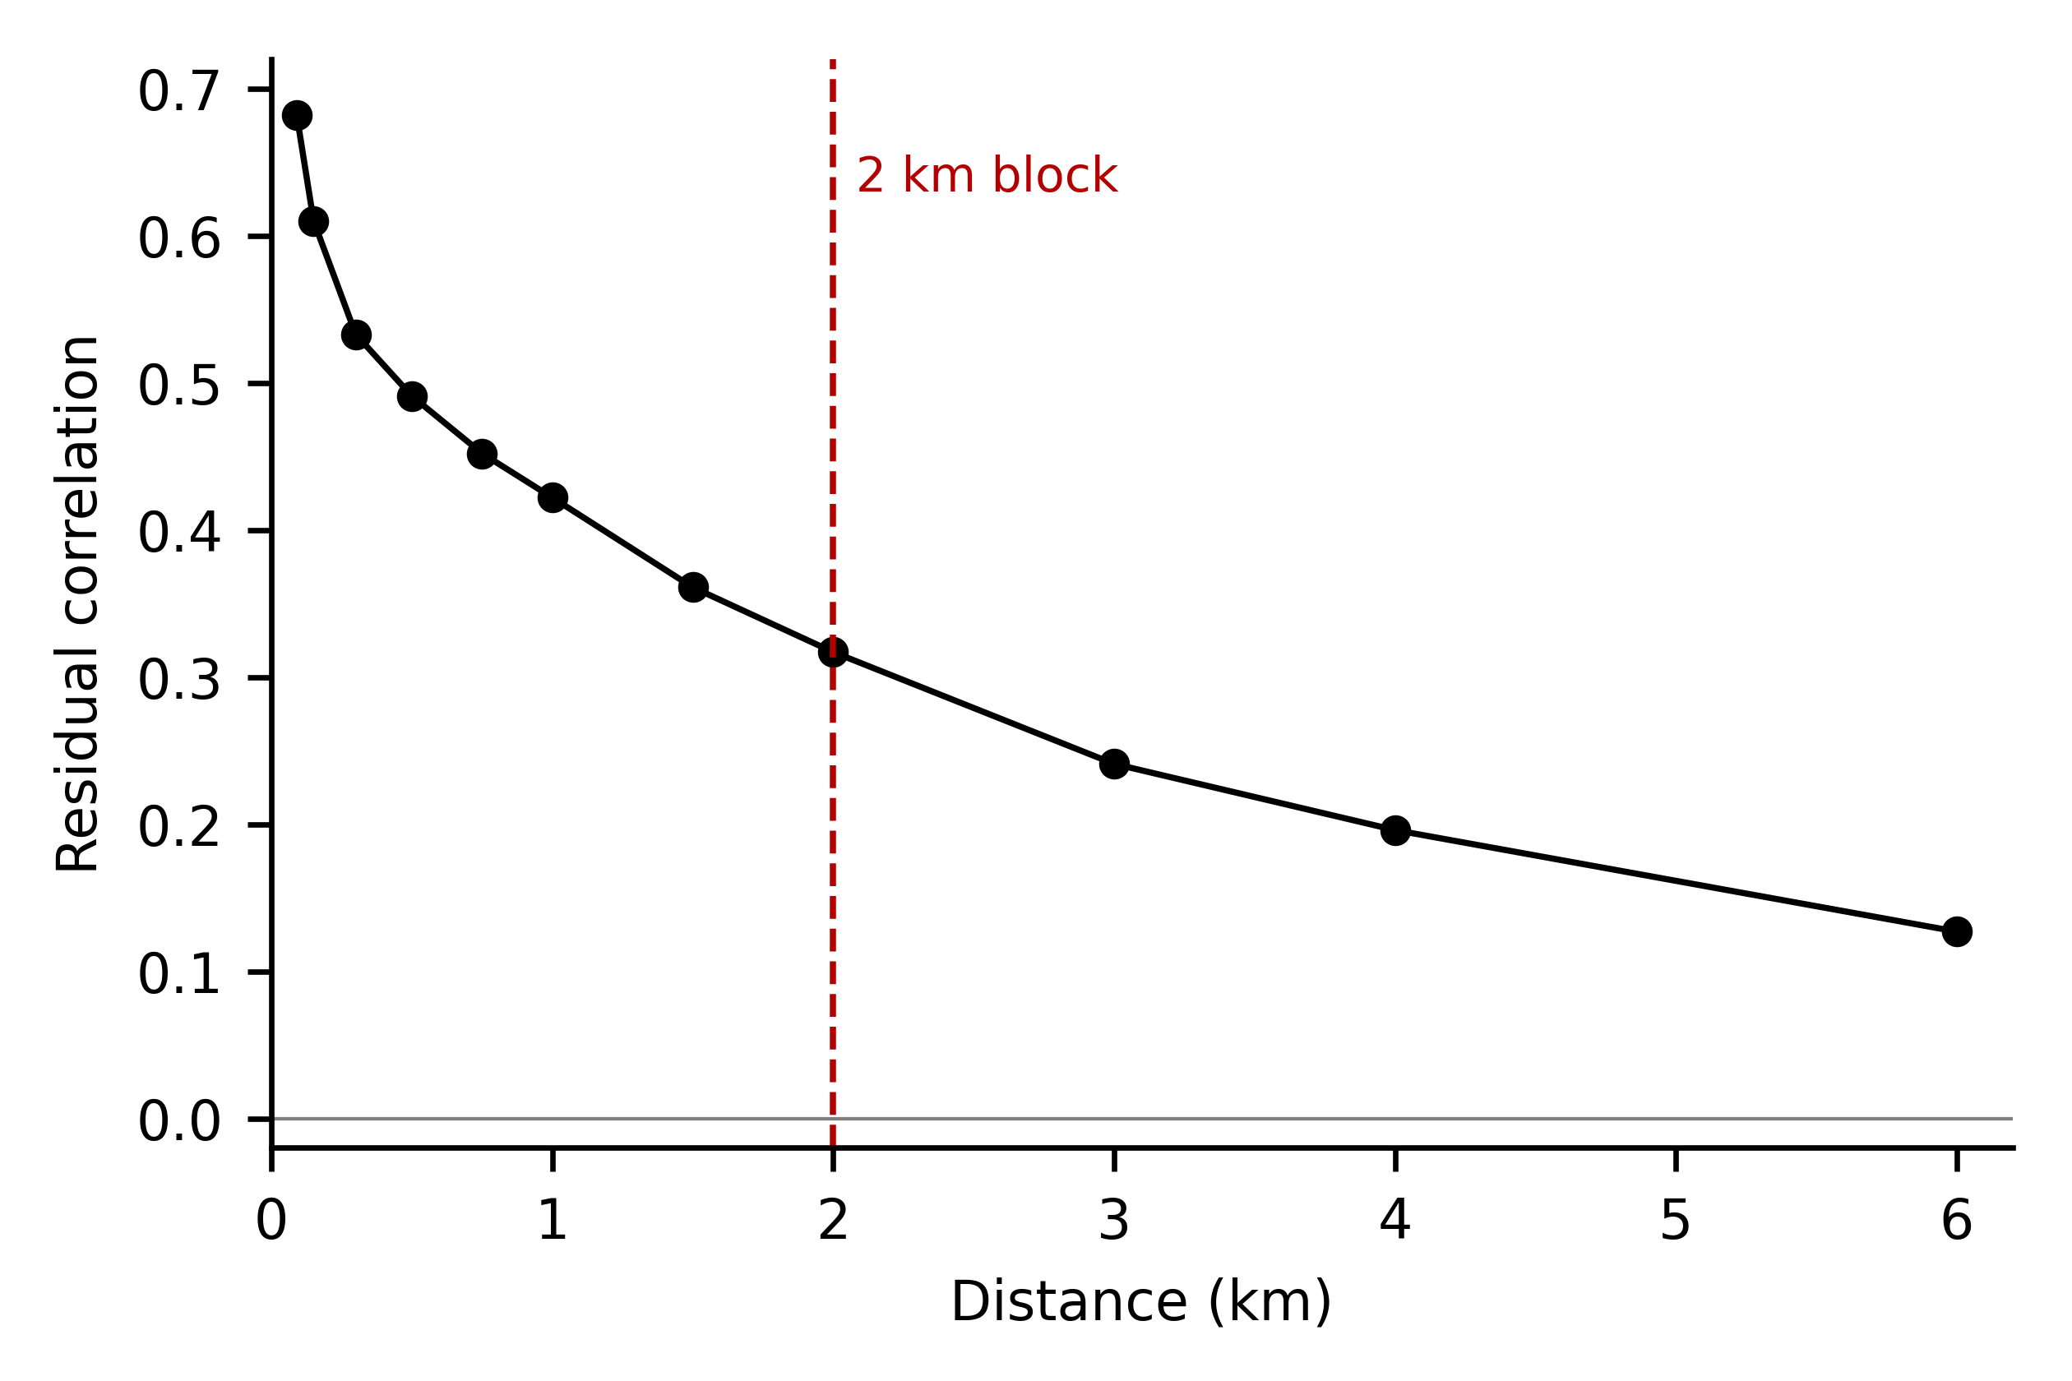
Figure S3. Correlogram of the residuals of the logistic-regression CA (observed 2015–2020 urban gain minus predicted probability), by distance between cells. The dashed line marks the 2 km block size used for the spatial tuning blocks and the secondary-test bootstrap; the main-test bootstrap used 4 km blocks, beyond which residual correlation remains weak but positive (r = 0.13 at 6 km).
Supplementary references
Breiman, L. (2001). Random forests. Machine Learning, 45(1), 5–32. https://doi.org/10.1023/A:1010933404324
Cohen, J. (1960). A coefficient of agreement for nominal scales. Educational and Psychological Measurement, 20(1), 37–46. https://doi.org/10.1177/001316446002000104
Congalton, R. G., & Green, K. (2019). Assessing the accuracy of remotely sensed data: Principles and practices (3rd ed.). CRC Press.
Czaplewski, R. L., & Catts, G. P. (1992). Calibration of remotely sensed proportion or area estimates for misclassification error. Remote Sensing of Environment, 39(1), 29–43. https://doi.org/10.1016/0034-4257(92)90138-A
Foody, G. M. (2020). Explaining the unsuitability of the kappa coefficient in the assessment and comparison of the accuracy of thematic maps obtained by image classification. Remote Sensing of Environment, 239, 111630. https://doi.org/10.1016/j.rse.2019.111630
Olofsson, P., Foody, G. M., Herold, M., Stehman, S. V., Woodcock, C. E., & Wulder, M. A. (2014). Good practices for estimating area and assessing accuracy of land change. Remote Sensing of Environment, 148, 42–57. https://doi.org/10.1016/j.rse.2014.02.015
Phan, T. N., Kuch, V., & Lehnert, L. W. (2020). Land cover classification using Google Earth Engine and random forest classifier—The role of image composition. Remote Sensing, 12(15), 2411. https://doi.org/10.3390/rs12152411
Pontius, R. G., & Millones, M. (2011). Death to Kappa: Birth of quantity disagreement and allocation disagreement for accuracy assessment. International Journal of Remote Sensing, 32(15), 4407–4429. https://doi.org/10.1080/01431161.2011.552923
Stehman, S. V. (1997). Selecting and interpreting measures of thematic classification accuracy. Remote Sensing of Environment, 62(1), 77–89. https://doi.org/10.1016/S0034-4257(97)00083-7
Stehman, S. V. (2014). Estimating area and map accuracy for stratified random sampling when the strata are different from the map classes. International Journal of Remote Sensing, 35(13), 4923–4939. https://doi.org/10.1080/01431161.2014.930207

