

Business Intelligence System
CT122-3-2-BIS
Individual Assignment

Student Name: Adam Mohamed Eldaleel
TP Number: TP077122
Intake Code: APD2F2409CS(DA)
Hand Out Date: Week 2
Hand In Date: Week 14

Project & Report Marking Grid (30%)

Assignment Components | Marks Allocated | Marks Awarded
Report Introductory & Formalities  - Aims & Objectives.  - Business Intelligence System Introduction. | 10 marks
Diagram & Report Formatting  - Relevant diagrams & illustrations.  - Appropriate formatting  - APA Referencing. | 10 marks
Critical Analysis & Discussion  - Methodology discussion  - Critical Analysis & Evaluation.  - Strategies & Recommendations. | 30 marks
Data Extraction with SQL tools  - Dataset extraction  - Dataset configuration | 5 marks
Business Analytic with Visual Studio  - Data source, data source view  - Multidimensional cubes  - Dimensions | 15 marks
Multi-Dimensional Expression (MDX)  - Implementation of MDX Queries. | 10 marks
Dashboard & Reporting  - Visualization charts.  - Dashboard designs. | 20 marks
Total Marks | 100 marks

Presentation Marking Grid (10%)
Components | Marks Allocated | Marks Awarded
Individual Presentation  - Presentation Skills  - Company Overview & Introduction  - Dashboard & Reports  - Analysis on Findings  - Q & A | 100 marks
Total Marks | 100 marks

Table of Contents
1.0 Company Profile: Velocity Cycles 5
1.2 Introduction 6
1.3 Aims & Objectives 6
2.0 Methodology (CRISP-DM) 7
CRISP-DM Methodology Diagram: 14
3.0 Insights Creation 15
3.0.1 Sales by Region 15
3.0.2 Product Profitability Analysis 17
3.0.3 Customer Segmentation & Preferences. 20
4.0 Strategies & Recommendations 24
5.0 Conclusion 25
6.0 References 26

1.0 Company Profile: Velocity Cycles
Company Name: Velocity Cycles, Inc.
Headquarters: San Francisco, California, USA
Industry: Bicycle Manufacturing and Distribution
Overview:
Velocity Cycles is a leading global manufacturer of high-performance bicycles and cycling components. Founded in 1985, Velocity Cycles has rapidly grown into one of the top brands in the bicycle industry, known for its commitment to superior quality, cutting-edge innovation, and sustainability. The company produces a wide range of bicycles, from mountain bikes and road bikes to electric bicycles and custom components.
With a state-of-the-art production facility and a robust network of suppliers, Velocity Cycles delivers its products to over 50 countries across North America, Europe, and the Asia-Pacific region. The company’s dedication to design excellence, product durability, and customer satisfaction has made it a trusted name among cycling enthusiasts, professional athletes, and everyday riders alike.
Mission Statement:
Velocity Cycles aims to lead the cycling industry by producing world-class bicycles and components that exceed customer expectations in performance, innovation, and sustainability. The company seeks to inspire individuals to lead active lifestyles, while expanding its global footprint and embracing new markets with the help of cutting-edge technologies.
Core Values:
Innovation: Continually pushing the boundaries of cycling technology and design.
Quality: Producing bicycles and components that are built to last.
Sustainability: Using environmentally responsible practices in manufacturing and distribution.
Customer Centricity: Providing exceptional customer service and a personalized experience.
Product Range:
Bicycles: Road Bikes, Mountain Bikes, E-Bikes, Hybrid Bikes, Kids’ Bikes
Components: Frames, Wheels, Handlebars, Pedals, Saddles, Gears, Chains
Accessories: Helmets, Pumps, Bicycle Locks, Cycling Apparel, Lights
Market Presence:
Domestic: Strong presence in the U.S. market, catering to cycling enthusiasts, recreational cyclists, and professional athletes.
International: Expanding into Europe, North America, and Asia-Pacific markets with growing retail and e-commerce channels.
Retail Channels: Sales through both direct-to-consumer (e-commerce platform) and a network of distributors and retail stores.

1.2 Introduction
Business Intelligence (BI) refers to the technologies, practices, and processes that enable organizations to collect, analyze, and visualize business data to support better decision-making. A BI system allows users to interact with data, identify patterns, detect anomalies, and uncover insights that inform operational and strategic choices. This report evaluates the implementation of a BI system built using SQL Server Analysis Services (SSAS), Power BI, and MDX (Multidimensional Expressions). The system is centered around a multidimensional cube designed to analyze customer-related data, sales metrics, and profitability indicators. Through Power BI dashboards, users can gain real-time insights into customer demographics, top-performing customers, and revenue trends segmented by various dimensions such as gender and age group. The MDX measures used—Customer Age Group, Profit, Top Gender Sales, and Top 10 Customers—were essential in extracting targeted insights from the cube, enhancing the accuracy and depth of the dashboard visuals. This BI solution exemplifies how data-driven intelligence can improve customer targeting, increase revenue, and boost organizational agility.

1.3 Aims & Objectives
The main purpose of this Business Intelligence project is to construct an analytical solution that would enable stakeholders to gain actionable insights from sales and customer data. More specifically, the objectives are:
- To develop a multi-dimensional data model that will facilitate advanced slicing and dicing of data.
- To utilize MDX queries to obtain complex analytical measures from the cube.
- To develop an interactive Power BI dashboard to visualize key indicators of performance.
- Improve strategic decision-making through revealing patterns in profitability and customer behavior.

2.0 Methodology (CRISP-DM)
The methodology used for this project follows the CRISP-DM (Cross Industry Process for Data Mining) approach, which is a widely recognized and standardized methodology for data mining and business analytics. CRISP-DM consists of six major steps, each focusing on different aspects of the data mining process. The approach is iterative, meaning that analysts can revisit previous steps based on new findings or challenges that arise during the project. This ensures that the business intelligence (BI) system developed for Velocity Cycles is comprehensive and robust.
- Business Understanding
The first step in CRISP-DM involves understanding the business objectives and the problem that needs to be solved. This step helps in framing the data analysis within the context of the business needs, ensuring the results will be actionable for decision-makers. For Velocity Cycles, the primary goal was to use Business Intelligence to support global expansion by improving the understanding of sales performance, customer preferences, and market trends.
- Objective: To align the BI system with Velocity Cycles' business strategy of expanding its presence across North America, Europe, and Asia-Pacific.
- Key Questions:
  - What are the key performance metrics (KPIs) that will drive decision-making?
  - How can the analysis of customer data support global market expansion?
- Data Understanding
In this step, the focus is on collecting the data and gaining an initial understanding of its contents. This phase involves data exploration and checking the data for completeness, quality, and relevance. For Velocity Cycles, this involved accessing the Data Warehouse (DW) and reviewing the available datasets related to sales, customer behavior, product performance, and regional data.
- Objective: To understand the structure of the available data and assess its suitability for the BI analysis.
- Key Actions:
  - Extracting relevant datasets from the Data Warehouse (e.g., sales records, customer demographics).
  - Evaluating the data quality by checking for missing values, inconsistencies, and outliers.
- Data Preparation
Data preparation is a critical step where the raw data is cleaned and transformed into a usable format for analysis. This includes data cleaning, data integration, and data transformation. For Velocity Cycles, this step involved ensuring that the sales, product, and customer data were appropriately structured for the multidimensional analysis required for the BI system.
- Objective: To prepare clean, structured, and integrated data for modeling.
- Key Actions:
  - Data cleaning (removing duplicates, correcting errors).
  - Data transformation (standardizing data formats, creating derived variables like "Profit").
  - Data integration (combining data from different sources, such as sales and customer information).
- Data Preparation and Extraction
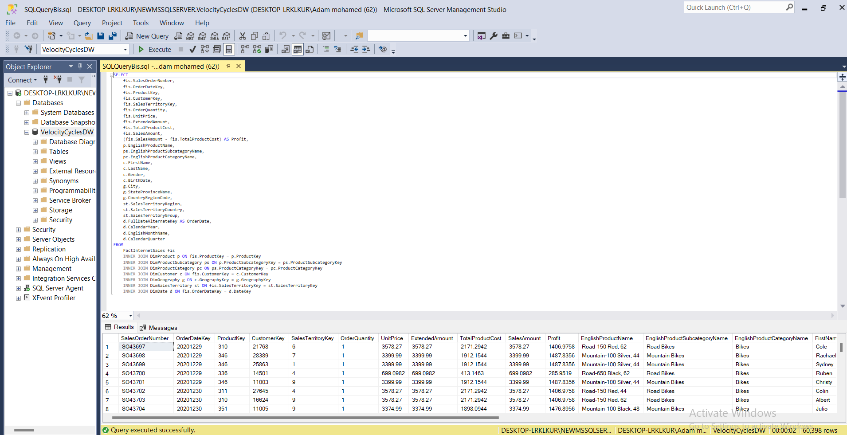
(Figure 1 SQL Queries in SQL server management studio)
Data was extracted using SQL queries and configured into a suitable structure for multidimensional analysis.
- Modeling
Modeling is the core phase of the CRISP-DM process where statistical models and algorithms are applied to the prepared data to uncover patterns, trends, and relationships. In this project, Velocity Cycles used multidimensional modeling with SQL Server Analysis Services (SSAS) to create a data cube that could analyze sales and customer data from different angles (e.g., product category, region, and customer demographics). This was followed by the development of MDX (Multidimensional Expressions) queries to create custom business measures like "Top 10 Customers" and "Customer Age Group."
- Objective: To build models that can generate meaningful insights from the data.
- Key Actions:
  - Creating a multidimensional cube with measures and dimensions (sales, customers, products, etc.).
  - Developing MDX queries to generate business metrics like "Top Gender Sales" and "Top 10 Customers."
  - Using Power BI to create interactive dashboards for data visualization.
- Data Modeling with SSAS
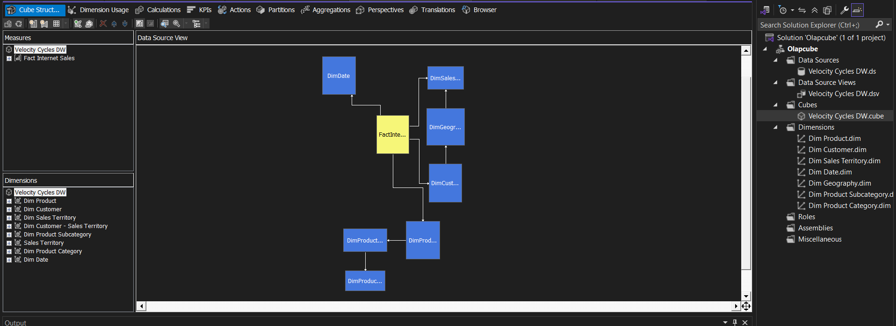
(Figure 2 Cube dimensions and fact table)
A multidimensional cube was developed in Visual Studio using SQL Server Analysis Services (SSAS). This involved defining measures and dimensions, including Top 10 Customers, top gender sales, Customer Age Group, and Profit.

- MDX Query Development
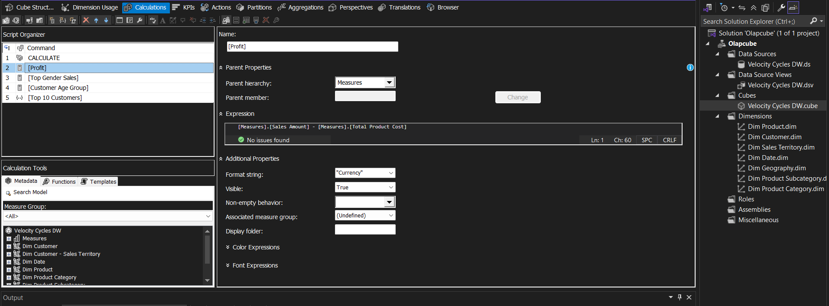
(Figure 3 showing the measures and calculated values)
MDX queries were implemented to create calculated measures and filter data in a more customized way. Key MDX expressions were developed for:
  - Customer Age Group: To segment sales by age brackets.
  - Profit: Calculated by subtracting cost from sales.
  - Top Gender Sales: Identifying gender-based sales performance.
  - Top 10 Customers: Ranking customers based on purchase value.

- Dashboard Development with Power BI
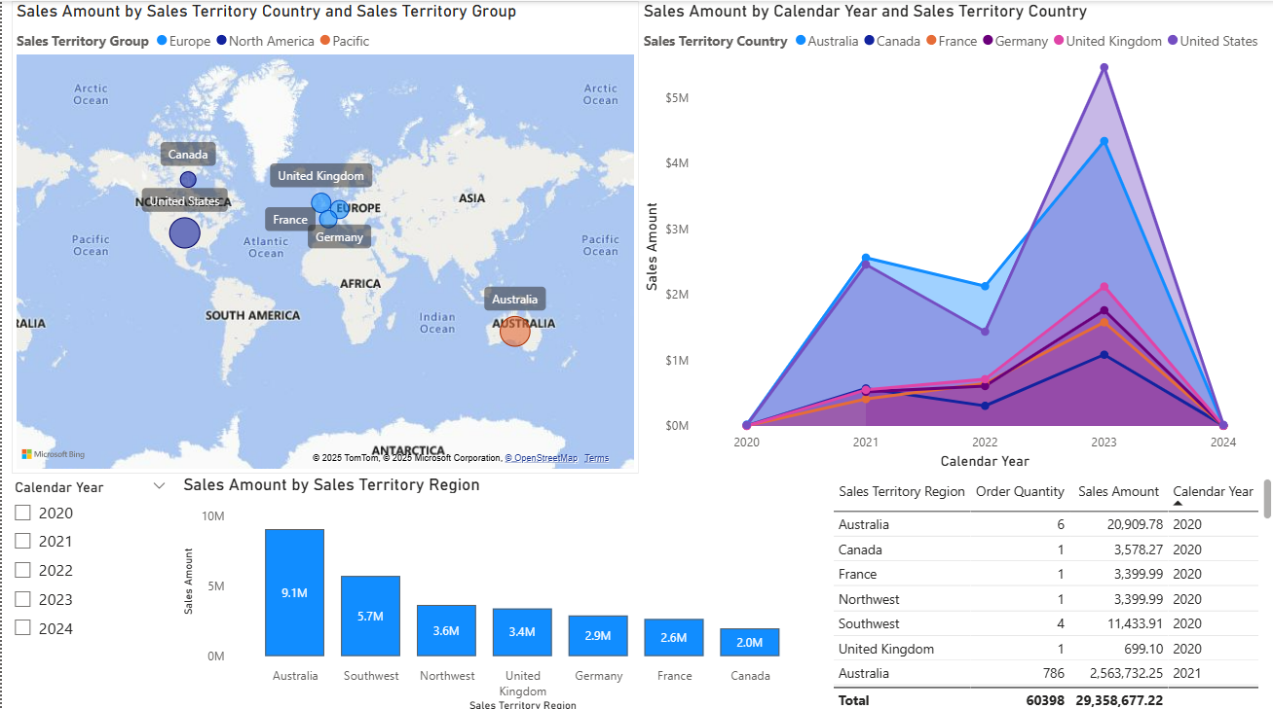
(Figure 4 Regional Sales Performance Dashboard)
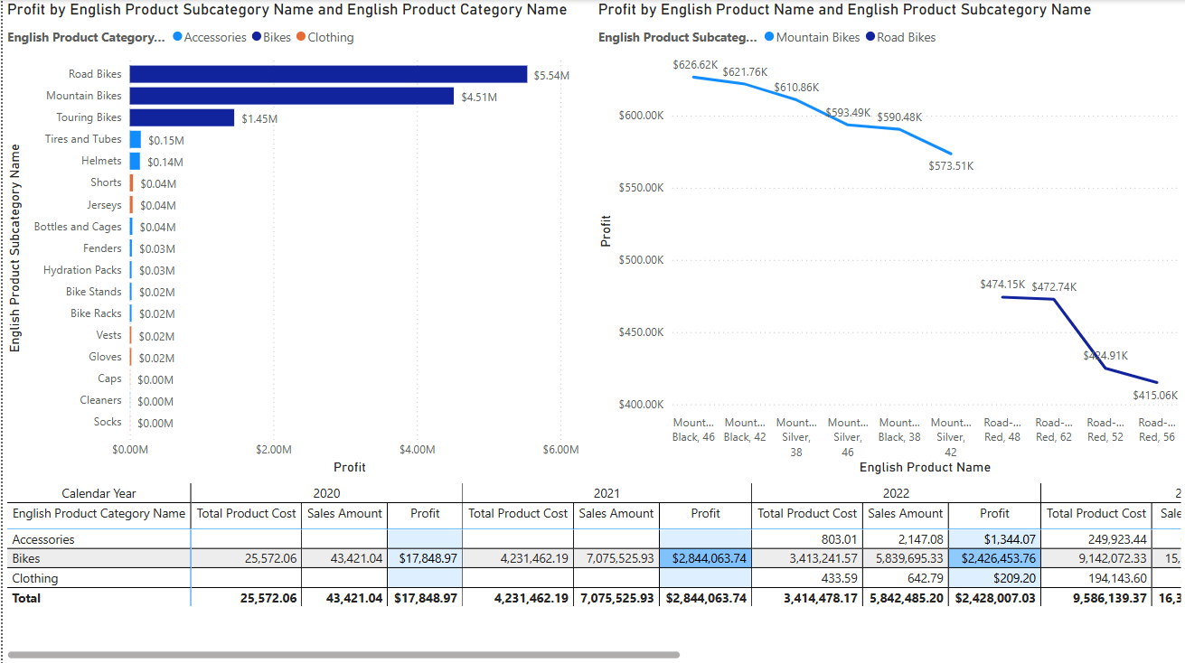
(Figure 5 Product Profitability Analysis Dashboard)

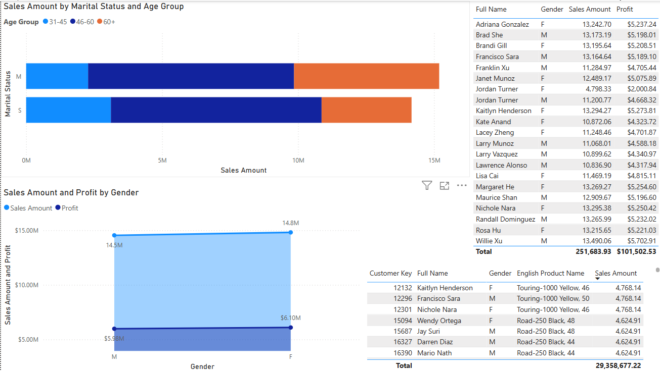
(Figure 6 Customer Segmentation & Preferences Dashboard)
Power BI was used to create an interactive dashboard with slicers and visualizations like bar charts, pie charts, and tables. These visuals were directly linked to the SSAS cube using live connections.
- Evaluation
After the models have been built, it is crucial to evaluate their performance and ensure they meet the business objectives set in the first step. The evaluation step assesses the usefulness of the model outputs and ensures that the insights generated align with the business needs. For Velocity Cycles, this step involved validating the BI dashboard, ensuring that the generated insights were actionable for strategic decision-making.
- Objective: To validate the effectiveness and relevance of the BI system.
- Key Actions:
  - Assessing whether the insights provided by the model align with Velocity Cycles' strategic goals.
  - Evaluating the usefulness of the BI dashboard for real-time decision-making (e.g., are the visualizations providing clear, actionable insights?).
- Deployment
The final step in CRISP-DM is deployment, where the model and analysis results are applied in real-world scenarios. For Velocity Cycles, this involved implementing the BI system through interactive dashboards in Power BI, allowing stakeholders to make informed decisions. It also includes monitoring the model's performance over time and making necessary adjustments based on new data or feedback.
- Objective: To deploy the BI system in a way that provides continuous value to the business.
- Key Actions:
  - Publishing the Power BI dashboards for real-time use by managers and decision-makers.
  - Ongoing monitoring and maintenance of the BI system to ensure it remains aligned with the company's evolving needs.

CRISP-DM Methodology Diagram:
Below is a diagram representing the CRISP-DM methodology, showing the six steps in a cyclic process, as it is often iterative and requires revisiting certain steps based on findings from later phases.
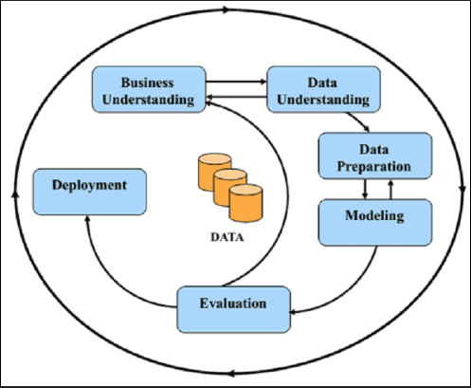

3.0 Insights Creation
The dashboard yielded several critical insights that were identified and evaluated:

3.0.1 Sales by Region
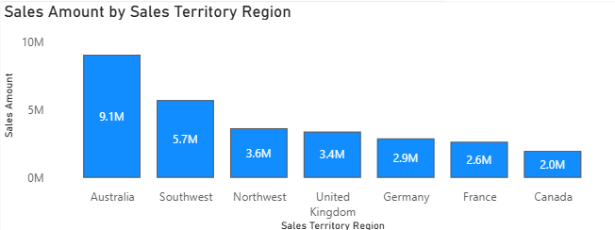
(Figure 7 Sales Amount by Region)
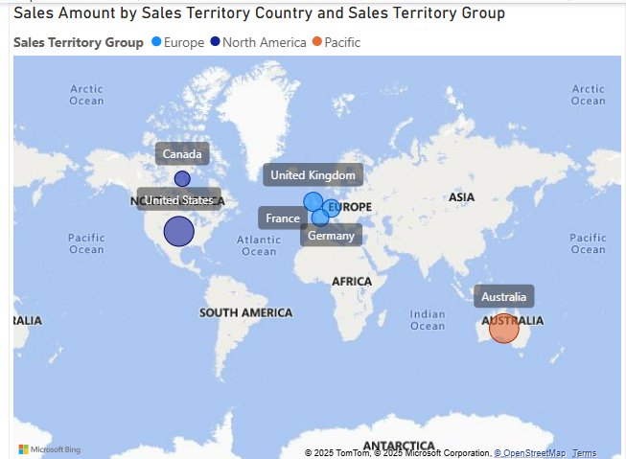
(Figure 8 Map of Sales amount by Country and Group)
One of the most outstanding visualizations on the dashboard was the comparison of sales across regions, and it exposed considerable differences in revenues achieved in various regions. Australia and Southwest (USA) regions were the leading locations in terms of overall sales, with both accounting for over 50% of the total revenue together. This implies a greater concentration of customers or a greater purchasing power in these regions. On the other hand, some areas like Europe and Canada reported relatively weaker sales volumes, suggesting lower market penetration or possibly logistical issues that could be having an impact on performance.
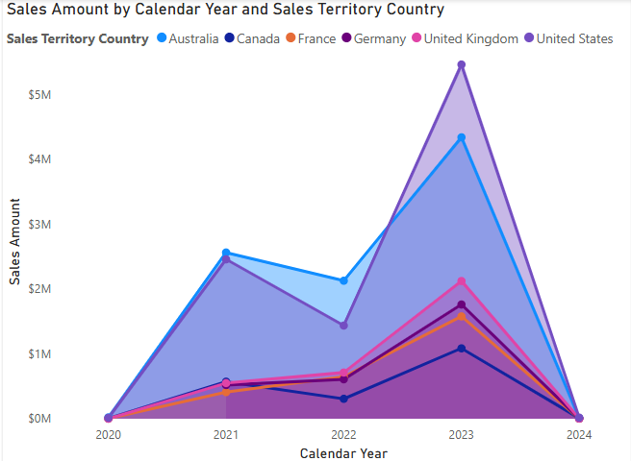
(Figure 9 sales amount by calendar year and sales territory country)
Analysis of sales amount by sales territory country and calendar year illustrates regional trends in sales performance over time. Through splits of the data by calendar year, I found sales trends and seasonal shifts in sales. States like United States of America and Australia demonstrated consistently high sales volumes, reflecting a mature established client base. On the other hand, developing countries like the United Kingdome had high year-on-year sales growth, and this suggests room to invest in future years. Year-on-year analysis in combination with geos provides an insightful guideline in creating reasonable regional sales targets and maximising sales in high-performing or high-growth geos.

3.0.2 Product Profitability Analysis
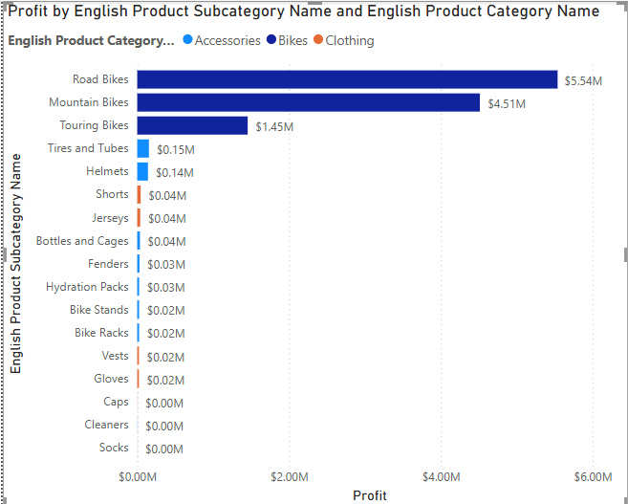
(Figure 10 Profit by English Product Subcategory Name and English Product Category Name)
The profit analysis by English Product Category Name and Subcategory Name identifies those product lines that are most profitable overall. Of the major categories, Bikes brought in the most profit, with the product line of Road Bikes being a major contributor to revenues. This is a good indication of market demand coupled with effective cost control in that segment. Others, such as Clothing, are consistently lower in terms of profit margin, and those are areas where pricing or operations could be improved. Such results can be used to direct product-oriented strategies, including inventory planning, promotional programs, and product development.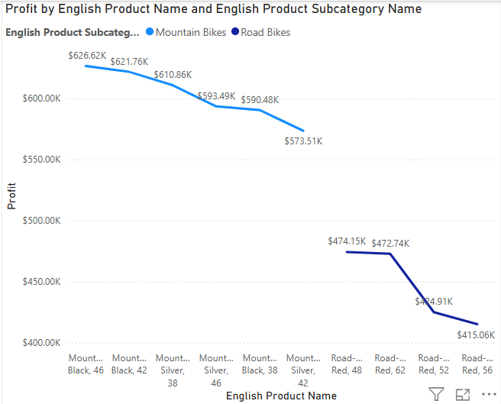
Figure 11 Profit by English Product Name and English Product Subcategory Name
Focusing on the most profitable product category (Bikes) and most profitable subcategories (Mountain Bikes and Road Bikes), the analysis of profit by Subcategory Name and English Product Name offers greater insight into product performance at the product level. Amongst these subcategories, items like Mountain-200 Black, 46 in the case of the Mountain Bikes or Road-150 Red, 48 in the case of the Road Bikes turned out to be the most profitable, reflecting high demand from customers and good profit margins. Such fine-grained insight supports more focused sales strategies, such as prioritizing stocking and promotion of high-margin bike models, and can guide decisions in bundling, upselling, and prices. It also supports the focus on high-performing subcategories within product categories.

Financial Performance Overview by Year and Category
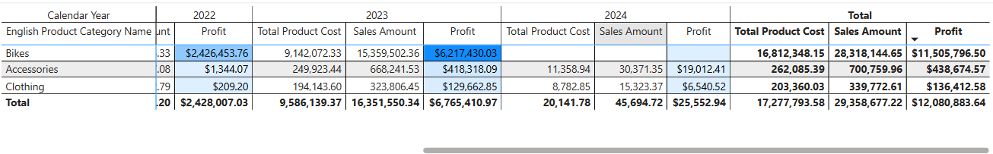
Figure 12 Financial Performance Overview by Year and Category
The matrix analysis of Sales Amount, Total Product Cost, and Profit over Calendar Years and Product Categories offers a holistic overview of business-wide performance. The Bikes category consistently maintained the highest year-over-year sales and profit value, reinforcing the segment's status as the most financially impactful product line. The Accessories and Clothing segments also picked up steadily but at less profitable levels, hinting at complementary product roles rather than prime cash cows. Year-over-year sales and profit gains in both sales and profit, notably in the Bikes segment, reflect well-positioned product success and cost control. This multi-measure breakdown allows stakeholders to view profitability in its entirety and make sound strategic decisions regarding budget, price, and product focus.

3.0.3 Customer Segmentation & Preferences.
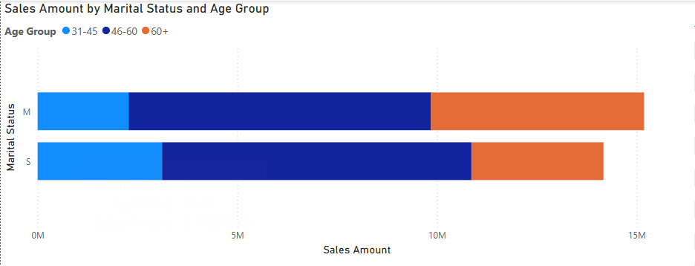
Figure 13 Sales Amount by Marital Status and Age Group
The Customer Segmentation & Preferences dashboard provides insight into purchasing patterns based on Marital Status and Age Group, the latter derived through a custom MDX query. The analysis reveals that 46-60 contributes the highest sales across both married and single customers, indicating a key target demographic with strong purchasing power. Married customers generally accounted for higher overall sales, especially within middle age ranges, suggesting a stable customer segment likely making family-oriented or long-term investments. In contrast, younger age groups showed lower sales volume but may represent opportunities for future growth through targeted marketing and entry-level products. These insights are valuable for personalising marketing strategies and aligning product offerings with specific customer segments.

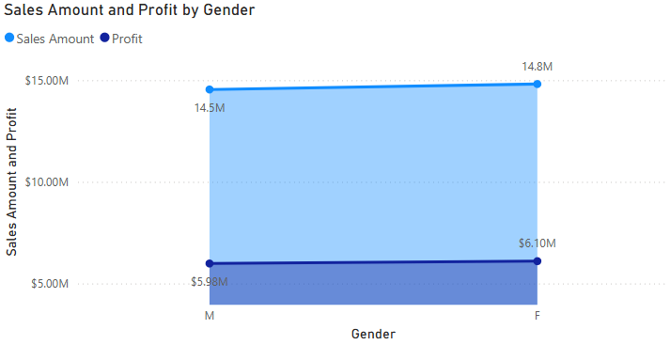
Figure 14 sales amount and profit by gender
Analysis of Profit and Sales by Gender reveals significant variations in the purchasing habits of male versus female customers. Female customers brought in the most sales and profit in total, with an indication of a stronger holding in current customers through this fact. Yet, despite having a smaller proportion of total sales, Male customers still held an appreciable share of profit—pointing to perhaps higher average profit per transaction. This fact implies that if females are superior in quantity, males might be more selective or strategic in their buys. Knowing these trends enables targeted marketing, promotion, and positioning towards product preferences based on gender.

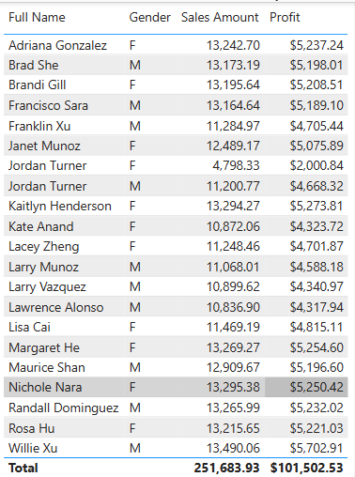
Figure 15 Top 20 Customers by sales, profit and gender
To obtain in-depth insight into individual customers' contributions, a Top 20 Customers table was created by running an MDX query, which computed the full name using first and last name—attributes not readily available in a single column in the data set. MDX logic also ranked and filtered the top 20 customers by Sales Amount. The final output shows each customer's full name, gender, total sales amount, and profit. This finely detailed granularity highlights high-value customers that contribute heavily to total revenue and profit. Interestingly, the top-performing individuals also typically align with the most profitable segments found in broader demographic analysis, such as particular age segments or marital status segments. This type of focused customer profiling is critical to loyalty programs, VIP marketing programs, and relationship management initiatives.

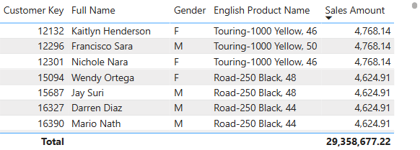
Figure 16 Customer-Product Sales Table
This table provides a detailed insight into customers' purchasing habits through a combination of Customer Key, Full Name, Gender, English Product Name, and Sales Amount. The Full Name field had to be created using an MDX query since the original data set did not contain a concatinated name column. Mapping a customer to the actual product(s) he or she bought provides this table with rich insight into single-buyer purchase behavior and preference. It makes it possible to identify leading products in particular segments of customers (e.g. males vs. females), and to follow a single customer's contribution to a product's sales. This level of granularity is helpful in perfecting personas, creating product recommendations based on particular segments, and enhancing cross-selling opportunities.

4.0 Strategies & Recommendations
According to the findings of the analysis, a number of strategic suggestions may be proposed in order to boost the company's performance:
- Invest in High Performers: As Bikes—specifically Mountain Bikes and Road Bikes—emerge as the most profitable product segment and category, inventory management, marketing initiatives, and promotional campaigns should be prioritized on such items. Bundle offers or time-sensitive discounts could also increase revenue from the high-performing segments further.
- Enhance Regional Emphasis: Maintaining steady sales increases in geographies like Australia implies that such geographies should be the focus areas of expansion strategies. Focused marketing and enhanced logistcs in good-performing nations can ensure not only sustainable competition but also a long-term advantage.
- High-Value Customer Targeting: A set of the top 20 clients, determined through MDX queries, accounted for a major proportion of sales and profitability. Building VIP loyalty programs, giving previews of special products, and customized communication can retain the clients and facilitate greater lifetime value.
- Optimize Gender-Oriented Marketing: Females had greater total sales and profit, but males had potentially greater per-purchase margins. This finding affirms developing targeted marketing approaches—volume-based marketing towards women and value-oriented initiatives (e.g., quality, exclusiveness) towards men.
- Leverage Age Group Data: Age Group 46-60 had maximum purchase activity. Target marketing initiatives like focused advertisements, lifestyle marketing, and product suggestions aligned with their interest should be aimed towards this age segment in an effort to boost conversion rates.
- Enhance Product Personalization: Through analysis of the Customer–Product Sales Table, a company can determine the most bought items by particular customer segments. Using this information in recommendations and personalized email marketing can lead to a dramatic increase in sales efficacy.
- Optimize Inventory Planning: Year-over-Year, Cost, and Profit Matrix analysis can be applied to forecast demand and optimize supply chain effectiveness. Investment should be allocated further in high-margin, fast-selling items, and low-margin items should be evaluated with a cost optimization or phase-out perspective.
- Apply MDX-Driven Analytics to Gain Greater Insight: Effective application of MDX queries to obtain age groups, full names, and best-selling lists is a testament to the strength of cube-based analysis. It is advisable to extend this analysis further through the inclusion of further enhanced segmentations (e.g., purchase frequency, recency, etc.) in order to make decisions with greater precision.

5.0 Conclusion
This analysis offered a detailed picture of the company's sales performance, customer behavior, and product profitability based on multimensional analysis of data and MDX queries. Bikes category, specifically Mountain Bikes and Road Bikes, appeared to be the most profitable lines of product, accounting for most of the sales and profit amounts. Region-wise, some countries consistently reflected high sales performance, reflecting opportunities for market expansion in those areas. The yearly analysis according to product category showed consistent sales and profitability development, most notably in well-performing groups such as Bikes. Customer segment analysis identified the 35–44 age bracket and married consumers as most prominent in terms of sales contribution, while men contributed greater total sales and profit, while females demonstrated promise in terms of margin. Advanced insights were made available through MDX queries, such as constructing full customer names, creating age segments, and determining the top 20 customers. These high-value customers accounted for a major share of revenues and may be targeted towards loyalty initiatives. Finally, the in-depth table correlating customers with product level purchases aided further insight into individual preferences in terms of purchase history, further allowing personalized marketing initiatives.

6.0 References
- Microsoft. (n.d.). Multidimensional Expressions (MDX). Retrieved from https://learn.microsoft.com/en-us/sql/mdx/mdx-query-overview
- Microsoft. (n.d.). Power BI Documentation. Retrieved from https://learn.microsoft.com/en-us/power-bi/
- Kimball, R., & Ross, M. (2013). The Data Warehouse Toolkit: The Definitive Guide to Dimensional Modeling (3rd ed.). Wiley.

word count: 3540

