Chapter 3

1)

A new scene has been created for the third homework

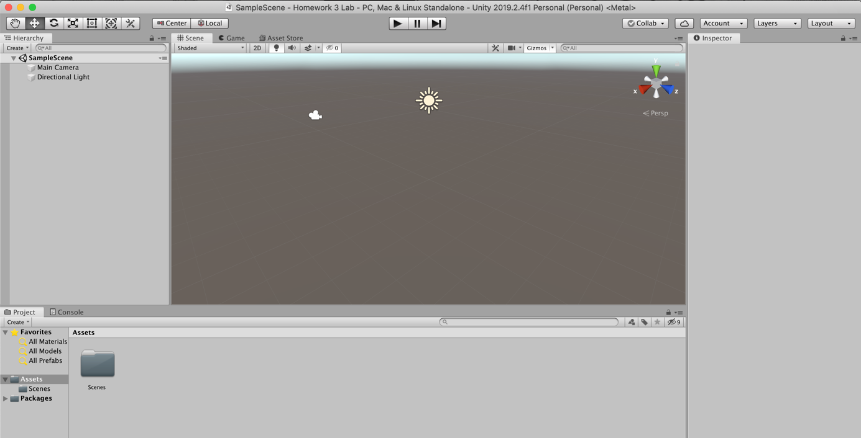

2)

I create two folders : Materials and Textures then I drag two files into the Textures folder

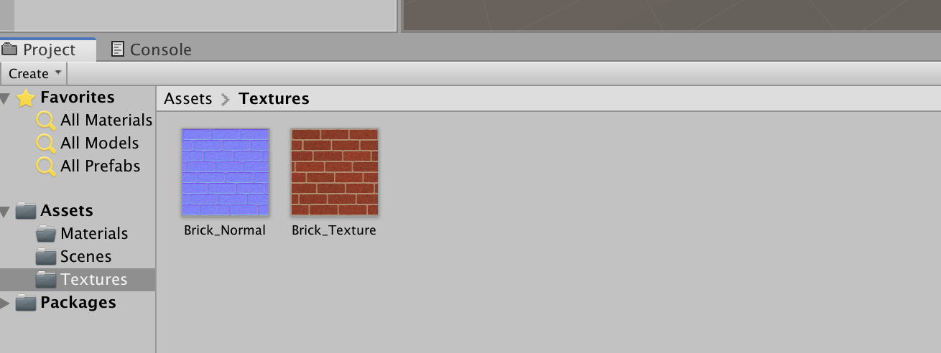

3)

I changed the aniso value from 1 to 3

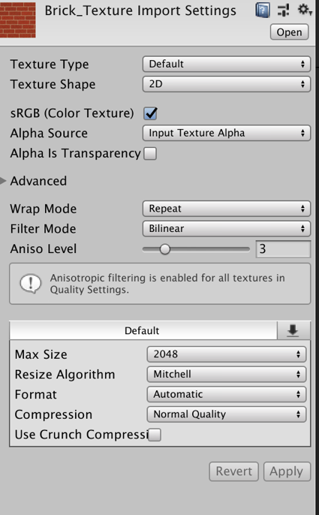

4)

I changed the texture type to Normal Map

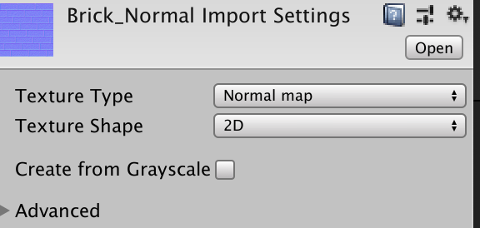

5)

I changed several params of the Directionnal Light you can check the new params on this picture

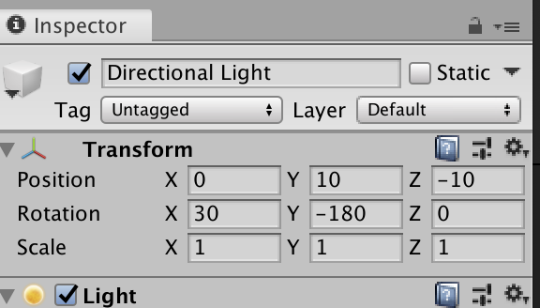

6)

I added 4 sphere and I scale them to (2, 2, 2) then I changed their position

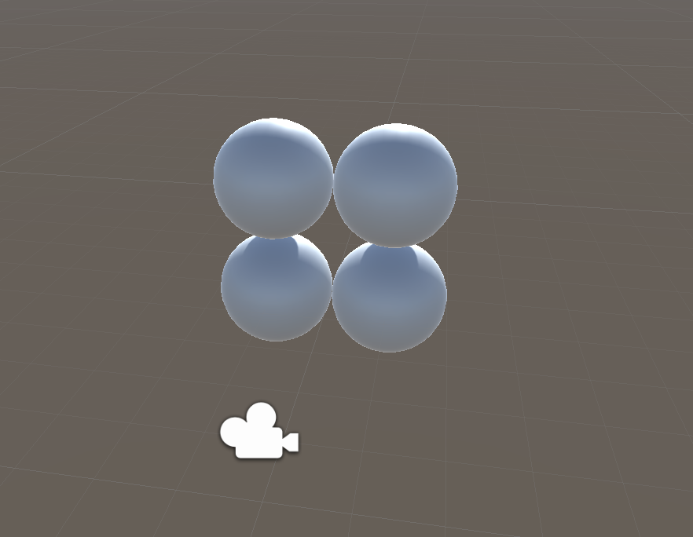

7)

I create 4 materials and I set their properties as you can see on the pictures ( thank you Sarah to having uploaded the file on canvas ☺ )

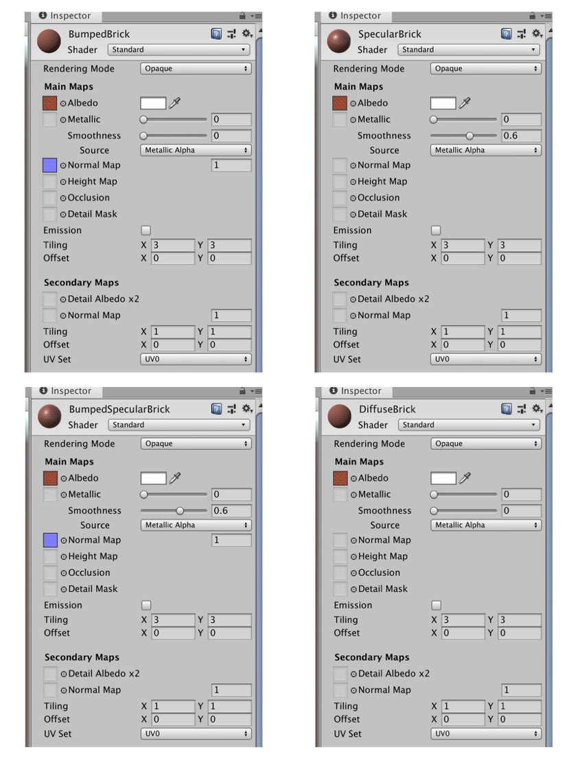

8)

I drag each material to a different sphere to see what happening. The light is very important to see some effects

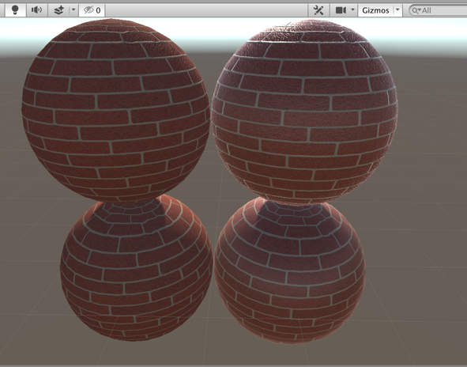

Chapter 4

0)

I create a new scene in my “Homework 3” project and I called this scene: Chapter 4 ( Because this is the chapter 4 ^^)

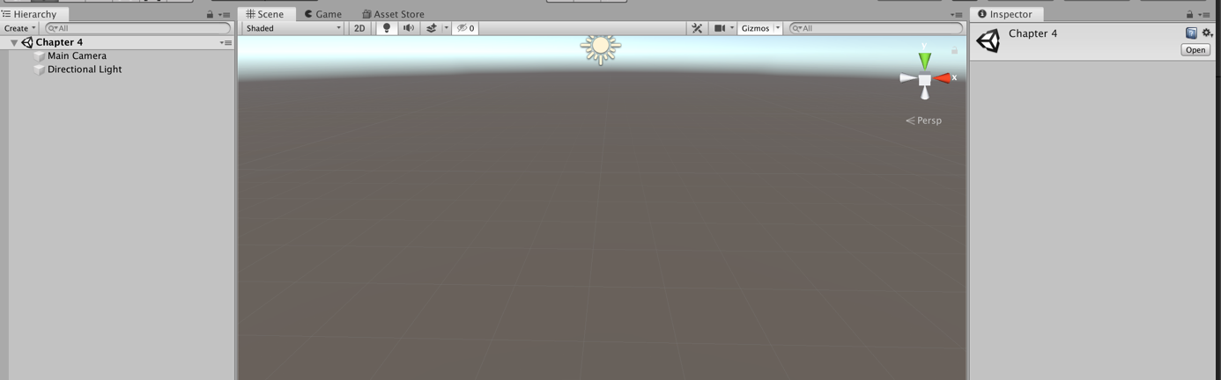

1)

I create a terrain like this: GameObject -> 3D Objects -> Terrain

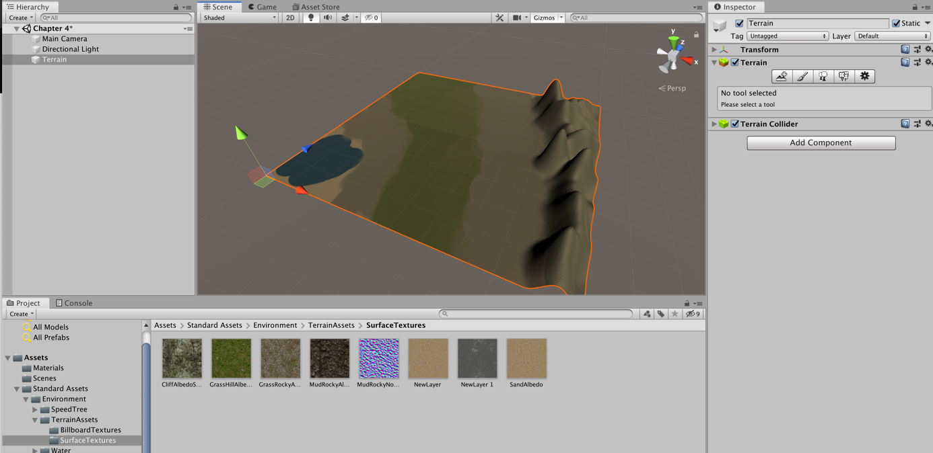

2)

This exercice was pretty fun because I learned a lot of thing about the layer. I added a lot of layer for the 3 environment’s (Beach, plains and Mountain) you will see the layer on the picture under this.



3)

I added a lot of vegetation such as tree and grass to the plain level and a little bit of tree for the other one

