华中农业大学英语电台招新笔试题

姓名_____________ 学号_____________________ 签到号________________

注意事项： 答卷前请填写姓名、签到号与学号，使用黑色签字笔答题，笔试时间30分钟。

Section A Translation (E to C)

1.Translate the sentence from an advertisement below: (LOL means laugh out loud)

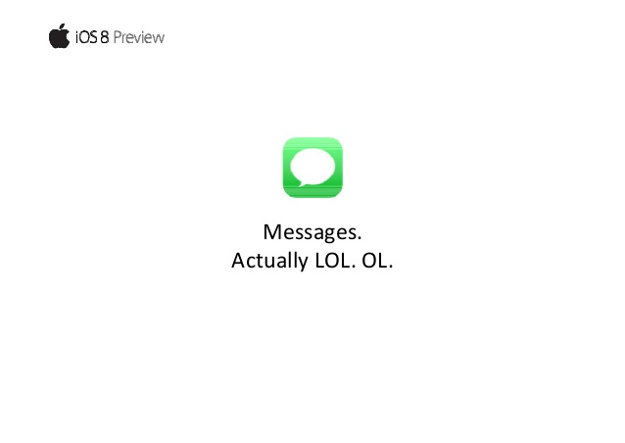

Messages, actually LOL. OL.

Your answer: ________________________________________________________

2.Translate the underlined sentence:

**The government of the people, by the people, for the people.**

From《Gettysburg Address》by Abraham Lincoln.

Your answer: ________________________________________________________

Section B Writing (select one out of three，100-200 words)

①Introduce your favorite music/movie.

②Describe a memorable journey you've experienced.

③Introduce one of your best friends to us.

I choose ______

|  |
| --- |
|  |
|  |
|  |
|  |
|  |
|  |
|  |
|  |
|  |
|  |
|  |
|  |
|  |
|  |
|  |
|  |
|  |

华中农业大学英语电台招新笔试题

姓名_____________ 学号_____________________ 签到号________________

注意事项： 答卷前请填写姓名、签到号与学号，使用黑色签字笔答题，笔试时间30分钟。

Section A Translation (E to C)

1. Translate the sentence from an advertisement below:

 **Yesterday you said tomorrow.**

Your answer:_______________________________________________________

2.Translate the sentences below (C to E)

**当人生走向晚年，就如一瓶待开封的好酒，其色彩是沉静的，味道中充满慷慨于智慧。**

Your answer:_________________________________________________________

__________________________________________________________________________________________________________________________________________

Section B Writing (select one out of three，100-200 words)

①Give your opinion on a current event

②Describe an unforgettable childhood experience.

③Introduce one of your favorite teacher to us.

I choose ______

|  |
| --- |
|  |
|  |
|  |
|  |
|  |
|  |
|  |
|  |
|  |
|  |
|  |
|  |
|  |
|  |
|  |
|  |
|  |