**第五部分 模糊数学**

**2018-10 模糊聚类分析**

某高中高二有7个班级，学生成绩的好与差，没有明确的评定界限，并且班级间成绩好坏的表现具有一定的模糊不确定性。各班级成绩指标值见表1。

表 7个班4门基础课的成绩指标

|  |  |  |  |  |  |  |
| --- | --- | --- | --- | --- | --- | --- |
| 1班 | 2班 | 3班 | 4班 | 5班 | 6班 | 7班 |
| 62.03 | 62.48 | 78.52 | 70.77 | 74.18 | 73.95 | 66.83 |
| 59.47 | 63.70 | 72.38 | 77.68 | 67.07 | 68.32 | 76.04 |
| 68.17 | 61.04 | 75.17 | 73.28 | 67.74 | 70.09 | 76.87 |
| 72.45 | 68.17 | 74.65 | 72.12 | 70.43 | 68.73 | 73.18 |

请将7个班进行分类。

**> data1<-scan()**

**1: 62.03 62.48 78.52 70.77 74.18 73.95 66.83**

**8: 59.47 63.70 72.38 77.68 67.07 68.32 76.04**

**15: 68.17 61.04 75.17 73.28 67.74 70.09 76.87**

**22: 72.45 68.17 74.65 72.12 70.43 68.73 73.18**

**29:**

**Read 28 items**

**> data1m<-matrix(data = data1,nrow = 7)**

**#用R中e1071包的cmeans进行3-6类模糊聚类分析，用scatterplot3d包进行FCM图示3类时的分类**

**> library(e1071)**

**> result1<-cmeans(data1m,3) #3类**

**> result1**

**Fuzzy c-means clustering with 3 clusters**

**Cluster centers:**

**[,1] [,2] [,3] [,4]**

**1 74.48522 68.23702 69.65479 70.15579**

**2 62.33656 61.65790 64.63816 70.31707**

**3 69.79584 76.40736 75.00170 72.82183**

**Memberships:**

**1 2 3**

**[1,] 0.07974478 0.87178786 0.04846735**

**[2,] 0.07855201 0.87724221 0.04420578**

**[3,] 0.48916705 0.08117285 0.42966009**

**[4,] 0.04715479 0.01394240 0.93890281**

**[5,] 0.94293121 0.02734579 0.02972300**

**[6,] 0.96874924 0.01152270 0.01972806**

**[7,] 0.06302192 0.02958993 0.90738815**

**Closest hard clustering:**

**[1] 2 2 1 3 1 1 3**

**Available components:**

**[1] "centers" "size" "cluster"**

**[4] "membership" "iter" "withinerror"**

**[7] "call"**

**> result1$cluster**

**[1] 2 2 1 3 1 1 3**

**> library(scatterplot3d)**

**> scatterplot3d(result1$membership,color = result1$cluster,type = "h",angle = 55,scale.y = 0.7,pch = 16)**

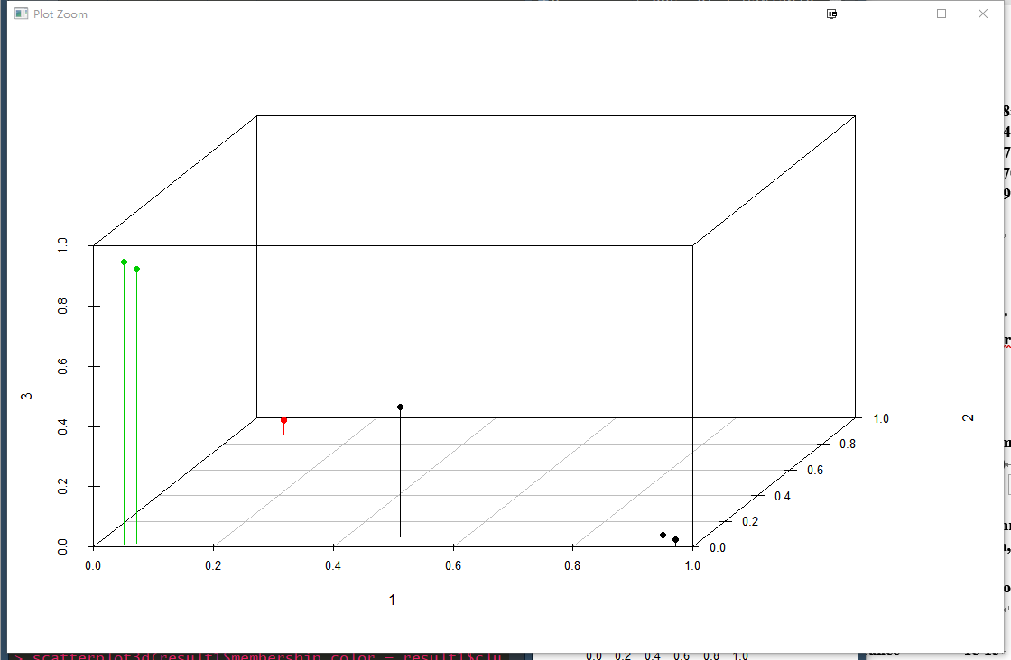

**> result1<-cmeans(data1m,4) #四类**

**> result1**

**Fuzzy c-means clustering with 4 clusters**

**Cluster centers:**

**[,1] [,2] [,3] [,4]**

**1 78.40425 72.39022 75.13000 74.61546**

**2 62.26492 61.63376 64.54210 70.26984**

**3 68.61982 76.74828 75.19752 72.68803**

**4 73.96293 67.66191 68.87993 69.60305**

**Memberships:**

**1 2 3**

**[1,] 0.03840709 8.277269e-01 0.0479028711**

**[2,] 0.03111303 8.436902e-01 0.0412980395**

**[3,] 0.99968274 3.182619e-05 0.0001346899**

**[4,] 0.08302940 1.944282e-02 0.8390802666**

**[5,] 0.01924186 1.252056e-02 0.0122824420**

**[6,] 0.02604502 1.171644e-02 0.0177902300**

**[7,] 0.04039564 1.583016e-02 0.9126413689**

**4**

**[1,] 0.0859631289**

**[2,] 0.0838987108**

**[3,] 0.0001507454**

**[4,] 0.0584475070**

**[5,] 0.9559551428**

**[6,] 0.9444483060**

**[7,] 0.0311328290**

**Closest hard clustering:**

**[1] 2 2 1 3 4 4 3**

**Available components:**

**[1] "centers" "size" "cluster"**

**[4] "membership" "iter" "withinerror"**

**[7] "call"**

**> result111<-cmeans(data1m,5) #五类**

**> result111**

**Fuzzy c-means clustering with 5 clusters**

**Cluster centers:**

**[,1] [,2] [,3] [,4]**

**1 74.05541 67.71589 68.92299 69.58991**

**2 78.44673 72.41605 75.15437 74.62607**

**3 62.48641 63.70788 61.04886 68.17262**

**4 68.62825 76.78526 75.23117 72.69566**

**5 62.03685 59.48214 68.17408 72.44946**

**Memberships:**

**1 2 3**

**[1,] 9.549509e-07 4.308384e-07 2.424797e-06**

**[2,] 8.806056e-07 3.299948e-07 9.999962e-01**

**[3,] 7.038727e-05 9.998395e-01 1.304521e-05**

**[4,] 5.796096e-02 8.141780e-02 1.830107e-02**

**[5,] 9.435546e-01 2.006159e-02 1.209965e-02**

**[6,] 9.399855e-01 2.390670e-02 9.920592e-03**

**[7,] 3.057723e-02 3.944892e-02 1.353317e-02**

**4 5**

**[1,] 5.374870e-07 9.999957e-01**

**[2,] 4.379057e-07 2.164006e-06**

**[3,] 6.180670e-05 1.521512e-05**

**[4,] 8.242128e-01 1.810741e-02**

**[5,] 1.284279e-02 1.144134e-02**

**[6,] 1.638349e-02 9.803752e-03**

**[7,] 9.002595e-01 1.618117e-02**

**Closest hard clustering:**

**[1] 5 3 2 4 1 1 4**

**Available components:**

**[1] "centers" "size" "cluster"**

**[4] "membership" "iter" "withinerror"**

**[7] "call"**

**> result1111<-cmeans(data1m,6) #六类**

**> result1111**

**Fuzzy c-means clustering with 6 clusters**

**Cluster centers:**

**[,1] [,2] [,3] [,4]**

**1 78.51576 72.37570 75.16434 74.64501**

**2 62.48272 63.70092 61.04181 68.17036**

**3 62.03263 59.47178 68.17014 72.44939**

**4 70.77197 77.67408 73.27758 72.11831**

**5 66.83205 76.03768 76.86783 73.17891**

**6 74.06642 67.68726 68.90045 69.59053**

**Memberships:**

**1 2 3**

**[1,] 2.125358e-08 1.198915e-07 9.999998e-01**

**[2,] 2.028724e-08 9.999997e-01 1.334580e-07**

**[3,] 9.999972e-01 1.627386e-07 1.897845e-07**

**[4,] 4.865513e-07 1.110927e-07 1.099069e-07**

**[5,] 1.905608e-02 1.152473e-02 1.089746e-02**

**[6,] 2.417737e-02 1.008493e-02 9.965476e-03**

**[7,] 9.975789e-08 3.461752e-08 4.138259e-08**

**4 5 6**

**[1,] 2.409721e-08 2.798369e-08 4.729965e-08**

**[2,] 2.711252e-08 2.605725e-08 5.441297e-08**

**[3,] 9.528843e-07 6.026451e-07 8.751287e-07**

**[4,] 9.999975e-01 1.481763e-06 3.500411e-07**

**[5,] 1.449211e-02 1.013652e-02 9.338931e-01**

**[6,] 1.987702e-02 1.346976e-02 9.224254e-01**

**[7,] 4.796972e-07 9.999993e-01 7.790381e-08**

**Closest hard clustering:**

**[1] 3 2 1 4 6 6 5**

**Available components:**

**[1] "centers" "size" "cluster"**

**[4] "membership" "iter" "withinerror"**

**[7] "call"**

**#用R中cluster包的fanny进行2类模糊聚类分析，用clusplot作图**

**> fanny1<-fanny(data1m,2,metric = "SqEuclidean")**

**> summary(fanny1)**

**Fuzzy Clustering object of class 'fanny' :**

**m.ship.expon. 2**

**objective 241.7882**

**tolerance 1e-15**

**iterations 19**

**converged 1**

**maxit 500**

**n 7**

**Membership coefficients (in %, rounded):**

**[,1] [,2]**

**[1,] 93 7**

**[2,] 94 6**

**[3,] 9 91**

**[4,] 7 93**

**[5,] 31 69**

**[6,] 19 81**

**[7,] 15 85**

**Fuzzyness coefficients:**

**dunn_coeff normalized**

**0.7827841 0.5655681**

**Closest hard clustering:**

**[1] 1 1 2 2 2 2 2**

**Silhouette plot information:**

**cluster neighbor sil_width**

**2 1 2 0.7684563**

**1 1 2 0.7504342**

**3 2 1 0.7789938**

**4 2 1 0.7641296**

**7 2 1 0.6412920**

**6 2 1 0.5733022**

**5 2 1 0.3708834**

**Average silhouette width per cluster:**

**[1] 0.7594453 0.6257202**

**Average silhouette width of total data set:**

**[1] 0.6639274**

**21 dissimilarities, summarized :**

**Min. 1st Qu. Median Mean 3rd Qu. Max.**

**10.03 119.39 198.24 233.89 373.83 574.27**

**Metric : SqEuclidean**

**Number of objects : 7**

**Available components:**

**[1] "membership" "coeff" "memb.exp"**

**[4] "clustering" "k.crisp" "objective"**

**[7] "convergence" "diss" "call"**

**[10] "silinfo" "data"**

**> fanny1$clustering**

**[1] 1 1 2 2 2 2 2**

**> fanny1$membership**

**[,1] [,2]**

**[1,] 0.93231873 0.06768127**

**[2,] 0.93777359 0.06222641**

**[3,] 0.08769657 0.91230343**

**[4,] 0.06753176 0.93246824**

**[5,] 0.31159650 0.68840350**

**[6,] 0.19352773 0.80647227**

**[7,] 0.14679330 0.85320670**

**>clusplot(fanny1)**

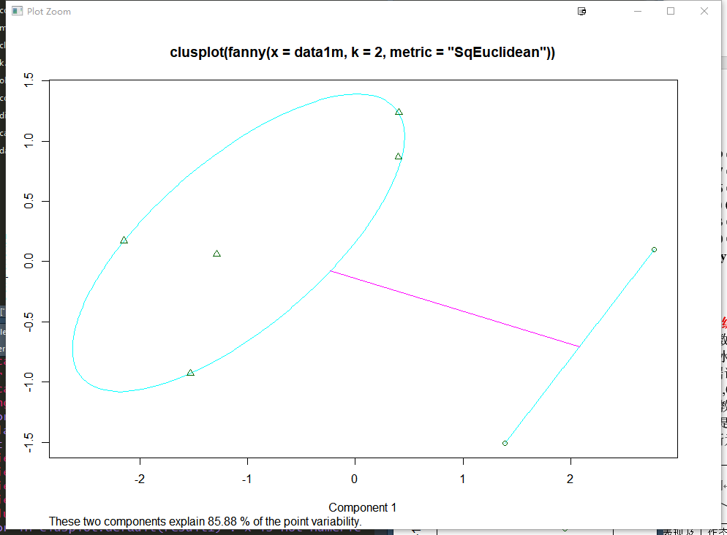

**2018-11 模糊综合评判**

“晋升”的数学模型，以高校教师晋升教授为例：因素集U={政治表现及工作态度，教学水平，科研水平，外语水平}；评判集：V={好，较好，一般，较差，差}；根据调研得到：以教学为主的教师，四个指标的权重A1=(0.2,0.5,0.1,0.2)

以科研为主的教师，四个指标的权重A2=(0.2,0.1,0.5,0.2)

请评价此教师是否能晋升为教授？如果能晋升，请指明是教学型教授还是科研型教授。（判断为“好”就可评上）

|  |  |  |  |  |  |
| --- | --- | --- | --- | --- | --- |
| 评  判  集  因  素  集 | 好 | 较好 | 一般 | 较差 | 差 |
| 政治表现及工作态度 | 4 | 2 | 1 | 0 | 0 |
| 教学水平 | 6 | 1 | 0 | 0 | 0 |
| 科研水平 | 0 | 0 | 5 | 1 | 1 |
| 外语水平 | 2 | 2 | 1 | 1 | 1 |

%MATLAB

A1=[0.2 0.5 0.1 0.2];

A2=[0.2 0.1 0.5 0.2];

R=[0.57 0.29 0.14 0 0; 0.86 0.14 0 0 0; 0 0 0.71 0.14 0.14; 0.29 0.29 0.14 0.14 0.14];

fuzzypredict(A1,R)

fuzzypredict(A2,R)

end

%% function[B]=fuzzypredict(A,R)

%模糊综合评判

B=[];

[m,s1]=size(A);

[s2,n]=size(R);

%主因素决定型

for(i=1:m)

for(j=1:n)

B(i,j)=0;

for(k=1:s1)

x=0;

if(A(i,k)<R(k,j))

x=A(i,k);

else

x=R(k,j);

end

if(B(i,j)<x)

B(i,j)=x;

end

end

end

end

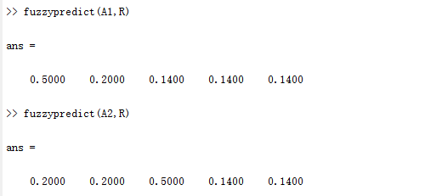

**2018-12 模糊线性规划**

某企业根据市场信息及自身生产能力，准备开发甲乙两种系列产品，甲种系列产品最多大约能生产400套，乙种系列产品最多大约能生产250套。据测算：

甲每套成本3万元，获纯利润7万元；乙每套成本2万元，获纯利润3万元。生产两种系列产品的资金总投入大约不能超过1500万元。问如何安排生产才能使企业获利最多？ （浮动范围比例为5%）

（1）

model:

max=7*x1+3*x2;

x1<=400;

x2<=250;

x1>0;

x2>0;

3*x1+2*x2<=1500;

End

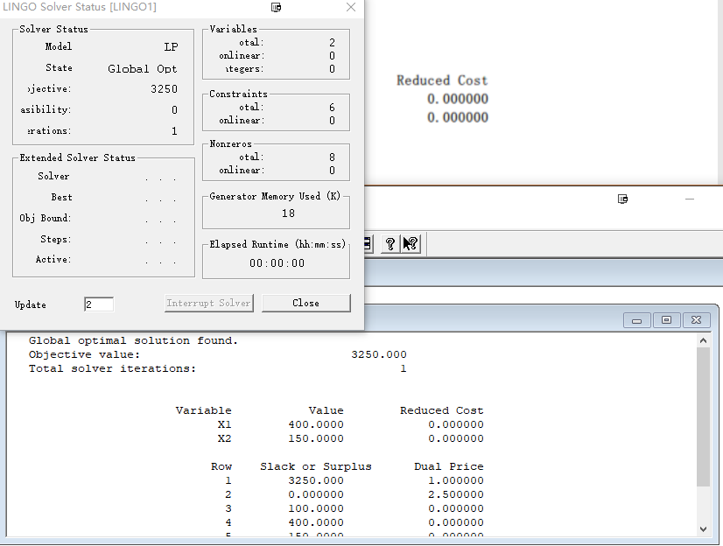

得最优解x1=400,x2=150,f=3250

（2）

model:

max=7*x1+3*x2;

x1<=420;

x2<=262.5;

x1>0;

x2>0;

3*x1+2*x2<=1575;

End

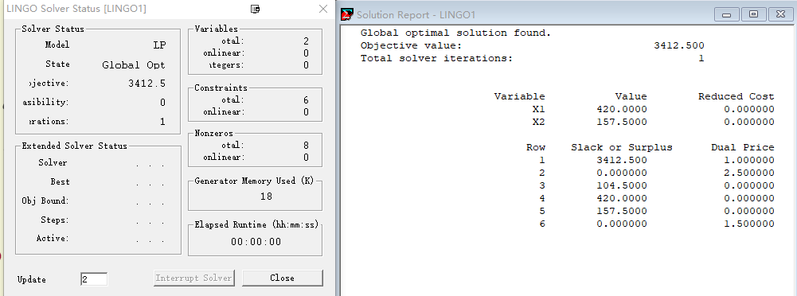

得最优解x1=420,x2=157,f=3412.5

（3）

F0=3250

D0=3412-3250=162.5

model:

max=l;

x1+20*l<=420;

x2+12.5*l<=262.5;

x1>0;

x2>0;

l>=0;

l<1;

7*x1+3*x2-162*l>=3250;

3*x1+2*x2+75*l<=1575;

End

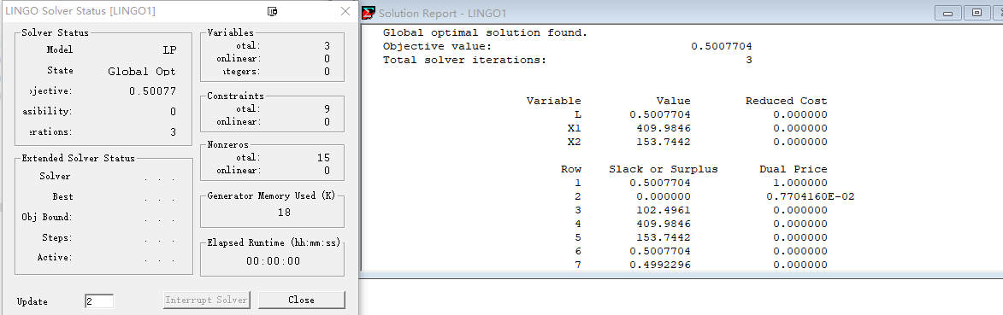

得模糊最优解x1=410，x2=154，lamda=0.5

F= 3331.125