FTP Algorithms

Definitions
- Input → Algorithm → Output
- An Algorithm is correct if, for a correct input, halts in finite time with correct output. → Solves computational problem

Algorithm Analysis
Definition:
Algorithm analysis involves predicting the resources an algorithm requires, primarily in terms of:
- Memory space: Maximum memory used during execution.
- Running time: Number of basic operations performed.
Purpose:
To evaluate the efficiency of algorithms and compare them to others solving the same problem.

Asymptotic Notations
Let f and g be non negative real valued functions (defined usually on the interval [0, ∞]).
Big-O Notation (O(f(n)):
- Describes the upper bound of an algorithm's growth rate.
- Ensures the running time does not grow faster than f(n) for large n.
f (x) = O(g (x)) as x → ∞ if there exists a positive number M and a real number x0 such that
f (x) ≤ M · g (x) ∀x ≥ x₀
Omega Notation Ω(g (x)):
- Describes the lower bound of an algorithm's growth rate.
- Ensures the running time does not grow slower than f(n) for large n.
f (x) = Ω(g (x)) as x → ∞ if there exists a positive number m and a real number x₀ such that
m · g (x) ≤ f (x) ∀x ≥ x0
Theta Notation (Θ(f(n))):
- Describes the tight bound of an algorithm's growth rate.
- Combines both O(f(n)) and Ω(f(n)).
m · g (x) ≤ f (x) ≤ M · g (x) ∀x ≥ x₀

Analyzing divide-and-conquer algorithms
Let D(n) be the time for dividing in sub–problems and C (n) be the time for combining together the solutions of the sub–problems.

Master Theorem
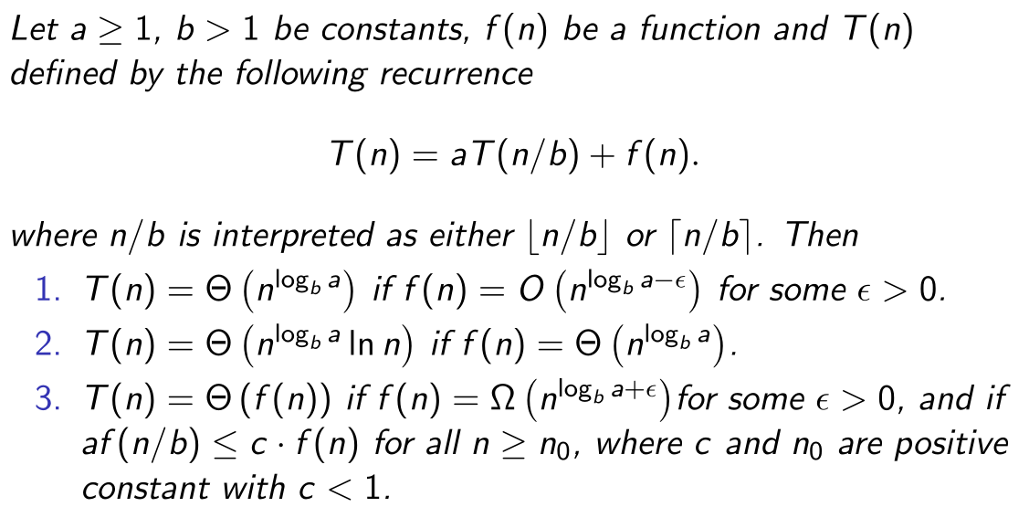

Sorting Algorithms
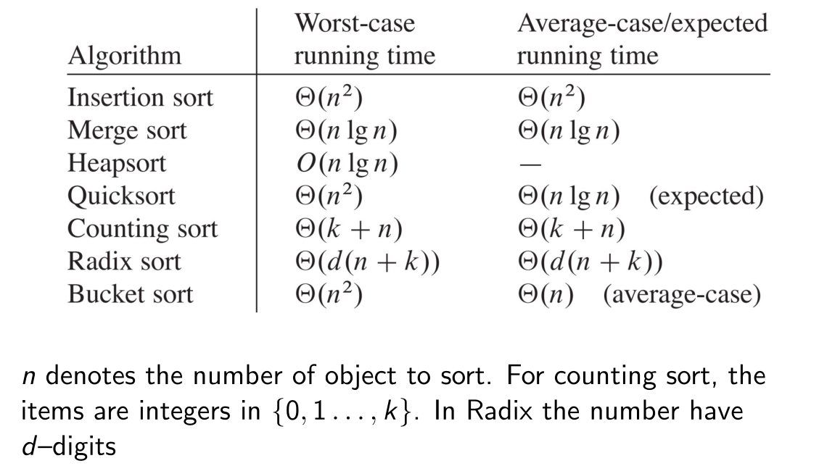

Insertion Sort
Input: A sequence of n numbers (a1 , a2 , . . . , an ) A
Output: A reordering (a’₁ , a’₂ , . . . , a’_{n} ) of the input sequence,
with the property a’₁ ≤ a’₂ ≤ . . . ≤ a’_{n}
INSERTION-SORT(A)
for j = 2 to A.length
key = A[j
// Insert A[j] into the sorted sequence A[1..j-1].
i = j - 1
while i > 0 and A[i] > key
A[i + 1] = A[i]
i = i - 1
A[i + 1] = key

Best case: Array is sorted → O(n)
Worst case: Array is sorted in reverse → O(n²)

Merge Sort
Input: A sequence of n numbers (a1 , a2 , . . . , an ) A, p: start index, r: end index
Output: A reordering (a’₁ , a’₂ , . . . , a’_{n} ) A of the input sequence,
with the property a’₁ ≤ a’₂ ≤ . . . ≤ a’_{n}
MERGE-SORT(A, p, r)
if p < r
q = ⌊(p + r) / 2⌋
MERGE-SORT(A, p, q)
MERGE-SORT(A, q + 1, r)
MERGE(A, p, q, r)

MERGE(A, p, q, r)
n1 = q - p + 1
n2 = r - q
let L[1..n1 + 1] and R[1..n2 + 1] be new arrays

for i = 1 to n1
L[i] = A[p + i – 1]

for j = 1 to n2
R[j] = A[q + j]

L[n1 + 1] = ∞
R[n2 + 1] = ∞
i = 1
j = 1

for k = p to r
if L[i] ≤ R[j]
A[k] = L[i]
i = i + 1
else
A[k] = R[j]
j = j + 1

Best Case: O(n * log⁡(n))
Worst Case: O(n * log(⁡n))
Comment: It does not sort in place.

Heap Sort
Input: A sequence of n numbers (a₁ , a₂ , . . . , a_{n} )
Output: A reordering (a’₁ , a’₂ , . . . , a’_{n} ) of the input sequence,
with the property a’₁ ≤ a’₂ ≤ . . . ≤ a’_{n}
pseude code: A: An array of n numbers, i: Index
MAX-HEAPIFY(A, i) // O(log(n))
left = LEFT(i)
right = RIGHT(i)
largest = i
if left ≤ A.heap_size and A[left] > A[largest]
largest = left
if right ≤ A.heap_size and A[right] > A[largest]
largest = right
if largest ≠ i
swap A[i] with A[largest]
MAX-HEAPIFY(A, largest)

LEFT(i) // O(1)
return 2 * I

RIGHT(i) // O(1)
return 2 * i + 1

PARENT(i) // O(1)
return ⌊i / 2⌋

BUILD-MAX-HEAP(A) // O(n)
A.heap_size = A.length
for i = ⌊A.length / 2⌋ down to 1
MAX-HEAPIFY(A, i)

HEAPSORT(A) // O(n * log(n)
BUILD-MAX-HEAP(A)
for i = A.length down to 2
swap A[1] with A[i]
A.heap_size = A.heap_size – 1
MAX-HEAPIFY(A, 1)

Best case:
Worst case: O(n * log(n))
Comment: Heap sort does sort in place. Stored in Array but used like binary tree.
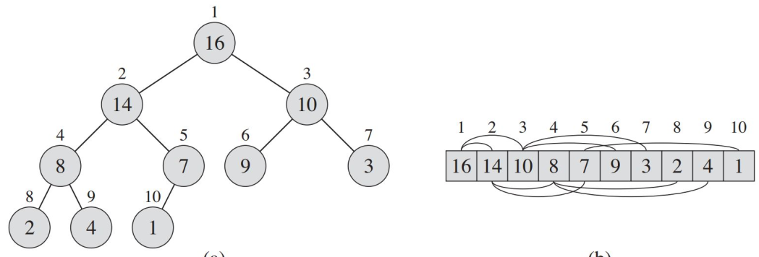
Heap Construction
The root is A[1]. A parent node can have two children, a left and a right one. PARENT(i) returns
⌊i/2⌋. If a node i has two children, LEFT(i) returns 2i, RIGHT(i) returns 2i + 1
For max–heap, the following property is true:
A[Parent(i)] ≥ A[i]
For min–heap, the following property is true:
A[Parent(i)] ≤ A[i]

Binary Search Trees
- In a BST, a node is restricted to having at most two children.
- Basic operations have O(h) runtime, worst case is therefore Θ(log(n)) for complete trees.
- Height of linear chain tree is n, so basic operations run in Θ(n)
- Randomly build BST has O(log(n))
- BST is linked data structure and has operations: SEARCH, MINIMUM, MAXIMUM, PREDECESSOR, SUCCESSOR, INSERT, and DELETE

Binary–search–tree–property
Let x be a node in a binary search tree. If y is a node in the left subtree of x, then y .key ≤ x.key . If y is a node in the right subtree of x, then y .key ≥ x.key.

INORDER-TREE-WALK(x) // Θ(n)
if x ≠ NIL
INORDER-TREE-WALK(x.left)
print(x.key)
INORDER-TREE-WALK(x.right)

Search
Input: Pointer to node x, Value of key k to be searched for
Output: Pointer to node with value k or null if element not in tree
pseude code:
TREE-SEARCH(x, k)
if x = NIL or k = x.key
return x
if k < x.key
return TREE-SEARCH(x.left, k)
else
return TREE-SEARCH(x.right, k)

ITERATIVE-TREE-SEARCH(x, k)
while x ≠ NIL and k ≠ x.key
if k < x.key
x = x.left
else
x = x.right
return x

Best case: The key is at the root → O(1)
Worst case: The key is at the deepest level (skewed tree) → O(n), but for balanced trees → O(log(n)). Regardless of tree stucture, its always O(h)

Minimum and Maximum
Input: The root node x of the BST.
Output: The node containing the minimum or maximum key.
TREE-MINIMUM(x)
while x.left ≠ NIL
x = x.left
return x

TREE-MAXIMUM(x)
while x.right ≠ NIL
x = x.right
return x

Best case: The root is the minimum/maximum → O(1)
Worst case: O(h)

Successor and predecessor
Input: The root node x of the BST.
Output: The node containing the predecessor or successor.
TREE-SUCCESSOR(x)
if x.right ≠ NIL
return TREE-MINIMUM(x.right)
y = x.parent
while y ≠ NIL and x = y.right
x = y
y = y.parent
return y

TREE-PREDECESSOR(x)
if x.left ≠ NIL
return TREE-MAXIMUM(x.left)
y = x.parent
while y ≠ NIL and x = y.left
x = y
y = y.parent
return y

Best case: The root is the minimum/maximum → O(1)
Worst case: O(h)

Insertion
Input: T: Binary search tree, z: Node to be inserted (with a defined key).
Output: The node z is inserted into the correct position in T, maintaining the binary search tree property.

TREE-INSERT(T, z)
y = NIL
x = T.root
while x ≠ NIL
y = x
if z.key < x.key
x = x.left
else
x = x.right
z.parent = y
if y = NIL
T.root = z // Tree was empty
else if z.key < y.key
y.left = z
else
y.right = z

Runtime: O(1) (in the case of an empty tree) or O(log⁡(n)) (in a balanced tree).
Worst case: Traverses the height of the tree → O(h)O(h) (where h=nh=n for skewed trees and h=log⁡nh=logn for balanced trees).

Deletion
Input: T: Binary search tree, z: Node to be deleted.
Output: The node z is removed from T, and the binary search tree property is maintained.
TREE-DELETE(T, z)
if z.left = NIL
TRANSPLANT(T, z, z.right)
else if z.right = NIL
TRANSPLANT(T, z, z.left)
else
y = TREE-MINIMUM(z.right)
if y.parent ≠ z
TRANSPLANT(T, y, y.right)
y.right = z.right
y.right.parent = y
TRANSPLANT(T, z, y)
y.left = z.left
y.left.parent = y

TRANSPLANT(T, u, v)
if u.parent = NIL
T.root = v
else if u = u.parent.left
u.parent.left = v
else
u.parent.right = v
if v ≠ NIL
v.parent = u.parent

Best case: The node is a leaf or has one child → O(1).
Worst case: Traverses the height of the tree → O(h) (where h=n for skewed trees and h=log⁡(n) for balanced trees).
Comment: For deleting a node z, we have to consider three basic cases:
- z is a leaf (no children):
Replace z's position in its parent with NIL.
- z has only one child:
Elevate z's child to take z's position, and update z's parent to point to z's child.
- z has two children:
Find the successor of z, denoted by y, which must be in z's right subtree. Replace z with y, taking care of the relationship between y and z's right child (if y is not the immediate right child of z).

Quick Sort
Input: A sequence of n numbers (a₁,a₂,…,a_{n}), array A with indices p and r.
Output: A reordered sequence (a′₁,a′₂,…,a′_{n}) such that a′₁≤a′₂≤…≤a′_{n}

Standart Quicksort
QUICKSORT(A, p, r)
if p < r
q = PARTITION(A, p, r)
QUICKSORT(A, p, q - 1)
QUICKSORT(A, q + 1, r)

PARTITION(A, p, r) // Θ(n)
x = A[r] // Pivot element
i = p - 1
for j = p to r - 1
if A[j] ≤ x
i = i + 1
swap A[i] with A[j]
swap A[i + 1] with A[r]
return i + 1

Best case: The array is split evenly into two halves at every step → O(n * log(⁡n))
Worst case: The array is split into n−1 and 0 elements at every step → O(n²)

Randomised Quicksort
RANDOMIZED-QUICKSORT(A, p, r)
if p < r
q = RANDOMIZED-PARTITION(A, p, r)
RANDOMIZED-QUICKSORT(A, p, q - 1)
RANDOMIZED-QUICKSORT(A, q + 1, r)

RANDOMIZED-PARTITION(A, p, r)
i = RANDOM(p, r) // Randomly select pivot index
swap A[i] with A[r]
return PARTITION(A, p, r)

Expected case: Balanced splits are achieved on average → O(n * log(⁡n))
T (n) = 2T (n/2) + Θ(n)
Worst case: Random selection consistently produces unbalanced splits → O(n²)
T (n) = T (n − 1) + T (0) + Θ(n), T (n) = Θ(n²)

Balanced Partitioning in Quick Sort (Average Case)

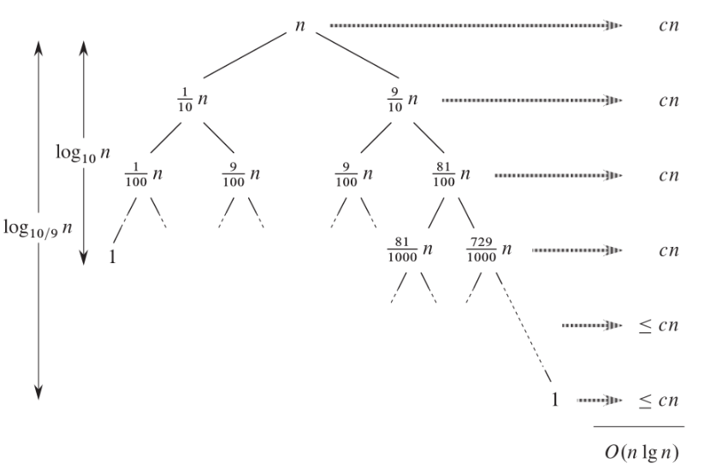
We present this following example where the partition algorithm produces a 9–to–1 proportional split. From this pictures one sees that T (n) = O(n log n). The same reasoning can be also done for a 99–to–1 proportional partitioning!

Intuition for Average Case
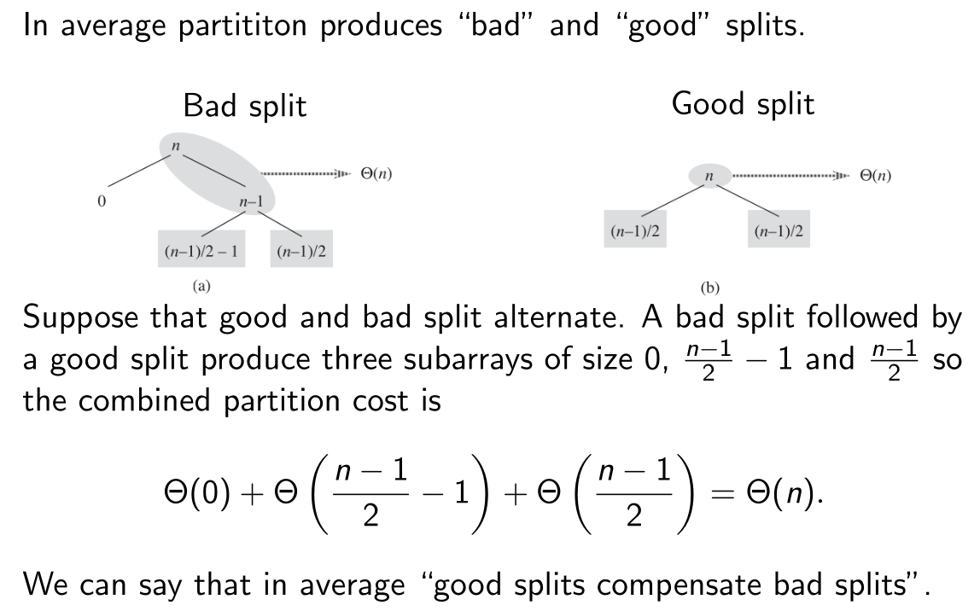

Counting Sort
Input: Array A of n integers between 0 and k, where k is a known positive integer
Output: Array B containing the sorted order of elements from A
COUNTING-SORT(A, B, k)
let C[0..k] = 0
for i = 1 to A.length
C[A[i]] = C[A[i]] + 1
for i = 1 to k
C[i] = C[i] + C[i - 1]
for j = A.length down to 1
B[C[A[j]]] = A[j]
C[A[j]] = C[A[j]] - 1

COUNTING-SORT(A, B, k)
let C[0..k] = 0
for i = 1 to A.length
C[A[i]] = C[A[i]] + 1
for i = 1 to k
C[i] = C[i] + C[i - 1]
for j = A.length down to 1
B[C[A[j]]] = A[j]
C[A[j]] = C[A[j]] - 1

Best case: All elements are already sorted → O(n+k)
Worst case: O(n+k), since counting sort does not rely on input ordering.

Orthogonal Range Searching
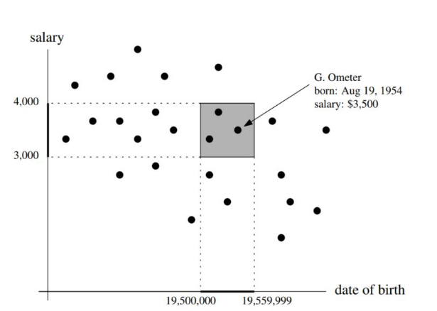
orthogonal range query

d-Dimensional Range Searching
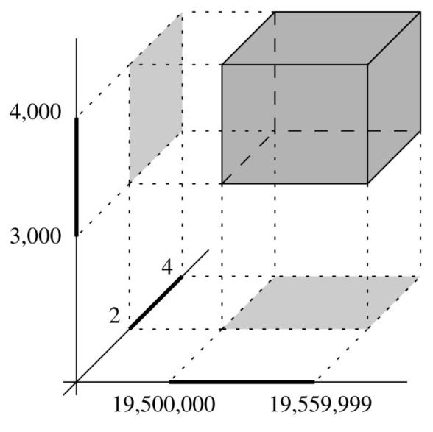

rectangle range query

1-Dimensional Range Searching (KD-Tree)
Input: Set P=[p₁,p₂,…,p_{n}], a list of n real numbers, and a query range [x, x'].
Output: All points in P within the range [x, x'].
FIND-SPLIT-NODE(v, x, x')
while v ≠ NIL and (x' ≤ v.key or x > v.key)
if x' ≤ v.key
v = v.left
else
v = v.right
return v

1D-RANGE-QUERY(v, x, x')
v_split = FIND-SPLIT-NODE(v, x, x')
if v_split is a leaf
if v_split.key ∈ [x, x']
report v_split
else
traverse left subtree of v_split and report all keys ≥ x
traverse right subtree of v_split and report all keys ≤ x'

Runtime:
- Building the Tree: O(n * log(⁡n))
- Querying: O(k+log⁡(n)), where k is the number of reported points.
Best case: Query range matches root node → O(log⁡(n))
Worst case: Traverses most of the tree to find leaves → O(k+log(n))⁡

Split Node
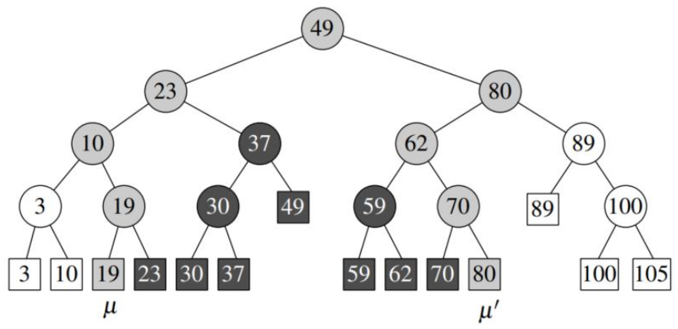
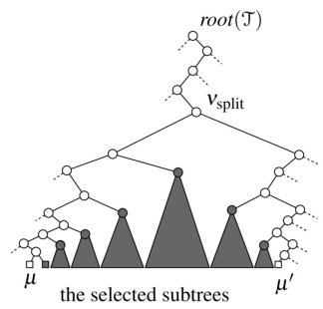

The picture represents the (sub)tree rooted in a so called split–node, that is the smallest (complete) tree containing the searched leaves. Thus first step in the query algorithm is to determine the split node.

Kd-Trees
Input: A set P of n points in a plane, given as coordinates (x,y), and a query rectangle [x, x'] × [y, y'].
Output: All points in P inside the query rectangle.
BUILD-KD-TREE(P, depth)
if P is empty
return NIL
if depth is even
choose median by x-coordinate
else
choose median by y-coordinate
v = new node with median as key
v.left = BUILD-KD-TREE(points left of median, depth + 1)
v.right = BUILD-KD-TREE(points right of median, depth + 1)
return v

QUERY-KD-TREE(T, [x, x'], [y, y'])
if T is NIL
return
if T.key is inside the range [x, x'] × [y, y']
report T.key
if left subtree overlaps with range
QUERY-KD-TREE(T.left, [x, x'], [y, y'])
if right subtree overlaps with range
QUERY-KD-TREE(T.right, [x, x'], [y, y'])

Runtime:
- Building the Tree: O(nlog⁡n)
- Querying: Dependent on tree depth and points reported, typically O(log⁡n+k), where k is the number of reported points.
Best case: Query overlaps small regions → O(log⁡n)
Worst case: Query overlaps multiple subtrees → O(k+log⁡n)

Building Kd-Trees
We construct a Kd–Tree with the following recursive procedure, whose input is a set of points P and a depth. The depth is important in the recursion as we alternate splitting with an horizontal line (depth is an even number) or with a vertical line (depth is an odd number).
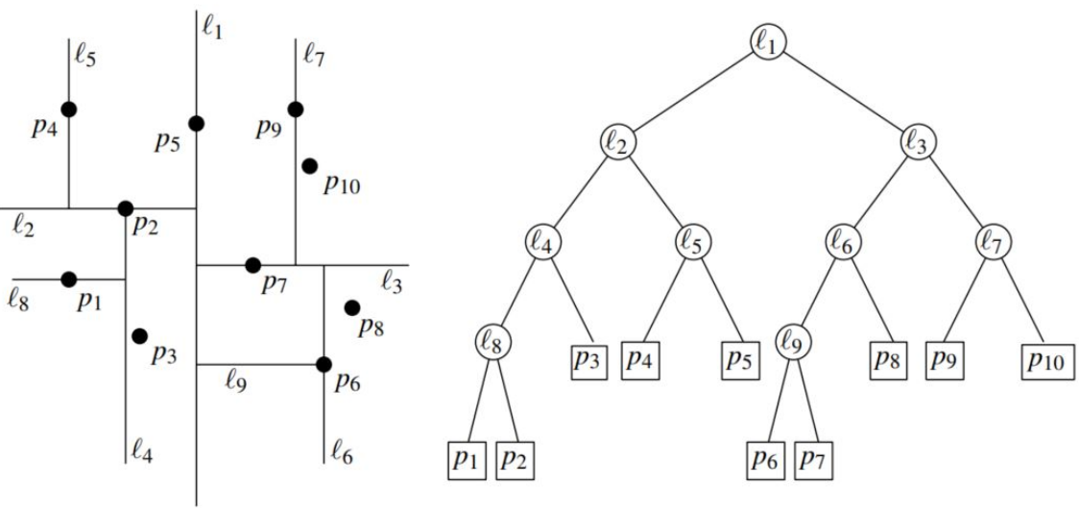
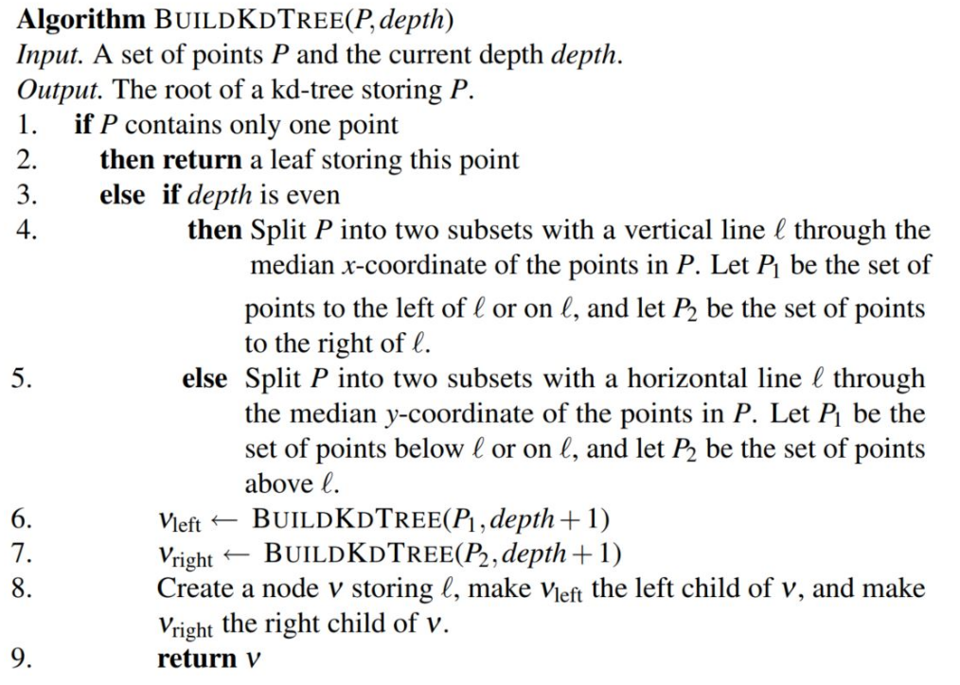
We will see as an exercise, that the procedure for a set of n points has running time is O(n log n) and uses O(n) storage.

Query on KD–Trees
Query on a KD-Tree works similarly to the one in 1-dimensional case, where the intermediate nodes are represented by the splitting lines.
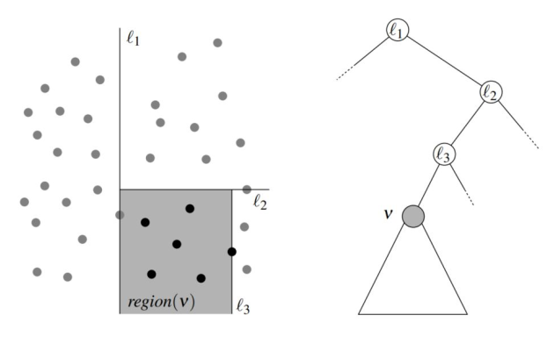
The region(v) (in grey in the plane) is the set of all leafs in the subtree rooted in v. We have to consider the subtree rooted at v only if the query rectangle intersects the region v.
- In a query on a KD–Tree we visit only nodes whose region is intersected by the query rectangle (in the picture below the grey nodes).
- When a region is fully contained in the query rectangle we report all leaves in the corresponding subtree (dark grey nodes).
- In the picture, nodes p3 , p12 and p13 are visited (they are grey) but not reported. All other grey points are visited and reported.
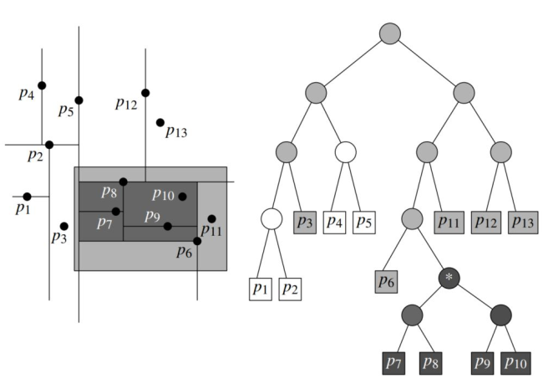

Storage and Running for a KD–Tree and Search on it
Theorem. A KD–tree for a set P of n points uses O(n) storage and can be built in O(n * log(n)) time. A rectuangular range query on the KD—tree takes O( √n + k) time, where k is the number of reported points.

Graphs
A graph is the data of two sets: V the vertices and E the edges joining some vertices in V. There are directed and undirected graphs. Both can be presented as a collection of adjacency list or as an adjacency matrix.
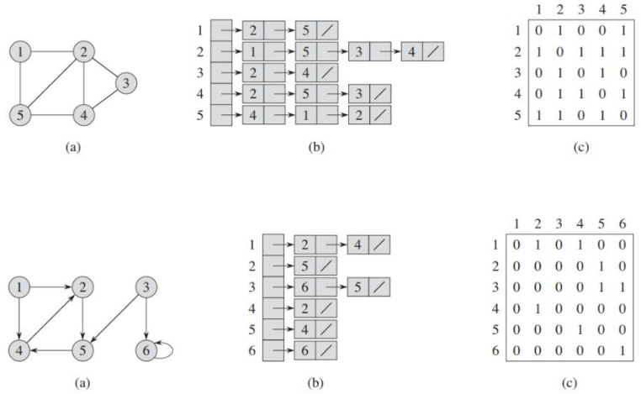
- In the adjacency–list representation we have for each vertex of u ∈ V a list with all vertexes v such that there is an edge (u, v ) ∈ E . This list is denoted by Adj[u]. There are exactly |V | adjacency lists
- Thus in a graph G = (V , E ), Adj[u] is the list of all vertexes of G adjacent to u. In pseudocode this will be denoted by G .Adj[u]
- In a undirected graph, the sum of all lenght of the adjacency lists is 2|E |. In a directed graph this sum is |E|
- An adjacency list needs a storage of Θ(|V | + |E |)
- An adjacency matrix needs Θ(|V |² ) storage (independent on |E |).
- A weighted graph is a graph G = (V , E ) equipped with a weight (or weight function) ω :
E → R (which measures a distance between two adjacent vertices)

Single-Source Shortest Paths
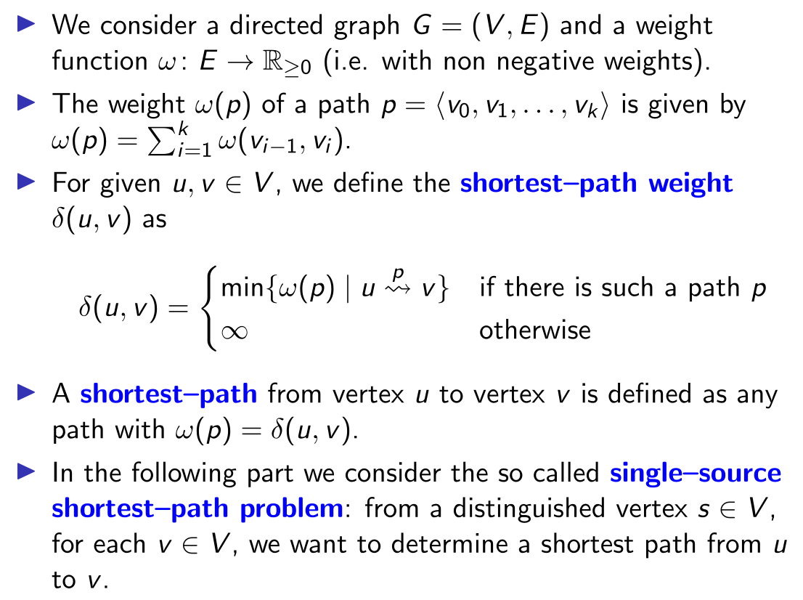
Lemma: Let G = (V , E ) be a weighted directed graph. Let p = ⟨v₀ , v₁ , . . . , v_{k} ⟩ be a shortest path between the vertex v₀ and the vertex v_{k}. Then for any integer i and j with 0 ≤ i ≤ j ≤ k, the path p_{ij} = ⟨v_{i}, v_{i+1}, . . . , v_{j} ⟩ is a shortest path from v_{i} to v_{j}.
Proof. If there will be a path q_{ij} from v_{i} to v_{j} with smaller length, then the path obtained from p by substituting p_{ij} with q_{ij} would have less weight. This would contradict that p is a shortest path.

- We define a tree rooted in the source s, so for each v ∈ V we have the predecessor v .π, that is the parent of v in the tree or it is NIL.
- We have a predecessor subgraph Gπ = (Vπ , Eπ ) where:
  - V_{π} = {v ∈ V | v .π ̸= NIL} ∪ {s}
  - E_{π} = {(v .π, v ) ∈ E | v ∈ Vπ \ {s}}.
- A shortest-paths tree rooted at s is a directed subgraph G ′ = (V ′ , E ′ ), where V ′ ⊂ V and E ′ ⊂ E , such that:
  - V ′ is the set of vertices reachable from s in G .
  - G ′ forms a rooted tree with root s.
  - For all v ∈ V ′ there is a unique simple path (i.e. with no cycles) in G ′ from s to v , which is shortest path from s to v in G .

Relaxation
- For a vertex v ∈ V , the attribute v .d (called shortest–path estimate) is an upper bound on the weight of a shortest path from the source s and v .
- Therefore the initial step of many shortest–paths algorithms is setting the attribute v.d to ∞ and their predecessor v .π to NIL
Relaxation process takes as input an edge (u, v ) ∈ E and the weight w of the edge (u, v ) and tests whether we can improve a “shortest–path”to v found so far by going thorough u. If so it update the attribute v .d (with the smaller value) and v .π = u.

Input: G: A graph represented by its vertices G.V, s: The source vertex.
Output: Initializes the distance v.d for all vertices v in G.V to ∞ (representing unknown distances). Sets the predecessor v.π for all vertices vv to NIL (indicating no parent yet).
Sets the distance of the source vertex s.d to 0, as the distance to itself is always zero.
INITIALIZE-SINGLE-SOURCE(G, s)
for each vertex v ∈ G.V
v.d = ∞
v.π = NIL
s.d = 0

Input: u: Current vertex, v: Neighbor of u, w(u,v): Weight of the edge from u to v.
Output: Updates v.d(distance to v) and v.π (predecessor of v) if a shorter path to v is found through u.
RELAX(u, v, w)
if v.d > u.d + w(u, v)
v.d = u.d + w(u, v)
v.π = u

Properties of Shortest Path and Relaxation
Some of the followings properties can be useful in the analysis of the correctness of shortest-paths algorithms:
- Triangle inequality. For all (u, v ) ∈ E , we have δ(s, v ) ≤ δ(s, u) + ω(u, v ).
- Upper–bound property. For all v ∈ V , v .d ≥ δ(s, v ), and when v .d achieves the value δ(s, v ) it never changes afterwards.
- No–path property. If there is no path from s to v , then v .p = δ(s, v ) = ∞.
- Convergence property. If s ⇝ u → v is a shortest path for some u, v ∈ V , and if u.d = δ(s, u) at any time prior the relaxing edge (u, v ), then v .d = δ(s, v ) at all times afterward.
- Path-relaxation property. If p = ⟨v₀ , v₁ , . . . , v_{k} ⟩ is a shortest path from s = v0 to vk , and we relax the edges of p in the order (v₀ , v₁ ), (v₁ , v₂ ), . . . , (v_{k−1} , v_{k} ) then v_{k} .d = δ(s, v_{k} ). This property holds regardless of any other relaxation steps that occur, even if they are intermixed with relaxations of the edges of p.
- Predecessor-subgraph property. Once v .d = δ(s, v ); for all v ∈ V , the predecessor subgraph is a shortest-paths tree rooted at s.

Dijkstra’s algorithm
Input: A weighted graph G=(V,E) with non-negative edge weights w(u,v), and a source vertex s
Output: The shortest path distances d[v] from the source vertex s to every other vertex v in G, and the predecessor vertices π[v] for reconstructing the shortest paths.
INITIALIZE-SINGLE-SOURCE(G, s)
for each vertex v ∈ G.V
v.d = ∞
v.π = NIL
s.d = 0

DIJKSTRA(G, w, s)
INITIALIZE-SINGLE-SOURCE(G, s)
S = ∅
Q = G.V // Priority queue
while Q ≠ ∅
u = EXTRACT-MIN(Q)
S = S ∪ {u}
for each vertex v ∈ G.Adj[u]
RELAX(u, v, w)

DIJKSTRA(G, w, s)
INITIALIZE-SINGLE-SOURCE(G, s)
S = ∅
Q = G.V // Priority queue
while Q ≠ ∅
u = EXTRACT-MIN(Q)
S = S ∪ {u}
for each vertex v ∈ G.Adj[u]
RELAX(u, v, w)

Runtime:
- With an array-based priority queue:
  - O(∣V∣²).
- With a binary heap:
  - O((∣V∣+∣E∣)log∣V∣).
- With a Fibonacci heap:
  - O(∣E∣+∣V∣log∣V∣).
Best case: Sparse graph with an efficient priority queue (e.g., Fibonacci heap) → O(∣E∣+∣V∣log∣V∣).
Worst case: Dense graph with an array-based priority queue → O(∣V∣²).

Sweep algorithms
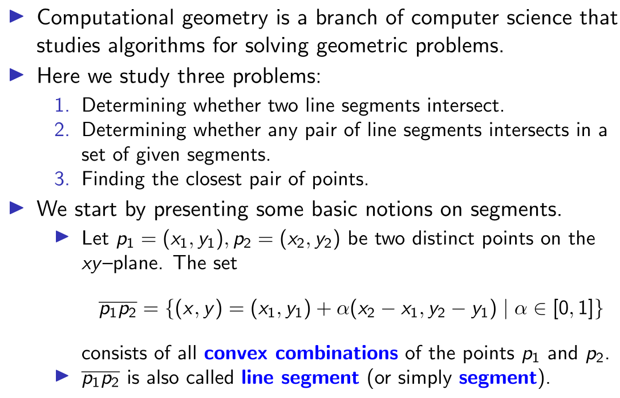

Cross Product
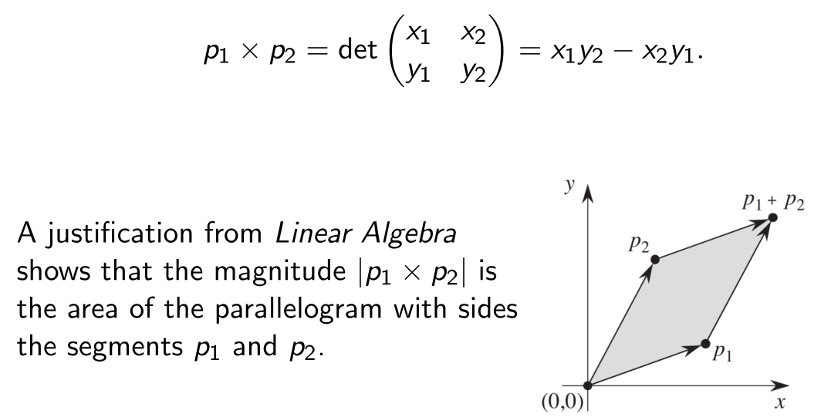

Determining whether consecutive segments turn left or right
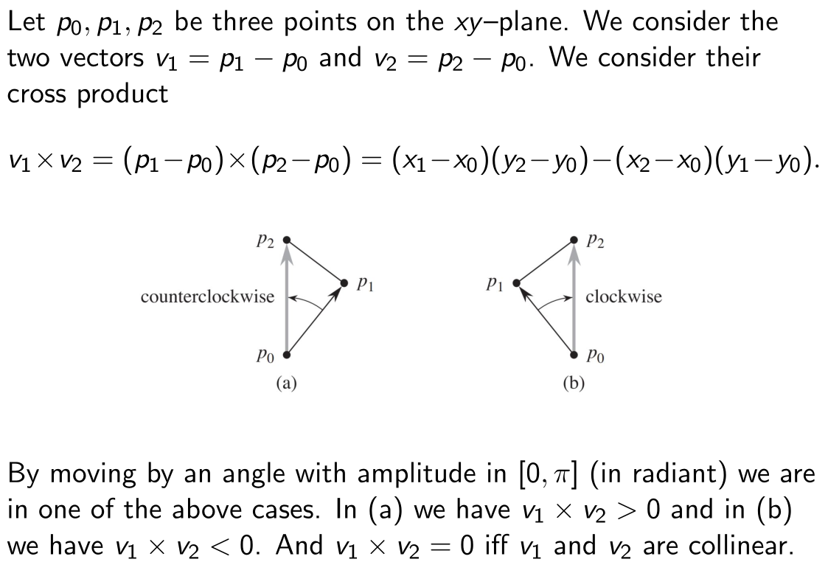
Input: Three points p,q,r in the plane.
Output: Orientation of the triplet:
- >0: Counterclockwise
- <0: Clockwise
- =0: Collinear
DIRECTION(p, q, r) // O(1)
return (q.x - p.x) * (r.y - p.y) - (q.y - p.y) * (r.x - p.x)

Determining whether two line segments intersect
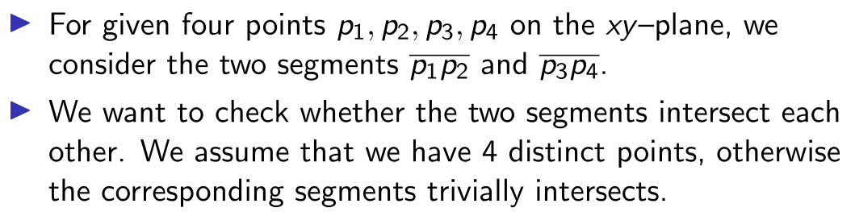
Input: Two line segments p₁p₂p₁​ and p₃p₄​ defined by their endpoints in the plane.
Output: True if the two line segments intersect, otherwise False.
SEGMENTS-INTERSECT(p1, p2, p3, p4) // O(1)
d1 = direction(p3, p4, p1)
d2 = direction(p3, p4, p2)
d3 = direction(p1, p2, p3)
d4 = direction(p1, p2, p4)
if (d1 > 0 and d2 < 0 or d1 < 0 and d2 > 0) and
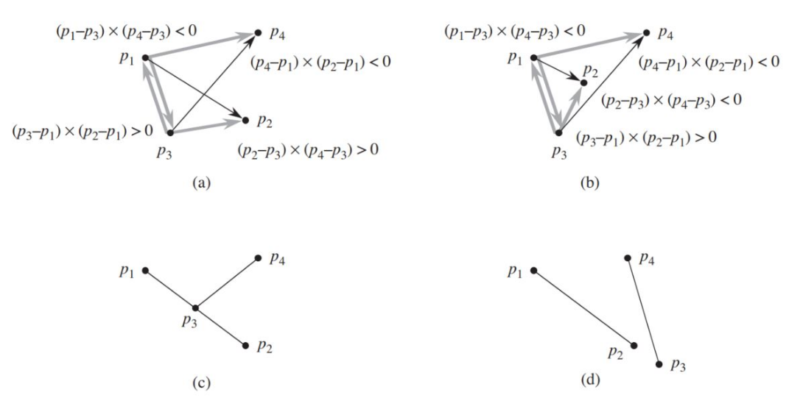
(d3 > 0 and d4 < 0 or d3 < 0 and d4 > 0)
return true
if d1 = 0 and ON-SEGMENT(p3, p4, p1)
return true
if d2 = 0 and ON-SEGMENT(p3, p4, p2)
return true
if d3 = 0 and ON-SEGMENT(p1, p2, p3)
return true
if d4 = 0 and ON-SEGMENT(p1, p2, p4)
return true
return false

Input: Three points p,q,r in the plane.
Output: Orientation of the triplet:
- >0: Counterclockwise
- <0: Clockwise
- =0: Collinear
DIRECTION(p, q, r) // O(1)
return (q.x - p.x) * (r.y - p.y) - (q.y - p.y) * (r.x - p.x)

Input: Three points p,q,r, where pp and qq define a line segment.
Output: True if r lies on the segment pq, otherwise False.
ON-SEGMENT(p, q, r) // O(1)
if min(p.x, q.x) ≤ r.x ≤ max(p.x, q.x) and
min(p.y, q.y) ≤ r.y ≤ max(p.y, q.y)
return true
return false

Determining whether any pair of segments intersects
- We consider a given set of segments on the plane and we present an algorithm to check whether there exists a pair of such a segments, which intersects each other.
- We will use a technique called sweeping, which is used in many algorithms in computational geometry. A vertical line is considered, i.e. the sweep line, which passes through a given set of objects (in our case points), usually from left to right.
- We consider a finite set S of segments of the plane. For simplicity of presentation we assume that no segment is vertical (parallel to the y –axis) and no three segments meet in a point. (These latter assumptions can be removed with a slight modification).

Ordering Segments
- Here we present a partial order on the set S of segments.
- Let r be a real number. We consider the sweep line, i.e. the vertical line, of the point of the plane having first coordinate x = r.
- We say that two segments s₁ , s₂ are compatible at r , if the both segments intersect the sweep line x = r . Recall that no line in S are vertical so s ∈ S intersects the line x = r at most once.
- We give a partial order on S . For s₁ , s₂ ∈ S we say that s₁ is above s₂ at r if are comparable at r and the intersection of s₁ with the sweep line is higher than or equal to the one of s₂ with the sweep line. We write s₁ ≽r s₂.

Total Preorder
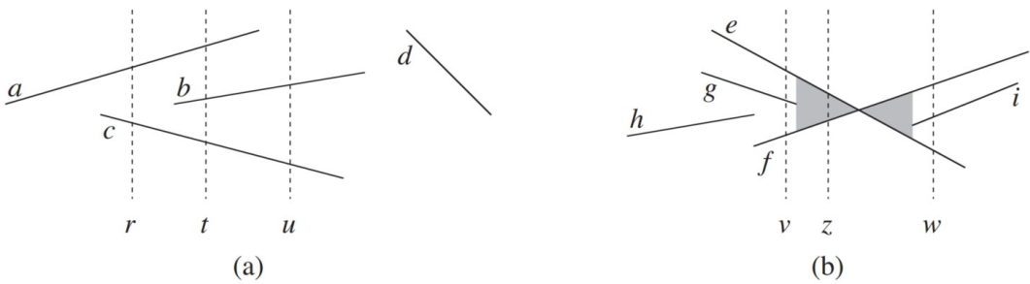
- The relation ≽_{r} is clearly reflexive, transitive, but is neither symmetric nor antisymmetric.
- Thus ≽_{r} is a total preorder on the subset of S of segment intersecting the sweep line {x = r }.

Moving the sweep line
As usual in general with sweeping algorithms, we will manage two sets of data:
- The sweep–line status: we will consider the above described total orders associated to each sweep lines.
- The event point schedule: We will consider a sequence of points, called event points, ordered from left to right. We will let move (“continuously”) the sweep line from left to right and stop at these event points. The process will analyze the sweep–line status at this points, and then resume.
- The event points will be the end points of the segments.
- The event points will be sorted according to the x–coordinate. If two or more endpoints have same x–coordinate, we breaks ties by putting before left endpoints than right endpoint. For tails we put before endpoints with smaller y –coordinate.

Operations of sweep–line status
Let T be a total preorder associated to a sweep–line status. We will consider the following operations on T .
- INSERT(T , s): insert the segment s into T .
- DELETE(T , s): delete segment s from T .
- ABOVE(T , s): return the segment immediately above the segment s in T .
- BELOW(T , s): return the segment immediately below the segment s in T .
We can perform all the above operations in O(ln n) by using red–black trees. Instead of using red–black trees you could compare two elements in T by using the cross ratio (exercise).

Any Segments Intersect
Input: A set S of n line segments in the plane.
Output: True if any two segments inS intersect, otherwise False.
ANY-SEGMENTS-INTERSECT(S) // O(n * log(n))
E = empty event queue
T = empty balanced binary search tree
for each segment s ∈ S
insert left endpoint of s into E
insert right endpoint of s into E
while E is not empty
p = REMOVE-MIN(E)
if p is the left endpoint of segment s
INSERT(T, s)
if SEGMENTS-INTERSECT(s, ABOVE(T, s)) or
SEGMENTS-INTERSECT(s, BELOW(T, s))
return true
else if p is the right endpoint of segment s
if SEGMENTS-INTERSECT(ABOVE(T, s), BELOW(T, s))
return true
DELETE(T, s)
return false

Runtime Analysis
- Sorting Endpoints:
2n endpoints sorted → O(n * log(n))
- Tree Operations:
  - Insert/Delete in T: O(log(n))
  - Each endpoint processed once → O(n * log(n))
- Intersection Checks:
  - Checking neighbors per event → O(1)
Overall Complexity:
O(n * log(n))

Sweeping to Detect Intersections
Input: A set S of line segments in the plane.
Output: True if any pair of line segments intersects; otherwise, false.
Algorithm:
- Use a sweep line to process events:
  - Event points: Left and right endpoints of segments, sorted by xx-coordinate.
  - Process events by maintaining an active set of segments intersected by the sweep line.
- Use a balanced binary search tree (e.g., red-black tree) to keep track of the order of segments intersecting the sweep line.

CLOSEST-PAIR(Q)
if |Q| ≤ 3
return brute-force closest pair
divide Q into Q_L and Q_R by vertical line
δL = CLOSEST-PAIR(Q_L)
δR = CLOSEST-PAIR(Q_R)
δ = min(δL, δR)
compute pairs in 2δ-wide strip
return closest pair found

Runtime:
- Sorting by x-coordinate: O(n * log(n))
- Recursive calls and combining: O(n * log(n))
- Total runtime: O(n * log(n))

Math Cheat Sheet

Logarithm Rules
- Definition of Logarithm: logb​(x)=y⟺by=x (Logarithms are the inverse of exponents.)

- Basic Rules:
  - Log of 1: any base logb​(1)=0for any base b>0,b=1
  - Log of the Base: logb​(b)=1
  - Log of the Base Raised to Itself: logb​(bx)=x

- Product Rule: logb​(xy)=logb​(x)+logb​(y)

- Quotient Rule: logb​(yx​)=logb​(x)−logb​(y)

- Power Rule: logb​(xy)=y⋅logb​(x)

- Change of Base Formula: is any positive base)logb​(x)=logk​(b)logk​(x)​(where k is any positive base).

- Logarithm of a Reciprocal: logb​(x1​)=−logb​(x)

- Logarithm of a Root: logb​(xy

