TECHNOLOGICAL INSTITUTE OF THE PHILIPPINES
QUEZON CITY
COLLEGE OF COMPUTER STUDIES
IT 010 - Systems Integration and Architecture 2
GROUP NO. 6
Leader: Espino, Luis David B. / IT41S1
Member 1: Egil, Abdullah Ibn Mujahid J. / IT41S1
Member 2: Libag, Joshua M. / IT41S1
Member 3: Penola, John Paul S. / IT41S1
Assessment Task: Progress Report
Project Title: HapagPamana: A Smart Catering Recommendation and Venue Layout Planning System Using SARIMA and Collaborative Filtering with A* Pathfinding and AABB Collision Detection
Reporting Period: Since the submission of the Project Accomplishment Report and Individual Member Accomplishment Report 1 — covering work up to September13, 2026
Link of the recorded system demonstration: https://drive.google.com/file/d/1WzKJFAqir1L8SNvRe4HRjVxSLuC2DgcW/view?usp=sharing
I. INTRODUCTION
HapagPamana is a cross-platform catering intelligence system developed for home-based catering operations. It combines a Flutter/Dart mobile application for guests and registered members with an HTML/CSS/JavaScript role-gated administrative web panel, both backed by Firebase (Firestore, Authentication, Cloud Storage). The system is designed to move a home-based caterer away from manual, paper-driven coordination and toward a single data-driven platform that spans customer booking, kitchen preparation, procurement, inventory, and delivery.
The project pursues one general objective and four specific objectives. The general objective is to develop an end-to-end catering platform that supports booking, fulfilment, and decision-making across both mobile and web front ends. The specific objectives are: (1) to develop an interactive drag-and-drop 3D venue layout planning module with a scaled grid floor plan; (2) to implement spatial validation using AABB (Axis-Aligned Bounding Box) collision detection and A* pathfinding for guest-flow analysis; (3) to design an AI-assisted recommendation component combining a rule-based layout evaluation engine, SARIMA-based demand forecasting for procurement, and expiry-aware Collaborative Filtering for personalized menu suggestions; and (4) to evaluate the resulting system against the ISO/IEC 25010 software quality model through User Acceptance Testing.
This progress report documents the work completed by each member since the last update, the proof of those completed tasks, what each member is currently working on, the obstacles the group encountered and how they were addressed, and the plan for completing the project. As of this reporting period, all core modules identified in the approved scope have been implemented and integrated; the remaining work is concentrated on algorithm refinement, cross-module regression testing, formal User Acceptance Testing, deployment, and the completion of the written documentation.
II. INDIVIDUAL ACCOMPLISHMENT
The tables below list the tasks completed by each member since the last update, the screenshot proof of those tasks with a description of how each was developed, and what each member is currently working on.
LEADER — ESPINO, LUIS DAVID B. / IT41S1
Name of the Student | Espino, Luis David B.
Completed Tasks | • Optimized the Three.js 3D scene in the Layout Designer using geometry instancing and level-of-detail swapping for repeated furniture meshes (chairs, round tables, buffet trays), restoring a stable frame rate on scenes exceeding 200 placed objects.  • Retuned the A* pathfinding grid resolution and corrected the give-way avoidance behaviour in the procedural crowd simulation so agents no longer deadlock at buffet and bar queue nodes.  • Wired the walkability and spatial-analysis scoring report into the shared booking record so that the clearance, reachability, emergency-egress, and congestion-heatmap results persist under bookings/{id}.layout.analysis.  • Standardized the role-gated staff portal shell (hp-guard.js, hp-shell.js) across all ten administrative dashboards after the module merge, eliminating the divergent sign-in and navigation code that had appeared in individual branches.  • Consolidated the project-wide Firestore security rules and composite indexes, and resolved the index errors that surfaced once live streams from all dashboards ran concurrently.
Proof of Completed Tasks (Actual screenshot and description) | 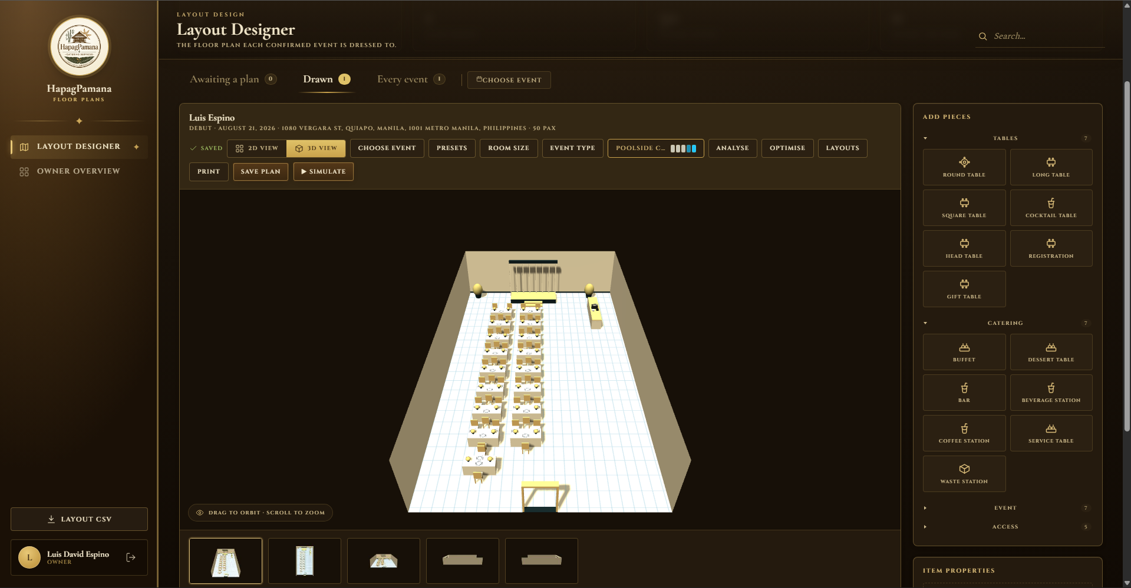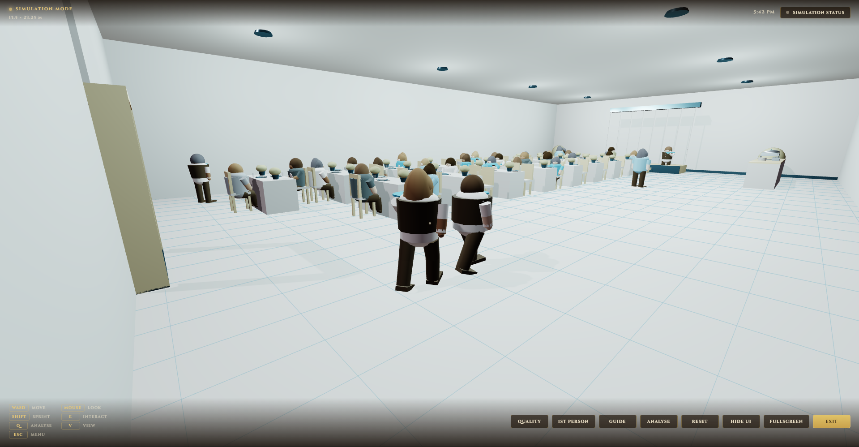  Description: Shows the 3D venue layout designer after the optimization pass — the scaled grid floor plan with instanced furniture meshes on the left, and the walkthrough/crowd-simulation view with A* agent paths on the right. Developed by profiling the render loop in Chrome DevTools, identifying per-object draw calls as the bottleneck, and replacing individually instantiated meshes with InstancedMesh batches plus a distance-based LOD swap in scene3d.js.  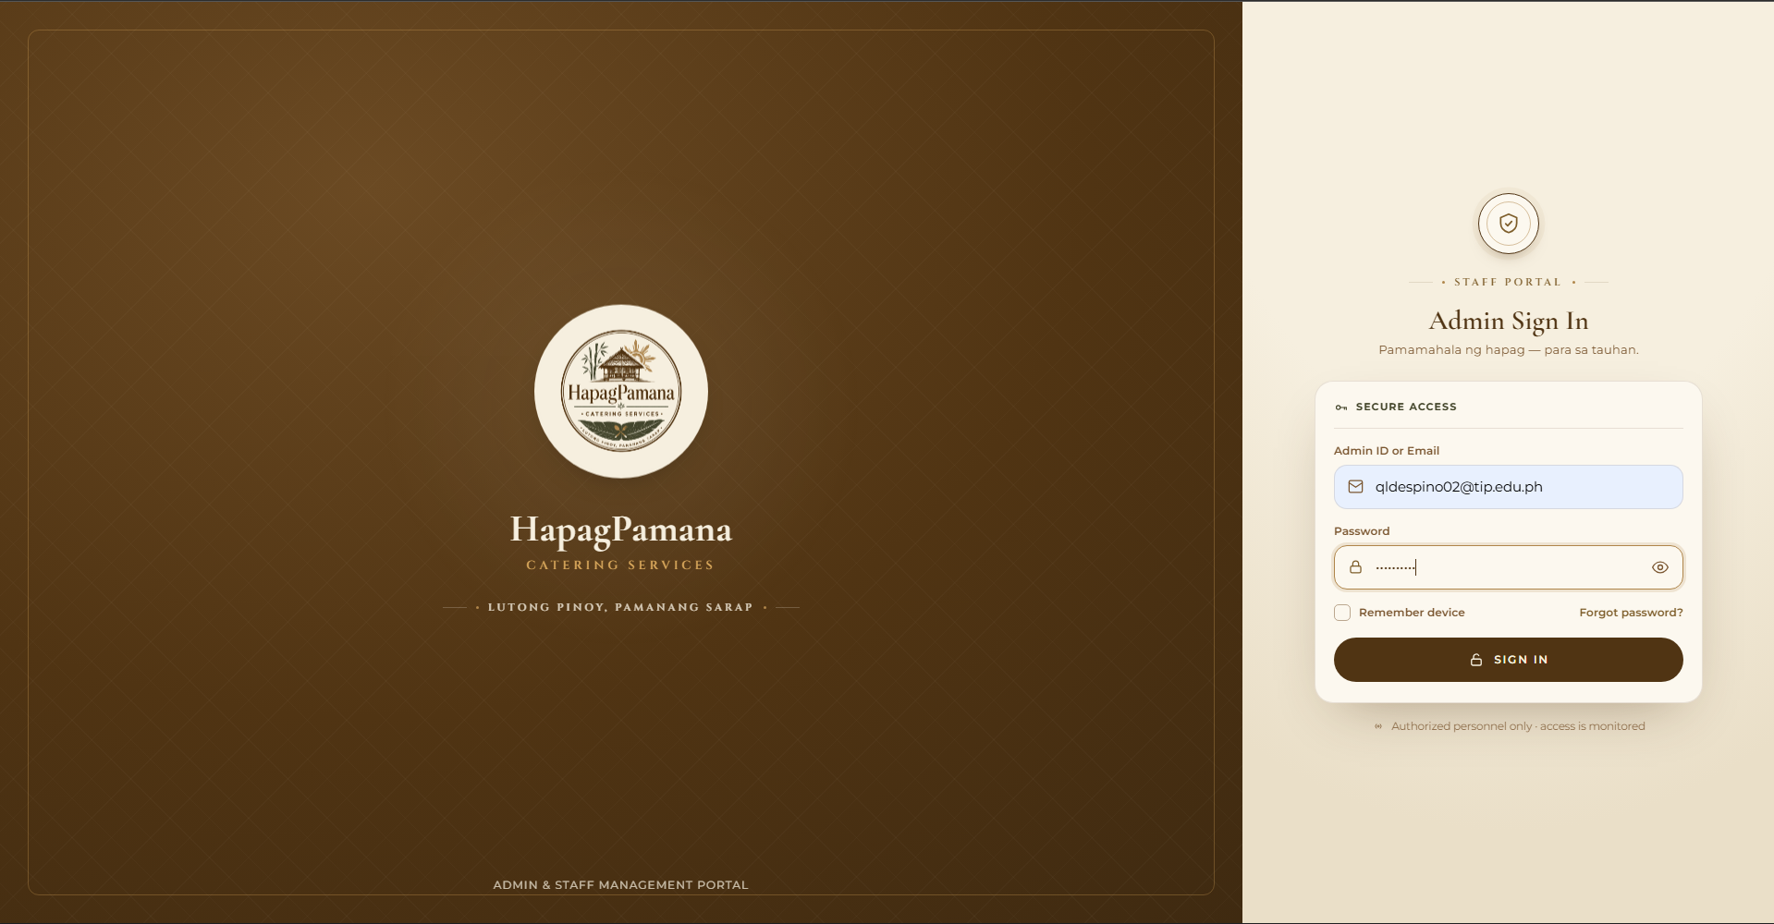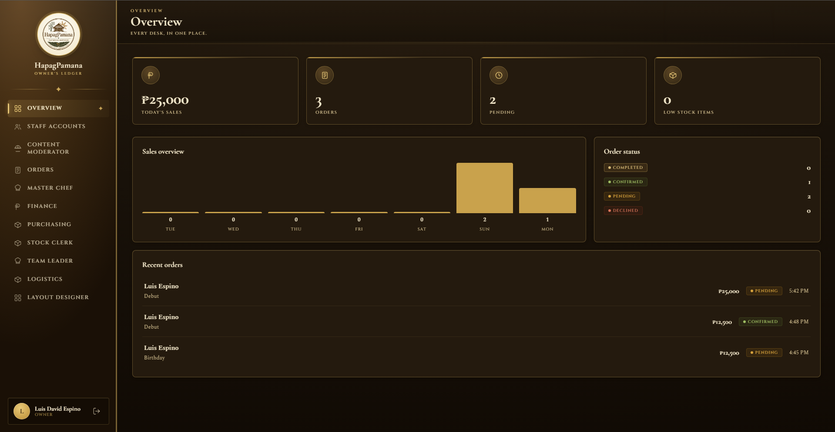  Description: Shows the unified role-gated administrative shell and the cross-desk overview reading from the shared data model. Accomplished by extracting the duplicated authentication guard and navigation frame from each dashboard into hp-guard.js and hp-shell.js, then refactoring all ten dashboards to consume that single shell contract.
Current Status | Currently leading the cross-module regression test pass across the mobile application and the ten administrative dashboards, and preparing the Firebase Hosting deployment configuration for the web admin panel together with the signed Android release build.
Challenges Faced | Frame drops appeared on mid-range Android devices once the crowd simulation and the full furniture set ran together. Addressed by instancing repeated geometry, adding LOD swapping, and capping the number of simultaneously simulated crowd agents.
Next Steps | Complete the regression matrix, finalize deployment of the web panel and the Android release build, and lead the ISO/IEC 25010 User Acceptance Testing sessions.

MEMBER 1 — EGIL, ABDULLAH IBN MUJAHID J. / IT41S1
Name of the Student | Egil, Abdullah Ibn Mujahid J.
Completed Tasks | • Hardened the preference synchronization in the member Settings suite so dietary, allergen, and language changes apply locally first and roll back cleanly when the Firestore write fails, removing the state desynchronization observed on unstable connections.  • Corrected the recipe rescaling logic in the Master Chef Prep Board so ingredient quantities round against actual purchase pack sizes rather than raw per-serving decimals, and finished the CSV export of the aggregated shopping list.  • Completed the four-check approval gate on the Finance Costing Board (labour, transport, markup, and margin validation) that must pass before a requisition slip can be released.  • Rebuilt the Petty Cash ledger so the running balance is always derived from the entry history rather than stored as a mutable field, and finished the Received view for receipt acknowledgment.  • Finished the Owner Dashboard cross-desk rollup with the seven-day sales trend chart and low-stock count, and completed staff account provisioning through a secondary Firebase app instance.
Proof of Completed Tasks (Actual screenshot and description) | 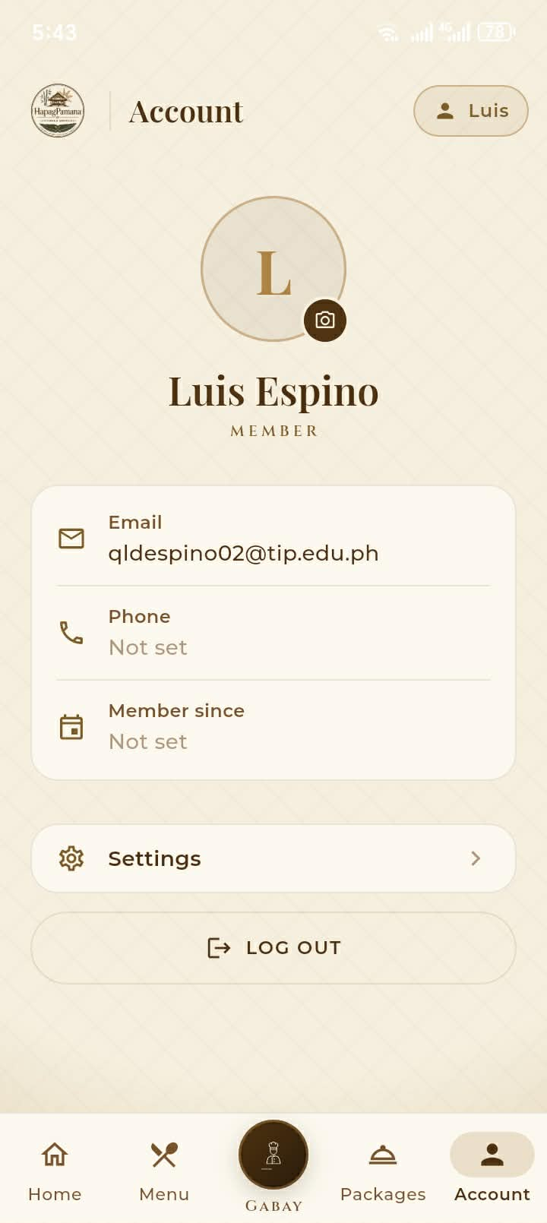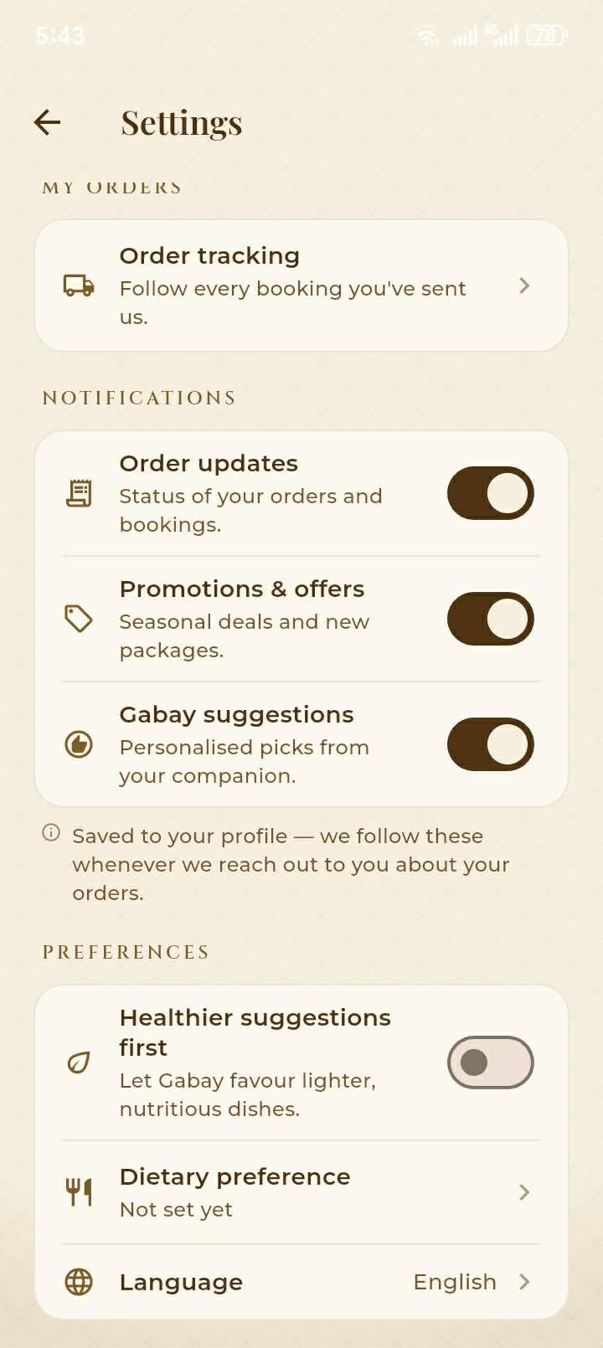  Description: Shows the member Account tab and the Settings suite with dietary and allergen preferences. Developed by writing the preference change to local state immediately, dispatching the Firestore update, and reverting the local value on a failed write so the interface never displays a preference the database did not accept.  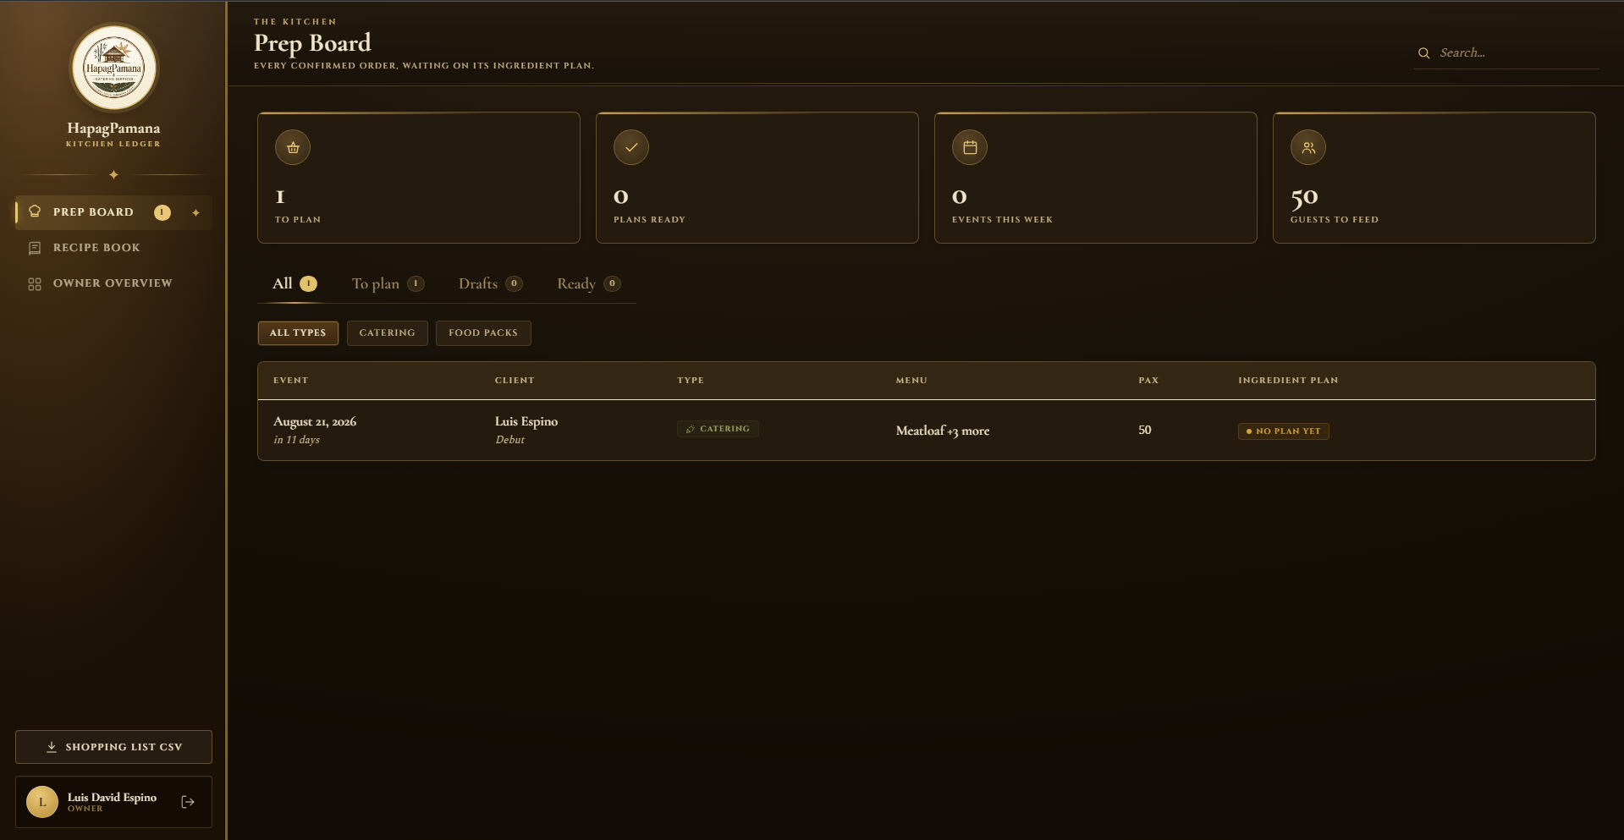  Description: Shows the Master Chef Prep Board with a confirmed order rescaled into an ingredient plan. Accomplished by streaming confirmed bookings live, reading the saved costed recipe, and rescaling each ingredient line to the order headcount before rounding upward to the nearest purchasable pack.  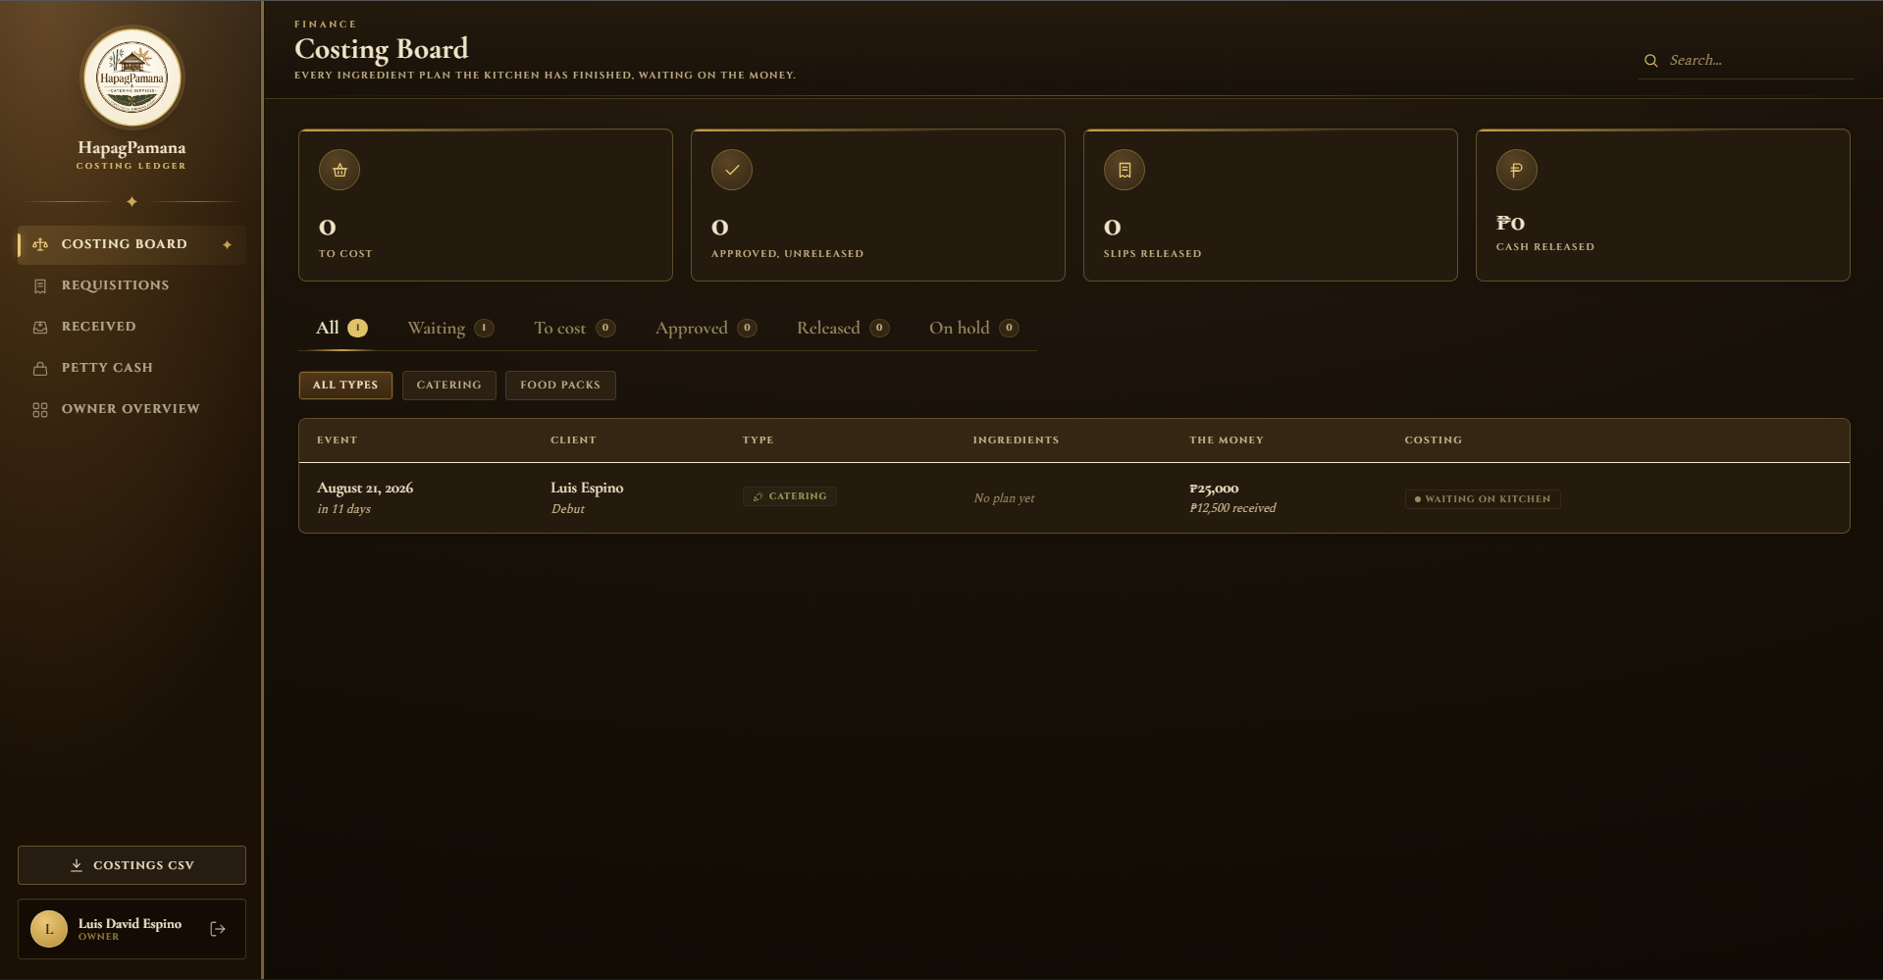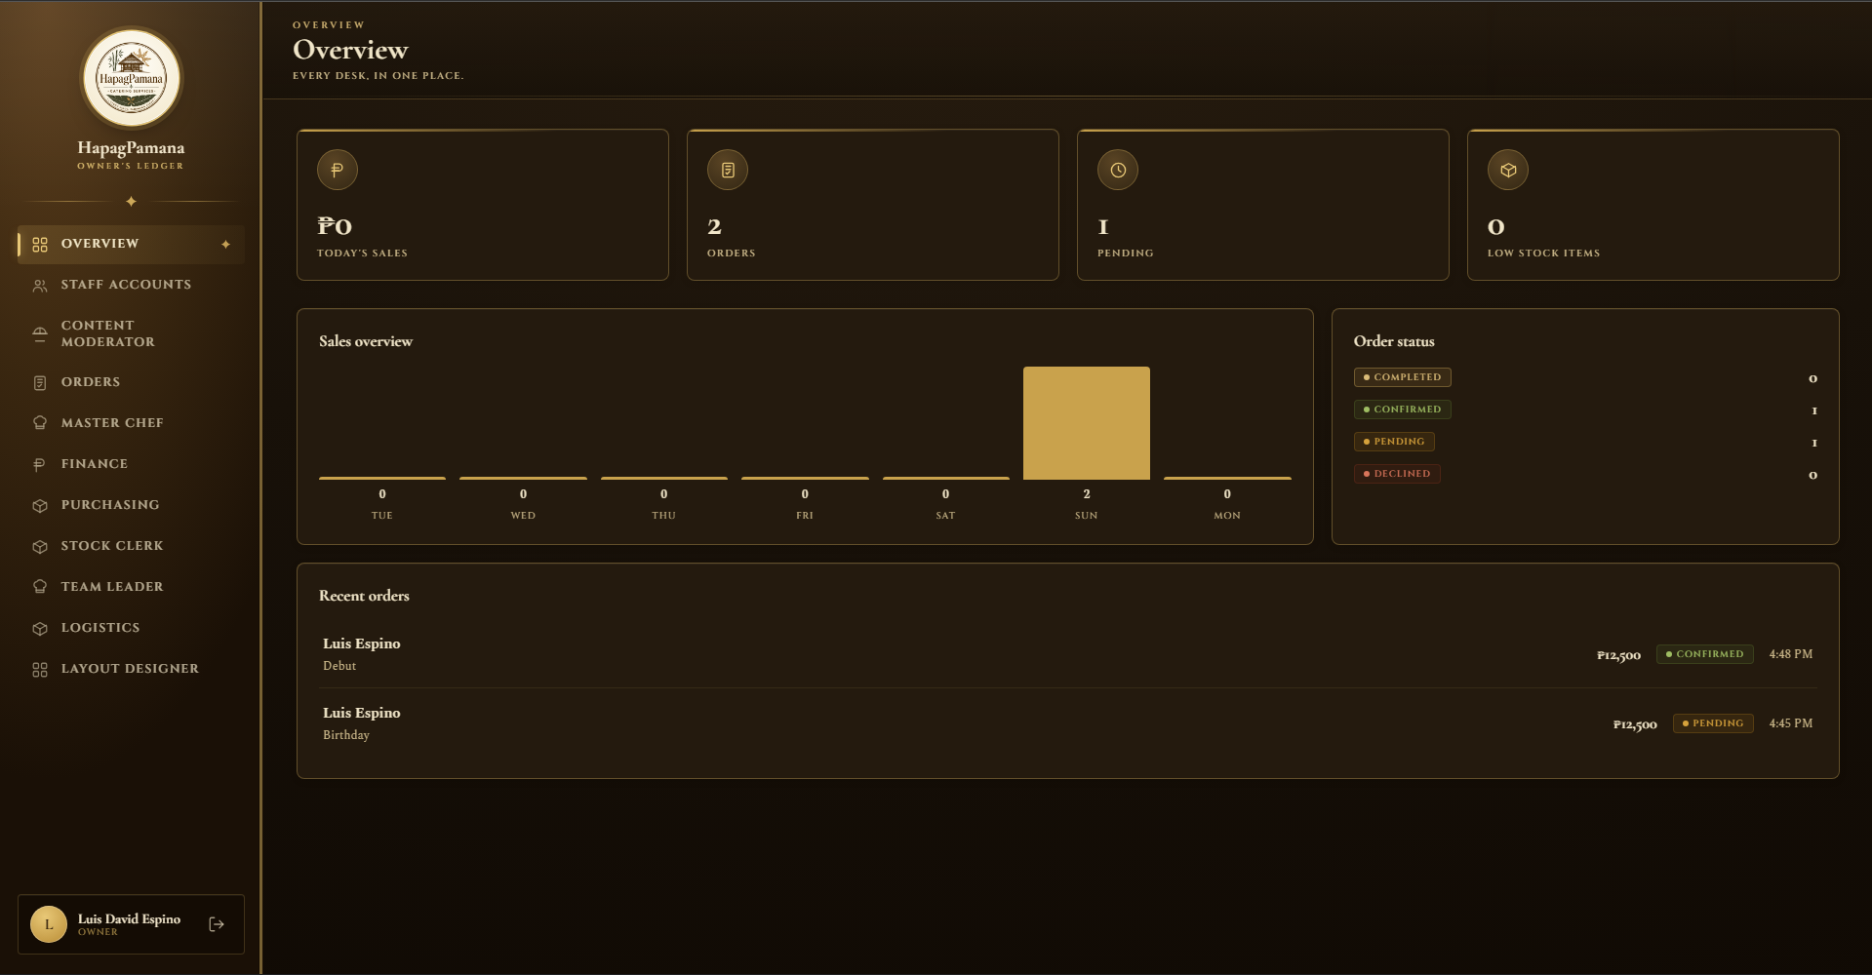  Description: Shows the Finance Costing Board with the requisition approval checks, and the Owner Dashboard overview with the seven-day trend chart and staff account management. The staff provisioning was accomplished by initializing a secondary Firebase app instance for the account-creation call, so the owner's own session is never replaced when a new staff login is created.
Current Status | Currently building the consolidated reports and analytics export for the Owner role, drawing from order, inventory, procurement, and forecasting data, with PDF and CSV output formats.
Challenges Faced | Creating a staff account through the standard Firebase Auth call signed the owner out of their own session. Addressed by performing account creation on a separate, secondary Firebase app instance that is disposed immediately afterwards.
Next Steps | Finish the Owner reports and analytics export, then assist with User Acceptance Testing on the finance and kitchen desks and contribute the corresponding sections of the documentation.

MEMBER 2 — LIBAG, JOSHUA M. / IT41S1
Name of the Student | Libag, Joshua M.
Completed Tasks | • Replaced client-side payment confirmation with server-side verification: the booking is only marked as paid after the PayMongo checkout session is re-read and confirmed, rather than trusting a flag returned to the device.  • Completed draft resumption and cross-field time validation across both the catering booking wizard and the food pack quotation wizard, so an interrupted booking can be resumed without data loss and overlapping ingress or egress times are rejected at entry.  • Finished the Content Moderator allergen severity heatmap, bulk product actions, and the institutional-only "Hapag Serbisyo" package rule enforcement.  • Completed the transactional status transitions on the Orders Dashboard (pending, confirmed, declined, completed) so concurrent staff actions cannot place a booking in an inconsistent state.  • Extended the Booking Calendar to flag real ingress and egress schedule overlaps between events rather than only same-day collisions, and completed walk-forward rolling-origin validation of the demand forecast with MAE, RMSE, and MAPE reporting.
Proof of Completed Tasks (Actual screenshot and description) | 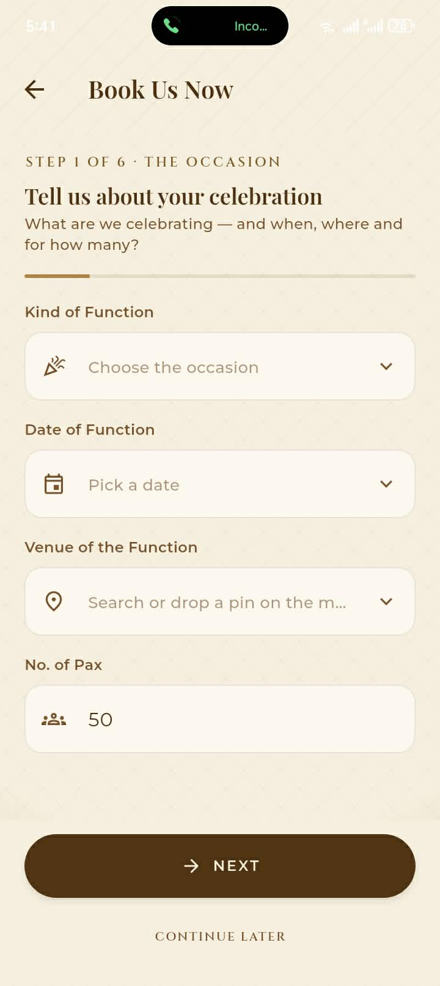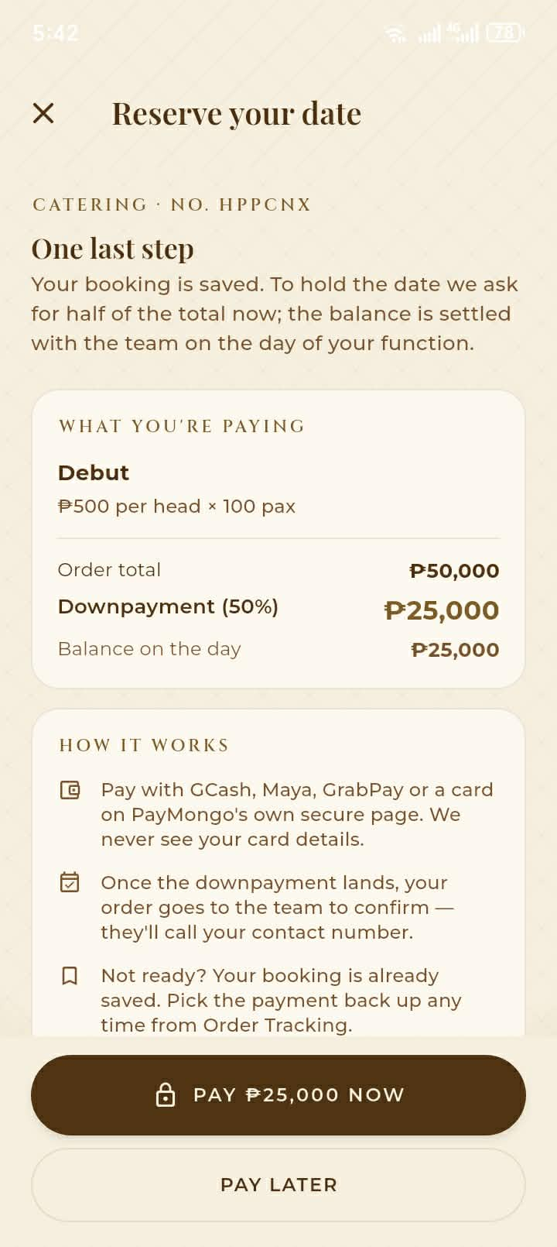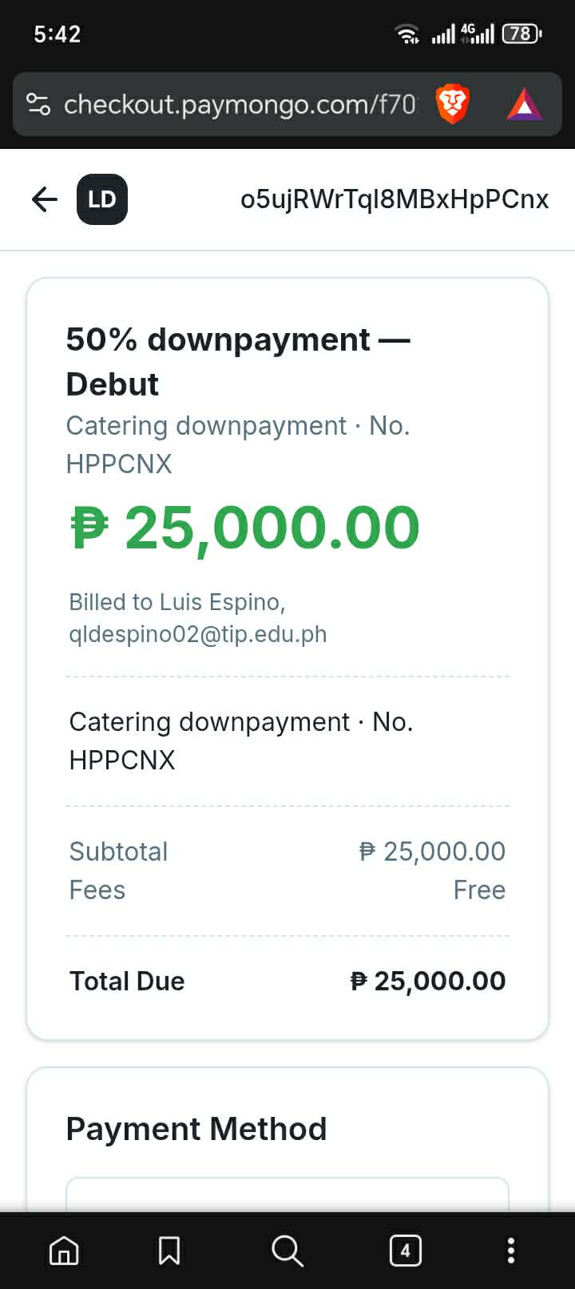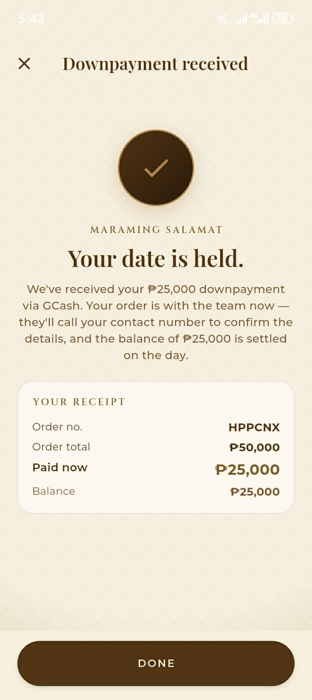  Description: Shows the multi-step catering booking wizard (Occasion, Client, Set-up, Program, Package/menu courses), the PayMongo 50% downpayment gate, and the live order tracking screen. Developed by filing the booking in a pending state before the payment gate opens, so an abandoned payment leaves a resumable draft rather than a lost booking.  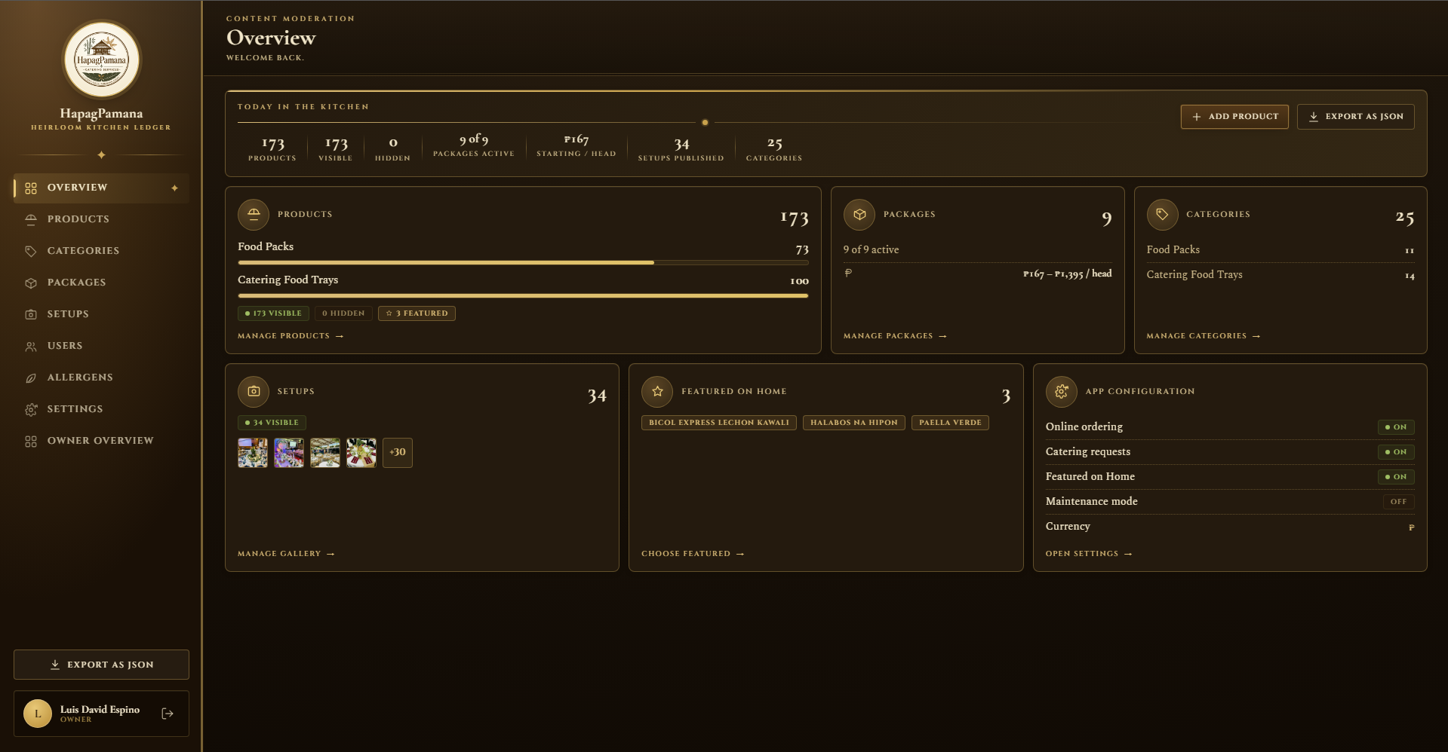  Description: Shows the Content Moderator dashboard managing products, categories, and the allergen severity heatmap that feeds every menu listing in the mobile application. Accomplished by driving the mobile menu entirely from these Firestore collections so no dish or allergen data is hard-coded in the app.  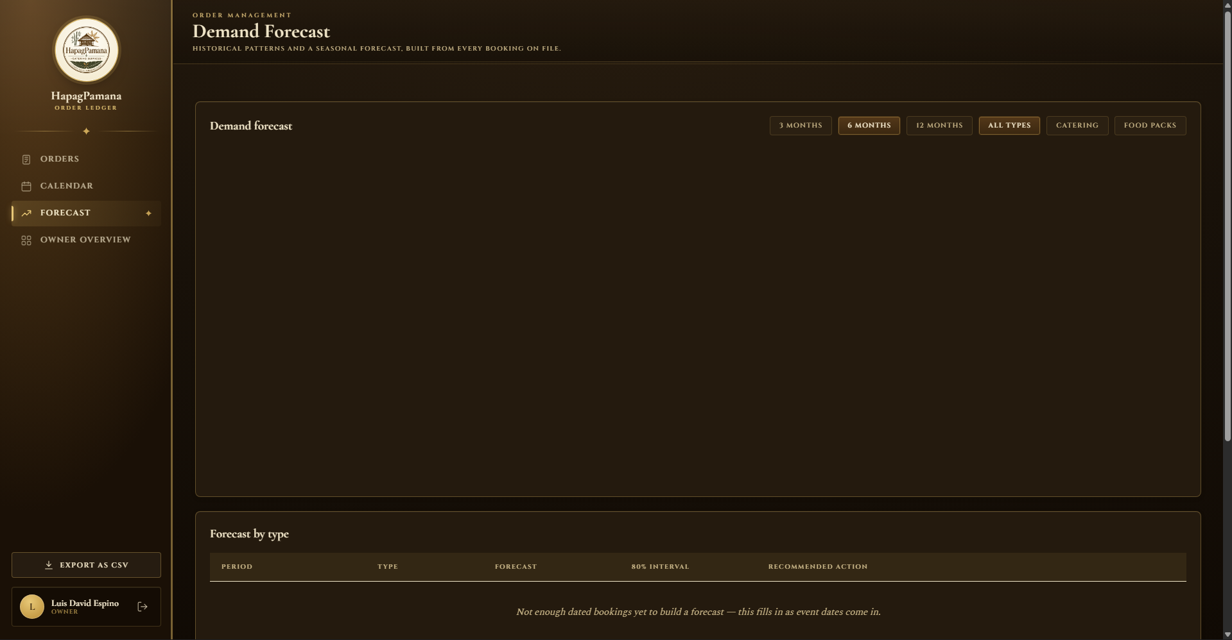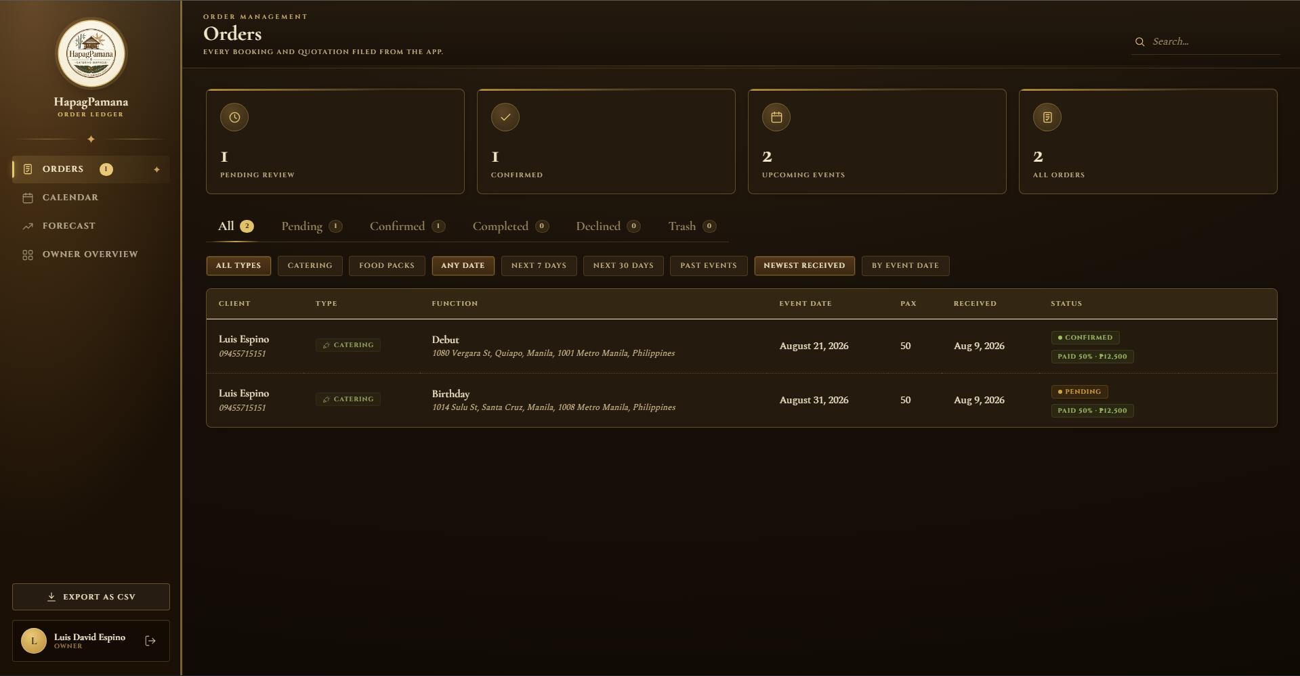  Description: Shows the live order queue with transactional status transitions and the demand forecasting view with historical trend, projected seasonal demand, and confidence bands. The validation metrics were produced by holding out successive time origins and scoring each forecast horizon against the actual bookings that followed.
Current Status | Currently refining the forecasting engine — replacing the seasonal-naive and trend-drift baseline with a fitted SARIMA model, and re-running the walk-forward validation to compare error metrics between the two approaches before committing to the final model.
Challenges Faced | The historical booking dataset was too sparse to fit a stable seasonal model. Addressed by seeding a seasonally grounded dataset derived from the Philippine event calendar (fiesta, graduation, and holiday peaks), blending it with a moving average, and validating the result through walk-forward testing rather than a single train-test split.
Next Steps | Finalize and retrain the SARIMA model, document the forecasting methodology and its validation results, and support User Acceptance Testing on the booking and orders flow.

MEMBER 3 — PENOLA, JOHN PAUL S. / IT41S1
Name of the Student | Penola, John Paul S.
Completed Tasks | • Refactored the shared Firestore repository layer (products, catering packages, customers, bookings, allergens, address autocomplete, and PayMongo configuration) that every other module in the mobile application depends on.  • Implemented offline caching for menu browsing and order drafting with automatic synchronization on reconnection, so a booking started without signal is not lost.  • Completed the Purchasing Dashboard purchase-run workflow, which converts a released requisition into a procurement document holding a frozen snapshot of the approved lines and tracks actual against authorized spend by stage.  • Finished the Stock Clerk pantry ledger, where every stock movement (received, issued, returned, wasted, corrected) is written transactionally, together with line-by-line partial-acceptance receiving and the liquidation reconciliation step.  • Completed the Logistics and Team Leader dashboards, keeping kitchen "ready" and logistics "released" as two separate accountable steps recorded on one shared fulfilment record.
Proof of Completed Tasks (Actual screenshot and description) | 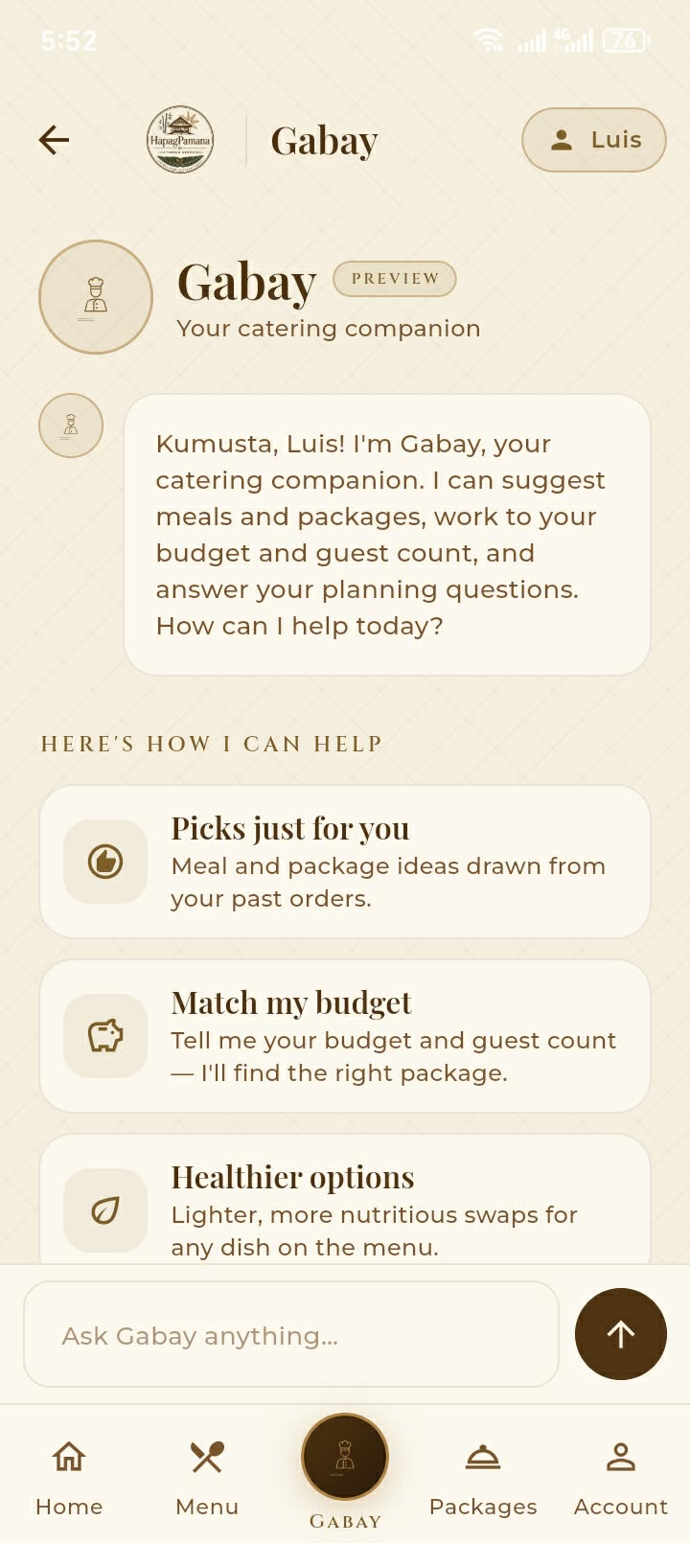  Description: Shows the HapagGabay assistant tab built on the shared repository layer — chat composer, starter prompts, and capability cards for recommendations, budget and headcount matching, and healthier-meal swaps. Developed by exposing every Firestore collection through a single repository interface so the assistant, the menu, and the booking wizards all read from one consistent data source.  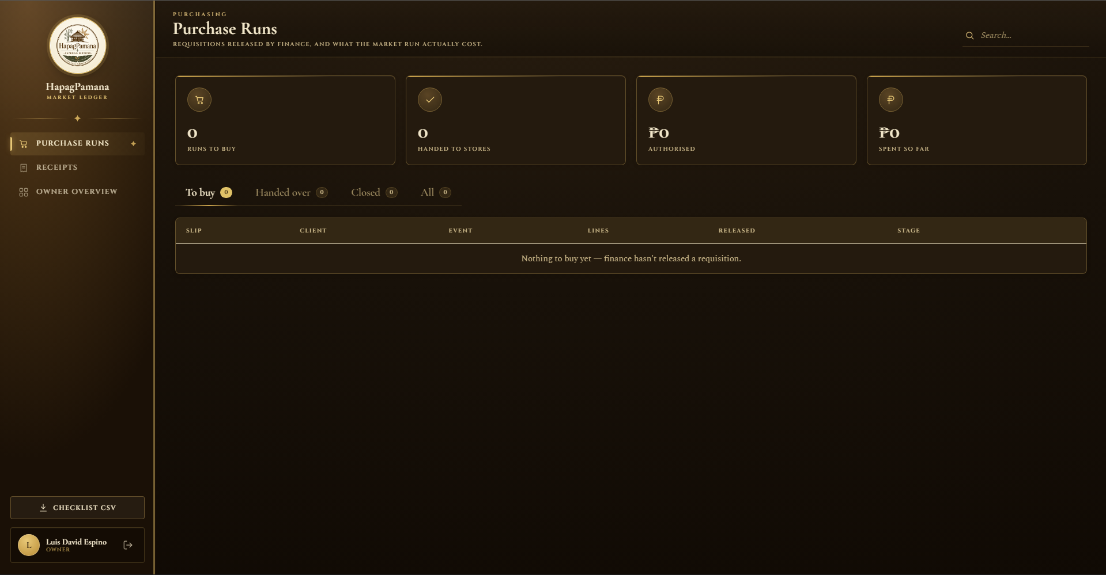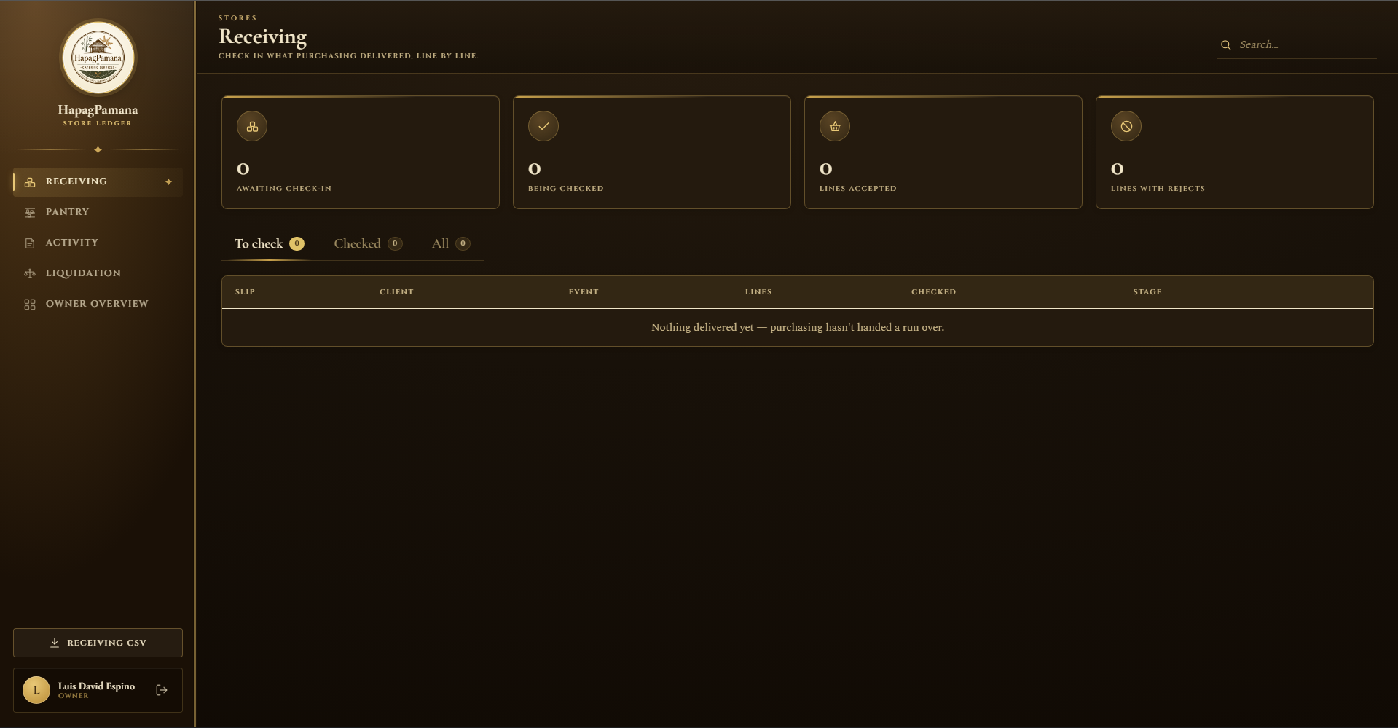  Description: Shows the Purchasing Dashboard purchase-run and receipt reconciliation view, and the Stock Clerk pantry ledger with par levels and low/out-of-stock states. Accomplished by freezing the approved requisition lines into the purchase document at release time, so later edits to the requisition cannot retroactively change what was authorized.  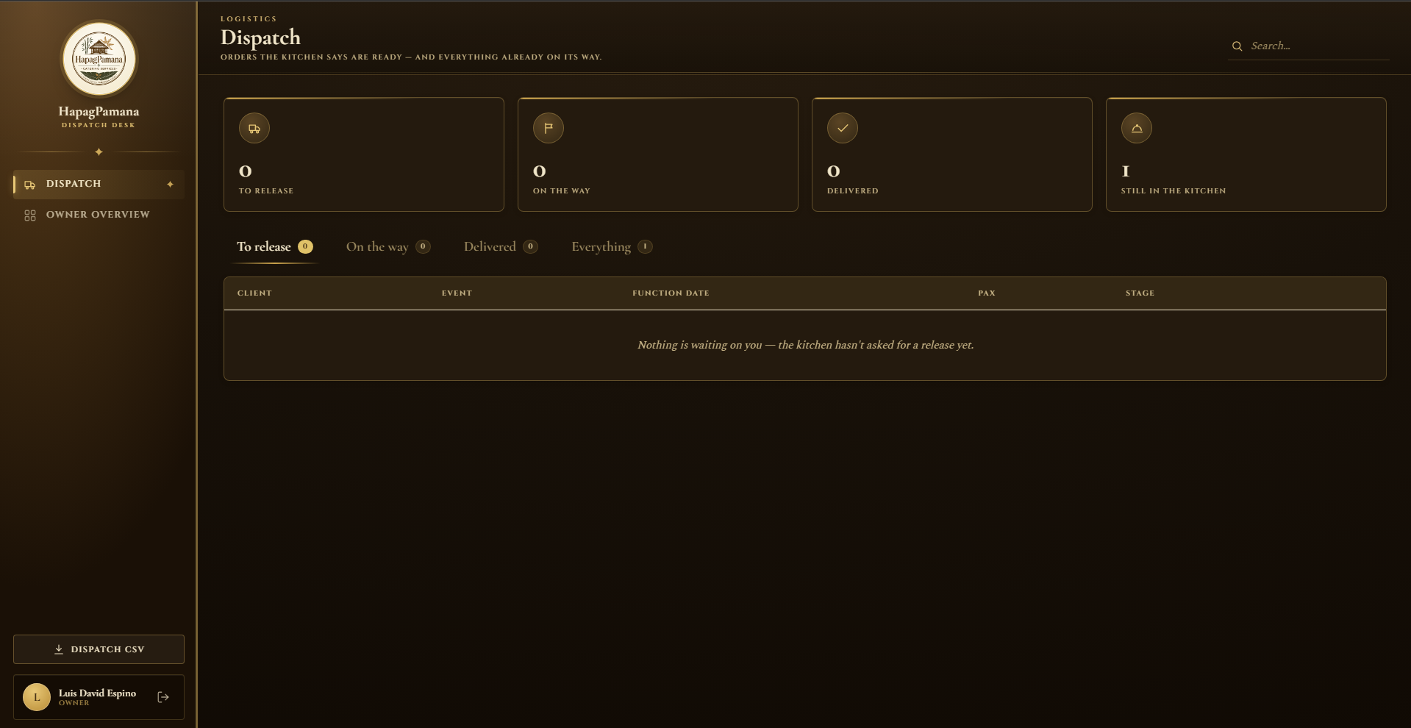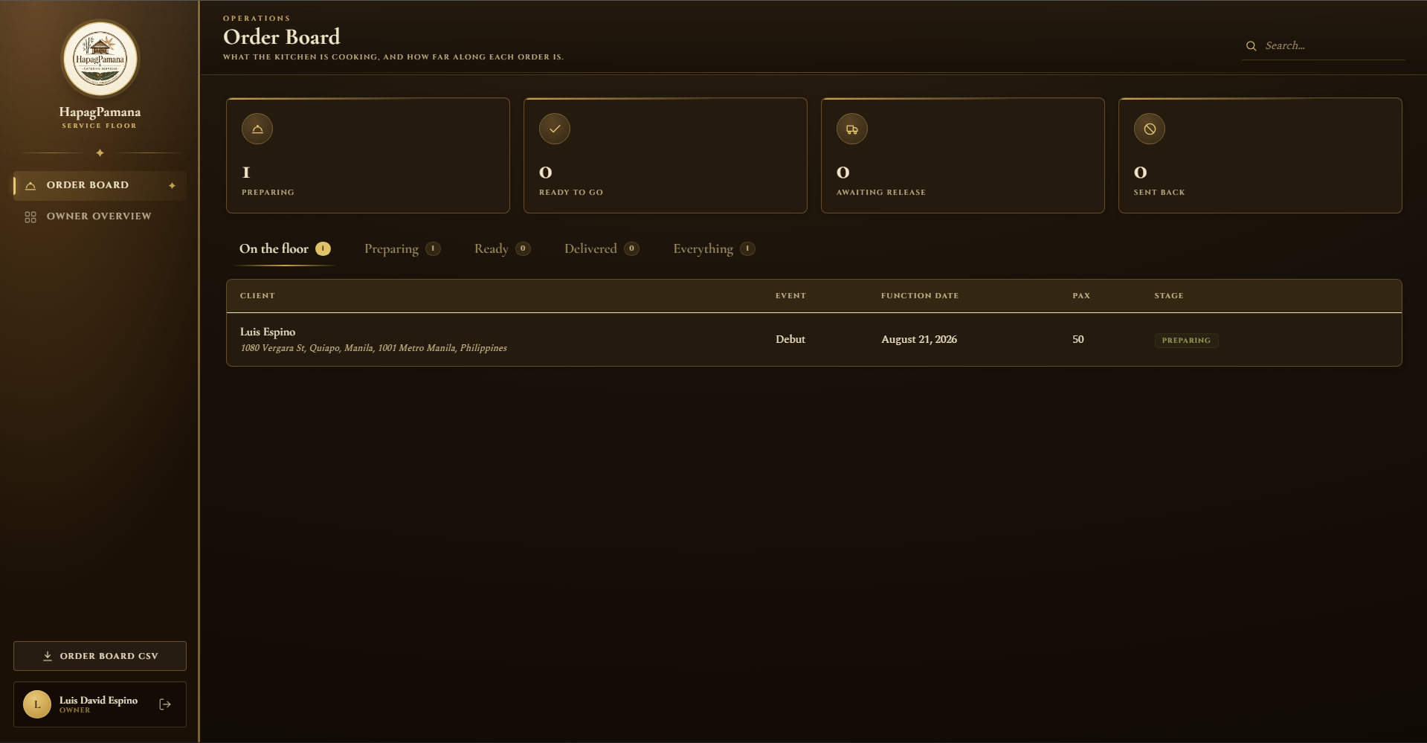  Description: Shows the Team Leader order board moving confirmed orders from Preparing to Ready, and the Logistics dispatch queue approving release and marking delivery. Developed deliberately so the Team Leader cannot release an order directly — kitchen readiness and logistics release remain two separate recorded actions.
Current Status | Currently integrating the expiry-aware Collaborative Filtering backend with the HapagGabay assistant interface, so the previously scaffolded chat UI returns live personalized recommendations computed from cosine similarity over customer order histories.
Challenges Faced | The HapagGabay assistant existed only as a design-stage interface with no recommendation source behind it, and the Collaborative Filtering module had been developed separately. Addressed by defining a single recommendation contract in the repository layer that both the "Recommended for You" and "Try Something New" surfaces consume.
Next Steps | Complete the Collaborative Filtering integration and the "Try Something New" menu mode, then verify offline synchronization behaviour during User Acceptance Testing.
III. CHALLENGES FACED
The following obstacles were encountered during this reporting period, together with the action the group took to resolve each one.
OBSTACLE ENCOUNTERED | HOW THE GROUP ADDRESSED IT | RESPONSIBLE MEMBER(S)
Sparse historical booking data for seasonal forecasting | The available booking history did not cover enough seasonal cycles to fit a stable SARIMA model, producing unreliable early forecasts. The group seeded a seasonally grounded dataset derived from the Philippine event calendar (fiesta, graduation, and holiday demand peaks), blended it with a moving-average component, and adopted walk-forward rolling-origin validation with MAE, RMSE, and MAPE instead of a single train-test split so the error figures reflect real forecasting conditions. | Libag, Joshua M.
3D renderer performance on mid-range Android devices | Running the full furniture set together with the crowd simulation caused visible frame drops during venue planning. The group profiled the render loop, replaced individually instantiated meshes with instanced geometry, added distance-based level-of-detail swapping, and capped the number of simultaneously simulated crowd agents, restoring a usable frame rate without reducing the object palette. | Espino, Luis David B.
Divergent sign-in and navigation code across ten dashboards | Because the administrative dashboards were built in parallel, each had drifted into its own authentication guard and navigation frame, which caused repeated merge conflicts. The group froze hp-guard.js and hp-shell.js as a shared contract, refactored every dashboard to consume that single shell, and moved to short-lived feature branches with review before merge. | Espino, Luis David B. (all members)
Payment confirmation trusted the client device | The initial PayMongo integration marked a booking as paid based on a flag returned to the application, which could be manipulated. The group changed the flow so the server re-reads the PayMongo checkout session and only then updates the booking status. | Libag, Joshua M.
Firestore read volume and missing composite indexes | Once all dashboards streamed live simultaneously, query costs rose sharply and several composite index errors surfaced. The group replaced broad live streams with manual, scoped subscriptions, added pagination on historical views, and consolidated the required composite indexes into the project configuration. | Espino, Luis David B. / Penola, John Paul S.
HapagGabay assistant had no recommendation source | The assistant interface was built ahead of the Collaborative Filtering engine, leaving a functional gap between the two. The group defined a single recommendation contract in the shared repository layer so both the assistant and the menu recommendation surfaces consume the same computed output. | Penola, John Paul S.
Conflicting member schedules across academic requirements | Overlapping deadlines in other subjects made synchronous work difficult. The group adopted a weekly synchronization meeting, a shared task board with explicit ownership per module, and asynchronous code review so progress did not stall when members were unavailable. | All members
IV. NEXT STEPS
The plan below outlines the remaining work required to complete the project.
PLANNED TASK | RESPONSIBLE MEMBER(S) | TARGET COMPLETION
Complete the Collaborative Filtering integration with the HapagGabay assistant, including the "Try Something New" menu mode and "Recommended for You" indicators. | Penola, John Paul S. | Week of Aug. 18–22, 2026
Replace the seasonal-naive baseline with a fitted SARIMA model, retrain on the seasonal dataset, and record the comparative MAE / RMSE / MAPE results. | Libag, Joshua M. | Week of Aug. 18–22, 2026
Finish the Owner reports and analytics export (PDF and CSV) drawing from order, inventory, procurement, and forecasting data. | Egil, Abdullah Ibn Mujahid J. | Week of Aug. 18–22, 2026
Run the full cross-module regression pass across the mobile application and the ten administrative dashboards; log and close all defects. | Espino, Luis David B. (lead), all members | Week of Aug. 25–29, 2026
Conduct User Acceptance Testing against the ISO/IEC 25010 quality characteristics with the partner caterer and student respondents; tabulate the results. | All members | Week of Aug. 25–29, 2026
Deploy the administrative web panel to Firebase Hosting and produce the signed Android release build for distribution to test users. | Espino, Luis David B. | First week of Sept. 2026
Complete Chapter 4 (Results and Discussion) and Chapter 5 (Conclusion and Recommendations), including the UAT tabulation and the forecasting validation write-up. | All members | First week of Sept. 2026
Record the final system demonstration video covering all modules and prepare the final defense presentation. | All members | Second week of Sept. 2026
V. OVERALL PROJECT STATUS
All modules defined in the approved scope have been implemented and merged into a single working system. The mobile application supports the guest, member, and booking flows end to end, and all ten administrative dashboards operate on a shared role-gated shell and a common Firestore data model. The 3D venue layout planning module, AABB collision detection, and A* pathfinding are functional and integrated into the booking process.
The remaining work is refinement rather than construction. Two algorithmic components are still being finalized — the SARIMA demand forecasting model, which is moving from a seasonal-naive baseline to a fitted model, and the Collaborative Filtering recommendation engine, which is being connected to the HapagGabay assistant interface. Formal User Acceptance Testing under ISO/IEC 25010, deployment, and the completion of Chapters 4 and 5 make up the balance of the project timeline. The group considers the project on track for completion within the scheduled period.

