**Jasmin extension feedback**

1. The first issue I ran into while using Jasmins extension was in the “Import a Google Font” task. The task requires me to use a Google font named Lobster. The link to that font is not provided in the task instructions. The link is provided in the extended explanation of the task. To fix this issue Jasmin could implement the link above or below the task instructions. The link is stored in an href attribute of a link tag which is a part of the solution. If he implemented that whole part it would give half of the solution away. I think the best way to fix this issue is to include only the Google fonts link stored inside the href attribute without the link tag.

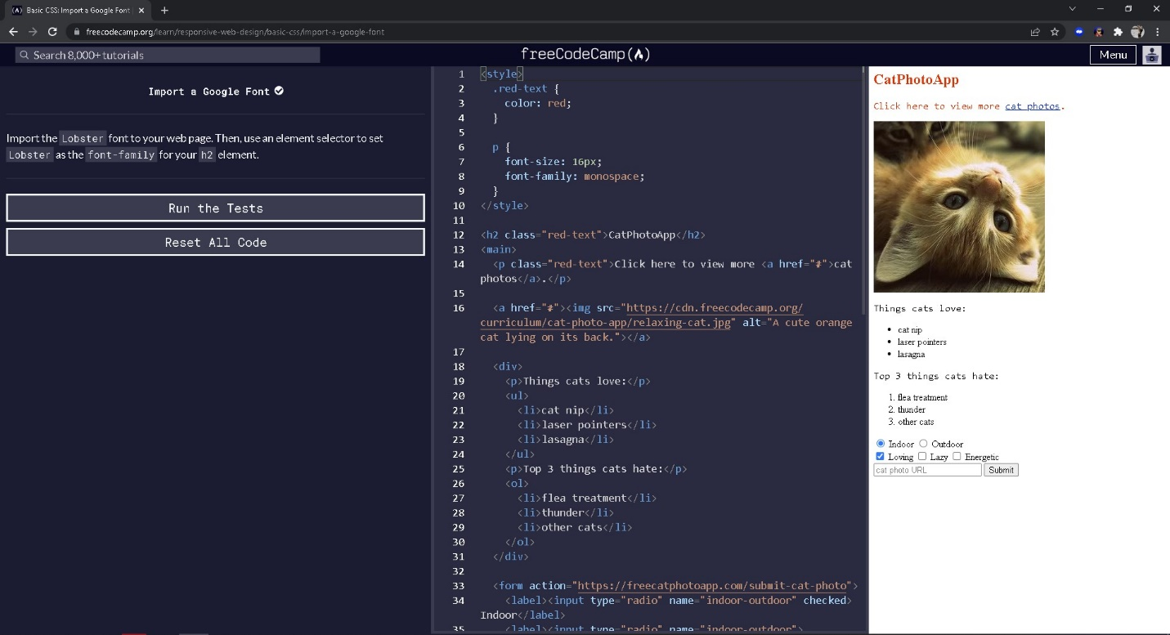

1. The second bug was missing instructions to the “Style Multiple Elements with a CSS Class” task. I think the problem with this task is that it doesn’t have any extended explanation and that is the reason the extension cuts out the instructions. This issue can be solved by including the instructions into the task by removing the restrictions for removing the extended explanation for this particular task.

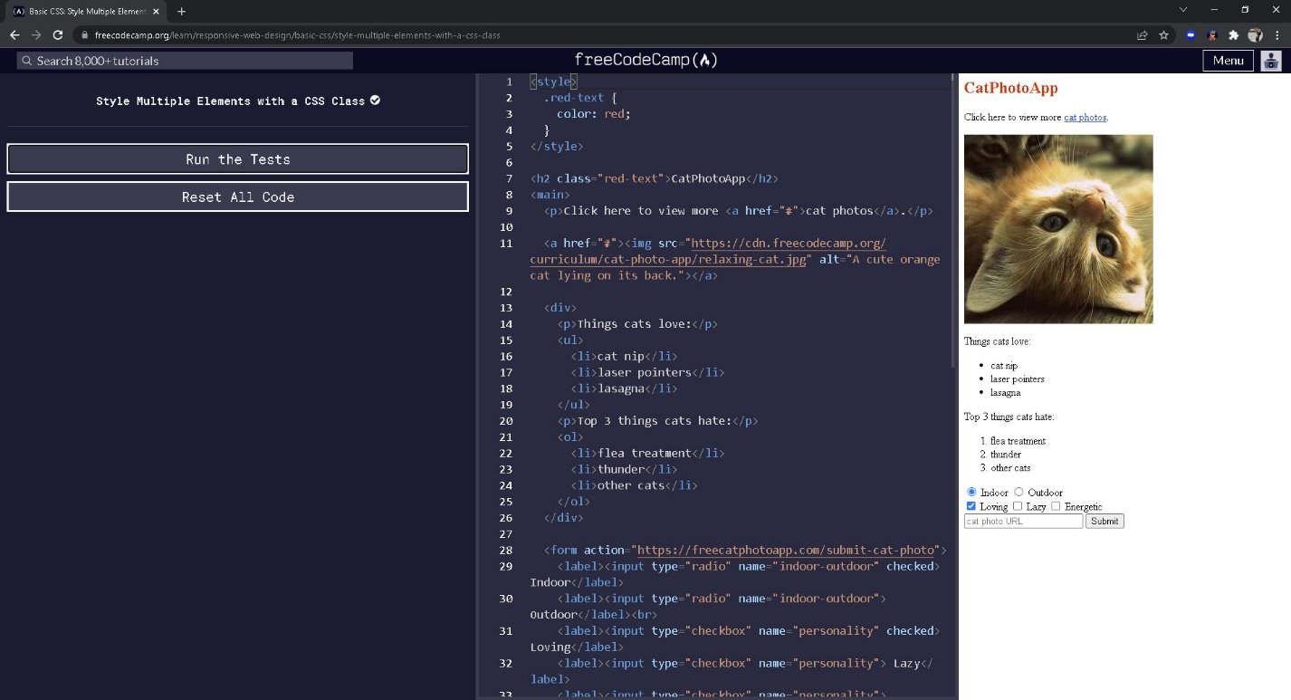

1. “Adjust the background-color Property of Text” task had missing rgba values that are provided in the extended explanation of the task. This bug can be fixed by including the missing rgba values above or bellow the task instructions. The missing rgba value is a value of a background-color property and it should be provided without the property so it doesn’t count as cheating.

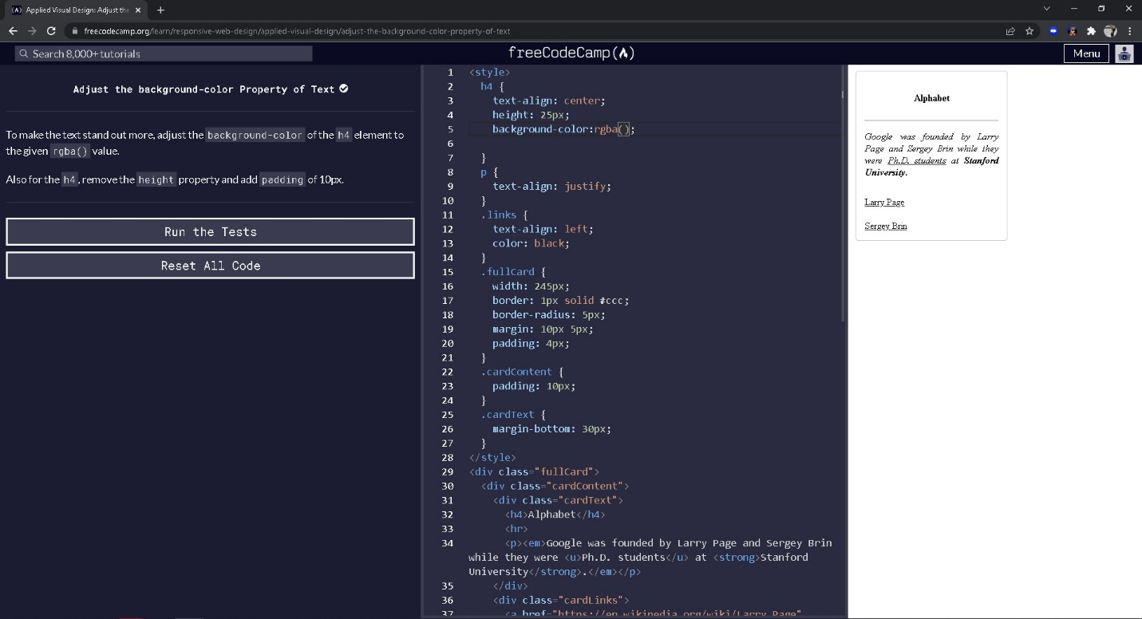

1. “Learn about Tertiary Colors” task has missing hex codes required to complete this task. It can be fixed by including those values above or bellow the task instructions. They are located above the horizontal line in a table in the extended explanation of the task.

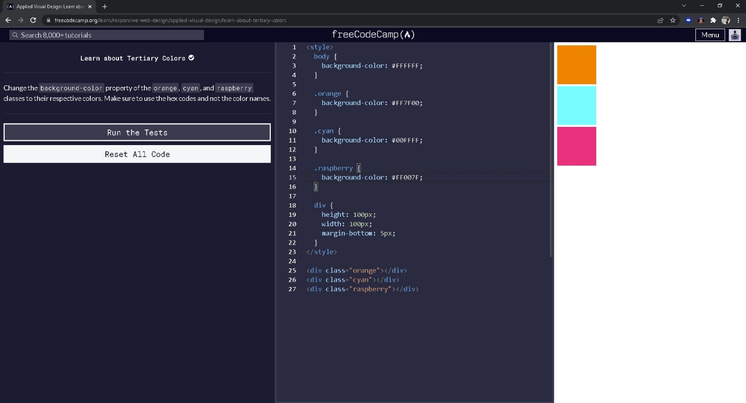

1. “Adjust the Hue of a Color” task has missing hsl values required to complete this task. It can be fixed by including those values above or bellow the task instructions. They are located above the horizontal line in a table in the extended explanation of the task.

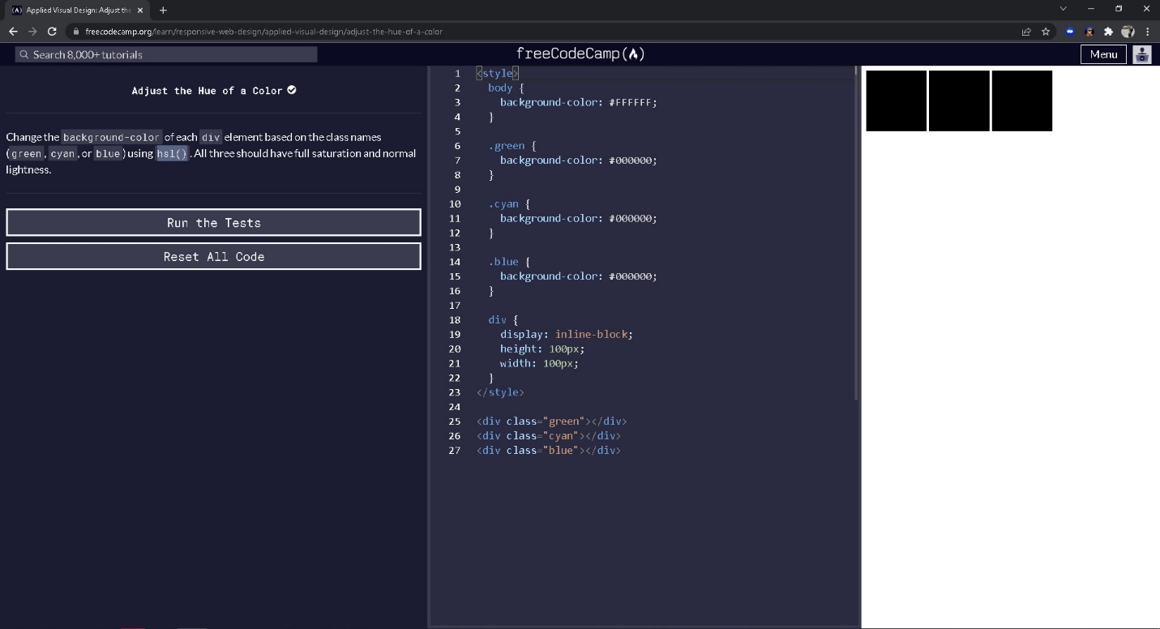

1. “Add a box-shadow to a Card-Like Element” has offset-x ,offset-y,blur radius and rgba values for 2 property values missing. They are required to complete this task. It can be fixed by including those values above or bellow the task instructions. They are located above the horizontal line in the extended explanation of the task. They are values of a box-shadow property and they should be displayed without the property to prevent cheating.

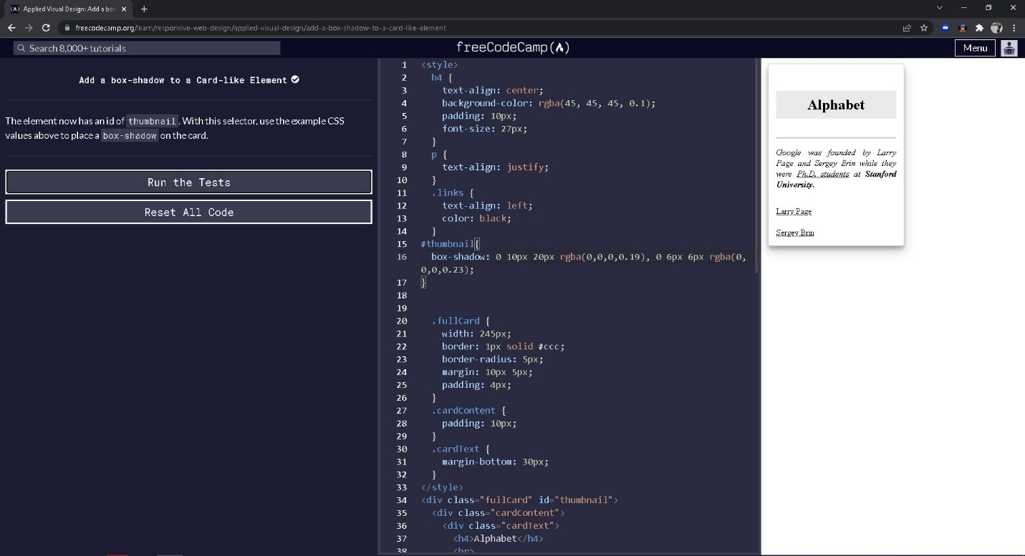

1. “Learn How Bezier Curves Work” has a missing cubic-bezier function with its values required to complete this task. It can be fixed by including that function and its values above or bellow the task instructions. They are located above the horizontal line in the extended explanation of the task as the property values of animation-timing-function property.

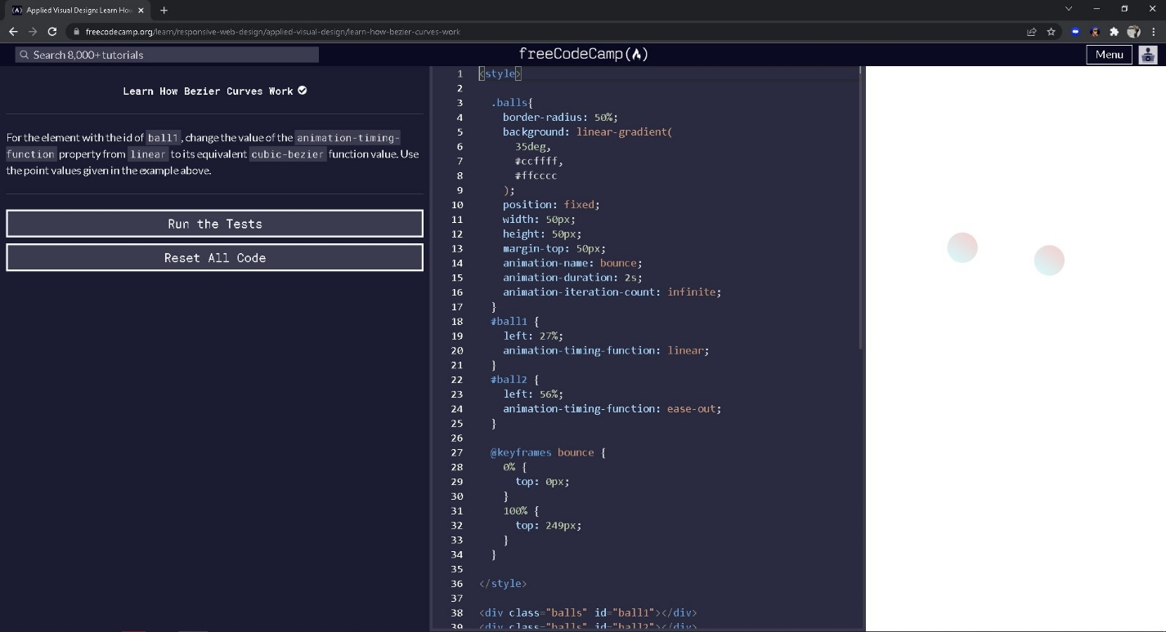

1. The final bug I found is related to the performance of the app for which I cannot provide proof. It might have been an internet connection issue but it happened to me a few times. When I wanted to submit or run the tests the extension wouldn’t do anything for up to 30 seconds. Its no big deal but it did make me second guess my solutions on occasions because it wasn’t going through.